# GMAT9600 Assignment – Radar Application

# Flood Mapping with Aerial and Satellite Images

DISCLAIMER

Satellite imagery provided for this assignment is for teaching GMAT9600 ONLY and hence should not be used for any other purpose. Students should delete the satellite imagery from their storage as soon as the assignment is submitted.

**Rules for submitting the Lab Reports and Assignments**

* The lab reports and assignments need to be submitted by email. (For the student in GMAT9600, email to GMAT9600@geos.org.au)
* Only one file per assignment in Word format.
* Name your file as "StudentID-YourLastName-CoureID-assignment2.doc". (For example: *z3012345-Charlton-GMAT9600-assignment2.doc*).
* Your email must have your name, student ID and the assignment name in the subject.
* Do NOT send multiple submissions for the same assignment. If you have to re-submit, you need to request permission from the course convenor.
* ***NOTE:******Failing to submit the file with correct format and/or naming convention will result in deduction of 1 mark.***

A. How can you identify the flood water extent from SAR intensity/ coherence images? What is the principle of the methods?

*Method and principle to identify SAR intensity*

SAR intensity method utilises the change in intensity level in different time stamp to identify the variation of surface condition[1]. It is done by firstly obtain the difference image and then identify the flooded areas using a global threshold derived from the histogram. This works well because the reflection pattern of different surface is easily identifiable. For example, still water body and flooded soil are characterised by specular reflection so most radar wave is reflected which results in black pixels. Also, rough water surface can diffuse reflect more waves which results a slightly higher intensity.

*Method and principle to identify SAR coherence*

B. Produce SAR intensity images and SAR intensity difference image. Compare the SAR intensity images and the SAR intensity difference image. What do the negative intensity difference and positive intensity difference represent? [Please include the SAR intensity difference image to answer this question] [/6 marks]

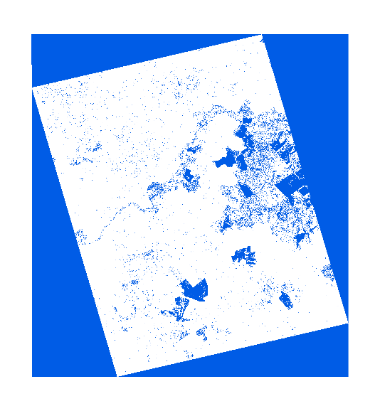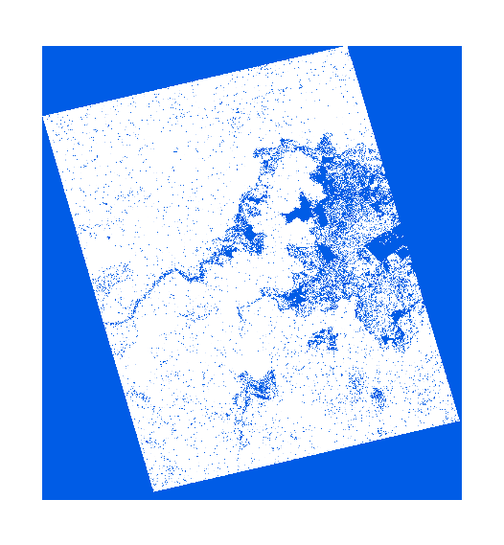

SAR intensity images 19(left) 20(right)

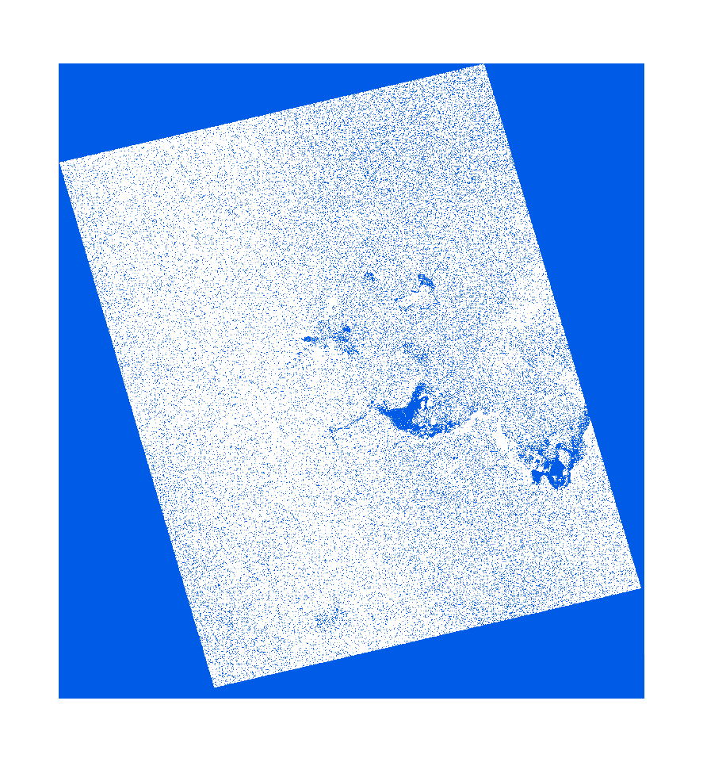

SAR intensity difference image

*Discuss about positive and negative intensity difference [/2 marks]*

C. Compare the SAR intensity analysis and SAR coherence analysis. Discuss the pros and cons of these methods in a table. [/6 marks]

|  |  |  |
| --- | --- | --- |
|  | Pros | Cons |
| Intensity analysis |  |  |
| Coherence analysis |  |  |

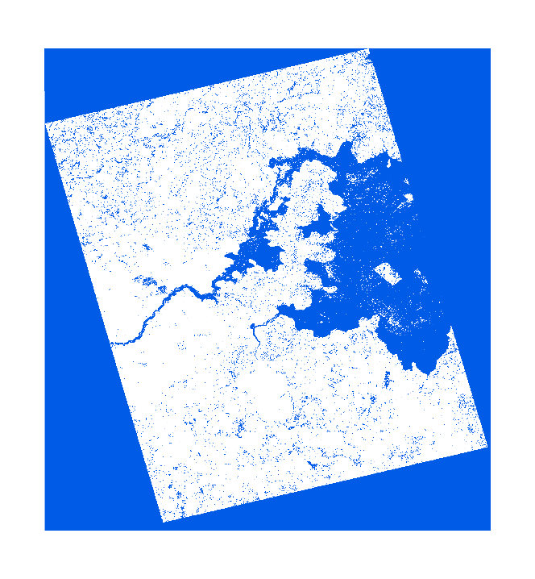

Coherence image

*With images to back up the answers [/2 marks]*

D. Compare the SAR images and optical images. What are the radar intensity and coherence values for the pixels over different surfaces, such as still water, flooded forest, bare soil, farm land, forest and buildings? Are these values reasonable? [Hint: Utilise the optical images] [/6 marks]

*Still water [/1 marks]*

*Flooded forest [/1 marks]*

*Bare soil [/1 marks]*

*Farm land [/1 marks]*

*Non-flooded Forest [/1 marks]*

*Buildings [/1 marks]*

E. Try different threshold values for mapping flood water extent from the SAR intensity and coherence images [i.e. m*odify the value in the colour table*]. What are the best threshold values for the generation of water extent map from the SAR intensity and coherence images? [Please include water extent maps generated from the SAR intensity/coherence images to answer this question] [/6 marks]

*Reasonable threshold values for SAR intensity image 1 and water extent map [/2 marks]*

*Reasonable threshold values for SAR intensity image 2 and water extent map [/2 marks]*

*Reasonable threshold values for SAR coherence image and water extent map [/2 marks]*

G. Compare the SAR images, the optical images and the flood extent map from SES (State Emergency Service). Discuss the pros and cons of these methods with illustrations. [/6 marks]

*Discuss about the accessibility [/1 marks]*

*Discuss about the cost [/1 marks]*

*Discuss about the spatial extent [/1 marks]*

*Discuss about the temporal extent [/1 marks]*

*Discuss about the resolution [/1 marks]*

*Discuss about the accuracy [/1 marks]*

**End of lab exercise.**

1. Flood Extent Mapping from Time-Series SAR Images Based on Texture Analysis and Data Fusion