1. **Activities and Quiz Student Name: Yiyan Yang ID: z5183946**
   1. *Add all HJ and MODIS data into ArcMap and compare the difference between them. Refer to the “Raster Dataset Properties” for detailed information.*

*Questions: The CCD images of HJ-1B were taken at the same time of its infrared images. Why their spatial coverage is not the same? Why the coverage of infrared images is larger?*

This is because that the spatial coverage is influenced by swath width and they have different swath width.

The reason why infrared images are larger is that the swath width of them is largest.

* 1. *Produce true colour images for both HJ CCD data and MODIS images.*

*Questions: What is the band combination of true colour images for HJ and MODIS? What is the key problem of identifying bushfires from these images directly?*

The band combination of true colour images for HJ CCD are band 1,2 and 3.

And the combination for MODIS images is band is band 3,4 and 1.

According to table 2 channel information, they represent blue, green and red respectively.

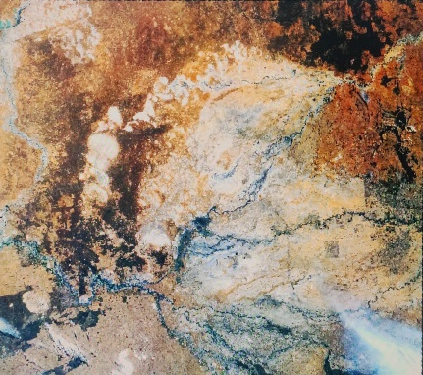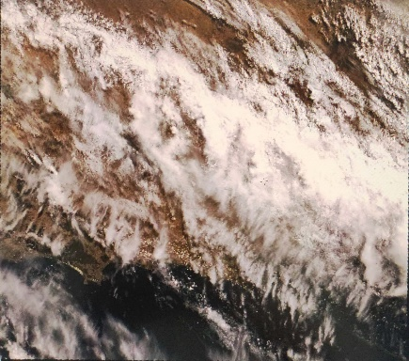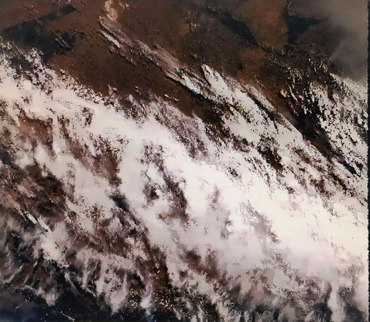

Images for HJ CCD

(left-to-right: HJ1B-CCD2-400-166-20090208-L20000065990,

HJ1B-CCD2-400-170-20090208-L20000065995, HJ1B-CCD2-400-171-20090208-L20000065993).

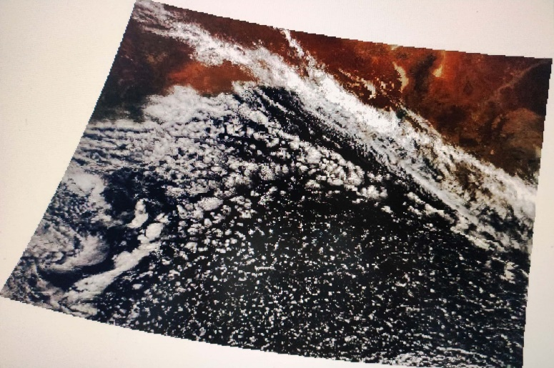

MODIS image

* 1. *Try to find out bushfires by observing each band of HJ data or combining different bands for true-colour and false-colour results.*

*Questions: How can you identify the bushfires? What is the principle of your method?*

Infrared is useful for identifying bushfires because it is mainly affected by temperature. So, I use infrared bands to produce a false-colour result which can highlight high temperature areas which are highly possible to be bushfires.

The image below is obtained by setting band 6(shortwave infrared) to green and band 7(mid infrared) red. Because Mid infrared is mainly sourced from radiation from high temperature objects. A more visible red colour stands for a possibly higher temperature.

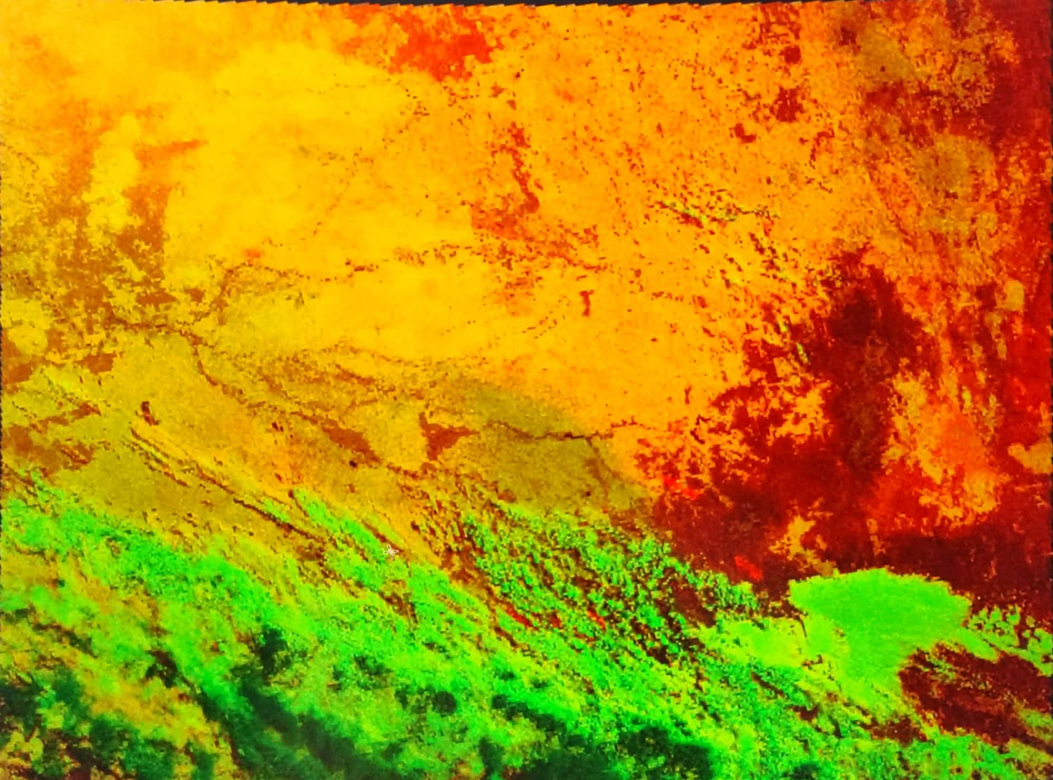

The areas with ruby colour in the image above are considered ongoing bushfires and the dark red area on the righthand side are possibly areas influenced by bush fires or simply high temperature areas that are in danger of being ignited.