Final paper

Lee Che Yuet Isaac

5/2/2022

# Environment preparation

**Preliminaries:**

rm(list=ls())

# required packages  
packages <- c('dplyr', 'AER','stargazer','haven','cem','Matching','MatchIt','cobalt')  
  
# install any packages that are not yet installed  
installed_packages <- packages %in% rownames(installed.packages())  
if (any(installed_packages == FALSE)) {  
 install.packages(packages[!installed_packages])  
}  
  
# load required packages  
invisible(lapply(packages, library, character.only = TRUE))

# load dataset  
peacekeeping <- read_dta("Replication_Costalli_Negri_IPSR2021.dta") %>%  
 as_tibble()  
peacekeeping

## # A tibble: 420 x 16  
## id municipality code year contig_hr contig_srb internal_bord nat_polar  
## <dbl> <chr> <dbl+l> <dbl> <dbl> <dbl> <dbl> <dbl>  
## 1 1 Banja Luka 1 [Ban~ 1992 0 0 0 0.816  
## 2 1 Banja Luka 1 [Ban~ 1993 0 0 0 0.816  
## 3 1 Banja Luka 1 [Ban~ 1994 0 0 0 0.816  
## 4 1 Banja Luka 1 [Ban~ 1995 0 0 0 0.816  
## 5 2 Banovici 2 [Ban~ 1992 0 0 0 0.751  
## 6 2 Banovici 2 [Ban~ 1993 0 0 0 0.751  
## 7 2 Banovici 2 [Ban~ 1994 0 0 0 0.751  
## 8 2 Banovici 2 [Ban~ 1995 0 0 0 0.751  
## 9 3 Bihac 3 [Bih~ 1992 1 0 0 0.784  
## 10 3 Bihac 3 [Bih~ 1993 1 0 0 0.784  
## # ... with 410 more rows, and 8 more variables: share_cultland <dbl>,  
## # pk_presence <dbl>, pk1dicot <dbl>, log_victims <dbl>, log_pop <dbl>,  
## # past_vict <dbl>, past_pkpres <dbl>, past_pk1dicot <dbl>

# Summary Statistics

peacekeeping %>%  
 mutate(contig_hr = factor(contig_hr),  
 contig_srb = factor(contig_srb),  
 internal_bord = factor(internal_bord),  
 pk_presence = factor(pk_presence),  
 pk1dicot = factor(pk1dicot),  
 past_pkpres = factor(past_pkpres),  
 past_pk1dicot = factor(past_pk1dicot),  
 municipality = factor(municipality)) %>%  
 summary()

## id municipality code year contig_hr  
## Min. : 1 Banja Luka : 4 Min. : 1 Min. :1992 0:332   
## 1st Qu.: 27 Banovici : 4 1st Qu.: 27 1st Qu.:1993 1: 88   
## Median : 53 Bihac : 4 Median : 53 Median :1994   
## Mean : 53 Bijelijna : 4 Mean : 53 Mean :1994   
## 3rd Qu.: 79 Bileca : 4 3rd Qu.: 79 3rd Qu.:1994   
## Max. :105 Bosanska Dubica: 4 Max. :105 Max. :1995   
## (Other) :396   
## contig_srb internal_bord nat_polar share_cultland pk_presence  
## 0:376 0:216 Min. :0.0359 Min. :0.001083 0:347   
## 1: 44 1:204 1st Qu.:0.7010 1st Qu.:0.049709 1: 73   
## Median :0.8308 Median :0.115317   
## Mean :0.7446 Mean :0.172614   
## 3rd Qu.:0.8910 3rd Qu.:0.272603   
## Max. :0.9828 Max. :0.673398   
## NA's :4   
## pk1dicot log_victims log_pop past_vict past_pkpres  
## 0:372 Min. :0.000 Min. : 8.331 Min. :0.000 0:380   
## 1: 48 1st Qu.:3.466 1st Qu.: 9.748 1st Qu.:2.833 1: 40   
## Median :4.324 Median :10.303 Median :4.078   
## Mean :4.362 Mean :10.287 Mean :3.838   
## 3rd Qu.:5.337 3rd Qu.:10.785 3rd Qu.:5.220   
## Max. :8.660 Max. :12.865 Max. :8.428   
## NA's :4 NA's :34   
## past_pk1dicot  
## 0:388   
## 1: 32   
##   
##   
##   
##   
##

### Generation of summary statistics results

##### All

sumstat_all <- peacekeeping %>%  
 dplyr::select(  
 "year",  
 "contig_hr",  
 "contig_srb",  
 "internal_bord",  
 "nat_polar",  
 "share_cultland",  
 "pk_presence",  
 "pk1dicot",  
 "log_victims",  
 "log_pop",  
 "past_vict",  
 "past_pkpres",  
 "past_pk1dicot"  
 )  
   
stargazer(  
 as.data.frame(sumstat_all),  
 digits = 2,  
 title = "Summary Statistics",  
 summary.stat = c("min", "max", "mean", "sd"),  
 covariate.labels = c(  
 "Year",  
 "Contiguity Croatia",  
 "Contiguity Serbia",  
 "Internal border",  
 "Ethnic polarization",  
 "Open terrain",  
 "Presence of peacekeeping",  
 "Active peacekeeping",  
 "Violence (logged)",  
 "Population (logged)",  
 "Violence (t−1) (logged)",  
 "Presence of peacekeeping (t−1)",  
 "Active peacekeeping (t−1)"  
 ),  
 type = "html",  
 out = "Summary Statistics all.doc"  
)

##   
## <table style="text-align:center"><caption><strong>Summary Statistics</strong></caption>  
## <tr><td colspan="5" style="border-bottom: 1px solid black"></td></tr><tr><td style="text-align:left">Statistic</td><td>Min</td><td>Max</td><td>Mean</td><td>St. Dev.</td></tr>  
## <tr><td colspan="5" style="border-bottom: 1px solid black"></td></tr><tr><td style="text-align:left">Year</td><td>1,992</td><td>1,995</td><td>1,993.50</td><td>1.12</td></tr>  
## <tr><td style="text-align:left">Contiguity Croatia</td><td>0</td><td>1</td><td>0.21</td><td>0.41</td></tr>  
## <tr><td style="text-align:left">Contiguity Serbia</td><td>0</td><td>1</td><td>0.10</td><td>0.31</td></tr>  
## <tr><td style="text-align:left">Internal border</td><td>0</td><td>1</td><td>0.49</td><td>0.50</td></tr>  
## <tr><td style="text-align:left">Ethnic polarization</td><td>0.04</td><td>0.98</td><td>0.74</td><td>0.23</td></tr>  
## <tr><td style="text-align:left">Open terrain</td><td>0.001</td><td>0.67</td><td>0.17</td><td>0.16</td></tr>  
## <tr><td style="text-align:left">Presence of peacekeeping</td><td>0</td><td>1</td><td>0.17</td><td>0.38</td></tr>  
## <tr><td style="text-align:left">Active peacekeeping</td><td>0</td><td>1</td><td>0.11</td><td>0.32</td></tr>  
## <tr><td style="text-align:left">Violence (logged)</td><td>0.00</td><td>8.66</td><td>4.36</td><td>1.45</td></tr>  
## <tr><td style="text-align:left">Population (logged)</td><td>8.33</td><td>12.86</td><td>10.29</td><td>0.81</td></tr>  
## <tr><td style="text-align:left">Violence (t-1) (logged)</td><td>0.00</td><td>8.43</td><td>3.84</td><td>1.90</td></tr>  
## <tr><td style="text-align:left">Presence of peacekeeping (t-1)</td><td>0</td><td>1</td><td>0.10</td><td>0.29</td></tr>  
## <tr><td style="text-align:left">Active peacekeeping (t-1)</td><td>0</td><td>1</td><td>0.08</td><td>0.27</td></tr>  
## <tr><td colspan="5" style="border-bottom: 1px solid black"></td></tr></table>

dim(sumstat_all)

## [1] 420 13

##### Treatment group

sumstat_tr <- peacekeeping %>%  
 filter(past_pkpres == 1) %>%  
 dplyr::select(  
 "year",  
 "contig_hr",  
 "contig_srb",  
 "internal_bord",  
 "nat_polar",  
 "share_cultland",  
 "pk_presence",  
 "pk1dicot",  
 "log_victims",  
 "log_pop",  
 "past_vict"  
 )  
   
stargazer(  
 as.data.frame(sumstat_tr),  
 digits = 2,  
 title = "Summary Statistics by treatment and control group",  
 summary.stat = c("min", "max", "mean", "sd"),  
 covariate.labels = c(  
 "Year",  
 "Contiguity Croatia",  
 "Contiguity Serbia",  
 "Internal border",  
 "Ethnic polarization",  
 "Open terrain",  
 "Presence of peacekeeping",  
 "Active peacekeeping",  
 "Violence (logged)",  
 "Population (logged)",  
 "Violence (t−1) (logged)"  
 ),  
 type = "html",  
 out = "Summary Statistics treatment group1.doc"  
)

##   
## <table style="text-align:center"><caption><strong>Summary Statistics by treatment and control group</strong></caption>  
## <tr><td colspan="5" style="border-bottom: 1px solid black"></td></tr><tr><td style="text-align:left">Statistic</td><td>Min</td><td>Max</td><td>Mean</td><td>St. Dev.</td></tr>  
## <tr><td colspan="5" style="border-bottom: 1px solid black"></td></tr><tr><td style="text-align:left">Year</td><td>1,993</td><td>1,995</td><td>1,994.33</td><td>0.86</td></tr>  
## <tr><td style="text-align:left">Contiguity Croatia</td><td>0</td><td>1</td><td>0.25</td><td>0.44</td></tr>  
## <tr><td style="text-align:left">Contiguity Serbia</td><td>0</td><td>1</td><td>0.10</td><td>0.30</td></tr>  
## <tr><td style="text-align:left">Internal border</td><td>0</td><td>1</td><td>0.55</td><td>0.50</td></tr>  
## <tr><td style="text-align:left">Ethnic polarization</td><td>0.11</td><td>0.95</td><td>0.77</td><td>0.20</td></tr>  
## <tr><td style="text-align:left">Open terrain</td><td>0.02</td><td>0.67</td><td>0.21</td><td>0.16</td></tr>  
## <tr><td style="text-align:left">Presence of peacekeeping</td><td>0</td><td>1</td><td>0.65</td><td>0.48</td></tr>  
## <tr><td style="text-align:left">Active peacekeeping</td><td>0</td><td>1</td><td>0.58</td><td>0.50</td></tr>  
## <tr><td style="text-align:left">Violence (logged)</td><td>2.30</td><td>8.66</td><td>5.11</td><td>1.35</td></tr>  
## <tr><td style="text-align:left">Population (logged)</td><td>9.65</td><td>12.85</td><td>10.97</td><td>0.84</td></tr>  
## <tr><td style="text-align:left">Violence (t-1) (logged)</td><td>2.30</td><td>8.43</td><td>5.17</td><td>1.24</td></tr>  
## <tr><td colspan="5" style="border-bottom: 1px solid black"></td></tr></table>

dim(sumstat_tr)

## [1] 40 11

##### Control group

sumstat_Cr <- peacekeeping %>%  
 filter(past_pkpres == 0) %>%  
 dplyr::select(  
 "year",  
 "contig_hr",  
 "contig_srb",  
 "internal_bord",  
 "nat_polar",  
 "share_cultland",  
 "pk_presence",  
 "pk1dicot",  
 "log_victims",  
 "log_pop",  
 "past_vict"  
 )  
   
stargazer(  
 as.data.frame(sumstat_Cr),  
 digits = 2,  
 title = "Summary Statistics by treatment and control group",  
 summary.stat = c("min", "max", "mean", "sd"),  
 covariate.labels = c(  
 "Year",  
 "Contiguity Croatia",  
 "Contiguity Serbia",  
 "Internal border",  
 "Ethnic polarization",  
 "Open terrain",  
 "Presence of peacekeeping",  
 "Active peacekeeping",  
 "Violence (logged)",  
 "Population (logged)",  
 "Violence (t−1) (logged)"  
 ),  
 type = "html",  
 out = "Summary Statistics control group.doc"  
)

##   
## <table style="text-align:center"><caption><strong>Summary Statistics by treatment and control group</strong></caption>  
## <tr><td colspan="5" style="border-bottom: 1px solid black"></td></tr><tr><td style="text-align:left">Statistic</td><td>Min</td><td>Max</td><td>Mean</td><td>St. Dev.</td></tr>  
## <tr><td colspan="5" style="border-bottom: 1px solid black"></td></tr><tr><td style="text-align:left">Year</td><td>1,992</td><td>1,995</td><td>1,993.41</td><td>1.11</td></tr>  
## <tr><td style="text-align:left">Contiguity Croatia</td><td>0</td><td>1</td><td>0.21</td><td>0.40</td></tr>  
## <tr><td style="text-align:left">Contiguity Serbia</td><td>0</td><td>1</td><td>0.11</td><td>0.31</td></tr>  
## <tr><td style="text-align:left">Internal border</td><td>0</td><td>1</td><td>0.48</td><td>0.50</td></tr>  
## <tr><td style="text-align:left">Ethnic polarization</td><td>0.04</td><td>0.98</td><td>0.74</td><td>0.24</td></tr>  
## <tr><td style="text-align:left">Open terrain</td><td>0.001</td><td>0.67</td><td>0.17</td><td>0.16</td></tr>  
## <tr><td style="text-align:left">Presence of peacekeeping</td><td>0</td><td>1</td><td>0.12</td><td>0.33</td></tr>  
## <tr><td style="text-align:left">Active peacekeeping</td><td>0</td><td>1</td><td>0.07</td><td>0.25</td></tr>  
## <tr><td style="text-align:left">Violence (logged)</td><td>0.00</td><td>8.43</td><td>4.28</td><td>1.44</td></tr>  
## <tr><td style="text-align:left">Population (logged)</td><td>8.33</td><td>12.86</td><td>10.21</td><td>0.77</td></tr>  
## <tr><td style="text-align:left">Violence (t-1) (logged)</td><td>0.00</td><td>8.39</td><td>3.68</td><td>1.90</td></tr>  
## <tr><td colspan="5" style="border-bottom: 1px solid black"></td></tr></table>

dim(sumstat_Cr)

## [1] 380 11

# Experimental Benchmark

### treatment only

lm1 <- lm(log_victims ~ past_pkpres, data = peacekeeping)  
summary(lm1)

##   
## Call:  
## lm(formula = log_victims ~ past_pkpres, data = peacekeeping)  
##   
## Residuals:  
## Min 1Q Median 3Q Max   
## -4.2827 -0.8816 -0.0201 0.9656 4.1450   
##   
## Coefficients:  
## Estimate Std. Error t value Pr(>|t|)   
## (Intercept) 4.28275 0.07388 57.966 < 2e-16 ***  
## past_pkpres 0.82789 0.23827 3.475 0.000566 ***  
## ---  
## Signif. codes: 0 '***' 0.001 '**' 0.01 '*' 0.05 '.' 0.1 ' ' 1  
##   
## Residual standard error: 1.433 on 414 degrees of freedom  
## (4 observations deleted due to missingness)  
## Multiple R-squared: 0.02834, Adjusted R-squared: 0.02599   
## F-statistic: 12.07 on 1 and 414 DF, p-value: 0.0005656

### with control variables

lm3 <- lm(log_victims ~ past_pkpres +  
 past_vict +  
 nat_polar +  
 log_pop +  
 contig_hr +  
 contig_srb +  
 internal_bord +  
 share_cultland,   
 data = peacekeeping)  
summary(lm3)

##   
## Call:  
## lm(formula = log_victims ~ past_pkpres + past_vict + nat_polar +   
## log_pop + contig_hr + contig_srb + internal_bord + share_cultland,   
## data = peacekeeping)  
##   
## Residuals:  
## Min 1Q Median 3Q Max   
## -2.6330 -0.5955 -0.1157 0.6206 3.7280   
##   
## Coefficients:  
## Estimate Std. Error t value Pr(>|t|)   
## (Intercept) -7.71716 0.76932 -10.031 < 2e-16 ***  
## past_pkpres 0.20242 0.17677 1.145 0.2529   
## past_vict -0.13567 0.02996 -4.529 8.01e-06 ***  
## nat_polar 1.50733 0.28183 5.348 1.56e-07 ***  
## log_pop 1.10190 0.08043 13.701 < 2e-16 ***  
## contig_hr -0.59025 0.14768 -3.997 7.75e-05 ***  
## contig_srb 0.25179 0.17204 1.464 0.1442   
## internal_bord 0.23654 0.10911 2.168 0.0308 *   
## share_cultland 0.33178 0.38730 0.857 0.3922   
## ---  
## Signif. codes: 0 '***' 0.001 '**' 0.01 '*' 0.05 '.' 0.1 ' ' 1  
##   
## Residual standard error: 0.9956 on 371 degrees of freedom  
## (40 observations deleted due to missingness)  
## Multiple R-squared: 0.5124, Adjusted R-squared: 0.5019   
## F-statistic: 48.74 on 8 and 371 DF, p-value: < 2.2e-16

# Coarsened Exact Matching

tr <- which(peacekeeping$past_pkpres == 1)  
ct <- which(peacekeeping$past_pkpres == 0)  
ntr <- length(tr)  
ntr

## [1] 40

nct <- length(ct)  
nct

## [1] 380

### Basic estimate

mean(na.omit(peacekeeping$log_victims[tr])) - mean(na.omit(peacekeeping$log_victims[ct]))

## [1] 0.8278944

vars <- c("past_vict", "nat_polar", "log_pop", "contig_hr", "contig_srb", "internal_bord" , "share_cultland","past_pkpres")  
covs1 <- na.omit(peacekeeping[,vars])  
bal.tab(covs1, treat = covs1$past_pkpres)

## Note: 's.d.denom' not specified; assuming pooled.

## Balance Measures  
## Type Diff.Un  
## past_vict Contin. 0.9142  
## nat_polar Contin. 0.0591  
## log_pop Contin. 0.8938  
## contig_hr Binary 0.0395  
## contig_srb Binary -0.0053  
## internal_bord Binary 0.0646  
## share_cultland Contin. 0.1962  
##   
## Sample sizes  
## Control Treated  
## All 342 40

1. nat_polar, past_vict, log_pop, contig_hr, contig_srb
2. municipality, internal_bord, share_cultland

### Coarsening 1

#cem1_var <- c("nat_polar", "past_vict", "log_pop", "contig_hr", "contig_srb","past_pkpres","log_victims")  
  
cem1_var <- c("log_victims",  
 "past_pkpres",  
 "past_vict",   
 "nat_polar",   
 "log_pop",   
 "contig_hr",  
 "contig_srb",  
 "internal_bord",  
 "share_cultland")  
data11 <- na.omit(peacekeeping[,cem1_var])  
  
X_11 <- data11 %>%  
 dplyr::select(nat_polar, past_vict, log_pop, contig_hr, contig_srb)  
  
#mat11 <- cem(treatment = "past_pkpres", data = data11, keep.all = T)  
#mat11  
  
m.out.cem <- matchit(past_pkpres ~ nat_polar + past_vict + log_pop + contig_hr + contig_srb, data = data11, method = "cem")

bal_tab_cem <- bal.tab(m.out.cem, thresholds = c(m = 0.1), un = TRUE)  
bal_tab_cem

## Call  
## matchit(formula = past_pkpres ~ nat_polar + past_vict + log_pop +   
## contig_hr + contig_srb, data = data11, method = "cem")  
##   
## Balance Measures  
## Type Diff.Un Diff.Adj M.Threshold  
## nat_polar Contin. 0.0458 -0.0186 Balanced, <0.1  
## past_vict Contin. 1.1756 -0.0858 Balanced, <0.1  
## log_pop Contin. 0.8422 -0.0132 Balanced, <0.1  
## contig_hr Binary 0.0412 0.0000 Balanced, <0.1  
## contig_srb Binary -0.0059 0.0000 Balanced, <0.1  
##   
## Balance tally for mean differences  
## count  
## Balanced, <0.1 5  
## Not Balanced, >0.1 0  
##   
## Variable with the greatest mean difference  
## Variable Diff.Adj M.Threshold  
## past_vict -0.0858 Balanced, <0.1  
##   
## Sample sizes  
## Control Treated  
## All 340. 40  
## Matched (ESS) 29.02 24  
## Matched (Unweighted) 54. 24  
## Unmatched 286. 16

lp.cem <- love.plot(  
 m.out.cem,  
 threshold = .1,  
 binary = 'std',  
 treat = data11$past_pkpres,  
 covs = X_11  
)  
  
lp.cem

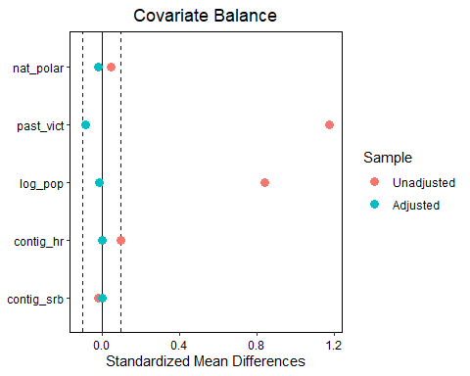 # 1:1 distance matching

m.out.1to1 <-  
 Match(  
 Tr = data11$past_pkpres,  
 X = X_11,  
 estimand = "ATT",  
 M = 1,  
 ties = TRUE,  
 replace = TRUE,  
 Weight = 2  
 )  
  
bal_tab_1to1 <- bal.tab(m.out.1to1, treat = data11$past_pkpres, covs = X_11, thresholds = c(m = 0.1), un = TRUE)  
bal_tab_1to1

## Balance Measures  
## Type Diff.Un Diff.Adj M.Threshold  
## nat_polar Contin. 0.0458 0.0101 Balanced, <0.1  
## past_vict Contin. 1.1756 0.0855 Balanced, <0.1  
## log_pop Contin. 0.8422 0.0830 Balanced, <0.1  
## contig_hr Binary 0.0412 0.0000 Balanced, <0.1  
## contig_srb Binary -0.0059 0.0000 Balanced, <0.1  
##   
## Balance tally for mean differences  
## count  
## Balanced, <0.1 5  
## Not Balanced, >0.1 0  
##   
## Variable with the greatest mean difference  
## Variable Diff.Adj M.Threshold  
## past_vict 0.0855 Balanced, <0.1  
##   
## Sample sizes  
## Control Treated  
## All 340. 40  
## Matched (ESS) 26.67 40  
## Matched (Unweighted) 31. 40  
## Unmatched 309. 0

lp.1to1 <- love.plot(  
 m.out.1to1,  
 threshold = .1,  
 binary = 'std',  
 treat = data11$past_pkpres,  
 covs = X_11  
)  
  
lp.1to1

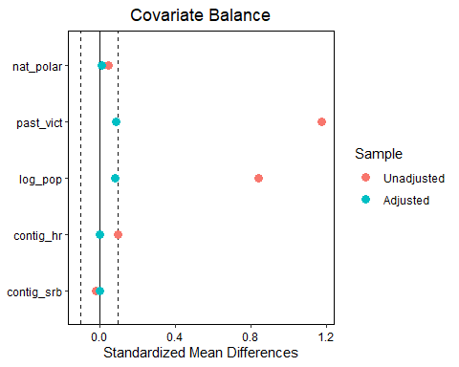 # 1:2 distance matching

m.out.1to2 <-  
 Match(  
 Tr = data11$past_pkpres,  
 X = X_11,  
 estimand = "ATT",  
 M = 2,  
 ties = TRUE,  
 replace = TRUE,  
 Weight = 2  
 )  
  
bal_tab_1to2 <- bal.tab(m.out.1to2, treat = data11$past_pkpres, covs = X_11, thresholds = c(m = 0.1), un = TRUE)  
bal_tab_1to2

## Balance Measures  
## Type Diff.Un Diff.Adj M.Threshold  
## nat_polar Contin. 0.0458 -0.0450 Balanced, <0.1  
## past_vict Contin. 1.1756 0.1015 Not Balanced, >0.1  
## log_pop Contin. 0.8422 0.1129 Not Balanced, >0.1  
## contig_hr Binary 0.0412 0.0000 Balanced, <0.1  
## contig_srb Binary -0.0059 0.0000 Balanced, <0.1  
##   
## Balance tally for mean differences  
## count  
## Balanced, <0.1 3  
## Not Balanced, >0.1 2  
##   
## Variable with the greatest mean difference  
## Variable Diff.Adj M.Threshold  
## log_pop 0.1129 Not Balanced, >0.1  
##   
## Sample sizes  
## Control Treated  
## All 340. 40  
## Matched (ESS) 37.21 40  
## Matched (Unweighted) 52. 40  
## Unmatched 288. 0

lp.1to2 <- love.plot(  
 m.out.1to2,  
 threshold = .1,  
 binary = 'std',  
 treat = data11$past_pkpres,  
 covs = X_11  
)  
  
lp.1to2

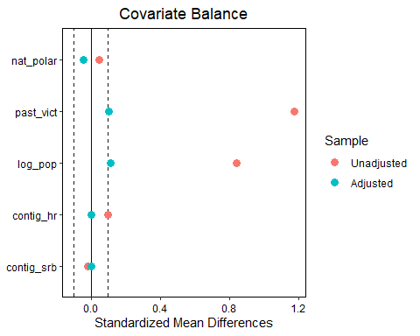 # 1:3 distance matching

m.out.1to3 <-  
 Match(  
 Tr = data11$past_pkpres,  
 X = X_11,  
 estimand = "ATT",  
 M = 3,  
 ties = TRUE,  
 replace = TRUE,  
 Weight = 2  
 )  
  
bal_tab_1to3 <- bal.tab(m.out.1to3, treat = data11$past_pkpres, covs = X_11, thresholds = c(m = 0.1), un = TRUE)  
bal_tab_1to3

## Balance Measures  
## Type Diff.Un Diff.Adj M.Threshold  
## nat_polar Contin. 0.0458 -0.0387 Balanced, <0.1  
## past_vict Contin. 1.1756 0.1491 Not Balanced, >0.1  
## log_pop Contin. 0.8422 0.1307 Not Balanced, >0.1  
## contig_hr Binary 0.0412 0.0000 Balanced, <0.1  
## contig_srb Binary -0.0059 0.0000 Balanced, <0.1  
##   
## Balance tally for mean differences  
## count  
## Balanced, <0.1 3  
## Not Balanced, >0.1 2  
##   
## Variable with the greatest mean difference  
## Variable Diff.Adj M.Threshold  
## past_vict 0.1491 Not Balanced, >0.1  
##   
## Sample sizes  
## Control Treated  
## All 340. 40  
## Matched (ESS) 48.32 40  
## Matched (Unweighted) 70. 40  
## Unmatched 270. 0

lp.1to3 <- love.plot(  
 m.out.1to3,  
 threshold = .1,  
 binary = 'std',  
 treat = data11$past_pkpres,  
 covs = X_11  
)  
  
lp.1to3

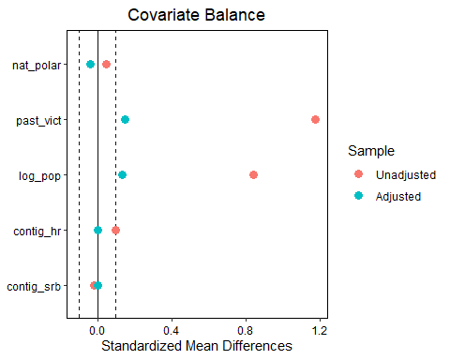 # Nearest neighbour matching

m.out.nnm <- matchit(past_pkpres ~ nat_polar + past_vict + log_pop + contig_hr + contig_srb, data = data11, replace = TRUE, method = "nearest")  
bal_tab_nnm <- bal.tab(m.out.nnm, thresholds = c(m = 0.1), un = TRUE)  
bal_tab_nnm

## Call  
## matchit(formula = past_pkpres ~ nat_polar + past_vict + log_pop +   
## contig_hr + contig_srb, data = data11, method = "nearest",   
## replace = TRUE)  
##   
## Balance Measures  
## Type Diff.Un Diff.Adj M.Threshold  
## distance Distance 0.7330 0.0772 Balanced, <0.1  
## nat_polar Contin. 0.0458 -0.1508 Not Balanced, >0.1  
## past_vict Contin. 1.1756 -0.3029 Not Balanced, >0.1  
## log_pop Contin. 0.8422 0.1939 Not Balanced, >0.1  
## contig_hr Binary 0.0412 0.1000 Not Balanced, >0.1  
## contig_srb Binary -0.0059 -0.1250 Not Balanced, >0.1  
##   
## Balance tally for mean differences  
## count  
## Balanced, <0.1 1  
## Not Balanced, >0.1 5  
##   
## Variable with the greatest mean difference  
## Variable Diff.Adj M.Threshold  
## past_vict -0.3029 Not Balanced, >0.1  
##   
## Sample sizes  
## Control Treated  
## All 340. 40  
## Matched (ESS) 25.81 40  
## Matched (Unweighted) 33. 40  
## Unmatched 307. 0

lp.nnm <- love.plot(  
 m.out.nnm,  
 threshold = .1,  
 binary = 'std',  
 treat = data11$past_pkpres,  
 covs = X_11  
)  
  
lp.nnm

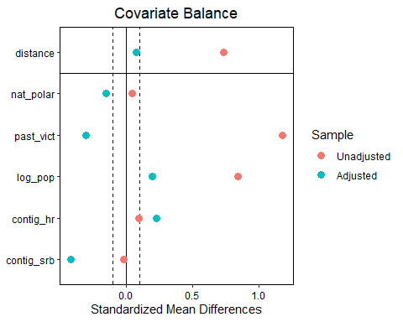 # Propensity score matching

m.out.pscore <- matchit(past_pkpres ~ nat_polar + past_vict + log_pop + contig_hr + contig_srb, data = data11, replace = TRUE, method = "full", distance = "glm", link = "probit")

## Warning: The argument 'replace' is not used with method = "full" and will be  
## ignored.

bal_tab_pscore <- bal.tab(m.out.pscore, thresholds = c(m = 0.1), un = TRUE)  
bal_tab_pscore

## Call  
## matchit(formula = past_pkpres ~ nat_polar + past_vict + log_pop +   
## contig_hr + contig_srb, data = data11, method = "full", distance = "glm",   
## link = "probit", replace = TRUE)  
##   
## Balance Measures  
## Type Diff.Un Diff.Adj M.Threshold  
## distance Distance 0.7585 0.0851 Balanced, <0.1  
## nat_polar Contin. 0.0458 -0.1832 Not Balanced, >0.1  
## past_vict Contin. 1.1756 -0.0809 Balanced, <0.1  
## log_pop Contin. 0.8422 0.0968 Balanced, <0.1  
## contig_hr Binary 0.0412 0.0348 Balanced, <0.1  
## contig_srb Binary -0.0059 0.0260 Balanced, <0.1  
##   
## Balance tally for mean differences  
## count  
## Balanced, <0.1 5  
## Not Balanced, >0.1 1  
##   
## Variable with the greatest mean difference  
## Variable Diff.Adj M.Threshold  
## nat_polar -0.1832 Not Balanced, >0.1  
##   
## Sample sizes  
## Control Treated  
## All 340. 40  
## Matched (ESS) 59.26 40  
## Matched (Unweighted) 340. 40

lp.pscore <- love.plot(  
 m.out.pscore,  
 threshold = .1,  
 binary = 'std',  
 treat = data11$past_pkpres,  
 covs = X_11  
)  
  
lp.pscore

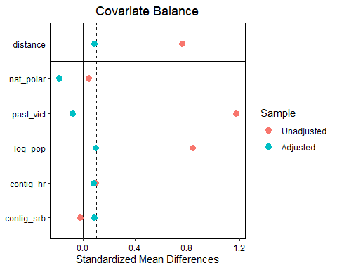 # Genetic matching

set.seed(1)  
m.out.gen <- matchit(past_pkpres ~ nat_polar + past_vict + log_pop + contig_hr + contig_srb, data = data11, replace = TRUE, method = "genetic")

## Warning: (from Matching) The key tuning parameters for optimization were are  
## all left at their default values. The 'pop.size' option in particular should  
## probably be increased for optimal results. For details please see the help page  
## and http://sekhon.berkeley.edu/papers/MatchingJSS.pdf

bal_tab_gen <- bal.tab(m.out.gen, thresholds = c(m = 0.1), un = TRUE)  
bal_tab_gen

## Call  
## matchit(formula = past_pkpres ~ nat_polar + past_vict + log_pop +   
## contig_hr + contig_srb, data = data11, method = "genetic",   
## replace = TRUE)  
##   
## Balance Measures  
## Type Diff.Un Diff.Adj M.Threshold  
## distance Distance 0.7330 0.1047   
## nat_polar Contin. 0.0458 0.0073 Balanced, <0.1  
## past_vict Contin. 1.1756 0.0059 Balanced, <0.1  
## log_pop Contin. 0.8422 0.0510 Balanced, <0.1  
## contig_hr Binary 0.0412 0.0000 Balanced, <0.1  
## contig_srb Binary -0.0059 0.0000 Balanced, <0.1  
##   
## Balance tally for mean differences  
## count  
## Balanced, <0.1 5  
## Not Balanced, >0.1 0  
##   
## Variable with the greatest mean difference  
## Variable Diff.Adj M.Threshold  
## log_pop 0.051 Balanced, <0.1  
##   
## Sample sizes  
## Control Treated  
## All 340. 40  
## Matched (ESS) 29.63 40  
## Matched (Unweighted) 33. 40  
## Unmatched 307. 0

lp.gen <- love.plot(  
 m.out.gen,  
 threshold = .1,  
 binary = 'std',  
 treat = data11$past_pkpres,  
 covs = X_11  
)  
  
lp.gen

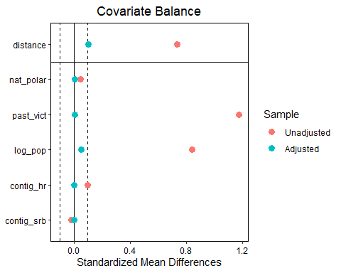 # ATT by CEM

m.data.cem <- match.data(m.out.cem)  
m.data.cem

## # A tibble: 78 x 11  
## log_victims past_pkpres past_vict nat_polar log_pop contig_hr contig_srb  
## <dbl> <dbl> <dbl> <dbl> <dbl> <dbl> <dbl>  
## 1 5.55 0 5.43 0.816 12.2 0 0  
## 2 6.25 1 5.55 0.816 12.2 0 0  
## 3 4.77 0 4.96 0.893 11.5 0 1  
## 4 5.20 1 4.77 0.893 11.5 0 1  
## 5 2.71 1 4.93 0.728 9.65 0 0  
## 6 5.07 0 5.79 0.832 11.4 1 0  
## 7 4.60 1 5.07 0.832 11.4 1 0  
## 8 3.91 0 4.06 0.679 9.75 0 0  
## 9 3.40 1 3.91 0.679 9.75 0 0  
## 10 6.13 0 4.96 0.863 10.8 0 0  
## # ... with 68 more rows, and 4 more variables: internal_bord <dbl>,  
## # share_cultland <dbl>, weights <dbl>, subclass <fct>

# ATT by 1:1

m.out.1to1.att <-  
 Match(  
 Y = data11$log_victims,  
 Tr = data11$past_pkpres,  
 X = X_11,  
 estimand = "ATT",  
 M = 1,  
 ties = TRUE,  
 replace = TRUE,  
 Weight = 2  
 )  
summary(m.out.1to1.att)

##   
## Estimate... 0.065958   
## AI SE...... 0.24682   
## T-stat..... 0.26724   
## p.val...... 0.78929   
##   
## Original number of observations.............. 380   
## Original number of treated obs............... 40   
## Matched number of observations............... 40   
## Matched number of observations (unweighted). 40

### cem regression

lm.cem1 <- lm(log_victims ~ past_pkpres, data = m.data.cem)  
summary(lm.cem1)

##   
## Call:  
## lm(formula = log_victims ~ past_pkpres, data = m.data.cem)  
##   
## Residuals:  
## Min 1Q Median 3Q Max   
## -2.26449 -0.47273 -0.06224 0.64340 2.38290   
##   
## Coefficients:  
## Estimate Std. Error t value Pr(>|t|)   
## (Intercept) 4.6624 0.1376 33.884 <2e-16 ***  
## past_pkpres 0.1132 0.2481 0.456 0.649   
## ---  
## Signif. codes: 0 '***' 0.001 '**' 0.01 '*' 0.05 '.' 0.1 ' ' 1  
##   
## Residual standard error: 1.011 on 76 degrees of freedom  
## Multiple R-squared: 0.002734, Adjusted R-squared: -0.01039   
## F-statistic: 0.2084 on 1 and 76 DF, p-value: 0.6494

### with control