# Implementation of the market taker strategy

Test-version (with market maker & order cancel (to represent the real reverse transaction) in both exchanges).The test results are follows

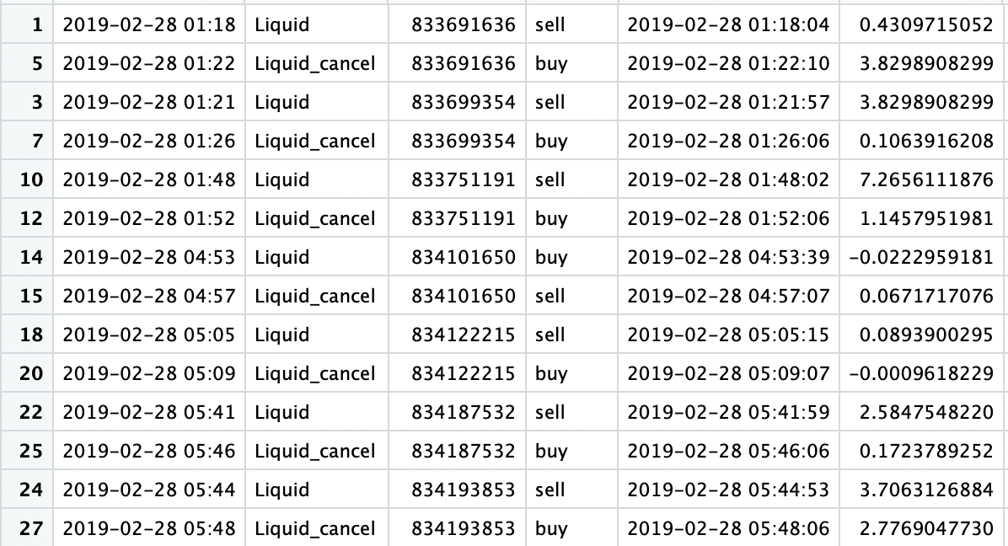 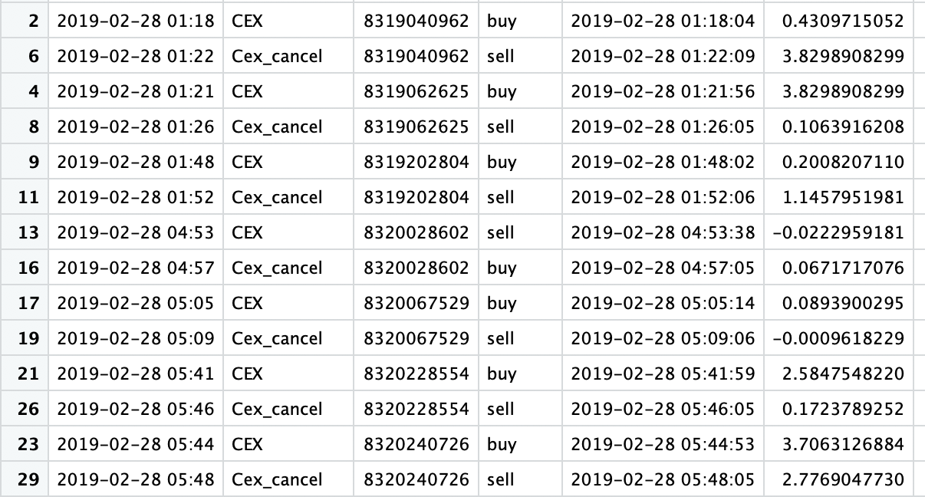

1. Simultaneous execution: Cex and liquid are execute order (cancelling order) at the same time
2. Holding period is 4 mins
3. Trigger is correct: If t > 0; buy at cex and sell at liquid ; after 4 mins, reverse

Above all, implementation meets my expectation, however, using the market price data the profit is slightly loss (-0.3 usd in 5h). Hence I did a bit more research on previous backtesting.

Micky mouse 1: Transaction fee= 0; close data; **holding period = 1min**; trading t amount of eth (threshold = 3.5), 1.5month

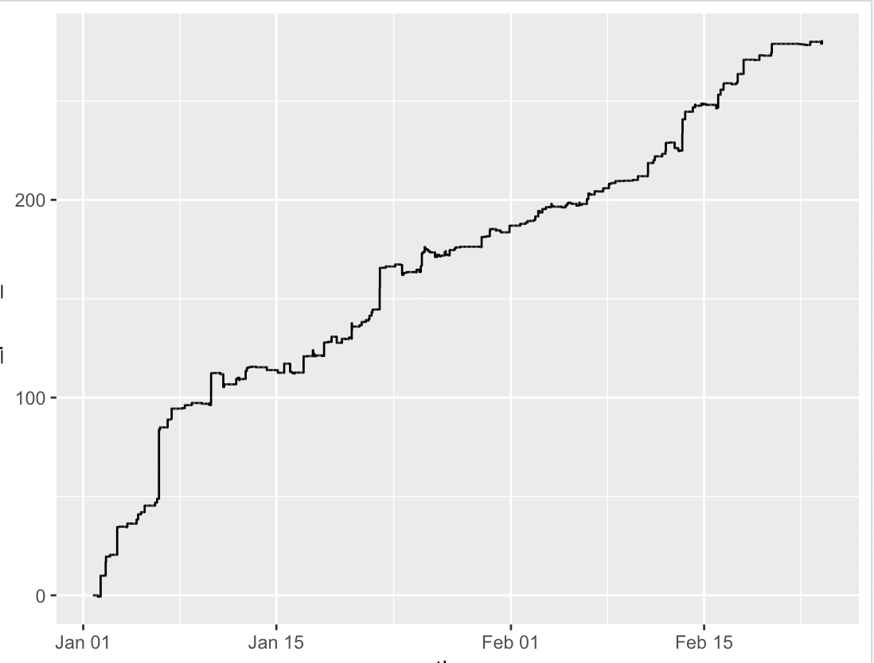

Micky mouse 2: Transaction fee= 0; close data; **holding period = 1min**; trading t amount of eth **(threshold = 0.8),** 1.5month

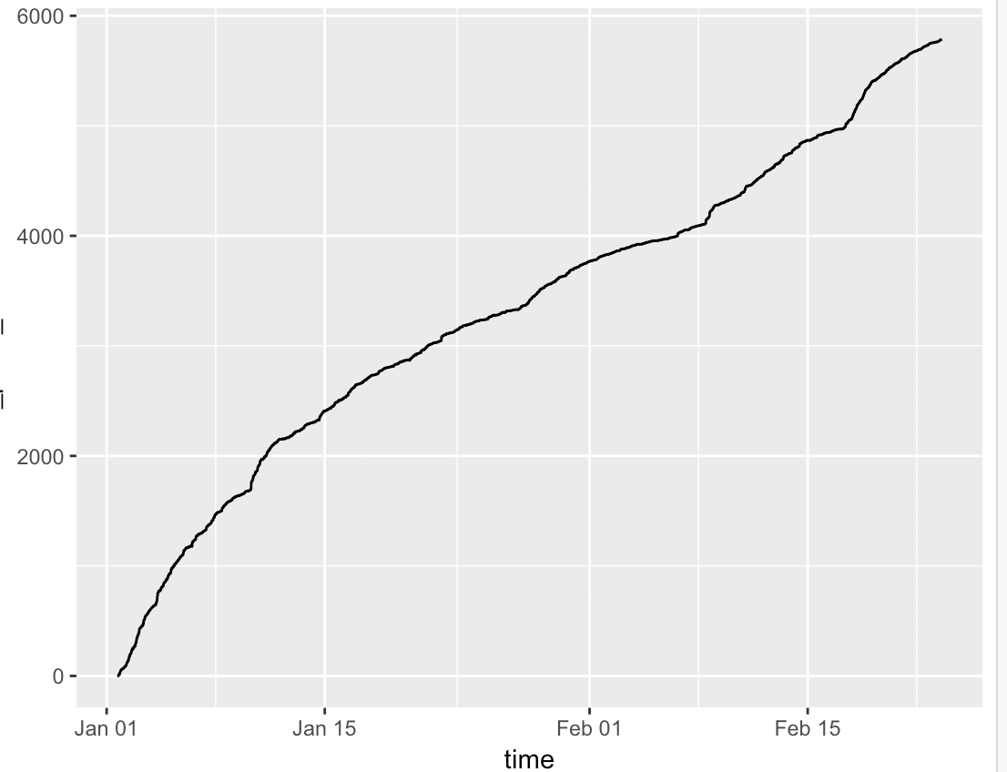

**Main take away: without any friction, the more trades we have the more profitable we are. -> lower threshold;**

Baseline: Transaction fee= 0; close data; holding period = 17min; trading t amount of eth (threshold = 3.5), 1.5month

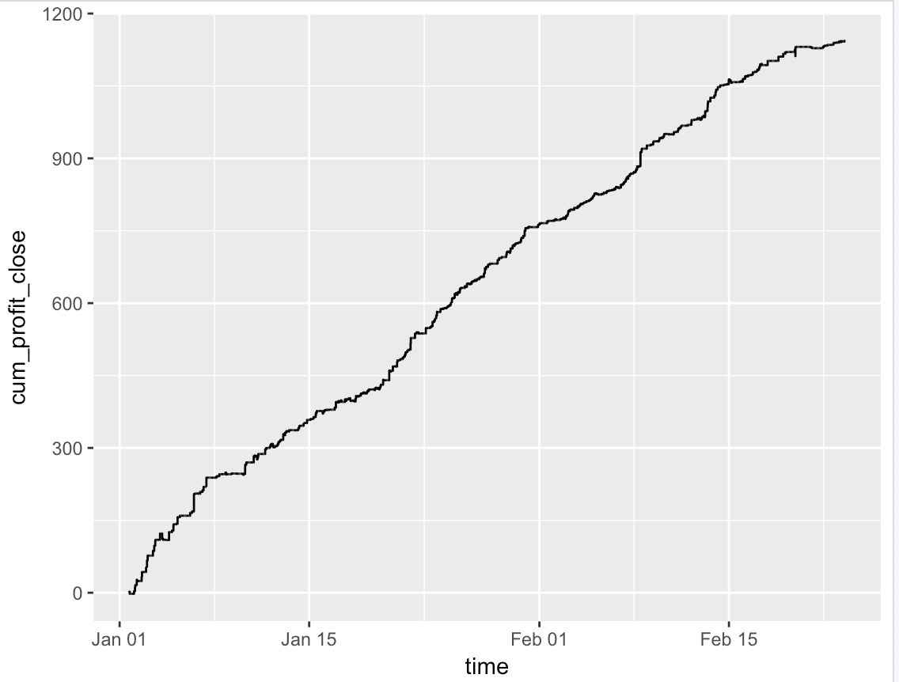

**Main take away: without any friction, the optimal holding period can be determine by the half-life formula:** 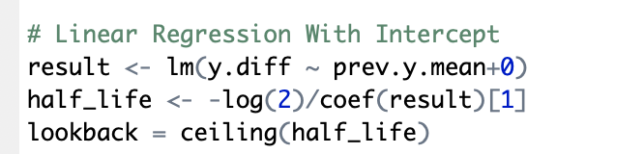where y is the error term after cointegration

Adding fraction

1. Transaction (0.25%)

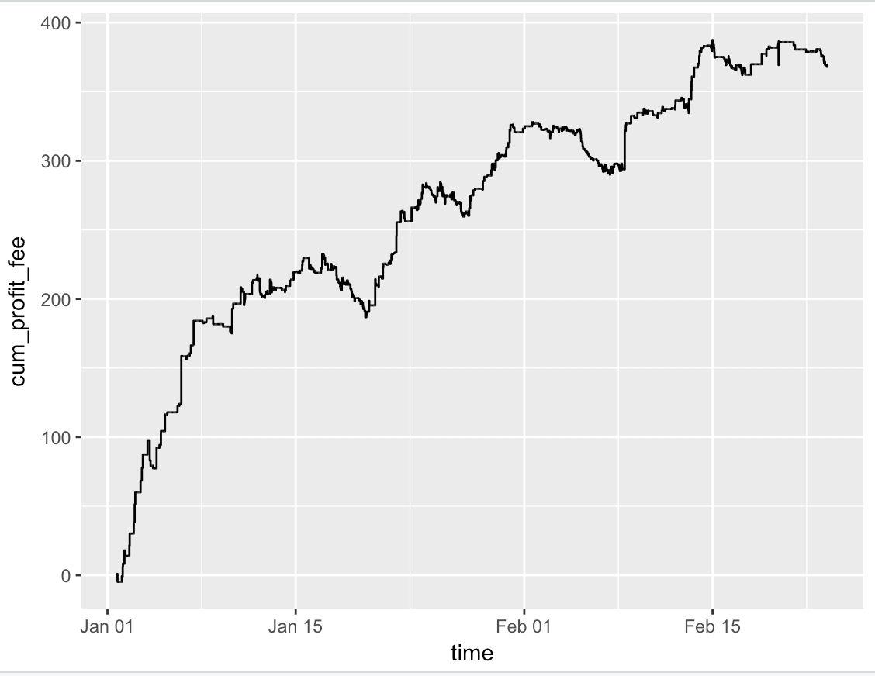

1. Using bid price (approximate by 1m high) for buy and ask price (1m low) for sell (instead of close price)

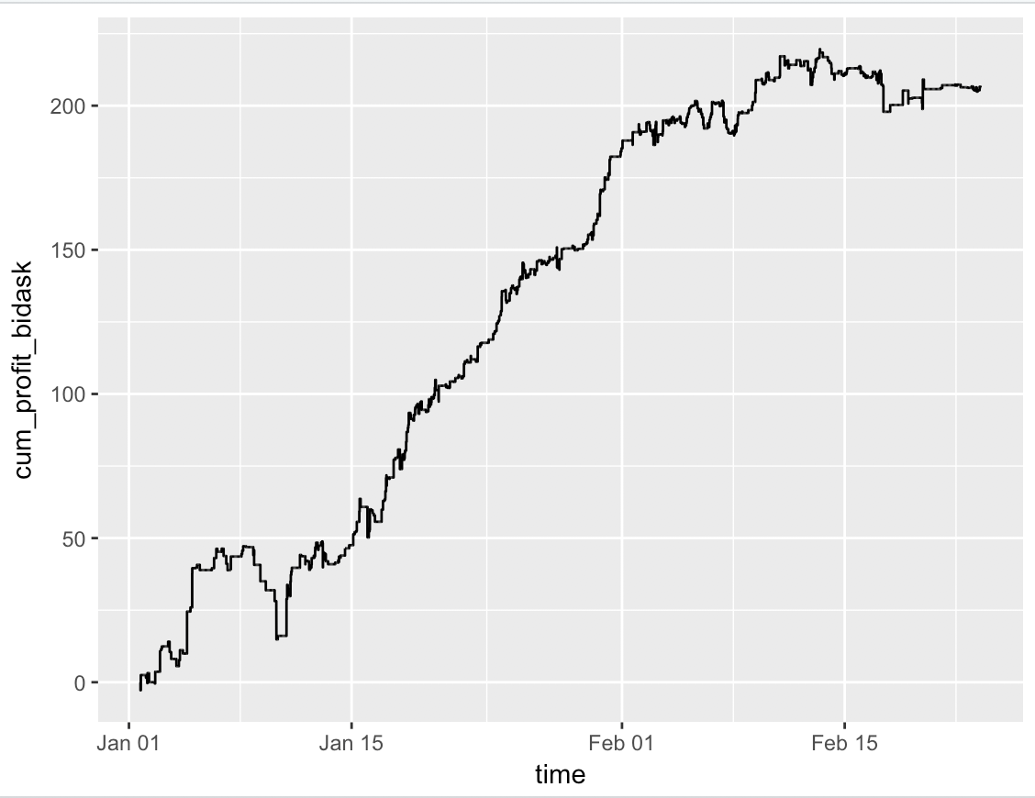

1. Transaction fee & bid/ask price

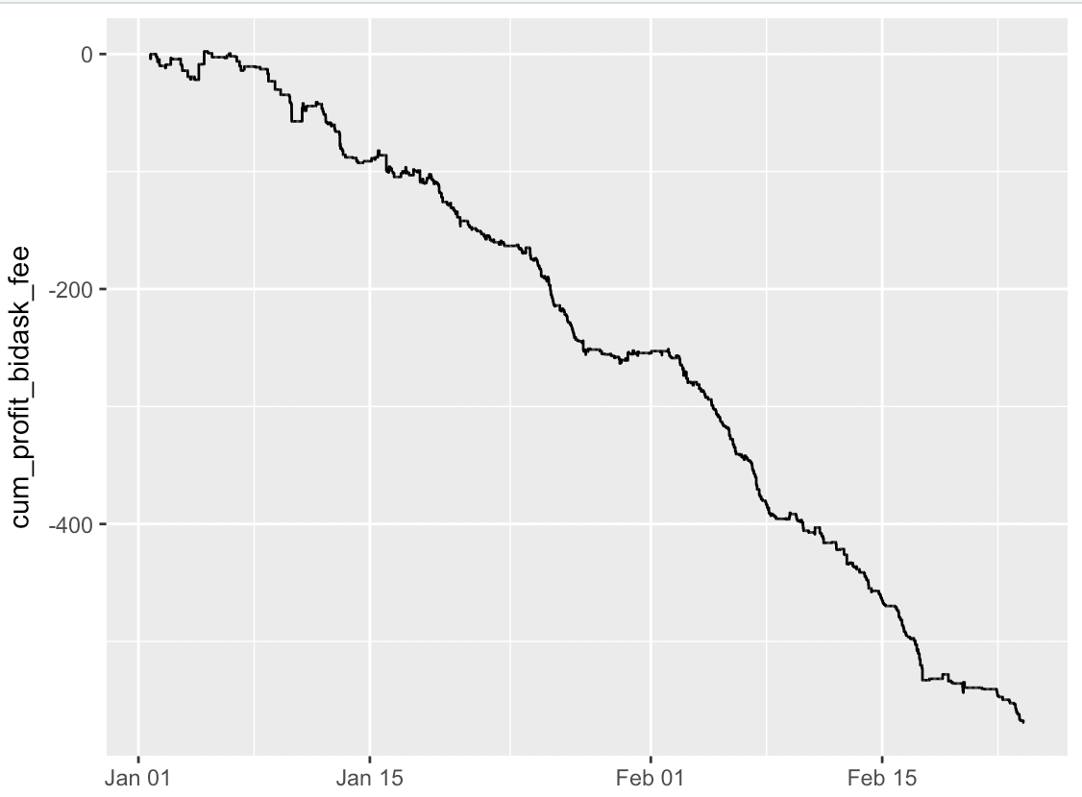

**Friction is really crucial: finding the lower spread market (in this case is even more important) & lower transaction fee market.**