Instituto tecnológico de Costa Rica

Programación orientada a objetos

Introducción del diseño al software

Isaac Herrera Monge

2019160455

29/11/2024

II Semestre 2024

William Mata Rodríguez
Table of Contents
Manual de usuario 3
Home page 3

Manual de usuario

Home page  Here you can either put your account information, create a new user by pressing the button or continue anonymously (By choosing this mode you will not be able to leave your records in the top 10, also by creating an user you can continue from where you left off).  By pressing the option to create a new user you can select an username and a password that will be used to save your information. | 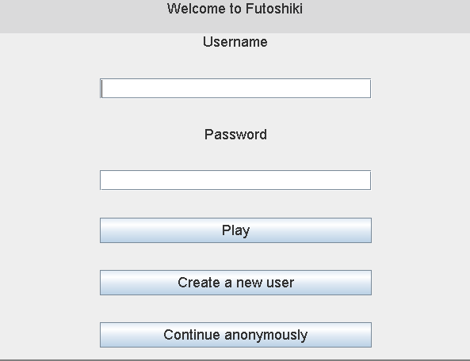
Create a new user  When creating the new username make sure that is more than 5 characters or it will not allow you to create a new user, also if the username already exists it will not let you create it.  The password can’t be empty | 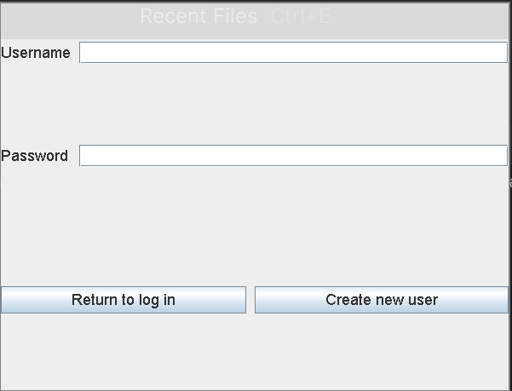
Home Page  Here you can select what you want to do, you can  - Go to Settings and update the game behavior  - See the top 10 records  - See the about us section  - See the user manual by pressing help  - Play the game! | 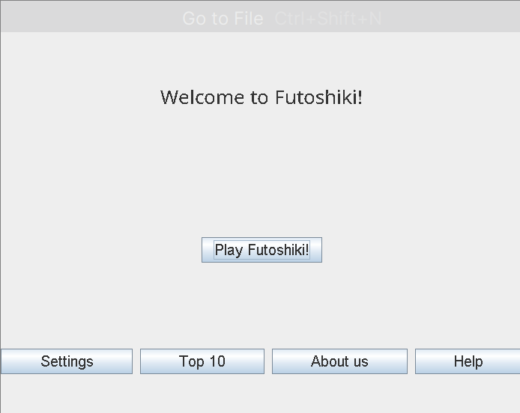
Settings menu  Here you can modify the behavior of the game, first you can set the board size, it goes from 3x3 to 10x10, you can also set the difficulty from Easy to Hard. Multilevel will make it so that every time you finish the game it will create a new game with the next difficulty. The time option will change it so you can have either a stopwatch or a timer or no time, if you select No you cannot create records. The button side can be modified | 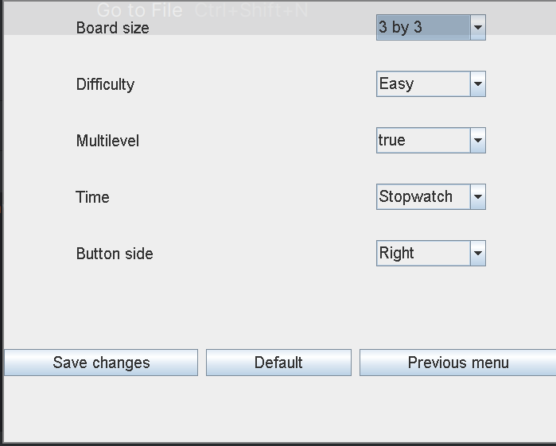
Top 10  Here you can see the top 10 records from difficulty, you can select the size of the matrix you need to check the records | 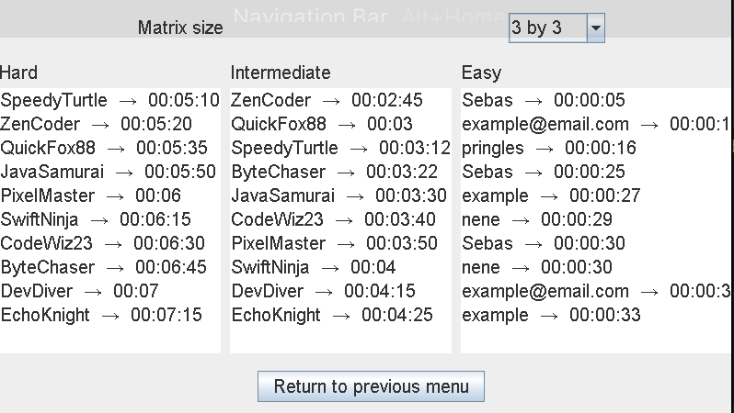
Play Futoshiki!  To play you can select the buttons on the right (Or left depending on your settings) and after you press it you select the square you want to assign that value. If you make a mistake you can either delete what you did by pressing delete and the square of going to options and undo/redo the mistake.  You win when the rows and columns have all of their numbers and the constraints are meet. When you finish you go to file and there you can finish the game, it will display a message.  In the file option you can either load the current game to the user info or load the game from memory | 