BUSINESS REQUIREMENTS DOCUMENT
Health Insurance Claim Intake & Adjudication Process Improvement
Independent Case Study
Prepared By | Isabah Tabenda Hasan
Date | June 2026
Document Type | Business Requirements Document (BRD)
Domain | Health & Life Insurance - Claims Operations
Data Source | Public sample claims dataset (n = 4,500 claims), used for illustrative analysis
Purpose | Demonstrate business analysis methodology: requirements gathering, process mapping, and data-informed recommendations for a claims process improvement initiative

1. Executive Summary
This document presents a business requirements analysis for improving the health insurance claim intake and adjudication process. Using a sample dataset of 4,500 claims, the analysis identifies a significant business problem: only about one-third of claims are approved without issue, while the remaining two-thirds are denied or left pending with no service-level visibility. This BRD defines the current-state process, the underlying pain points, and a set of business and functional requirements for a future-state solution designed to reduce denials caused by incomplete documentation, shrink claim backlog, and give both members and staff visibility into claim status.
Note: this is a self-directed case study built to practice and demonstrate business analyst methodology using a publicly available sample dataset. Findings are illustrative rather than a production audit of any specific insurer's operations.

2. Background & Problem Statement

2.1 Business Context
Insurers process high volumes of claims through channels that mix paper, phone, and online submissions. When intake is not standardized, downstream teams inherit inconsistent, incomplete, or hard-to-validate data which lead to avoidable denials, rework, and delays that affect both operational cost and member experience.

2.2 Problem Statement
- Of 4,500 claims analyzed, only 33.8% were Approved on first pass.
- 33.6% of claims were Denied and 32.6% remained Pending, indicating a large share of claims requiring rework, escalation, or extended wait times.
- Claims arrive through three disconnected channels (Paper, Phone, Online) with no shared validation step, so documentation gaps are caught only after manual review — well after intake.
- No service-level agreement (SLA) or backlog metric exists in the current process, so neither staff nor members have visibility into expected resolution time.
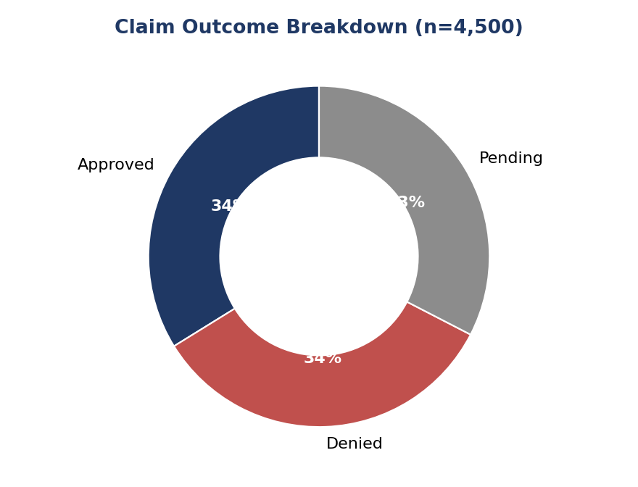
Figure 1 — Claim outcome breakdown across the sample dataset (n = 4,500).

3. Current-State Process
The diagram below reflects the as-is claim intake and adjudication workflow, reconstructed from the process implied by the sample data's channel, status, and claim-type fields.
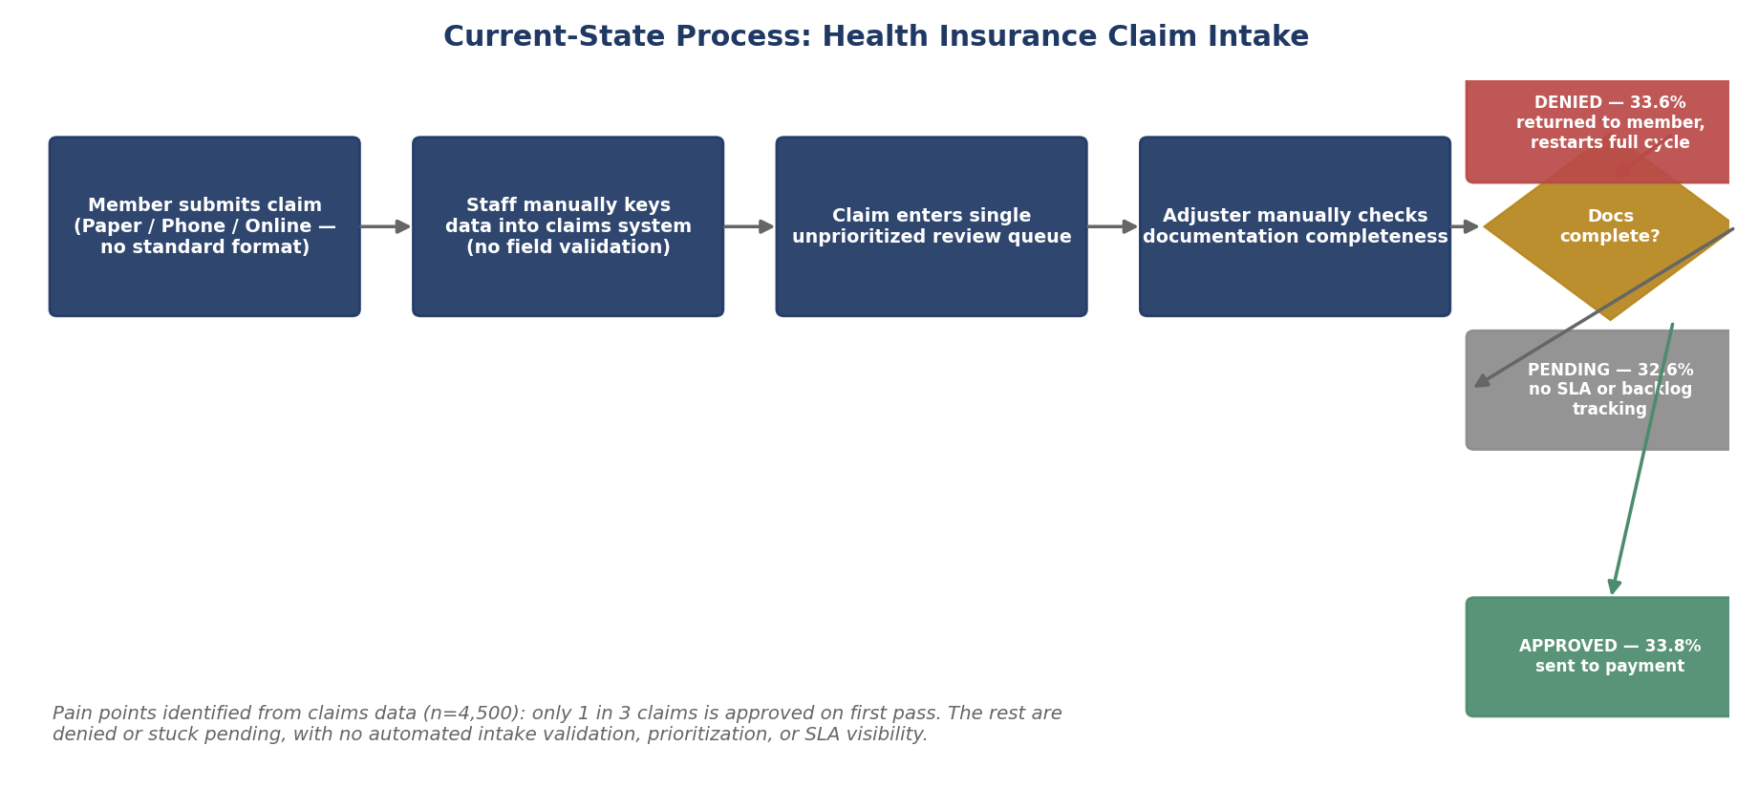
Figure 2 — Current-state process map: claim intake through adjudication decision.

3.1 Root Causes
- Manual, channel-specific intake (Paper/Phone/Online) with no standard required-fields template.
- No automated completeness check at the point of submission and gaps are found only during manual adjuster review.
- Single undifferentiated review queue and claims are not prioritized by type, urgency, or complexity.
- No SLA tracking mechanism, so "Pending" claims can sit indefinitely without escalation.

4. Stakeholder Analysis
Stakeholder | Interest / Concern | Involvement
Members / Claimants | Fast, transparent claim resolution; clear reason if denied | Primary claim submitter; end user of intake portal
Claims Adjusters | Complete, validated claims to review efficiently | Reviews and decides on claims; needs prioritized queue
Claims Operations Manager | Reduced backlog, lower denial-driven rework, SLA compliance | Owns process KPIs; sponsors improvement initiative
IT / Systems Team | Feasible, maintainable system changes | Builds validation rules, portal, and SLA tracking features
Compliance / Risk | Accurate, auditable claim handling and fraud controls | Reviews requirements for regulatory and audit alignment

5. Business Requirements
BR-1: Provide a single, standardized digital intake channel that captures all required fields at submission.
BR-2: Automatically validate document completeness before a claim enters the adjuster queue.
BR-3: Prioritize claims in the review queue by type and urgency rather than first-in-first-out only.
BR-4: Track and report claim resolution time against a defined SLA, visible to staff and members.
BR-5: Provide members with a clear, specific reason and next steps for any denied claim.

6. Functional Requirements (User Stories)
ID | User Story | Acceptance Criteria
US-1 | As a member, I want to submit my claim online with guided required fields, so my claim isn't delayed by missing information. | Portal blocks submission until all required fields/docs for the claim type are provided.
US-2 | As an adjuster, I want claims pre-checked for completeness, so I don't spend time on claims that will be returned. | System flags incomplete claims before they enter the adjuster queue; adjuster queue shows only validated claims.
US-3 | As an operations manager, I want a real-time view of claims by SLA status, so I can identify and escalate backlog. | Dashboard shows count/% of claims by SLA bucket (on-track, at-risk, breached), refreshed daily.
US-4 | As a member, I want to see why my claim was denied, so I know what to correct or appeal. | Denied claims include a specific reason code and plain-language explanation sent within 1 business day.

7. Future-State Process
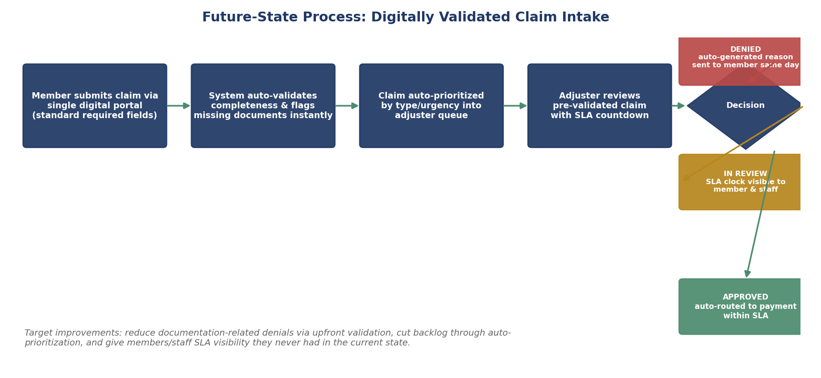
Figure 3 — Future-state process map with upfront validation, prioritization, and SLA visibility.

8. Success Metrics (KPIs)
KPI | Current State (Baseline) | Target
First-pass approval rate | 33.8% | Increase by identifying and eliminating documentation-driven denials
Denial rate due to incomplete documentation | Not tracked | Establish baseline, then reduce via upfront validation (BR-2)
Average claim resolution time (SLA) | Not tracked | Define SLA by claim type; track % resolved within SLA
Member-reported clarity on denial reason | Not measured | Establish via post-decision survey; target majority satisfaction

9. Supporting Data Analysis
The charts below summarize the claim volume by channel and type from the sample dataset, used to size the intake standardization and prioritization requirements above.
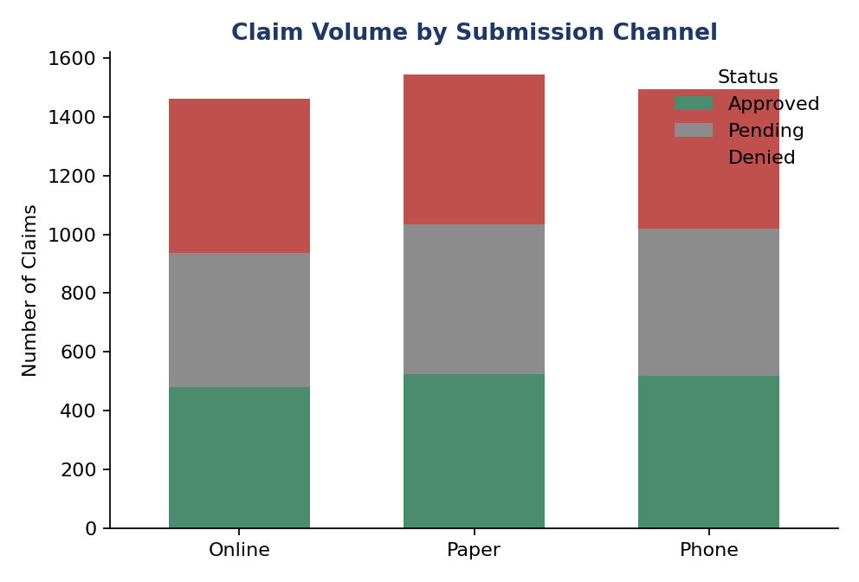
Figure 4 — Claim volume and outcome by submission channel.
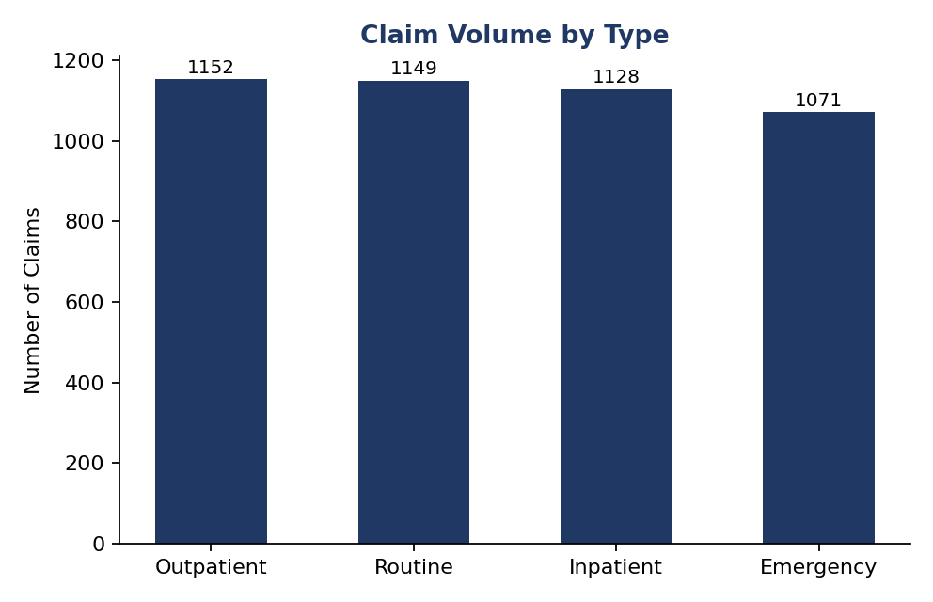
Figure 5 — Claim volume by claim type, used to inform queue prioritization design.

10. Assumptions, Constraints & Next Steps

10.1 Assumptions & Constraints
- The analysis is based on a sample dataset for demonstration purposes. In a real project, the findings would be validated using live operational data and input from key stakeholders.
- The proposed solution assumes that the necessary budget and IT resources are available to implement a self-service member portal and make improvements to the adjuster workflow.

10.2 Recommended Next Steps
- Validate root-cause hypotheses with claims operations staff through stakeholder interviews.
- Prioritize BR-1 and BR-2 (intake standardization and validation) as the highest-impact, lowest-complexity first phase.
- Define SLA thresholds by claim type in partnership with operations and compliance.
- Pilot the future-state intake flow with one claim type before full rollout.

