New Phytologist Supporting Information
Article title: Translational priming poises RNA-low genes for rapid protein output
Authors: Isabel Cristina Vélez-Bermúdez, Wen-Dar Lin, Wolfgang Schmidt
Article acceptance date: [to be completed]
The following Supporting Information is available for this article:
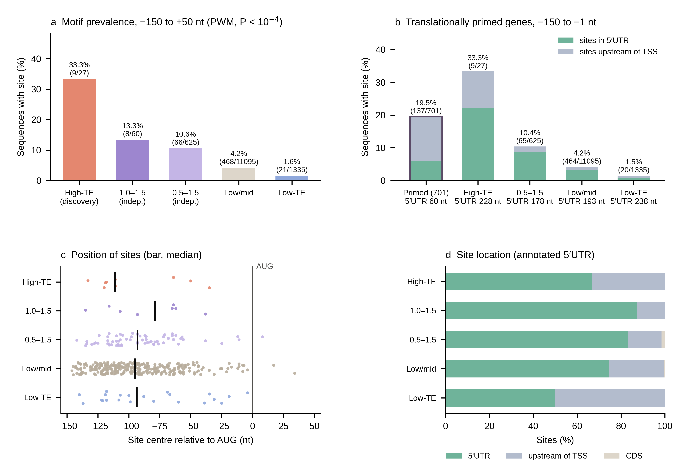
Fig. S1 Analysis of the CTATA[A/T]A[A/T]A-like motif upstream of the start codon. (a) Percentage of sequences (−150 to +50 nt relative to the A of the AUG) with at least one motif site (position weight matrix, P < 10⁻⁴) in the discovery set (high-TE, log₂TE > 1.5 in both tissues), in two independent sets not used for motif discovery (1.0 < log₂TE ≤ 1.5 and 0.5 < log₂TE ≤ 1.5 in both tissues) and in the remaining low/mid-TE and low-TE genes, all with log₂ RNA-seq RPKM ≥ 2 in both tissues. Numbers of sequences above bars. (b) Percentage of sequences with a site in the −150 to −1 region for the 701 nuclear-encoded translationally primed genes and the reference sets, split by site location; median annotated 5′UTR length below each set. (c) Position of site centres relative to the AUG (black bar, median; at most 300 randomly selected sites per set). (d) Location of sites relative to the annotated 5′UTR (Araport11). Statistics (two-sided Fisher's exact tests against the low/mid-TE and low-TE genes) are given in Table S9.

