**Title: Save the semicolon**

Name: Yishan Ji  
Date: 31rd December 2022  
Student Number: 22124985(MU) 832203109(FZU)

**Introduction:**

Save the semicolon is a game in which the player should manipulate the character to get to the terminal of the maze. The aim of the project is to entertain the player. When open the game, there will be background story and instructions on how to play it. To win, the player should use his/her mouse to control the light to observe the maze, and use the UP, DOWN, LEFT, RIGHT on the keyboard to control the character. On its way to the terminal, the character must avoid the walls and the monsters in the maze. Once the game is opened, the background music should be played unless it was paused by the toggle. When the character hit the wall, a short bongo sound will be made.

To complete this project, I've used the library Minim (developed by Damien Di Fade and Anderson Mills) and library ControlP5(developed by Andreas Schlegel). I've also use Couvrir by TobyFox-fallen down as background music. I've also look up the lab guidance for this semester as references. Minim is a popular library used to import the music into the project. I used this library to play background music and sound affect when the character hit the walls. With the combination of library ControlP5, I made a toggle that can pause or play the music.

**Overview of the code**:

I uses 5 class(character ,end ,SaveTheSemicolon ,TheHint, walls) .

Class character contains the display of the character(void display()), the way to manipulate the character(void keyPressed()), decide which terminal to use by using switch statement(void select()), make monsters visible when shed light on (boolean monsterDisplay()), the code that use imported image to make monsters and enable them move in routine(void monster()), and the code that force the character back to the start point when it hit the wall or monsters(void back()). Among all these code block, void back() is used in void display() and class end.

Class end contains void win() which pop “Congrats” on the screen and print “you win”, void lose() which pop ”Lose!” on the screen when lives—and print “you lose”, and void live() that controls the amount of lives and print out “Game over” when lives==0; Among all these code block, void lose() is used in class character(void display() and void monster() ), and void win() is used in class character void select().

Class SaveTheSemicolon is the main class. I import Minim and ControlP5 here. In void setup() I load images for monsters and music for background music and character hit the wall, a toggle that control the display of music. In void draw(), I create the light and instantiation of all the other classes in the order that make the maze cover in black unless the player shed light on. Also I used void music to create the affect of the toggle.

Class TheHint creates an introduction before the player starts the game. And class walls creates the walls in the maze.

**Testing**:

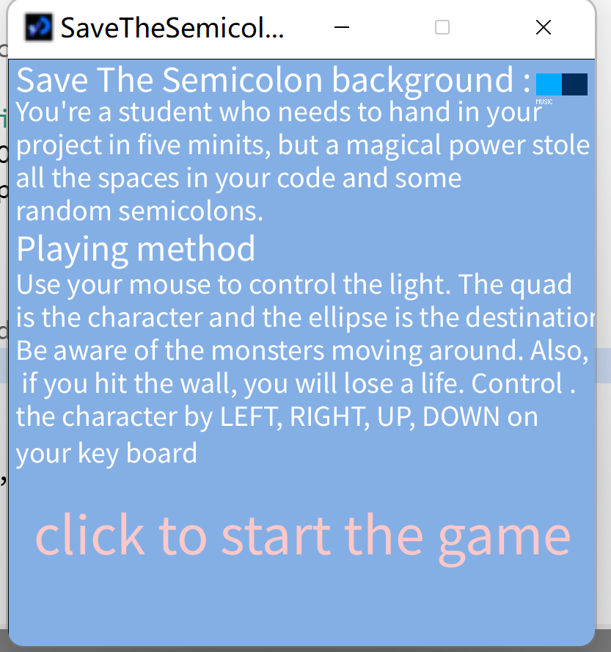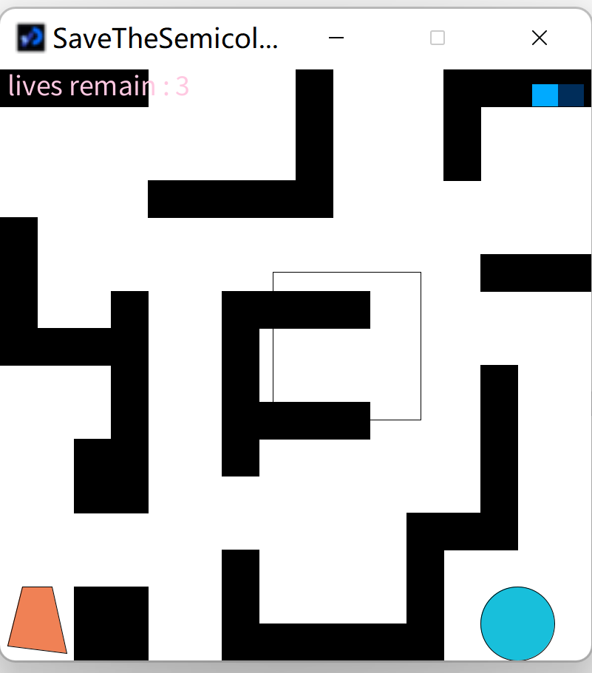

Figure 1 : the hint Figure 2: maze without the night setting

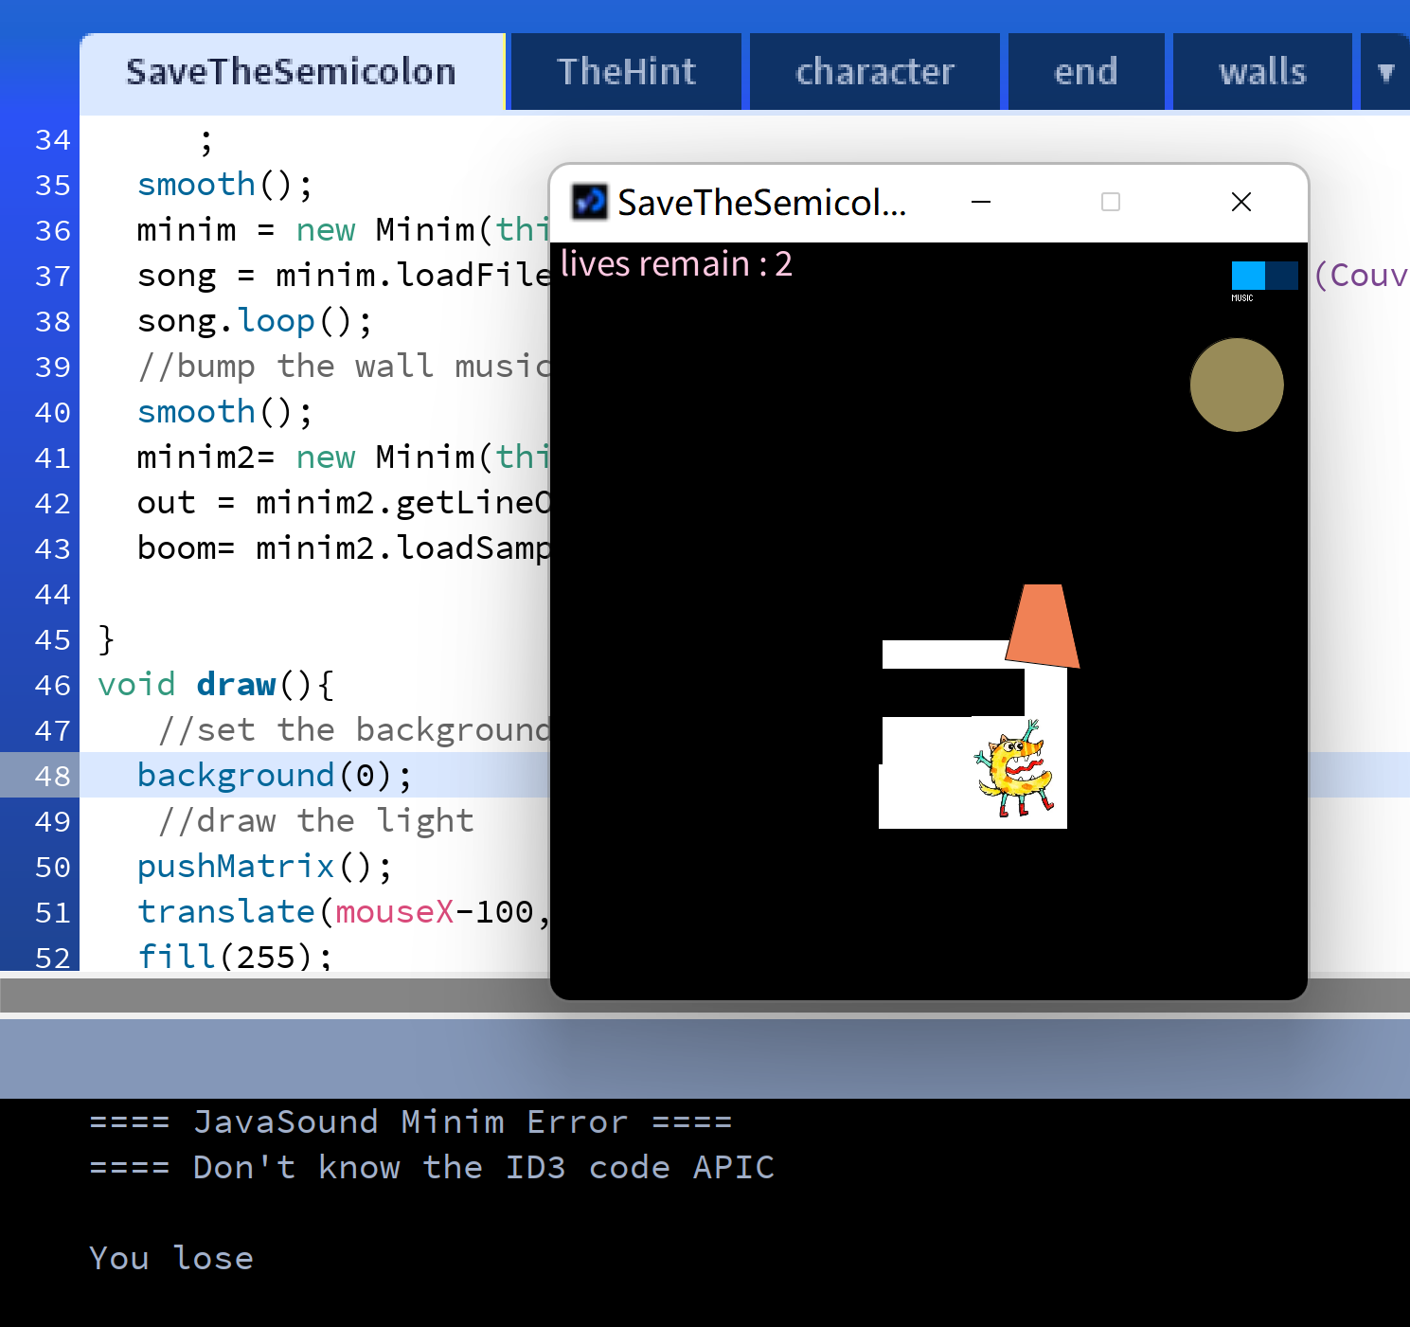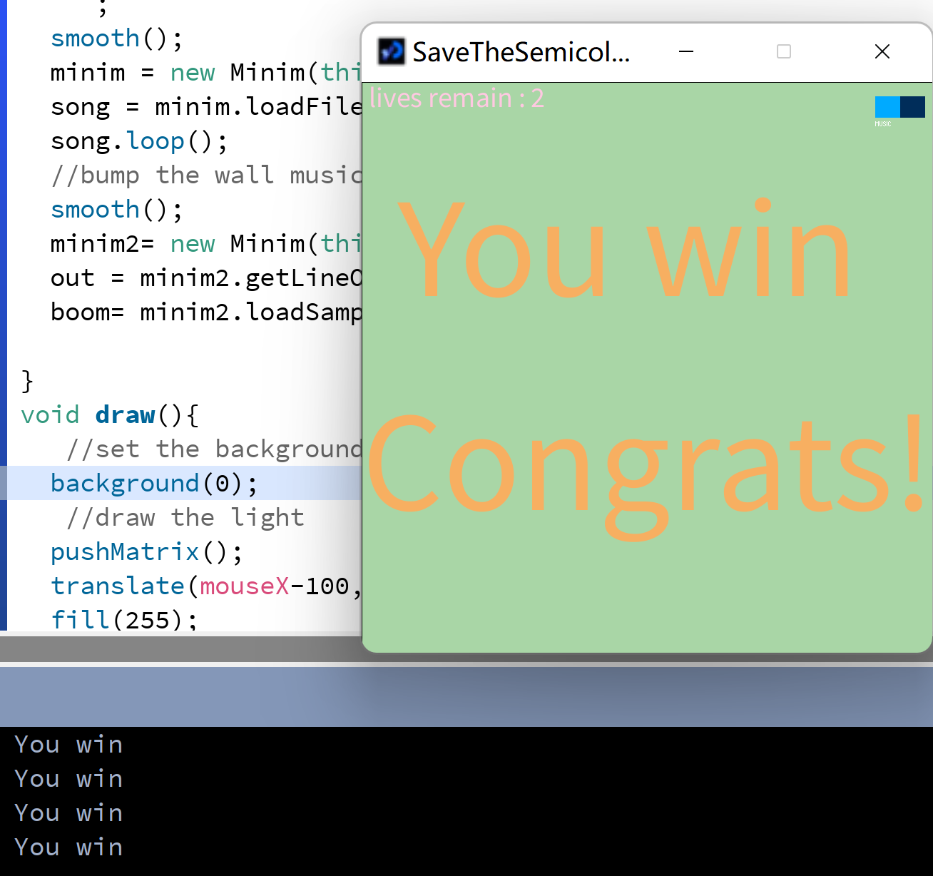

Figure 3: lose once Figure 4: wining.

**Conclusion**:

I've use the library Minim (developed by Damien Di Fade and Anderson Mills) and library ControlP5(developed by Andreas Schlegel) ,and also use Couvrir by TobyFox-fallen downas background music to complete the game Save the semicolon.

I could make when winning statements last 30s then start the game again in the future. I also can make the monsters follow the character once the character comes near. I could even count the time the player uses to finish the game. Or maybe add some constriction on the time player spend.