Customer Manager — Classroom Lab
ICT261 Advanced Java Programming · Lecture 3
Mulungushi University · School of Engineering and Technology
Student Name | Isabella
Student Number | [Add your student number]
Date | 7 October 2026
GitHub Repository | https://github.com/Isabella895/CustomerManager

1. Overview
This document provides evidence that the Customer Manager classroom lab was completed. The JavaFX application (CustomerManagerApp) presents a form with a Customer name field and a Province ComboBox, validates input before saving, displays saved customers in a TableView, and asks for confirmation before deleting a selected customer. All five required scenarios were tested: a valid save, a missing-name error, a missing-province error, a cancelled deletion and a confirmed deletion.

2. Evidence of Testing

2.1. Missing-name error
The Province field was left unselected and the Customer name field was left empty, then Save customer was clicked. The app displayed "Enter the customer name." and returned keyboard focus to the name field, so no invalid customer was saved.
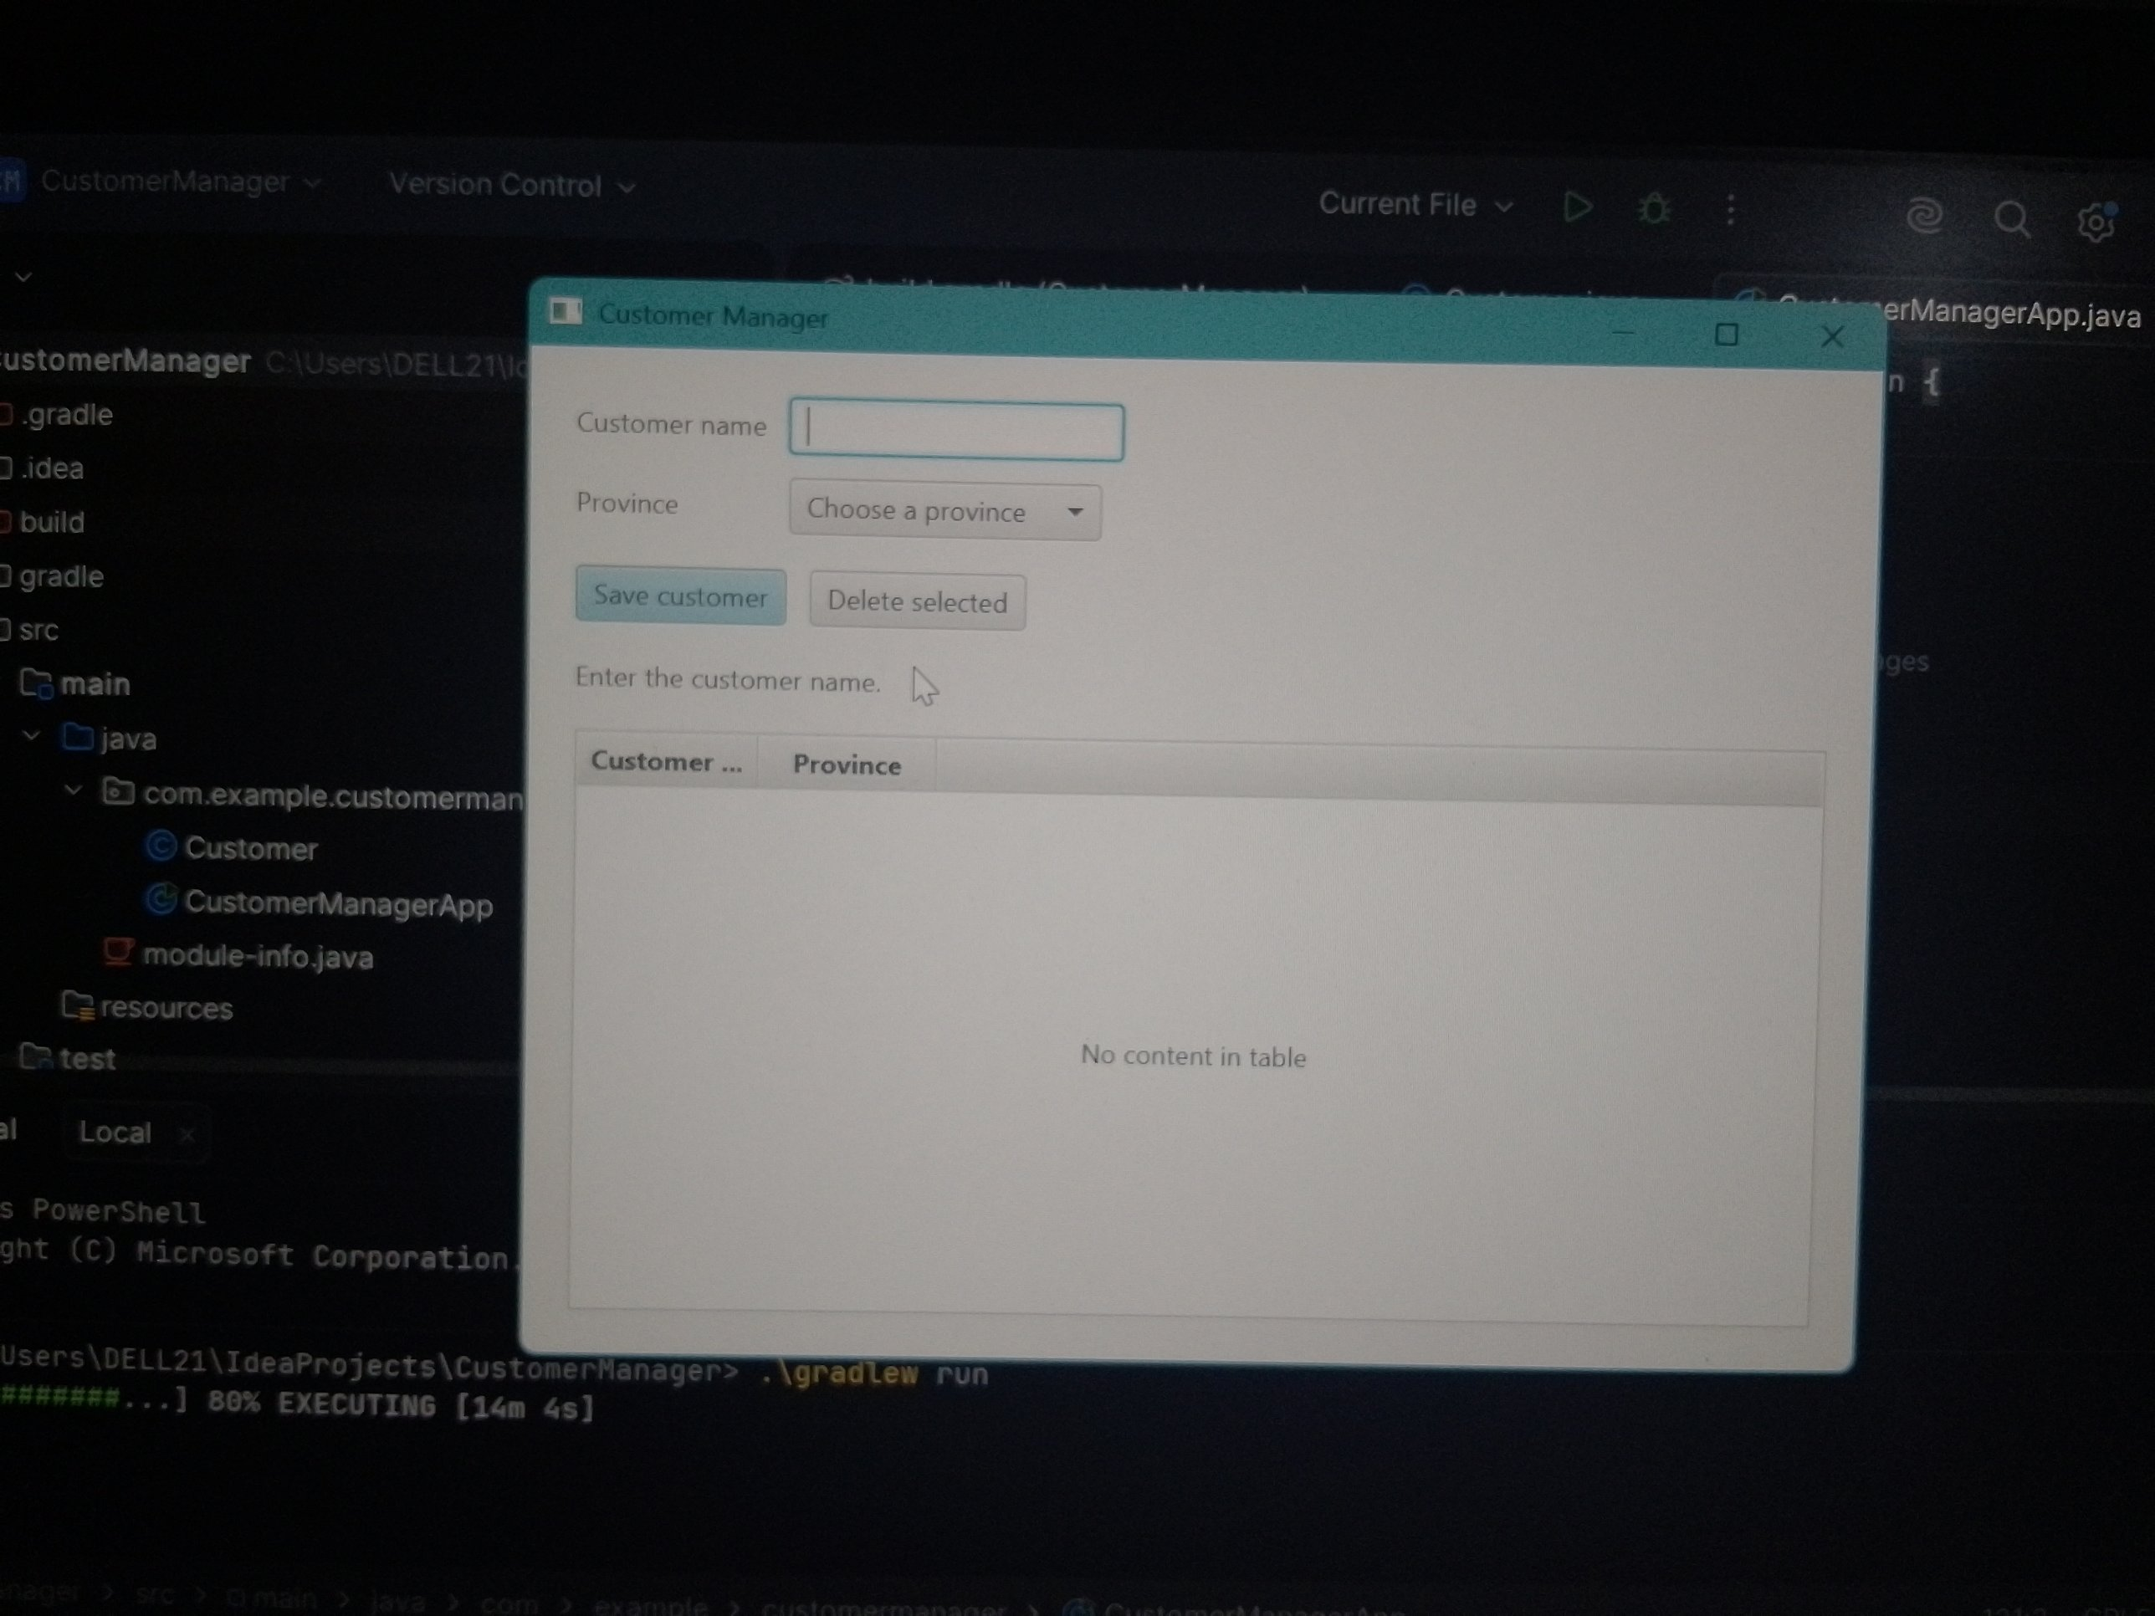
Missing-name error

2.2. Missing-province error
A valid name ("Mary Banda") was entered but no province was chosen, then Save customer was clicked. The app displayed "Choose a province." and returned focus to the province ComboBox, while keeping the typed name.
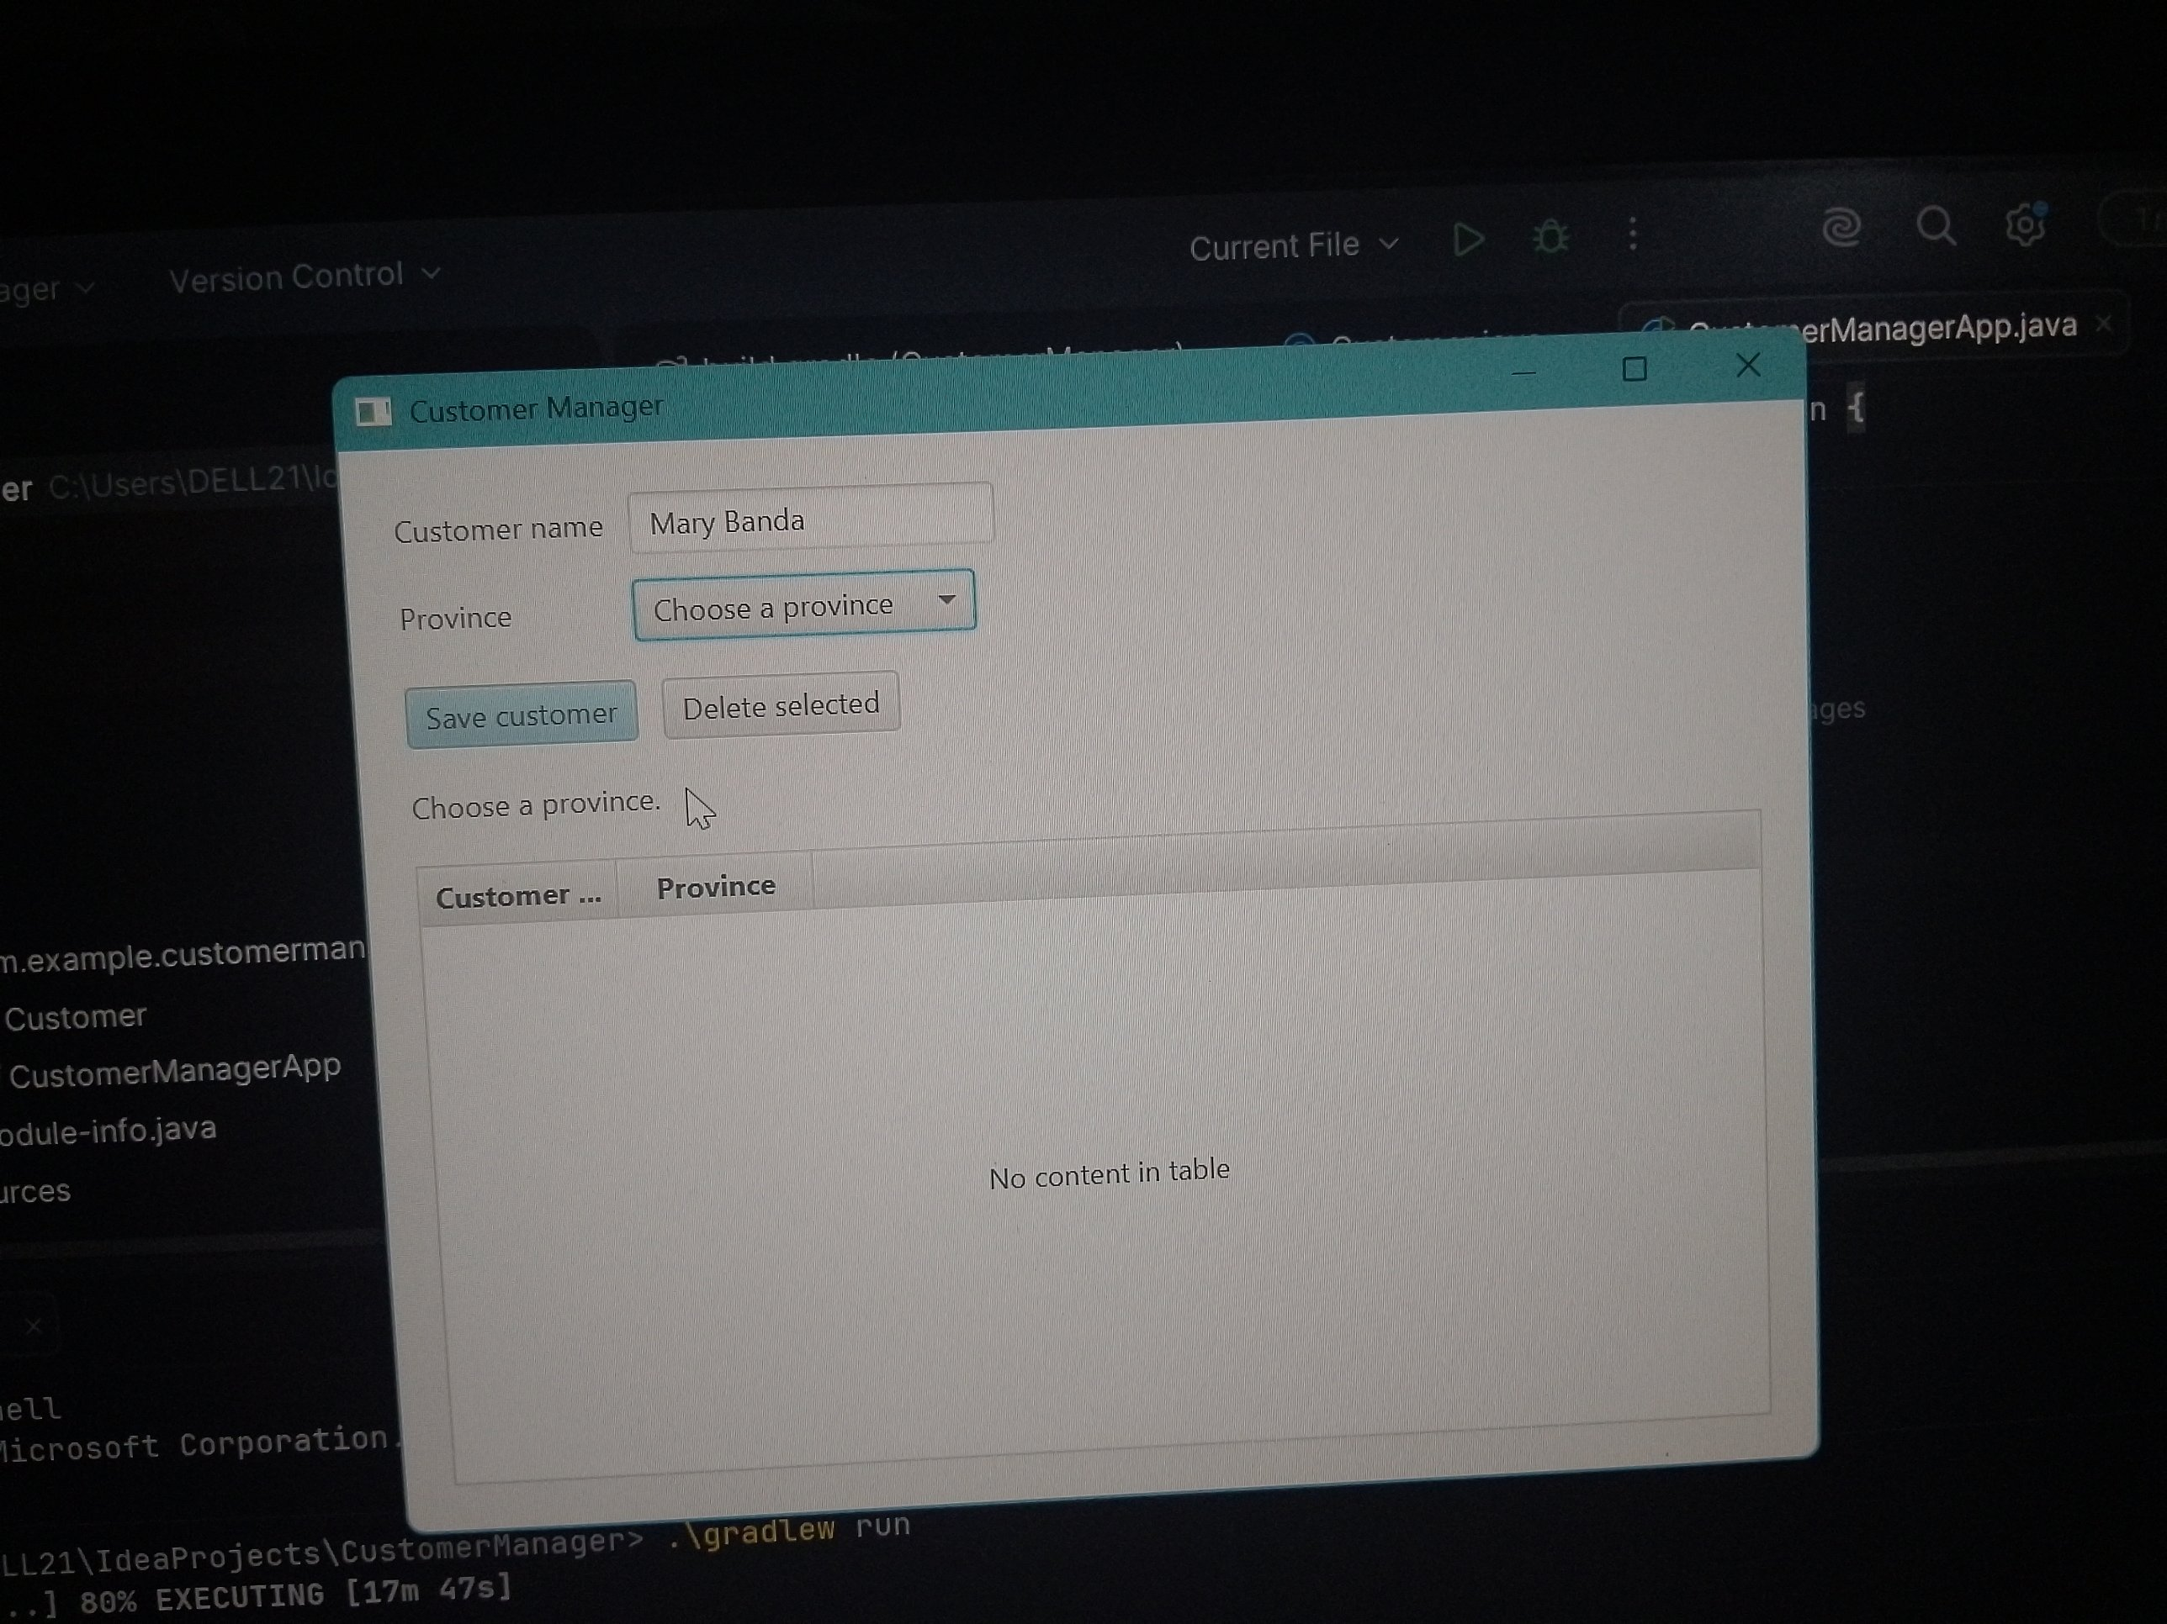
Missing-province error

2.3. Valid save
With both a name and a province supplied, Save customer added a new row to the TableView and displayed "Customer saved." Two customers (Mary Banda / Copperbelt and Abigail Mwanza / Lusaka) are shown in the table.
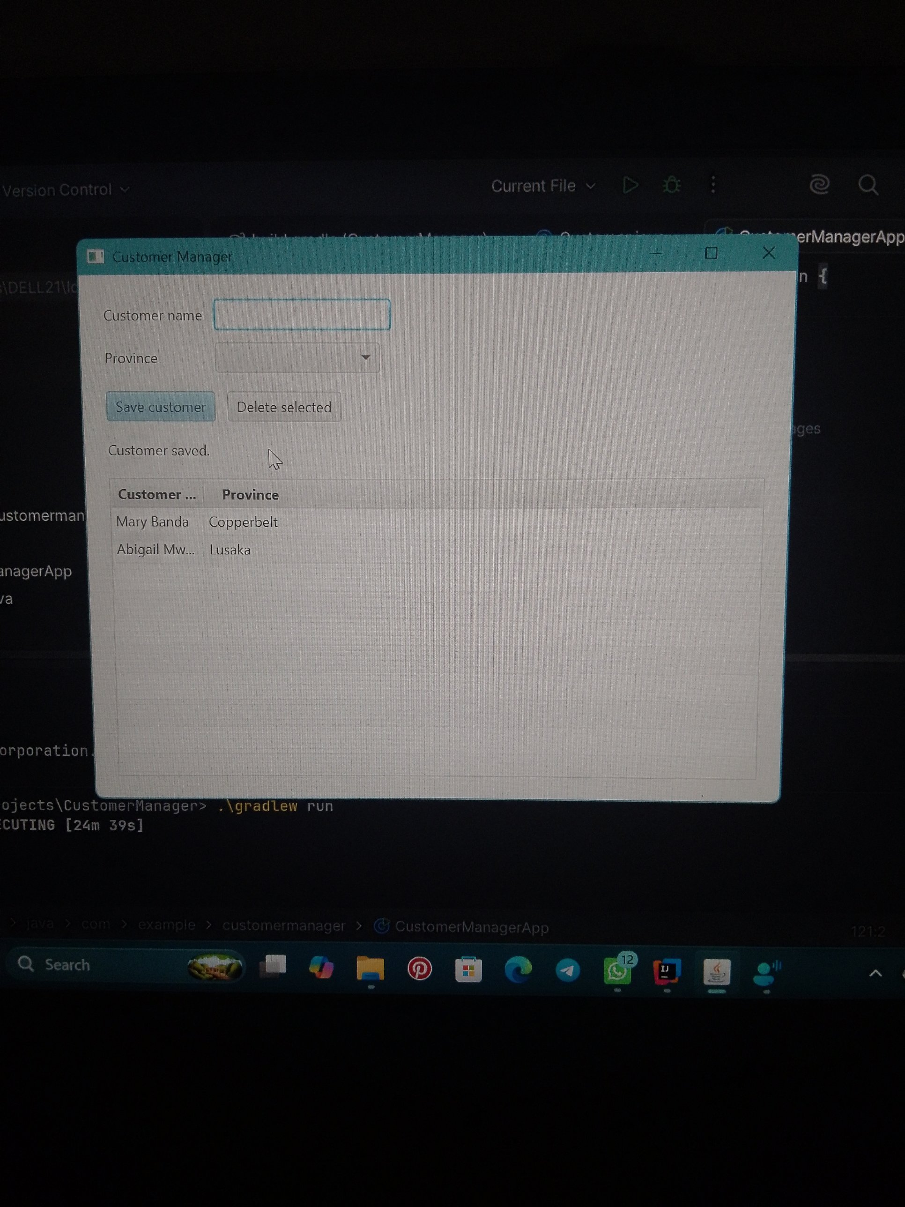
Valid save

2.4. Delete — cancelled
A row was selected and Delete selected was clicked, then Cancel was chosen in the confirmation Alert. The record remained in the table and the status label read "Deletion cancelled.", confirming the record was left unchanged.
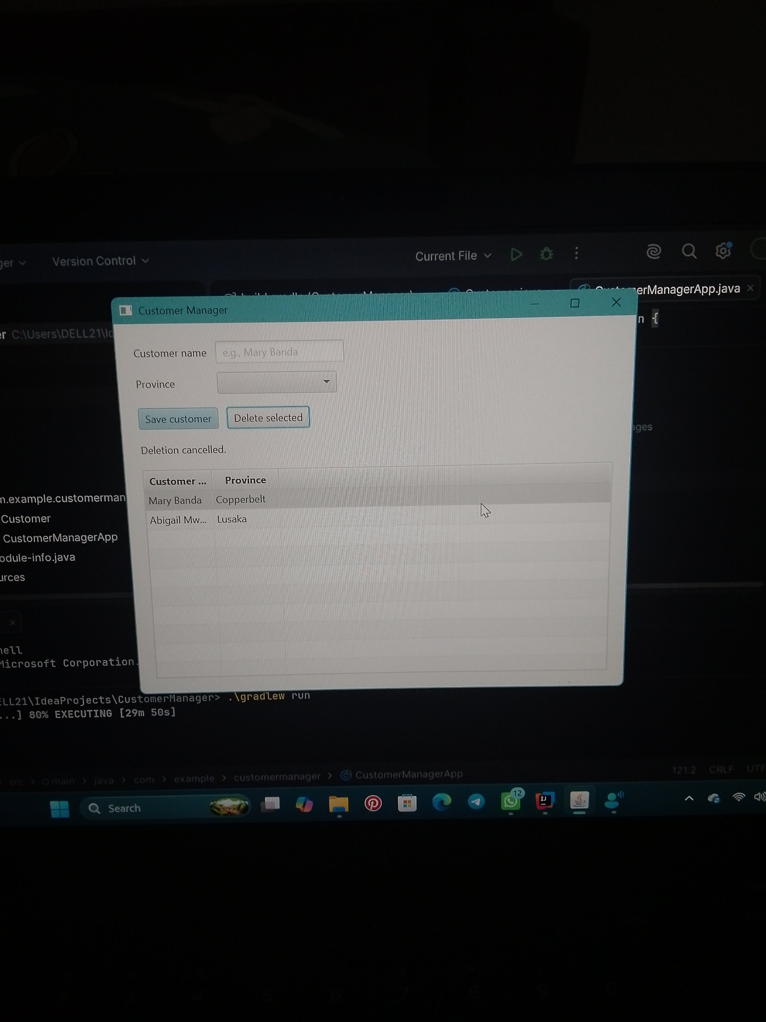
Delete — cancelled

2.5. Delete — confirmed
A row was selected and Delete selected was clicked, then Delete was chosen in the confirmation Alert. The selected customer (Abigail Mwanza) was removed from the table and the status label read "Customer deleted."
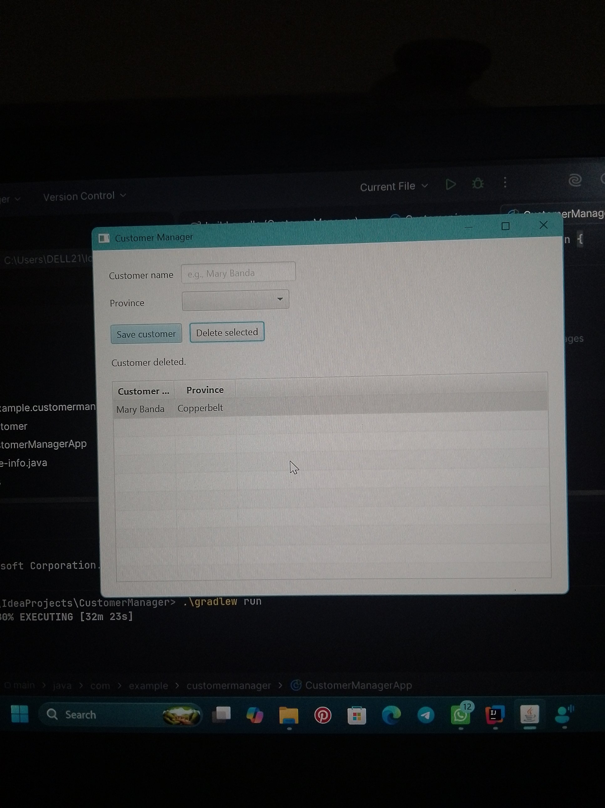
Delete — confirmed

3. Keyboard Access and Navigation
The Customer name field receives focus automatically when the window opens (nameField.requestFocus()), and the Label for the name field is linked with setLabelFor() so screen readers announce it correctly.
Pressing Tab moves focus in a logical order: Customer name field → Province ComboBox → Save customer button → Delete selected button → back to the TableView, with no control skipped or unreachable.
Save customer is set as the default button (setDefaultButton(true)), so pressing Enter anywhere in the form activates Save without requiring a mouse click, satisfying the keyboard-access requirement.

4. Where Each Responsibility Belongs
This lab's CustomerManagerApp keeps the UI construction, event handling and validation together in one class, which is appropriate for a small classroom prototype. In a larger application, these concerns would be separated as follows:
Part | Responsibility | In this lab
View | Layout and appearance | The GridPane form, HBox buttons, TableView and column layout built in CustomerManagerApp
Controller | Responds to UI actions | The setOnAction handlers on Save customer and Delete selected, including input validation and focus management
Service | Application rules | The logic that decides a customer may be created only with a name and province, and is removed only after confirmation
DAO | Reads and writes stored data | Not yet implemented — customers live only in the in-memory ObservableList, so data is lost when the app closes. A DAO would replace this list with database calls

5. Conclusion
All six lab requirements were met: a form with a name field and province list, a Customer class with an ObservableList, a TableView with name and province columns, input validation before saving, confirmed deletion, and tested invalid input alongside keyboard access. The source code has been committed to Git and pushed to the GitHub repository listed above.

