Table of Contents
Experience Flow and Design Concept: 2
Prototype: 2
Design Rationale: 2
Scan Design: 3
Performer, Spectator and Bystander 3
AR Recreations Design: 3
Past Recreations Design: 4
Messages Design: 5
Mobile Collocated Interaction Design Framework 5
Social Perspective 5
Technological Perspective 5
Spatial Perspective 6
Temporal Perspective 6
Prototype References: 6
Scan (S): 7
AR Recreations (R): 7
Past Recreations (PR): 8
Messages (M): 9
Academic References: 9
Project References: 10

Experience Flow and Design Concept:

The design builds on Artlink's concept that museum visitors want more than just knowledge, they want a meaningful and social experience, which can be achieved through connections with artefacts and other visitors. The prototype links the display of Keighton artefacts with the site itself. The setting of the prototype is intended to be used alongside an in-person tour of the museum in a group, and using their phones as shared devices would mean participants would have to stay together. By forming groups from strangers, visitors perceive themselves as part of a collective, which deepens their engagement with the exhibit.

They will view the collection of Keighton artefacts and others from a similar period, with QR codes that visitors can scan to add them to their collection for later use. After the tour, the group will be taken to the Keighton site, where they will collaborate with others in their tour group to recreate a historical representation of a building located at Keighton. Transforming the exhibition from something to observe into something to engage with and interact with via the AR environment enhances the visitor’s experience. Only one group will be able to recreate a building at a time.
Each participant will be assigned a room within the building. Through augmented reality (AR) via their camera lenses, they can view the room’s bare-bone structure and drag and place the artefacts they’ve collected from the museum into the space to bring the room to life. Once a participant completes their room, they will submit it. When the whole group has finished the recreation, the completed building will be available for others to visit and vote on, adding an element of competition.

Prototype:
Figma Link

The navigation bar is designed to feature the app's interactive elements, ordered according to their expected usage during the experience (M3). This ensures easier mapping of the interactive features. Additionally, the screen name is removed from the navigation bar as a visual marker (M2), indicating the user's current location within the app.

As the user has direct control over the environment, it’s important for good transparency by letting them see the results of their actions with real-time updates; the interactivity speed of the responses of the prototype shows this.

In the AR environments of the prototype, buttons are included (PR3) to allow manipulation around the AR room, simulating the user moving in their phone, they wouldn't be included in the final design.

Design Rationale:

Awareness: Adding visual markers to represent collaborators’ locations (R7) makes them feel more immersed and present in the digital space. This approach draws on similar techniques discussed in Collaborator Awareness for User Cohabitation in Co-located Collaborative Virtual Environments, where spatial indicators are used to maintain awareness of others’ positions and actions.

Scan Design:
Common ground: Allowing users to share their thoughts on displayed artefacts (S1) with the group while highlighting the most similar response (S2) helps them identify common ground before collaborating in the AR experience and form a deeper connection with the artefacts and other visitors. This means visitors are more trusting of others and can better predict how they will behave within the AR experience. Sharing their reactions to artefacts draws on a similar concept discussed in Artlinks, where visitors share their reactions to the exhibitions with words.

Performer, Spectator and Bystander

In the AR environment, participants will engage at multiple levels throughout the experience: they will primarily act as performers and spectators. They perform by actively manipulating the scene within their room through the placement of artefacts. And spectators when visiting the rooms of other group members and witnessing the effects of their manipulations. Additionally, participants will act as interactive spectators when exploring past recreations from other groups and voting for the best recreation.

AR Recreations Design:
Time-space matrix: All participants engage in the activity simultaneously, collaborating in real time. Most of the experience aligns with Same Time, Different Place (STDP), as participants focus on recreating individual AR rooms located in different areas of the building. The progress of each room is tracked and can be checked (R2), fostering awareness among group members. However, Same Time, Same Place (STSP) can occur if group members collaborate in the same room (Spectator To Performer).

Bystanders: Inspired by Designing the Spectator Experience, the prototype builds anticipation and excitement for bystanders awaiting their turns, enhancing the payoff when they finally participate. During the AR experience, suspense is generated through screens (R4) that reveal performers’ manipulations, such as placing artefacts while hiding the room’s bare-bones structure. This approach also highlights how participants act as performers.

Bystanders To Performer: When it is their group’s turn to recreate, they will be asked to select the building they want to recreate and assign specific rooms to each person. After which, participants will put on headsets that play the sounds of Keighton to increase the number of senses being simulated and the breadth of vividness, making them feel more present in the digital AR world. Using headsets over headphones allows for location-based calling (R10) and verbal synchronous communication between participants.

Performers: When the participants enter their assigned room, they are performers who manipulate the room AR directly. Manipulations of the interface are revealed, enabling the performer to see the immediate impact of their actions. The interaction with the room is user-led as they have direct control over the environment and how its content changes by choosing which and where to place the artefacts (R5). The performer can also select, highlighted by visual marker (R13), and attach comments (R12) to a placed artefact, allowing written commutation with DTSP participants. The effect of the performer’s manipulation will be private and hidden. However, the performer’s movement around the AR room will be public, indicated by a cursor (R7) to help with location awareness of group members. The option to transfer collected artefacts (R6) between users adds another element of collaboration to the experience.

Performer To spectator: Group members can enter another member's room at any time, allowing group awareness and transparency. Spectators will be aware of whose room they’ve entered (R1).

Spectators: By default, the effects of the manipulations remain hidden for spectators, as the performers use their phones (PDA) until the artefact’s placement is confirmed, at which point it becomes revealed in the AR room, creating an overall magical effect. The issue of allowing privacy when articulating an idea in relaxed WYSIWIS (what you see is what I see) was highlighted by Boardnoter. The prototype allows the performer to have privacy when choosing an artefact, and the placement of it, by the confirmed feature (R3), also enables the performer to control when their manipulation is revealed.

Spectator To Performer: Performers can transform certain spectators into performers (R11) who can then help with the recreation of the room (STSP), creating asymmetry within the interaction abilities. Artefacts placed by other performers are highlighted (R8), providing the main performer with reciprocal awareness, explicitly showing who placed and where they placed the artefact. Letting the participants choose who gets to collaborate and how they engage in their room by removing the artefacts (R9) ensures collaboration readiness.

Past Recreations Design:

Different time, same place (DTSP): To encourage DTSP communication, artefacts with comments will be highlighted with visual markers (PR2), while others remain unmarked, creating location awareness and guiding users to discover the comments. The inspiration for attaching a message to a location came from the Drop Message. The prototype will leverage GPS to tag the comment locations. Participants can read these comments and directly message (PR6) the room's designer, once common ground is established through messaging and trust is built (PR5), both users can agree to reveal their identities (PR7) to one another.

Interactive spectators: Participants visit past recreations they will act as interactive spectators, appearing anonymously in ‘Ghost Mode’ (PR1), with the room designer’s identity also hidden (PR4) for privacy. The participants can engage with the room by reading the comments on artefacts. When exiting the recreation, they can vote (PR8) on whether the recreation is the best, adding an element of competition via a nonverbal acknowledgement, as suggested for interactive spectators in Designing the spectator experience.

Messages Design:
Different time, different place (DTSP): The message screen (M1) enables users who initially connected in the same place to maintain communication from other locations, such as their homes, supporting asynchronous communication.

Mobile Collocated Interaction Design Framework

Social Perspective
Focus: Collaboration, as users collaborate to recreate the building and may collaborate within a room if permission is granted. Communication features, such as calling, are added to facilitate collaboration. While voting for the best creation introduces a competitive element, these are secondary to the prototype’s collaborative focus.

Coordination Of Actions: Timing actions as user work simultaneously within their rooms so they don’t rely on the actions of others although they are aware of group progress (R2).

Framing: Public as the site of Keighton is in a public space. The museum tour guide reminds participants to act professionally and be aware of those outside experiences (e.g., not wearing headsets).

Technological Perspective
Information Symmetry: Symmetrical, all users can see the position of others in the AR room. The positions are system-generated, with the system tracking the positions of users. Asymmetrical, only the performer of the room can see the artefact and its placement before they confirm it.

Interaction Abilities: Symmetrical when participants are within their rooms, as they can all perform the same actions. Asymmetrical when participants act as spectators in group members’ rooms, as interaction ability changes depending on if the room performer grants permission for you to also perform.

Information Distribution: Unfolding after the performer confirms the placement of the artefact.

Event triggers:
Proximity-based –
- When you're in the same location as a group member within your room, the option to transform them into a performer will become available.
- If the user’s location goes outside the range of the room or building, the sensors will alert the user.

Information-based – progress tracker gets updated as group members submit their room.

Spatial Perspective
Movement: is an inherent feature of the prototype, requiring participants to physically navigate the AR space on the go (walking) to complete the experience.
- Participants walk through the physical museum to scan QR codes and collect artefacts.
- Participants move around the AR site to engage with rooms and artefacts.
- Participants navigate between their own AR room and others’ rooms in the building for collaboration and exploration.
Location: Participants’ experiences occur across many virtual locations, with AR rooms and buildings situated in different parts of the Keighton site.

- Each room has boundaries defined by sensors mapped onto the floor, ensuring varying levels of control and interaction based on the participant's role (e.g., performer or spectator).
- When the participants leave one virtual location for another, the system triggers an event to notify them, maintaining spatial awareness.
Proximity: Combines locations (defined by GPS coordinates), devices, and objects to trigger activities in the AR environment.
- Objects and Location. Virtual objects (artefacts) are placed in specific AR locations, and proximity between participants and these locations determines their ability to interact (reading or attaching comments or removing artefacts).
- Devices and Location. Proximity between devices in the AR environment implies proximity between users and allows users to call others.

Temporal Perspective
Synchronisation: User-driven timing as participants work at their own pace in their rooms.
Engagement: Involves intermittent engagement, such as participating during the museum tour, recreating rooms in AR, and later exploring or voting on past recreations.
Pacing: User-paced, as participants control the placement of artefacts and their interactions with others. However, seeing the progress of other participants’ rooms (R2) and realising that theirs is the only one left incomplete could cause the user to increase their pace.

Prototype References:

Scan (S):
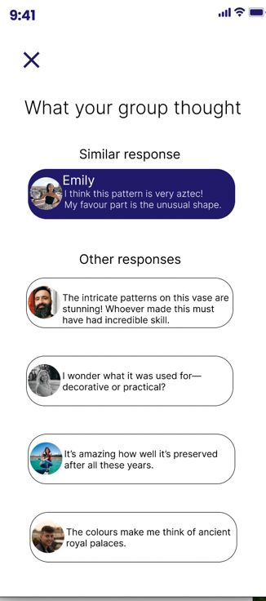
(S2)
(S1)

AR Recreations (R):

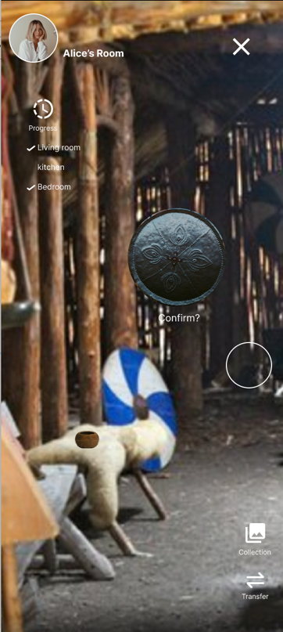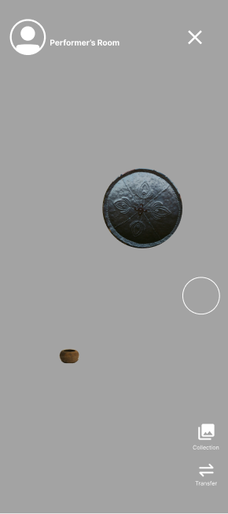
(R3)
(R2)
(R1)
(R7)
(R6)
(R5)
(R4)

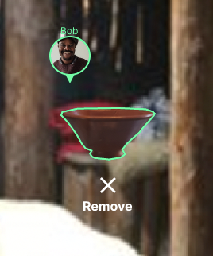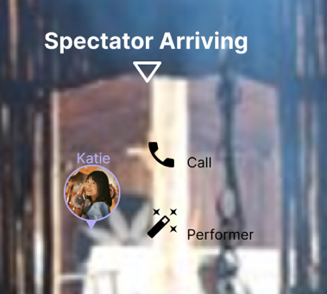
(R9)
(R12)
(R10)
(R11)
(R8)
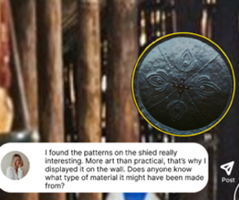
(R13)

Past Recreations (PR):
(PR1)
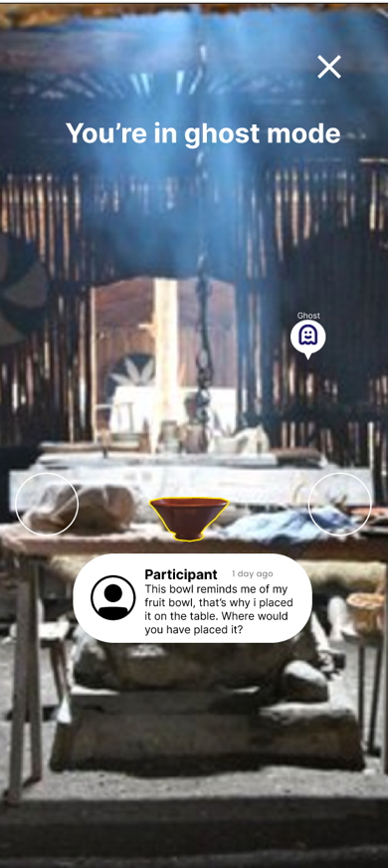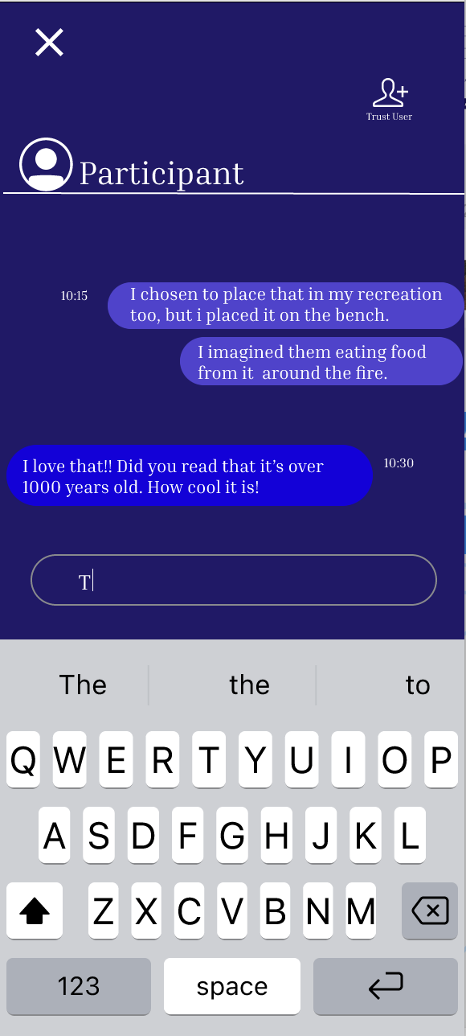
(PR3)
(PR4)
(PR2)
(PR6)
(PR5)

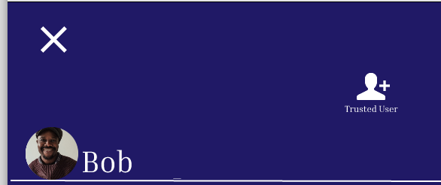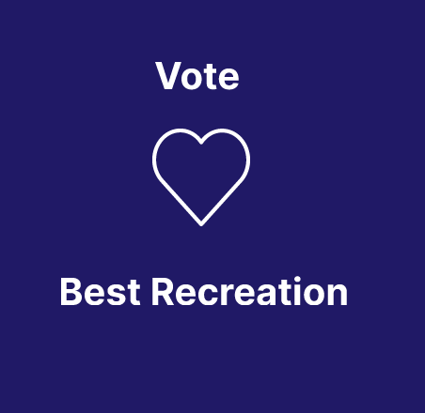
(PR8)
(PR7)

Messages (M):
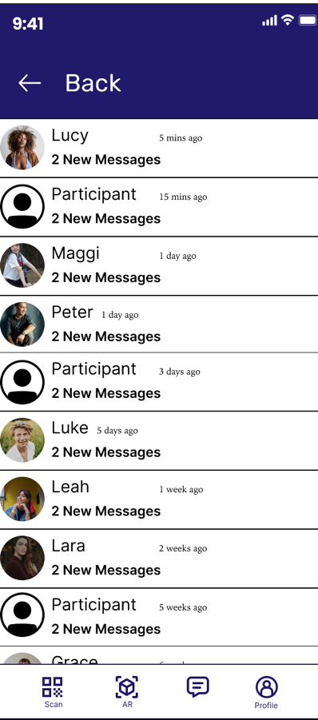
(M3)
(M1)

(M2)

Academic References:
Reeves, S., Benford, S., O’Malley, C. and Fraser, M. (2005). Designing the spectator experience. Proceedings of the SIGCHI Conference on Human Factors in Computing Systems. doi:https://doi.org/10.1145/1054972.1055074.
‌Lacoche, J., Pallamin, N., Boggini, T. and Royan, J. (2017). Collaborators awareness for user cohabitation in co-located collaborative virtual environments. Proceedings of the 23rd ACM Symposium on Virtual Reality Software and Technology. doi:https://doi.org/10.1145/3139131.3139142.
Lundgren, S., Fischer, J.E., Reeves, S. and Torgersson, O. (2015). Designing Mobile Experiences for Collocated Interaction. Proceedings of the 18th ACM Conference on Computer Supported Cooperative Work & Social Computing. doi:https://doi.org/10.1145/2675133.2675171.
Ali, S., Bedwell, B. and Koleva, B. (2018). Exploring relationships between museum artefacts through spatial interaction. Proceedings of the 10th Nordic Conference on Human-Computer Interaction. doi:https://doi.org/10.1145/3240167.3240217.

Project References:

(2024). Boardnoter. Same Time - Same Place (1). COMP3010: Meeting rooms and shared surfaces [6]. University of Nottingham.
Firefly (2015). Drop Messages. [online] YouTube. Available at: https://www.youtube.com/watch?v=1p5DRoDCd7s.
Cosley, D., Lewenstein, J., Herman, A., Holloway, J., Baxter, J., Nomua, S., Boehner, K. and Gay, G. (n.d.). ArtLinks: Fostering Social Awareness and Reflection in Museums. [online] Available at: https://www.cs.cornell.edu/~danco/research/papers/artlinks-chi2008.pdf.

