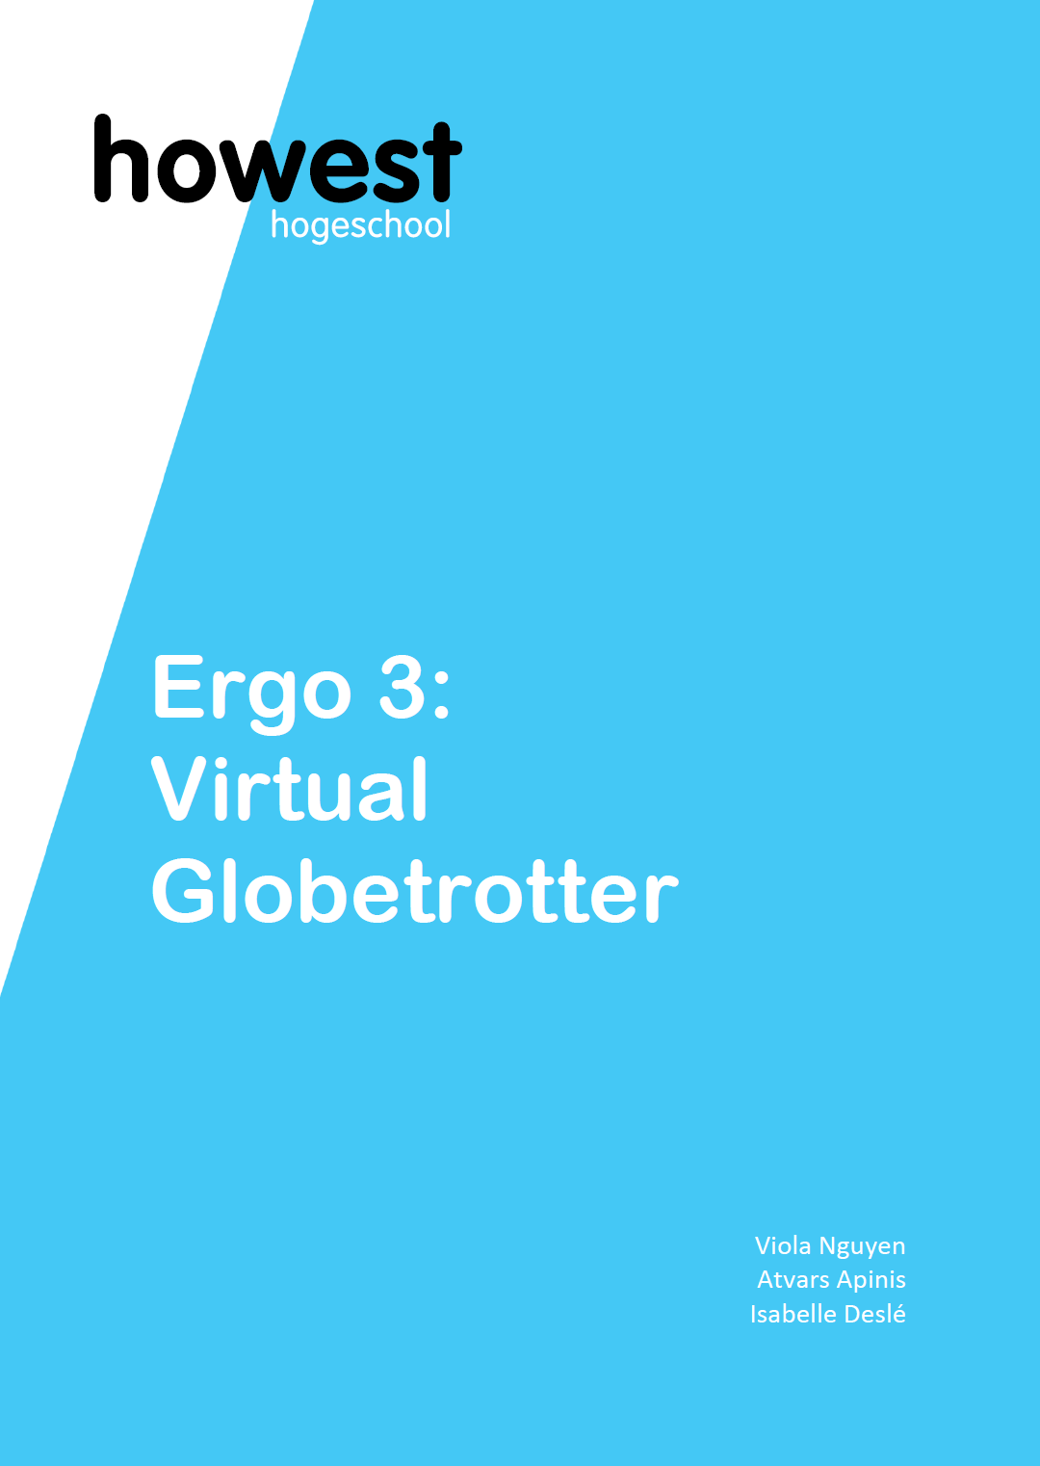
Table of Contents
Contents
Proof of Concepts: 2
Team Role Distribution 2
Project Description 2
Draft of technical solution 3
Research summary 7
Github 7
Trello 7

Proof of Concepts:

Team Role Distribution
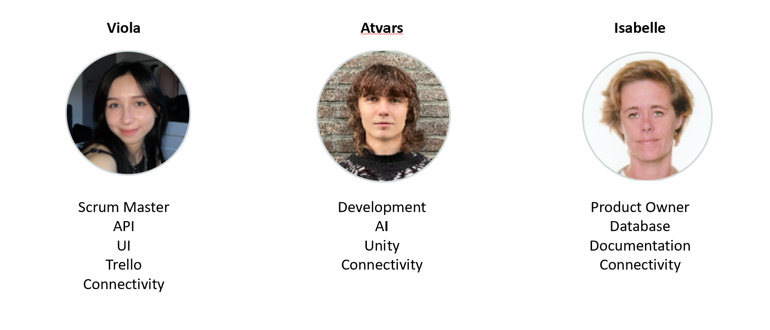

Project Description
The "Virtual Globetrotter" project aims to provide children around 10 years with an opportunity to experience the world virtually using our immersive room. Children can explore locations using an interactive map. These virtual trips will utilize AI-generated images, speech recognition, and audio to create an immersive and enriching experience.
The immersive room in The Core in Howest will be used.
The child is in the immersive room and has a tablet or phone with the user interface connected to the pc in the immersive room. The child chooses a continent shown on the user interface and a 360° image is shown and music is played corresponding to the continent choice.
The child is then asked to say a location, landmark or point of interest it wants to explore. For example, the beach, the pyramids or Disneyland.
The voice input is used by an AI model to generate another 360° image to show in the immersive room.

Draft of technical solution
Website
Users will be able to interact with the immersive room through a multi-page website on a dedicated local tablet. We will run the whole application in a Docker container on one of our local machines and connect the tablet through the local network.
The frameworks that will be used are Flask for the API part of the website and Vue.js for the frontend.

Frameworks
- Flask:
- will connect to the SQL database, managing read and write operations.
- Since the AI part will be in a separate class, we will import it and integrate the AI components into our application logic.
- Vue.js
- will be used to create a pleasant user experience: the design as well as the web navigation will be programmed in this section.

User Journey
- Starting page welcomes users and initializes the application. By pressing a start button, users will arrive at the next page where they need to choose a location.
- Location is chosen with an interactive world map that consists of a simplified world map, where the continents are clickable buttons. When pressed on the map, a random pre-generated image of a place in that region is pulled from the database, connected to the Unity environment and displayed in the immersive room.
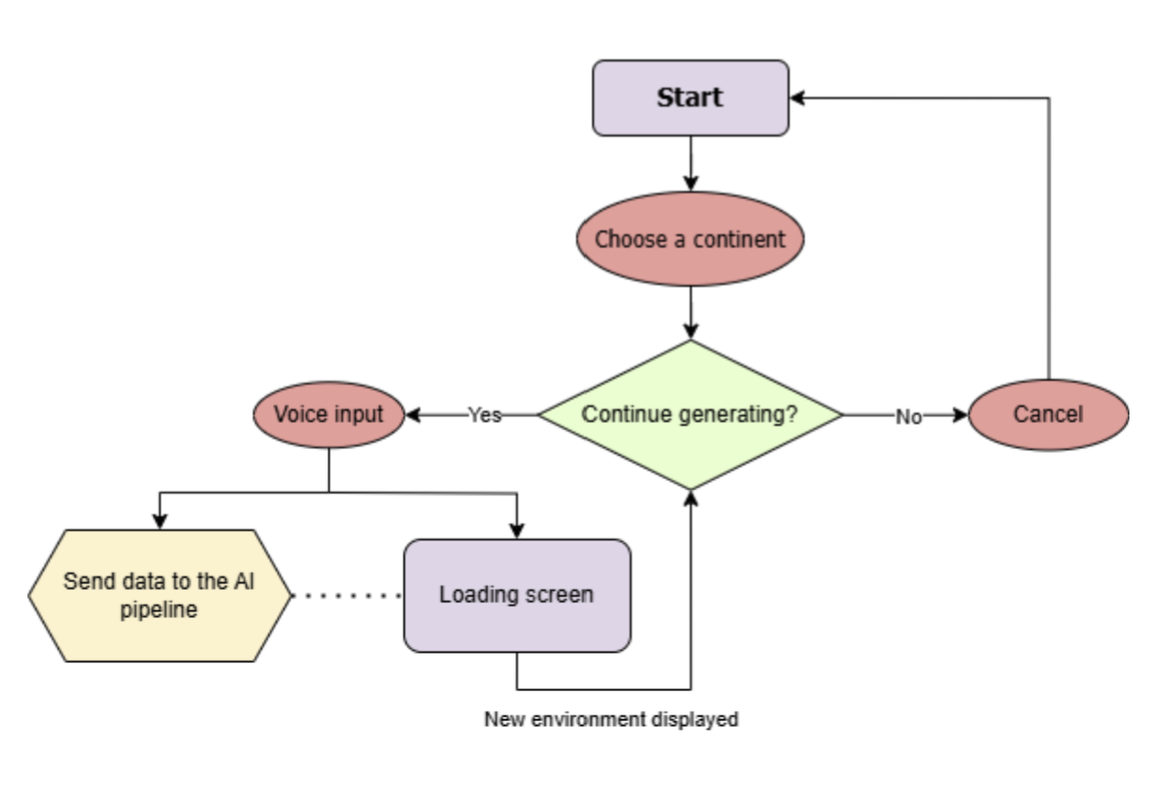

Database
Images that have been generated already will be stored in a database. For now the idea is to use a relational database and a full text search but further research will reveal if this is the best choice and if NoSql is better for this case.
A path to the image is stored the table Images and also the prompt that have been used to create it with the AI model. Keywords / tags can be added in a separate field.
For the music: a limited number of ambient sounds will be stored by continent.
No music will be generated while the child is standing in the immersive room. If there is no image in the database that corresponds to the voice input, a new image will be generated by the AI model. The image is stored and the path to it is stored in the database, together with the prompt used to create it.
Every created image is stored in the database and can be reused if the voice input corresponds to it.
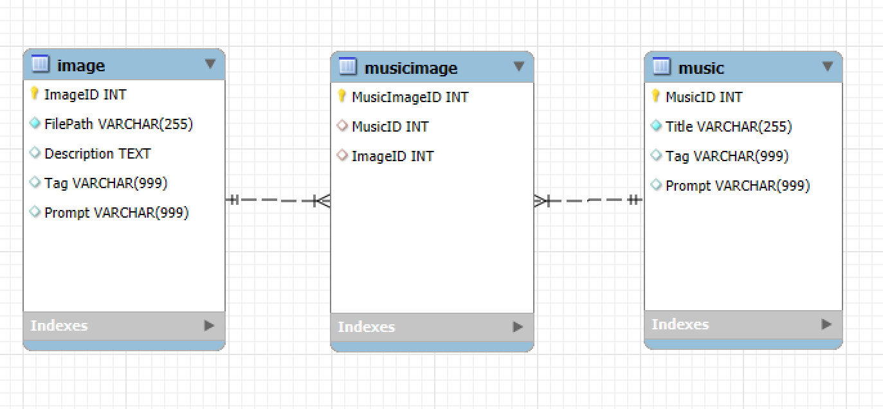

Unity
The AI generated images will be displayed in the Immersive room. Unity will be used to carry this out. We will create an empty environment, and add a large sphere to it, so that the centre of the sphere is the (0,0,0) coordinate.
As a requirement for the Immersive room, we will also add four cameras, one for each cardinal direction.
After that, we will overlay the AI generated image on the inside surface of the sphere. This will create the illusion that the user is in the AI generated environment. Furthermore, we will play the AI generated music in the background to add a layer of immersion.
There will also be a user interface to interact with the program (E.g. change the music, enter a prompt).
If we have enough time, we will implement some post-processing effects to help hide some of the defects of the image, and make the experience more polished.

AI
In this project, AI is used to capture speech input, and create media that aligns to the user's request. The finished product will be an AI pipeline that converts the user's speech input to an image, with the possibility to make adjustments (also done by voice input). The user will also be able to change parts of the image after it has been generated.
Since the use of AI can be costly, we are prioritizing free models, and have found that the largest selection of them is on the Hugging Face hub. Here, it is also possible to perform GPU accelerated inference in the cloud with (some of) these models for free, using the Serverless API. The free tier has a daily limit of 1000 requests to the API.
The AI pipeline will consist of six different AI models:
· Voice-To-Text
o Used to capture voice input and convert it to text that will serve as input later down the pipeline.
· Text-To-Audio
o Generates background music to be played in the Immersive room.
· Text-To-Text
o Enhances the user’s prompt to get better performance from the image generating model.
o Current choice is “Flux-Prompt-Enhance”, but this may change.
· Text-To-Image
o Uses the enhanced prompt to generate a 360 degree image.
o Current model choice is “flux-dev-panorama-lora-2”, but this may also change.
· Inpainting
o Fills in the image so that both ends connect seamlessly.
o The image will be vertically split, and the both parts will switch places with a gap in-between. This model will fill in the gap.
· Image-To-Image
o If a user wants to change something in the image, this model is used.
o Takes the original generated image and the user’s prompt of the changes to be made.
o The input prompt will not be enhanced, as that might mislead the model regarding the changes specified by the user.
o Outputs an updated image.

Connectivity
Connecting to different storypoints to 1 will be the biggest challenge:
Examples:
Connecting Result of the query (image) is used to show in the immersive room.
Connecting

Documentation
Technical documents
User manual for the teacher or parent coming with the child
Diagrams

Research summary
Researching to use of relational database or MySql.
Image generated on the spot : time needed
Connectivity of unity, database, website.
Querying text in relational databases

Github
https://github.com/IsabelleDesle/VirtualGlobeTrotter

Trello
https://trello.com/b/6RqMp3PU/virtual-globetrotter

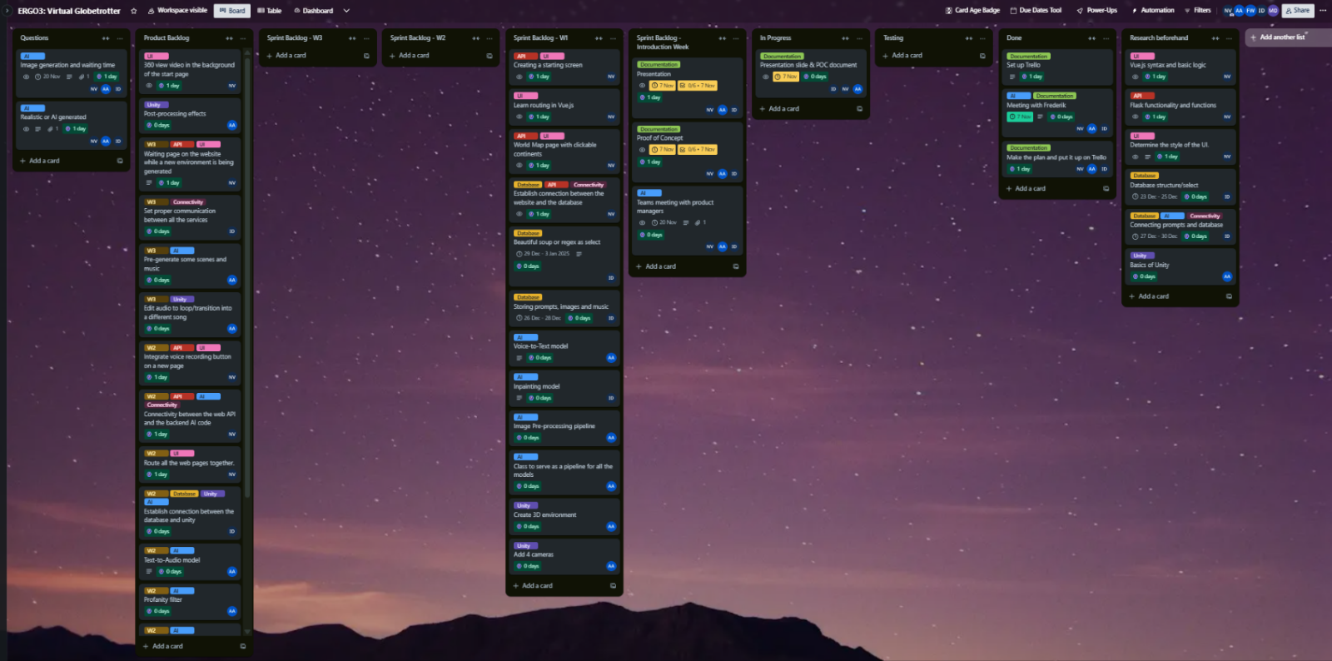

or Trello setup, we inspected all the necessary functionality that we want to see in out project and made detailed tasks. We made lists that correspond to Agile methodology and carefully placed necessary cards to the dedicated lists.
Sprints
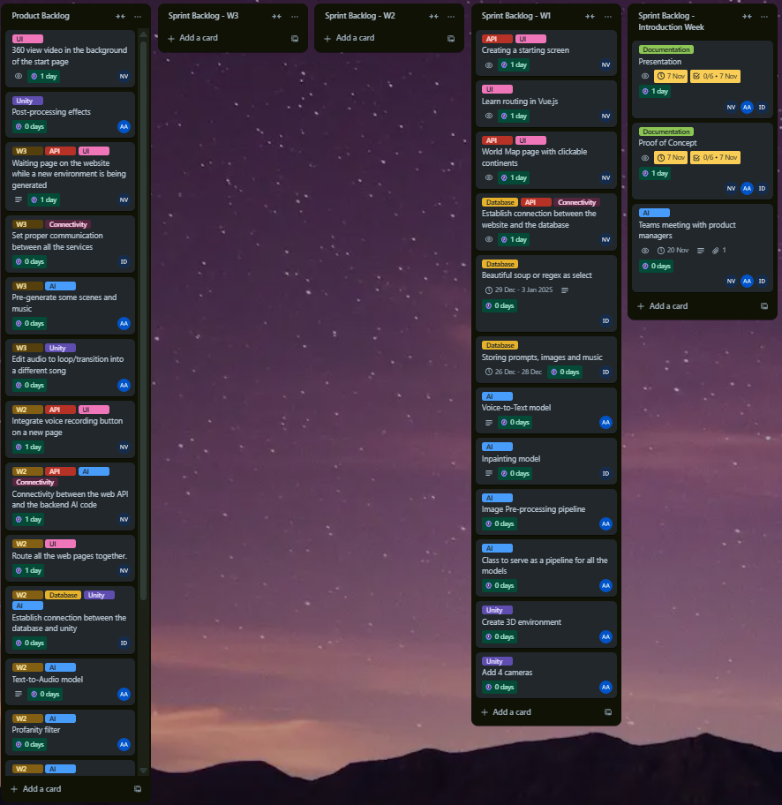The sprint length was decided to be 1 week, with a thorough retrospective after each sprint.
For now, we planned the tasks for the first week of the project weeks. After that, we will look back at how accurate we estimated our times and resources and based on that decide on the second sprint.
Each person in our group has their own responsibility. To make our time productive, we will do some research before the actual start of the project weeks. That way we can have a better understanding about what we can expect while working on the project.
The workflow was made in a way that we start building the whole application with simple building blocks, which we will focus on during the first week.
When every service the application has a solid base, we will connect the parts all together. After that, we will implement more complex features of the application as well as nice-to-haves if we have enough time.
The estimated tasks for weeks 2 and 3 of the project weeks can be found under the label W2 and W3 respectively. Cards without a label in the Product Backlog lists are our nice-to-haves.

