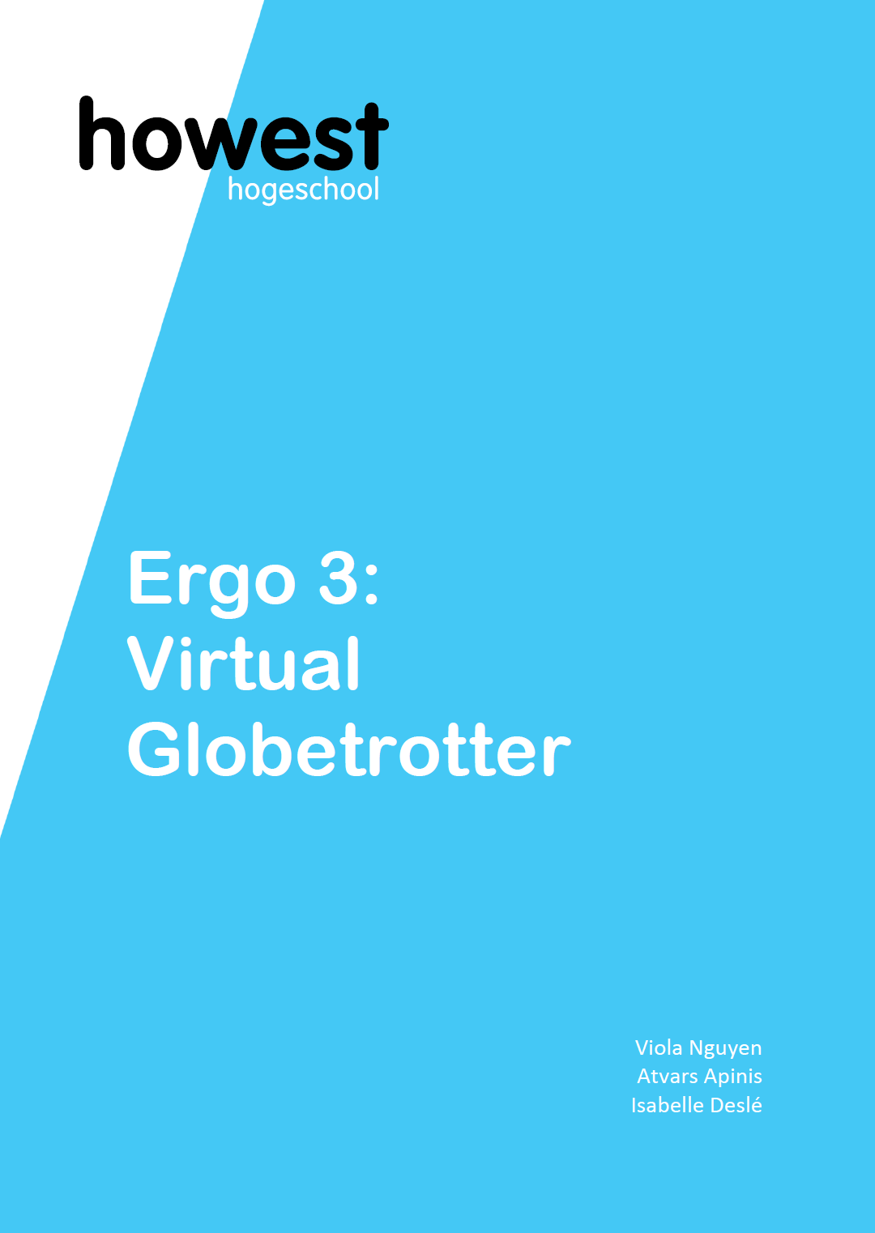

Table of Contents

Proof of Concepts:
- The

Team Role Distribution
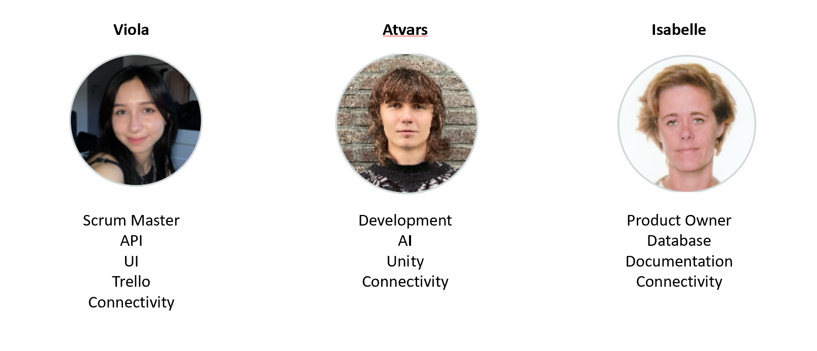

Project Description
isabelle

Draft of technical solution
Website
Users will be able to interact with the immersive room through a multi-page website on a dedicated local tablet. We will run the whole application in a Docker container on one of our local machines and connect the tablet through the local network.
The frameworks that will be used are Flask for the API part of the website and Vue.js for the frontend.
Frameworks
· Flask: - will connect to the SQL database, managing read and write operations. - Since the AI part will be in a separate class, we will import it and integrate the AI components into our application logic.
· Vue.js - will be used to create a pleasant user experience: the design as well as the web navigation will be programmed in this section.
User Journey
· Starting page welcomes users and initializes the application. By pressing a start button, users will arrive at the next page where they need to choose a location.
· Location is chosen with an interactive world map consists of a simplified world map, where the continents are clickable buttons. When pressed on the map, a random pre-generated image of a place in that region is pulled from the database, connected to the Unity environment and displayed in the immersive room.
· After choosing the location, users land on the next page, where they can modify the prompt by using a voice input, or cancel the generation and go back to the starting page. - The voice input option uses the tablet's microphone to get a voice recording while the user presses the button. Then this recording is sent to the AI pipeline function as an input. As the result, the user sees a newly generated environment in the immersive room. While a new scene is generating, users see

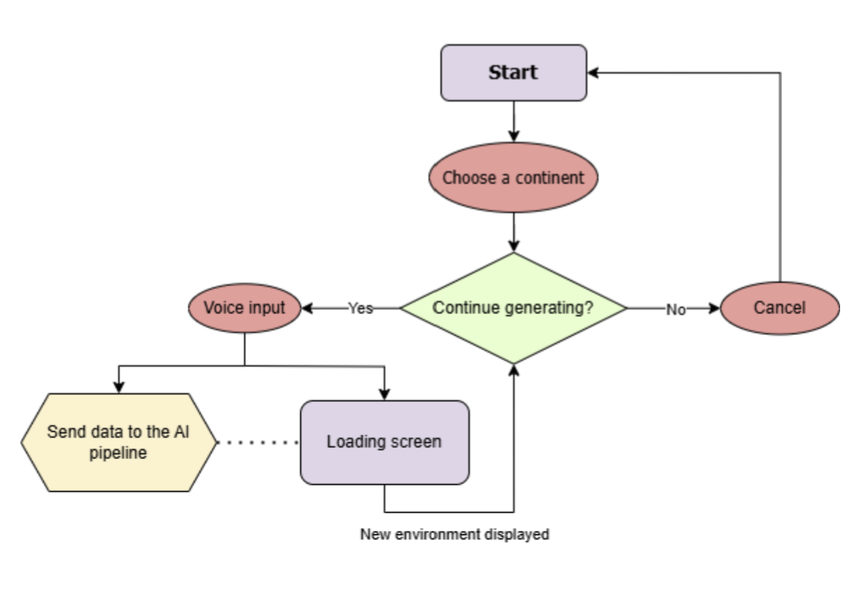

Database
Images that have been generated already will be stored in a database. For now the idea is to use a relational database but further research will reveal if it is the best choice.
A path to the image is stored the table Images and also the prompt that have been used to create it with the AI model.
For the music: a limited number of ambient music will be stored by continent.
No music will be generated while the child is standing in the immersive room.

Unity
The AI generated images will be displayed in the Immersive room. Unity will be used to carry this out. We will create an empty environment, and add a large sphere to it, so that the centre of the sphere is the (0,0,0) coordinate.
As a requirement for the Immersive room, we will also add four cameras, one for each cardinal direction.
After that, we will overlay the AI generated image on the inside surface of the sphere. This will create the illusion that the user is in the AI generated environment. Furthermore, we will play the AI generated music in the background to add a layer of immersion.
There will also be a user interface to interact with the program (E.g. change the music, enter a prompt).
If we have enough time, we will implement some post-processing effects to help hide some of the defects of the image, and make the experience more polished.
AI
In this project, AI is used to capture speech input, and create media that aligns to the user's request. The finished product will be an AI pipeline that converts the user's speech input to an image, with the possibility to make adjustments (also done by voice input). The user will also be able to change parts of the image after it has been generated.
Since the use of AI can be costly, we are prioritizing free models, and have found that the largest selection of them is on the Hugging Face hub. Here, it is also possible to perform GPU accelerated inference in the cloud with (some of) these models for free, using the Serverless API. The free tier has a daily limit of 1000 requests to the API.
The AI pipeline will consist of six different AI models:
- Voice-To-Text
  - Used to capture voice input and convert it to text that will serve as input later down the pipeline.
- Text-To-Audio
  - Generates background music to be played in the Immersive room.
- Text-To-Text
  - Enhances the user’s prompt to get better performance from the image generating model.
  - Current choice is “Flux-Prompt-Enhance”, but this may change.
- Text-To-Image
  - Uses the enhanced prompt to generate a 360 degree image.
  - Current model choice is “flux-dev-panorama-lora-2”, but this may also change.
- Inpainting
  - Fills in the image so that both ends connect seamlessly.
  - The image will be vertically split, and the both parts will switch places with a gap in-between. This model will fill in the gap.
- Image-To-Image
  - If a user wants to change something in the image, this model is used.
  - Takes the original generated image and the user’s prompt of the changes to be made.
  - The input prompt will not be enhanced, as that might mislead the model regarding the changes specified by the user.
  - Outputs an updated image.
Connectivity
Isabelle Atvars Viola

Documentation
isabelle

Research summary

Link to Github
https://github.com/IsabelleDesle/VirtualGlobeTrotter

Link to Trello
viola

