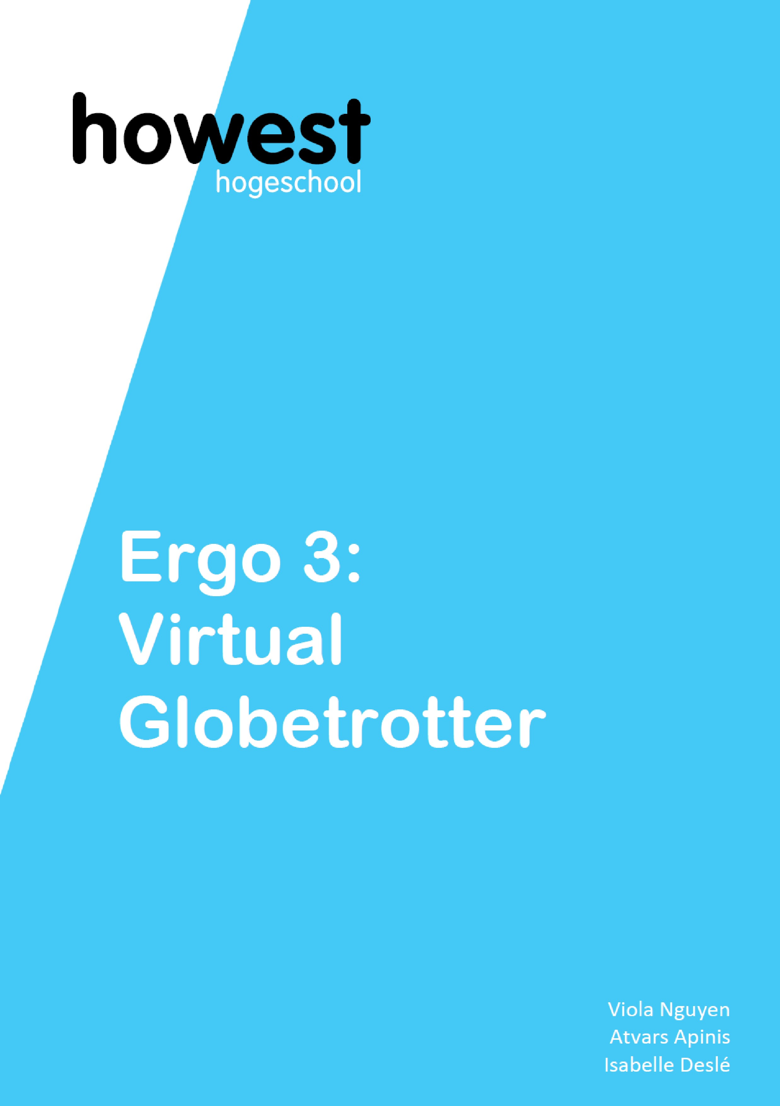
Functional Analysis

Table of Contents
Team Role Distribution 3
Project Description 4
Key question 4
Solution 4
Target audience analysis 4
MVP features 5
Website 6
User Journey 6
Database 8
Artificial Intelligence 9
Unity 9
Trello 10
Sprints 10
User testing: 11
10/01/2025 Immersive room 11
14/01/2025 Immersive room 11
20/01/2025 Immersive room 11
22/01/2025 Immersive room 12
23/01/2025 Immersive room 12
24/01/2025 Immersive room 13
27/01/2025 Immersive room 14
Links: 14
Github 14
Trello 14

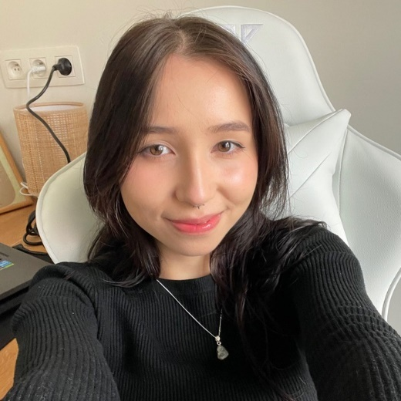
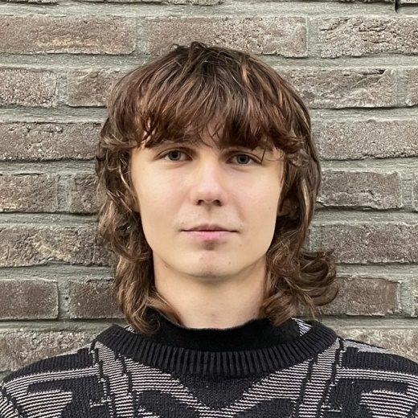
Team Role Distribution
Scrum Master
AI
Website: API & UI
Trello
Connectivity
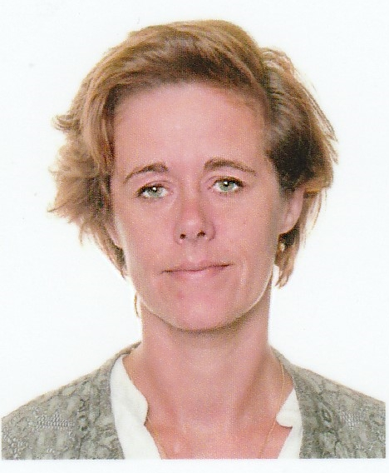
Isabelle
Viola
Atvars
Unity
Connectivity
AI
Product Owner
Database
AI
Documentation
Connectivity

Project Description

Key question
How can we let children with certain limitations experience the world virtually using AI?

Solution
The "Virtual Globetrotter" project aims to provide children of age 11 to 14 years with an opportunity to experience the world virtually using the immersive room. Children can explore different locations using an interactive map. These virtual trips utilize AI-generated images, and speech recognition to create an immersive and interactive experience.
The immersive room in The Core at Howest University of Applied Sciences is used. The child can use a website application that runs on a tablet to choose a continent to visit.
The child can then use the voice recorder on the website to say a location, landmark or point of interest to explore. The voice input is not mandatory. If not voice input is given a random pregenerated image of the continent is shown. At the beginning of this project there are approximately 100 images provided by continent. Continents are North America, South America, Europe, Asia, Africa, Australia and Other (for the oceans).

The continent and voice input combination are sent to the backend AI pipeline to find a relevant image in a database or (if not found) to generate an image on the spot. A new image is generated in approximately 1 minute and during the generation a game is provided to search for objects in the screen: the Find-The-AI-Robot-Game.

Once found or generated, the image is shown in the 360° environment in the immersive room: on the 4 walls (2,6m high – 5m wide each) and accompanied by a relevant ambient sound.

The immersive and enriching experience has no end point as new images can be generated and added continuously to the database as long enough space is provided to save the images (of size of 1 MB by image).

Target audience analysis

During our conversation with Ilse Meerschaert, Lector Ergotherapy at Howest and our business owner, about the impossibility of current available free AI models to generate images that are an actual representation of a real study trip and that are comparable to real photos e.g. with the actual architecture when the image is created, the educational goal of the project has changed.

The primary educational goal is since then not longer to provide a replacement of the real study trip but to help children to think critically about the reliability and accuracy of AI-generated content.

This project will not only provide an immersive experience to explore the world and to foster creativity and curiosity but will also aim to introduce children to AI technology and to open the starting point for a conversation with the teacher about the limitations and the advantages in AI and to develop critical thinking and digital literacy by comparing generated images to their expectations or to real-world representations. The conversation itself with the teacher is out of the scope of this project.

By consequence and in accordance to our discussion with customer, the audience has changed from children of approximately 11 years to children from 11 to 14 years.

Minimum Viable Product Features

Minimal features
Choice of continent on a navigation screen and a button to add (optional) voice input to provide an Immersive experience.
Image must be shown on the 4 walls of the immersive room.
Image must be in a good resolution and in correct size and scale.
Sounds or music must be relevant for the image.
All images must be AI generated.
Images that are generated on the spot must take an acceptable time to be generated.
Ai model for generation of images must be for free.
Pregenerated images must be shown if relevant for the chosen continent and voice input.

Nice to have
Access the user interface with a tablet or phone instead of the keyboard.
Access a database with pregenerated images using full text search and fuzziness to find images that are approximately corresponding to the voice input
Use of AI model to generate music or ambient sounds.

Edge cases
1. Combination of video/animation with free models and acceptable waiting time (less than 2 minutes) is not possible.
Solution: conversation with the customer about choices:
- Free model = images
- Paid model = animation or video
Images are chosen.

2. AI generated images are not always accurate and cannot replace an educational study trip.
Solution: brainstorm with the customer about the role of AI in education of children.
Shift of the educational concept from the study trip to the use of AI generated images to
- Awaken the creativity and curiosity of the child in an interactive situation.
- Awaken the critical thinking and the digital literacy of the child when using AI generated material (assisted by teacher).

User flow diagram

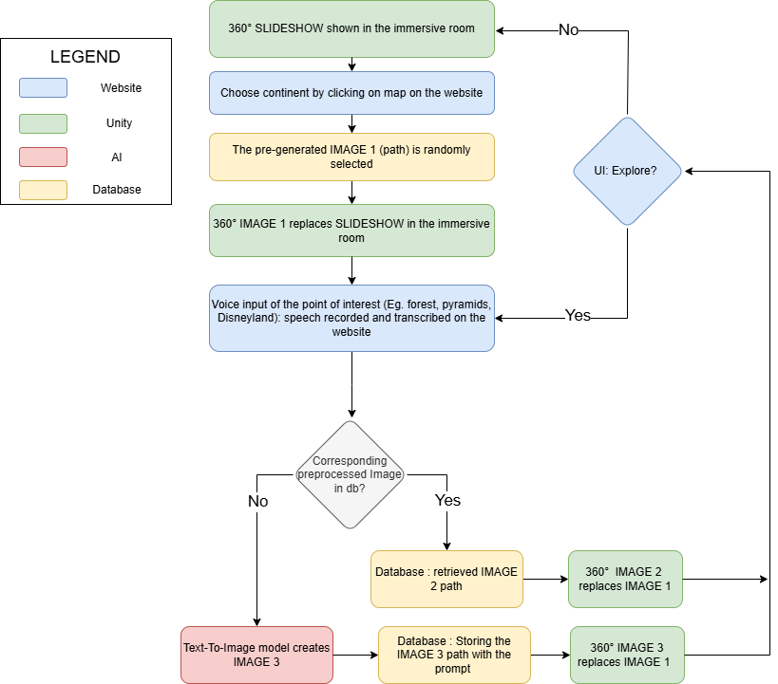

Website
The website component of our project facilitates user interaction with the immersive room through a multi-page interface, hosted on a local network. This web application leverages the Flask framework to handle backend logic, incorporating several key endpoints:
- /process-request: This endpoint receives the user-selected continent and transcribed voice input from the frontend, returning the request status and a corresponding message. In the absence of voice input, a random environment from the chosen continent is retrieved from the database and displayed in the immersive room.
- /generate_environment: This endpoint establishes a connection to the Elastic Search database, searching for a relevant image based on the voice input and continent. If a matching image is found, its path is sent to the Unity application for display in the immersive room. Otherwise, the AI pipeline functions are utilized to generate a new image, which is then sent to Unity for display.

The frontend is built using Vue.js, providing a visually appealing and intuitive user interface across multiple pages:
- Starting view: A simple page featuring an AI-generated background and a start button that initializes the application.
- World Map view: An interactive page displaying a world map, where each continent is a clickable button. Upon selection, the chosen continent's value is stored and transmitted to the subsequent page.
- Loading view: A transitional page that appears after continent selection, where an API request is made to retrieve or generate the environment.
- Voice Recording view: A page enabling users to provide a unique voice prompt, which is transcribed and sent to the API for environment retrieval or generation.

User Journey
The user journey is designed to guide users through the application:
- The starting page welcomes users and initializes the application, prompting them to select a location via the interactive world map.
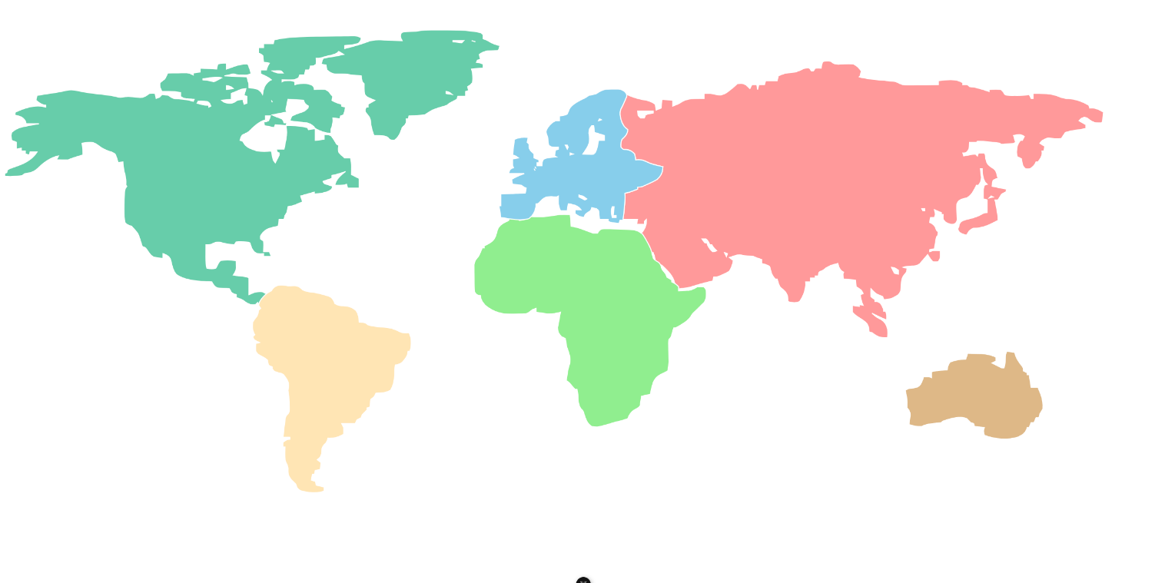

- Upon selecting a continent, users are presented with a loading screen while a random pregenerated image from the chosen region is retrieved from the database and displayed in the immersive room.
- Users can then get a new environment from the same continent by providing a voice input, which is sent to the AI pipeline function for processing. The resulting generated environment is displayed in the immersive room, accompanied by a loading screen during the generation process.
- Alternatively, users can cancel the generation process and return to the starting page.

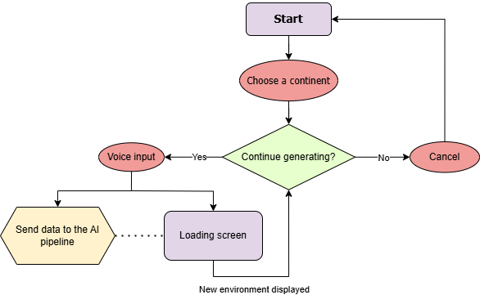

Database
The database component of our project utilizes Elastic Search to store metadata associated with generated images. For each image, the following information is stored:
- Image path: The file path of the generated image is stored in Elastic Search, enabling efficient retrieval and reuse of existing images.
- Enhanced prompt: The prompt used to generate the image with the AI models is stored, providing context and facilitating future image retrieval based on similar inputs.
- Title: A title is assigned to each image, which is used as the filename, allowing for organized storage and retrieval.
- Continent: The continent associated with each image is stored, enabling filtering and retrieval of images based on geographical location.
This metadata is transmitted to Elastic Search in a CSV format, ensuring efficient data storage and querying.
In cases where a user's voice input and continent selection do not match an existing image in the database, or they are not relevant enough, a new image is generated by the AI model. The resulting image is stored, and its metadata, including the folder path, prompt, title, and continent, is added to the database. This approach enables the reuse of existing images when the same combination of continent and voice input is encountered in the future, reducing computational overhead and improving system efficiency.

By storing the path to each created image in the database, our system can efficiently retrieve and display existing images, while also generating new images as needed to accommodate novel user inputs. This hybrid approach balances computational resources with user experience, providing a responsive and engaging interactive environment.

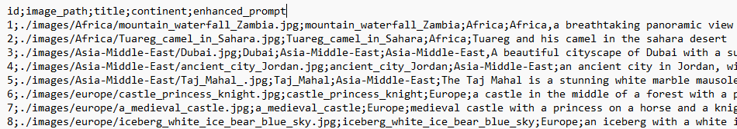

Artificial Intelligence
This project uses AI to capture user speech input and generate media that matches their requests. It creates an AI-powered pipeline that converts user speech into immersive images displayed in the Unity-based environment.

The AI pipeline has five main stages, each playing a key role in turning user voice input into a cohesive and engaging visual experience:

- Data Collection and Database Connection: We start by capturing user voice input through a website interface and transcribing the audio into text using a Vue.js library. The transcribed text is the foundation for the next stages, providing a written version of the user's spoken words.

- Text-to-Text Processing (Prompt Enhancement and Profanity Filtering): In this stage, we refine and enhance the transcribed text using a specified continent as context. We optimize the prompt to improve performance in the text-to-image generation model and filter out any profanity to ensure a respectful output. We use the Google Gemma-2-2b-it model for this task.

- Text-to-Image Generation: The enhanced prompt is then fed into a fine-tuned version of the Stable Diffusion model called Cyber Realistic, running on local machines. This model generates a 360-degree image based on the refined prompt, considering the continent-specific context from the user's voice input. The resulting image is a direct representation of the user's request, transformed into a visual format.

- Inpainting (Seamless Environment Generation): To create an immersive experience, we apply an inpainting model to the generated image, smoothing out any seams and mismatched edges. We split the image into two parts, swap them, and then re-generate the edges taking into consideration the content of the whole image using the inpainting model. This creates a cohesive environment where the two image halves seamlessly connect.

- Upscaling (Image Resolution Enhancement): Finally, we use an upscaling model to enhance the image resolution, increasing it to 8K for crisp and clear display in the immersive room environment. This final stage enables the generated image to be displayed in high detail on the walls of the immersive room, providing an engaging and immersive experience for the user. We use the Real ESRGAN model for this task.

Throughout the pipeline, we use various AI models that work together to transform user voice input into a visually stunning and immersive experience. This demonstrates the potential of AI-powered media generation in creating engaging and interactive environments.

Unity
We use the Unity game engine to display the AI-generated images in the immersive room by running an executable file. The images are sent over the network and then used to update the skybox of the environment. This means that the environment can change in real-time based on the user's input.
To make sure the images are displayed correctly, we use a Unity prefab that was provided by the HITLAB team. This prefab is a template that helps us position and render the images in the right way. By using it, we can ensure that the images are aligned properly and look good in the Immersive Room.

Agile Methodology and Trello
For Trello setup, we inspected all the necessary functionality that we want to see in out project and made detailed tasks. We made lists that correspond to Agile methodology and carefully placed necessary cards to the dedicated lists.

ERGO3: Virtual Globetrotter | Trello

User testing

10/01/2025 Immersive room: image resolution and connect to internet
Purposes of the test:
1. Evaluation of the resolution of the image
2. Connection pc immersive room and laptop using a 5G adaptor

Present :
Thibaut De Tandt, Tom De Cavele, Viola Nguyen, Atvars Apinis, Isabelle Deslé

Results :
1. Resolution must be higher: 8k by wall, instead of 8k for entire image
2. Instead of a 5G adapter, the pc will be connected to the internet via an ethernet cable, and the laptop can then send images to it over Wi-Fi.

14/01/2025 Immersive room: inpainting, connection laptops and pc
Purpose of the test:
1. Evaluation of the image inpainting to change the image to a seamless 360° view.
2. Testing the connection of the laptop and the pc of the immersive room

Present :
Thibaut De Tandt, Viola Nguyen, Atvars Apinis, Isabelle Deslé

Results:
1. The Max Size parameter for the images in Unity Editor should be set to 8192, instead of 2048
2. To send images to the Immersive Room PC, we need to either turn off the firewall or enable file sharing over the network. We tried enabling file sharing, but that did not work, something else needs to be enabled/disabled. Fully turning off the firewall will probably not be allowed: searching for a solution in the next meeting with Thibaut.
3. We can set the IP address to "all" to receive the images.

20/01/2025 Immersive room: pregenerated images, webservice
Purpose of the test:
Test the generated images, the sounds, the slide show, webservice on mobile phone and the waiting game.
- Instead of fun facts, 8 or more CTAI robots will be shown in the image during the generation of a new image. The viewer is asked to search the 8 CTAI robots while waiting no slide show will be shown during waiting.
- Pregenerated images are shown even if input is not corresponding to the image
- some images show edges, other are not shown completely
- audio ambient sound is not relevant for the image.
- webservice is accessible via mobile phone, layout is consistent and pretty
- prompt needs to be better to generate more realistic images of animals

Present :
Thibaut De Tandt, Viola Nguyen, Atvars Apinis, Isabelle Deslé

Results:
- The game itself can not be tested yet, explanation needs to be a bit bigger to read.
- an improvement is needed of elastic search queries because the pregenerated images are shown even if not relevant: add “and” operator to search for all the words (except stop words like “the”, “and”, “a”..), higher score for field “title” than for field “content”, boost score if total input phrase is found and relevance threshold = 8 instead of 4, fuziness 1, no fuziness for searching phrase.
- Use 4 rectangle images instead of the sphere in unity? No we will still use the sphere but adjust the images instead.
- Webservice should also be accessible via tablet
- Adjust the prompt enhancer to avoid the creation of multiple animals on the image and place the animal not in the middle in the image where the inpainting will happen but on the right or left side of the image.
- Audio be careful with copyright. Should be relevant for the category of the image e.g. category Nature, City, Ocean, City, Underwater, Wind. We will add it in the csv and in filename, e.g. nature-sheep in a meadom.jpg, underwater-coral reef.jpg.

22/01/2025 Immersive room: sounds and image generation
Purpose of the test:
Test the audio and the “find the robot” game during image generation and ask Thibaut for his voice input

Present :
Thibaut De Tandt, Viola Nguyen, Atvars Apinis, Isabelle Deslé

Results:
- Robot game works. Robots could be a little smaller and avoid putting them in the door opening.
- Audio is good. Research the possibility to adjust volume.
- Research if possible to add automatically an appropriate category for new generated images.
- Finding the pregenerated images is better now. Add a continent “other” for all images that are not in a continent or are in more than one continent and adjust query to first search for exact continent and after that for continent “other”.

23/01/2025 Immersive room: sounds, game and image generation
Purpose of the test:
This is the last test before the test with Ilse Meerschaert of Ergo on Friday.
We asked Jordy to give voice input.

Present:
Jordy Verbruggen, Viola Nguyen, Atvars Apinis, Isabelle Deslé

Results:
- The friendliness of AI: AI doesn’t generate profanity, violence or inappropriate images because of our use of negative prompt. But it also generates images of animals in natural environment rather than in a zoo and images of dolphins in an ocean rather than in a dolphinarium, images of free birds instead of caged ones. AI will not generate cartoon, game or film of marvel characters in respect the creator (designer code of conduct).
- An A4 with disclaimer and tips for voice input should be available in the immersive room: tips like be specific and detailed eg. not just "animal" but "giraffe in the forest" not just "paris" but "sky view of Eiffel tower on the right side and on the left side the Seine”. Not just "beach" but "beach, sun, blue ocean and palm trees"
- All pregenerated Images must be available in the database: monuments, animals and landscapes. We will create images to have at least 100 by continent

24/01/2025 final test with customer and target audience in the immersive room
Purpose of the test:
Test the total experience, including the use of a pregenerated image, the generation on the spot of a new image, the game during waiting, the sounds. Test users are Japke and Michael, both 13 years old and Ilse Meerschaert and Laura Kyndt of Ergotherapie representing the project customer.

Present:
Japke, Michael, Ilse Meerschaert, Laura Kyndt, Marie Dewitte, Frederik Waeyaert, Thibaut De Tandt, Atvars, Viola, Isabelle

Results:
  - We forgot the change the ip addresses: the images were not sent to the Unity. We need a check point table on paper when doing a test or demo in order not to forget necessary setup.
  - Michael and Japke started first hesitantly for the voice input but after a few images they became more outgoing and added more specificity to their voice input:
- Input “Everest” showed mountains with snow
- Continent North America an input “spider man” showed spider man with the Eiffel tower in the background.
- Input “the highest buildings in the world” showed a newly generated image of a fictive city with high scrapers.
- Input “nature” showed a beaver in a river and Michael expected to see snow.

These first inputs by the children were then followed by more specific input and therefor better prompts.
For each image Ilse and Laura asked the children what they thought about the image and about the reliability of the AI generated images. And that made the children think more critically about the images. The children liked the immersive room and because of the game during the image generation (which takes approximately 1 minute) the waiting was not perceived as boring or waste of time. The children wanted to stay a bit longer and were sad they had to leave.
For Ilse Meerschaert and Laura Kyndt the waiting of 1 minute didn’t seem long and the ambient sound which was adapted to the pregenerated images, gave the experience an immersive feeling. At the same time the children were not overstimulated while their curiosity and creativity was still addressed. As the test showed, the immersive experience is well balanced and interactive. Marie De Witte appreciated the addition of the game and especially the continuous part of the experience. The models can keep on generating new images and there is no end point to the experience.

3. From now no changes anymore in the code. No new images. No new sounds. Focus on the documents needed for next assignment and on a prefect times presentation. Use the 20 seconds rule by slide to help us being concise.

27/01/2025 Immersive room
Purpose:
To make a video of the experience including the use of a pregenerated image, the generation on the spot of a new image, the game during waiting, the sounds.

Links:

Github
https://github.com/IsabelleDesle/VirtualGlobeTrotter

Trello
ERGO3: Virtual Globetrotter | Trello

