|  |  |
| --- | --- |
| **NAME :** | TAMILVANAN P |
| **DEPARTMENT :** | ELECTRONICS AND COMMUNICATION ENGINEERING |
| **COLLEGE :** | GOVERNMENT COLLEGE OF TECHNOLOGY |
| **NAAN MUDHALVAN COURSE:** | DIGITAL MARKETING |
| **NAAN MUDHALVAN ID :** | E62FF4F17889CADBA5C435E5907219CA |

ASSIGNMENT ON DIGITAL MARKETING

1. Create a blog or website using blogspot and wordpress.Customize the theme design and post new article with 500 words.

Blogspot:

<https://tamizhva.blogspot.com/2023/08/nature.html?m=1>

Wordpress

<https://nature411.wordpress.com/2023/10/29/nature/>

https://tamizhva.blogspot.com/2023/08/nature.html?m=1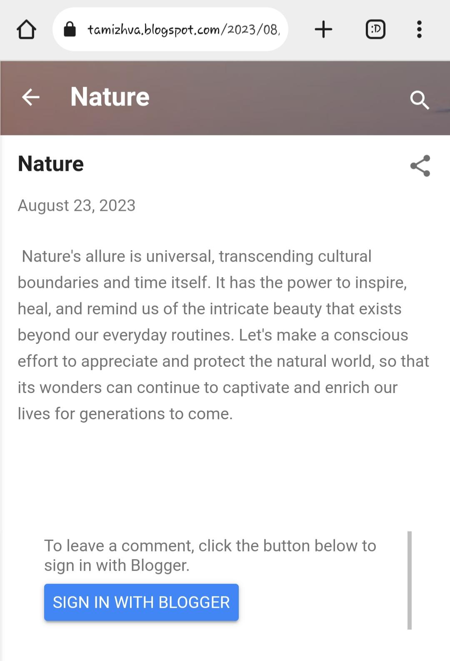

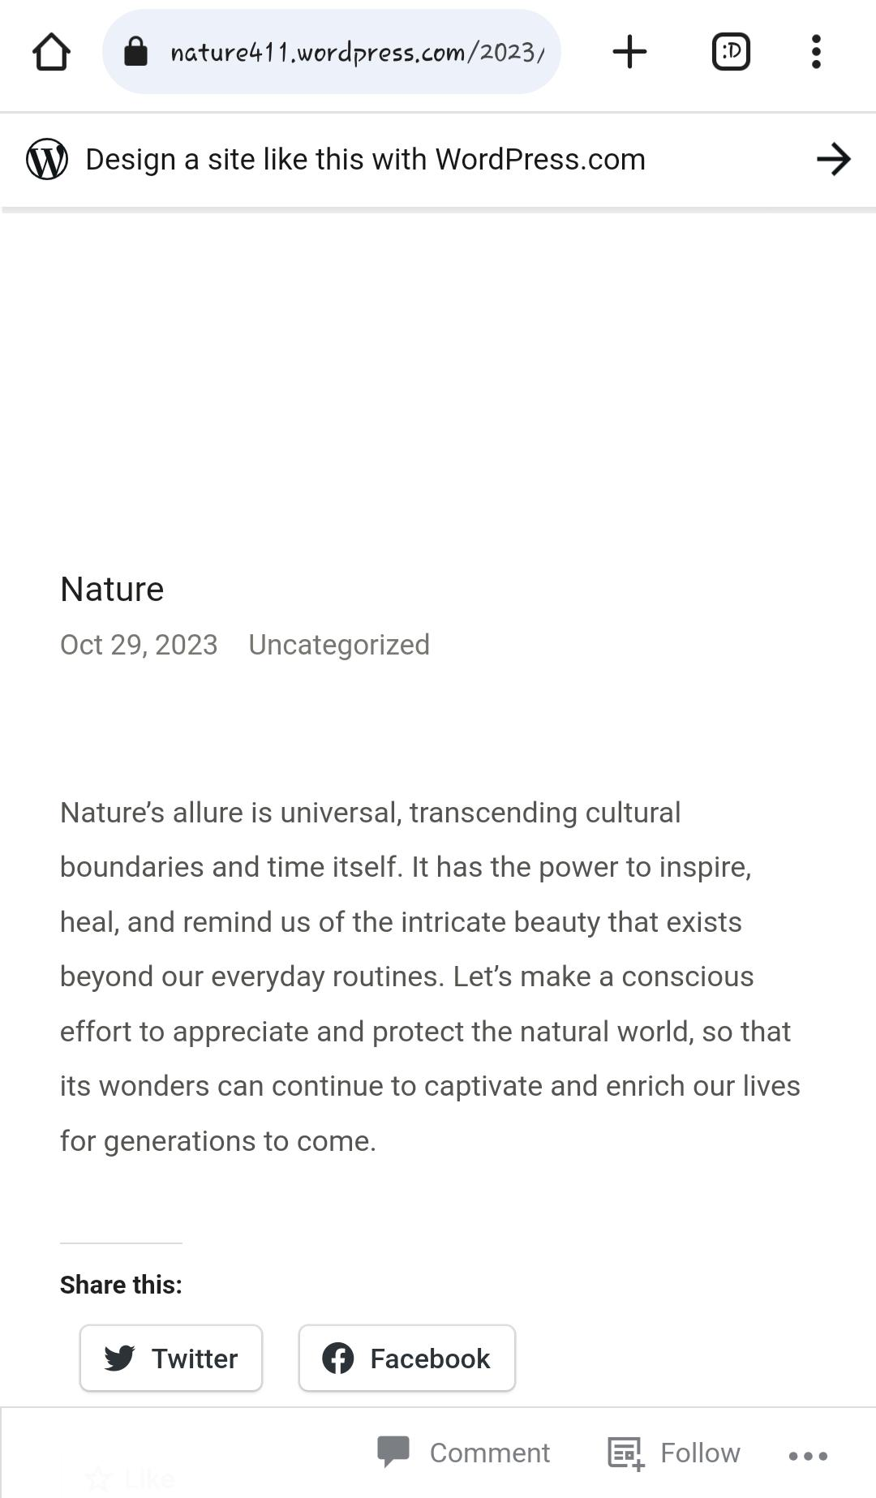

2.Create and design a social media advertisement poster using canva.

https://tamizhva.blogspot.com/2023/09/meme-context.html?m=1

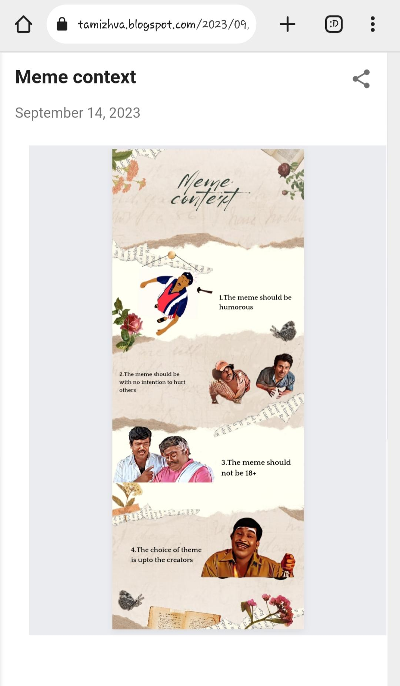

3.Create email newsletter design using Mailchimp or canva tool

<https://tamizhva.blogspot.com/2023/09/sports-shop-email-newsletter.html?m=1>

