|  |  |
| --- | --- |
| **NAME :** | VINOTH V |
| **DEPARTMENT :** | ELECTRONICS AND COMMUNICATION ENGINEERING |
| **COLLEGE :** | GOVERNMENT COLLEGE OF TECHNOLOGY |
| **NAAN MUDHALVAN COURSE:** | DIGITAL MARKETING |
| **NAAN MUDHALVAN ID :** | 4104F8575552CB48A8E4515E8D0FEF9D |

ASSIGNMENT ON DIGITAL MARKETING

1. Create a blog or website using blogspot and wordpress.Customize the theme design and post new article with 500 words.

Blogspot:

<https://mydigitallearningforyou.blogspot.com/2023/08/seo-search-engine-optimisation.html>

Wordpress:

<https://digitalmarketingvinoth.wordpress.com/2023/10/29/seo-optimization/>

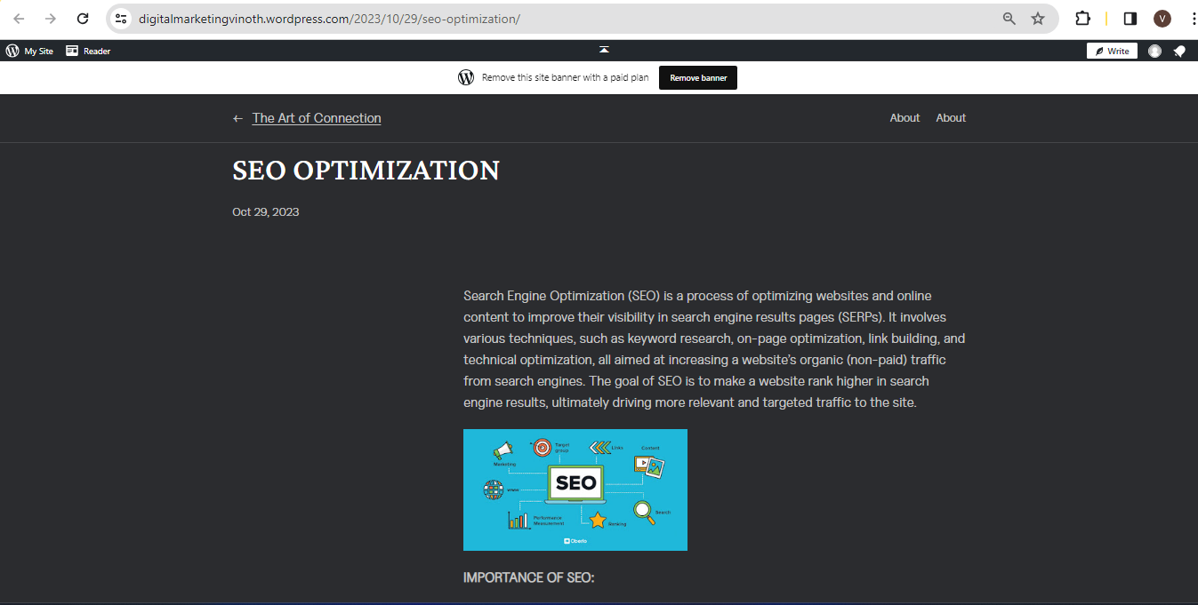

2.Create and design a social media advertisement poster using canva.

https://mydigitallearningforyou.blogspot.com/2023/09/unlock-your-potential.html

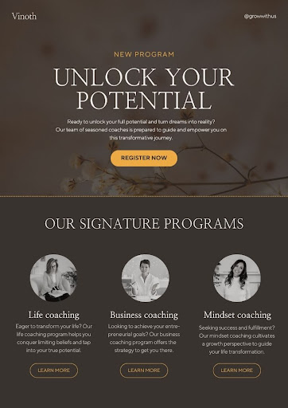

3.Create email newsletter design using Mailchimp or canva tool

https://mydigitallearningforyou.blogspot.com/2023/09/travel-to-enjoy-this-world.html

