| **NAME :** | YUVARAJ M |
| --- | --- |
| **DEPARTMENT :** | ELECTRONICS AND COMMUNICATION ENGINEERING |
| **COLLEGE :** | GOVERNMENT COLLEGE OF TECHNOLOGY |
| **NAAN MUDHALVAN COURSE:** | DIGITAL MARKETING |
| **NAAN MUDHALVAN ID :** | 55729B3DC0D83DE90D6424C121C46CBE |

ASSIGNMENT ON DIGITAL MARKETING

1. Create a blog or website using blogspot and wordpress.Customize the theme design and post new article with 500 words.

Blogspot:

https://drkyaanaidoctorbyyuvi.blogspot.com/2023/08/drk-elephant-doctor.html

Wordpress:

https://doctork00.wordpress.com/

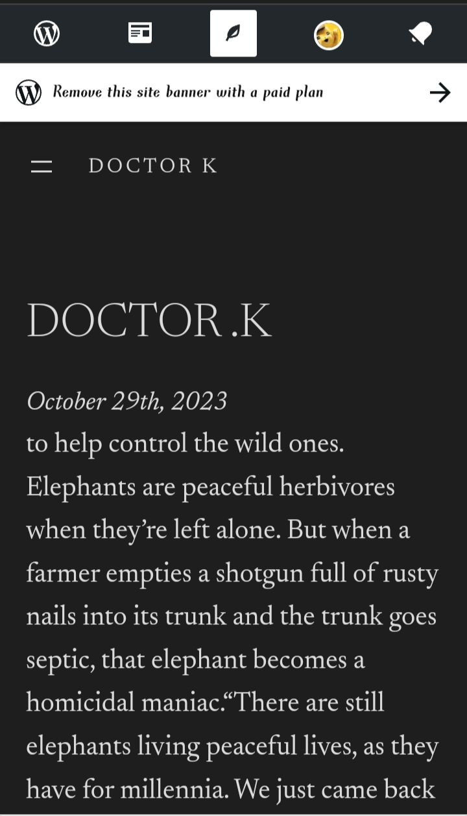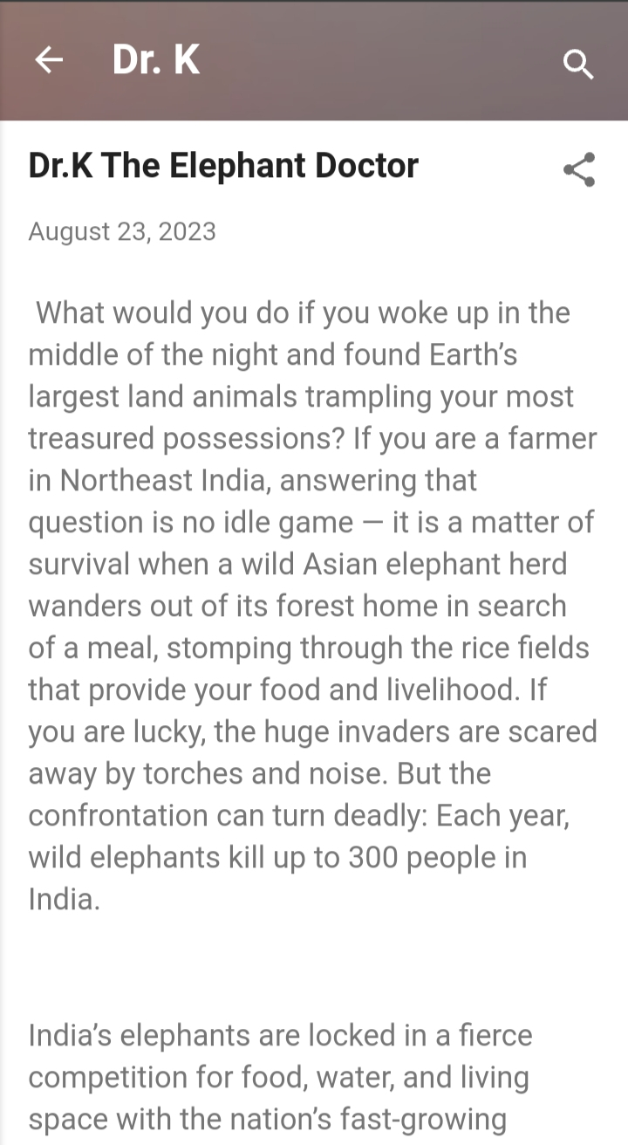

2.Create and design a social media advertisement poster using canva.

https://drkyaanaidoctorbyyuvi.blogspot.com/2023/09/yu.html

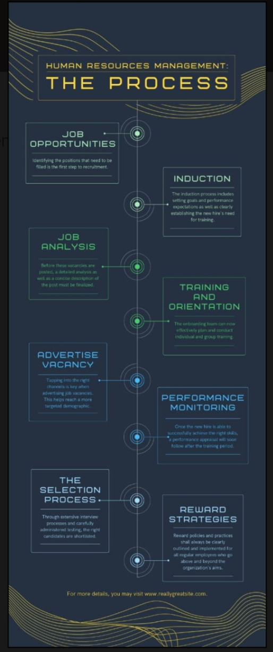

Create email newsletter design using Mailchimp or canva tool

https://drkyaanaidoctorbyyuvi.blogspot.com/2023/09/yuv.html

