Iowa State University
Electrical And Computer Engineering

EE 2300
LAB 1 REPORT

January 19, 2022

Partner 1: Isaiah Pridie
Partner 2: Josh Wolff

Introduction
Provide an overview of what you did in this lab.

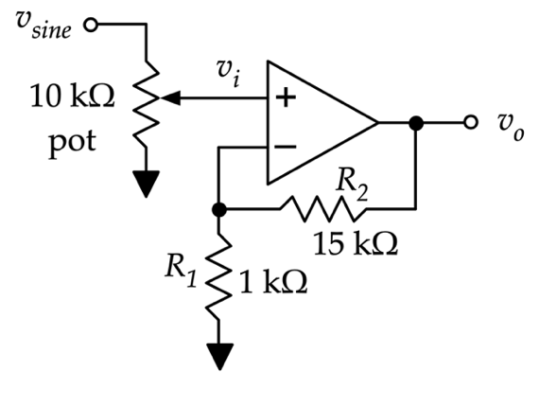
Non-Inverting Amplifier

The table below lists the measurement results:
Description | Value
Calculated Gain | $$G_{calc}=$$
Measured $v_{i}$ | $$v_{i}=572 mV$$
Measured $v_{o}$ | $$v_{o}=9.2 V$$
Measured Gain | $$G_{mes}=16.08$$

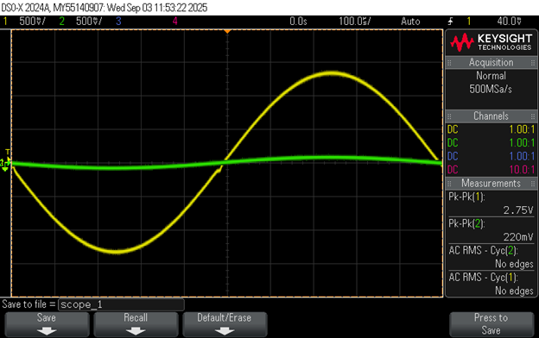
Figure 1: Oscilloscope trace of undistorted $v_{i}$ (yellow) and $v_{o}$(green)
This was the straightest we could get the green line. We have 1 more image way more clipped

Non-Inverting Amplifier Transfer Characteristics

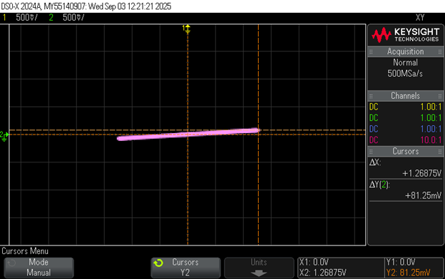
Figure 2: X-Y mode capture of non-inverting amplifier showing $v_{o}$ vs. $v_{i}$ (no clipping)

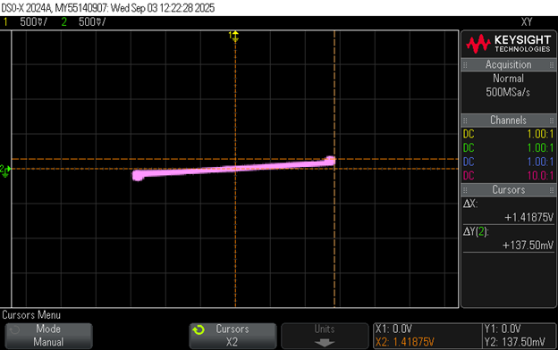
Figure 3: X-Y mode capture of non-inverting amplifier showing $v_{o}$ vs. $v_{i}$ (clipped)
Explain the behavior observed in Figures 2 and 3
The potentiometer is decreasing the magnitude of Vi. This is causing weird stuff to happen. On the oscilloscope it looked to decrease the magnitude irregularly of the input waveform. This is magnified in the output. The positive y side of the input wave acts relatively normal and scales normally. This is reflected on the XY graph on the right side the ‘slope 16’ gradually becomes greater in shape/size. But the negative y side of the input waveform scales irregularly with the potentiometer – it changes very slowly but then starts to change faster and faster like an asymptote. This is greatly reflected by the vertical spike on the left side in XY time mode.

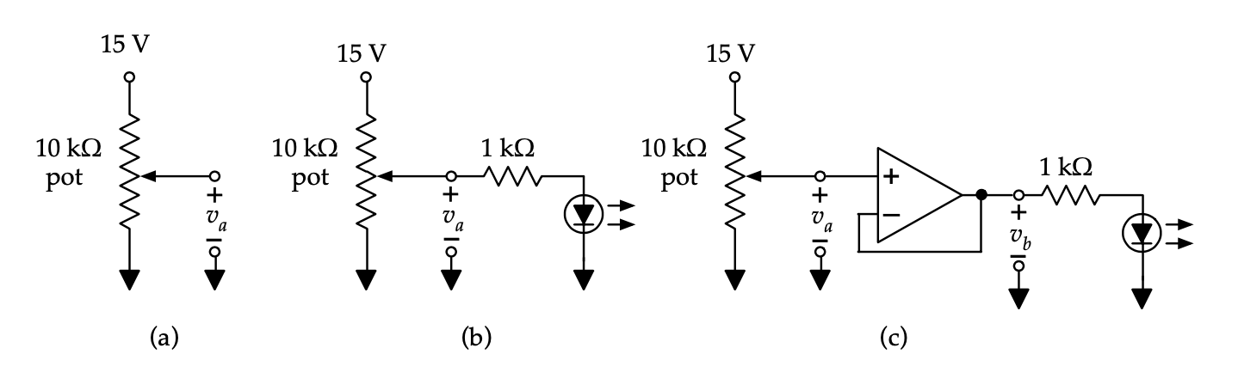
Unity-Gain Buffer
The table below lists the measurement results:

Circuit | Pot ~ $25\%$ | Pot ~ $50\%$ | Pot ~ $75\%$
(a) No Load | $$2.91 V$$ | 8.20 V | 12.32 V
(b) Resistor and diode ($v_{diode}=$) | 1.86 V | 1.95 V | 1.84 V
(c) Buffer, resistor, and diode ($v_{a})$ | 3.2 V | 7.9 V | 11.5 V
(c) Buffer, resistor, and diode ($v_{b})$ | 3.2 V | 7.9 V | 11.5 V

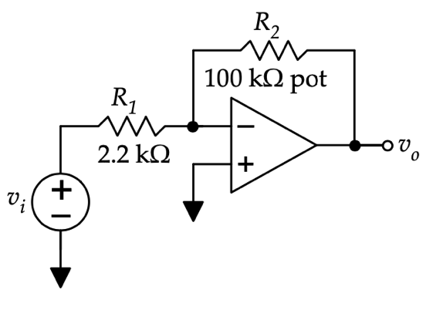
Inverting Amplifier
The table below lists the measurement results:

Description | Value ($R_{2}=50 kΩ$) | Value ($Max Gain$)
Calculated Gain | $$G_{calc}=$$ | $$G_{calc}=$$
Measured $v_{i}$ | $v_{i}=$ 0.201 V | $v_{i}=$ 0.21 V
Measured $v_{o}$ | $v_{o}=$ 4.35 V | $v_{o}=5.3$ V
Measured Gain | $$G_{mes}=21.6$$ | $G_{mes}=$25.2

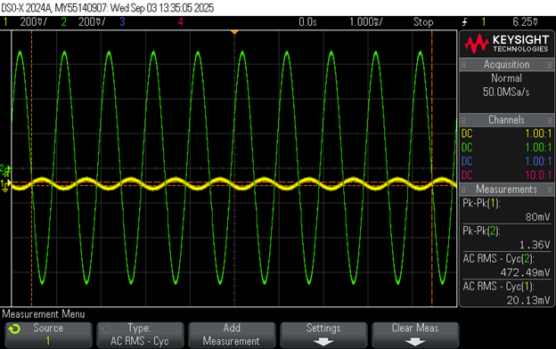
Figure 4: Oscilloscope trace of undistorted $v_{i}$ (yellow) and $v_{o}$(green)
I also have an image of the green and yellow clipping – The yellow is still a sinusoidal wave while the output turns into a step function instead of just a line.

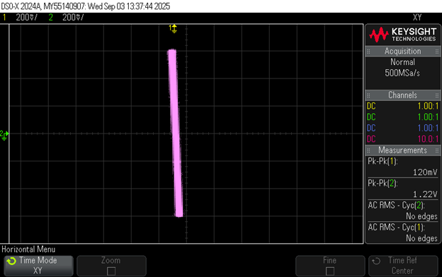
Figure 5: X-Y mode capture of inverting amplifier showing $v_{o}$ vs. $v_{i}$ (no clipping)

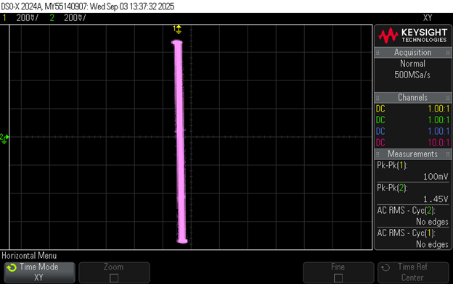
Figure 6: X-Y mode capture of inverting amplifier showing $v_{o}$ vs. $v_{i}$ (clipped)
Discuss what you think would happen if you used a potentiometer at the input of this circuit to attenuate $v_{i}$ before it enters the amplifier.

Putting a resistor (potentiometer) on the input AC voltage before the op amp would reduce the amplitude of the waveform. This will not only make the output smaller but could also change the sensitivity of the circuit; reducing the amplitude can decrease how many steps the op amp produces for the output.

Design Challenge: Summing Amplifier As DAC
Give the expression for $v_{o}$ in terms of the inputs $D_{2}$, $D_{1}$, and $D_{0}$.

The required resistor ratios are given below:

$\frac{R_{f}}{R_{D_{2}}}=$4
$\frac{R_{f}}{R_{D_{1}}}=$ 2
$\frac{R_{f}}{R_{D_{0}}}=$ 1
To obtain these ratios, the following resistor values were chosen:
$R_{f}=$ 33k
$R_{D_{2}}=$ 47k || 10k
$R_{D_{1}}=$ 15k + 1.5k
$R_{D_{0}}=$ 33kΩ

The table below lists the output $v_{o}$ for all 8 input combinations:
$D_{2}$ (V) | $D_{1}$ (V) | $D_{0}$ (V) | $v_{0}$ (V)
$$0$$ | $$0$$ | $$0$$ | $$0.1mV≅0$$
$$0$$ | $$0$$ | $$1$$ | $$-1.011V$$
$$0$$ | $$1$$ | $$0$$ | $$-2V$$
$$0$$ | $$1$$ | $$1$$ | $$-3V$$
$$1$$ | $$0$$ | $$0$$ | $$-4.03V$$
$$1$$ | $$0$$ | $$1$$ | $$-5.032V$$
$$1$$ | $$1$$ | $$0$$ | $$-6.03V$$
$$1$$ | $$1$$ | $$1$$ | $$-7..03V$$

Integrating Amplifier
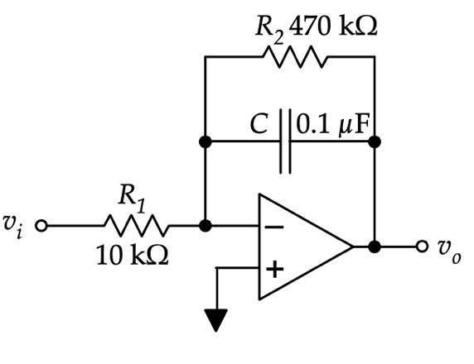

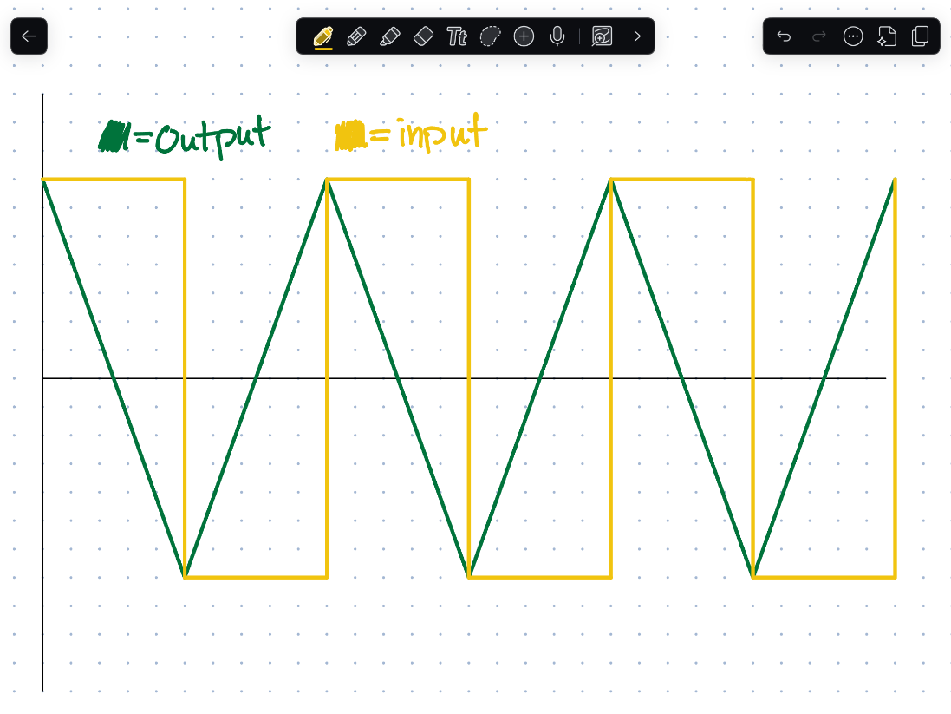
Figure 7: Sketch of expected integrator output for square-wave input

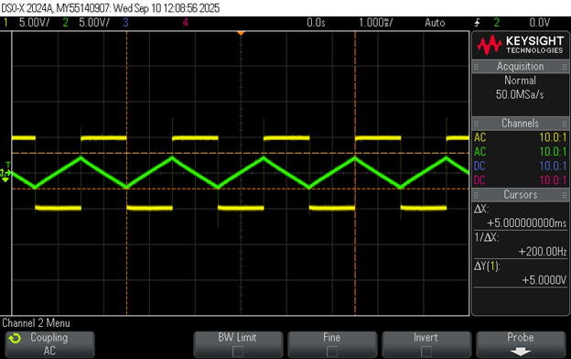
Figure 8: Oscilloscope trace of $v_{i}$ (yellow) and $v_{o}$(green) for square-wave input

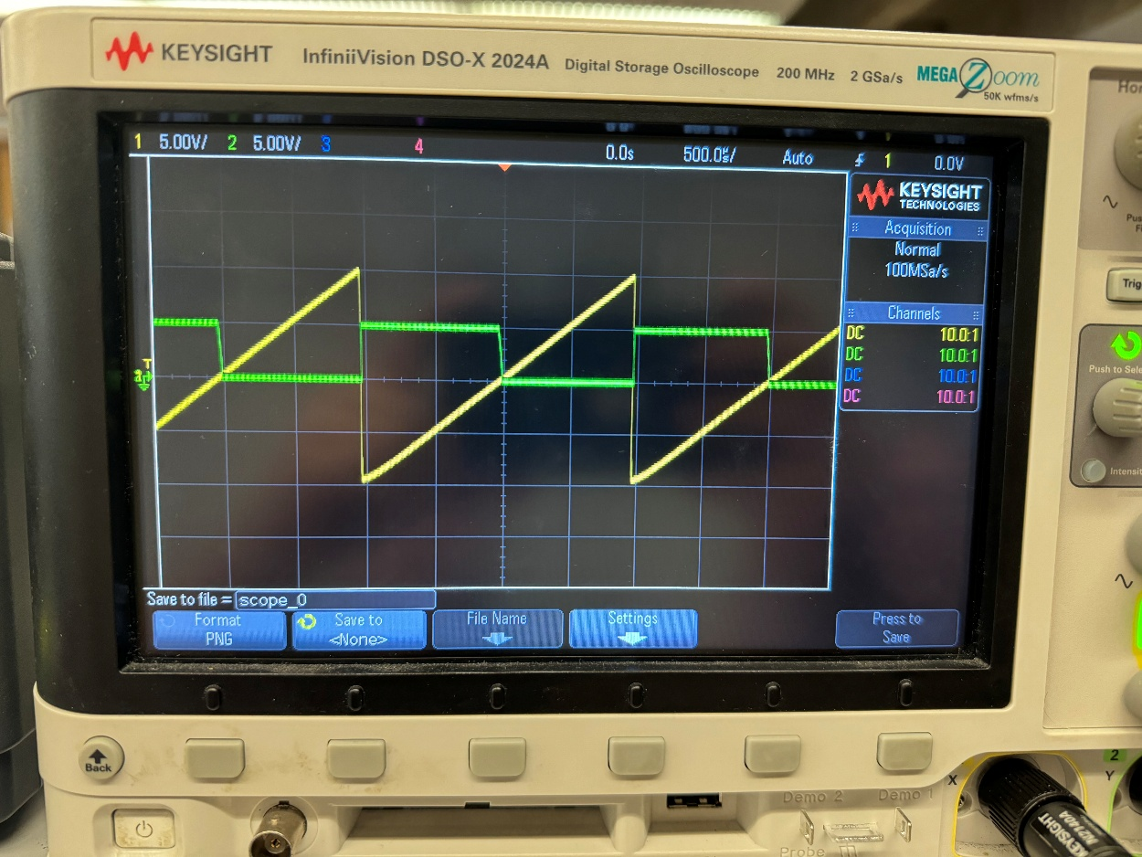
Figure 9: Oscilloscope trace of $v_{i}$ (yellow) and $v_{o}$(green) for ramp input

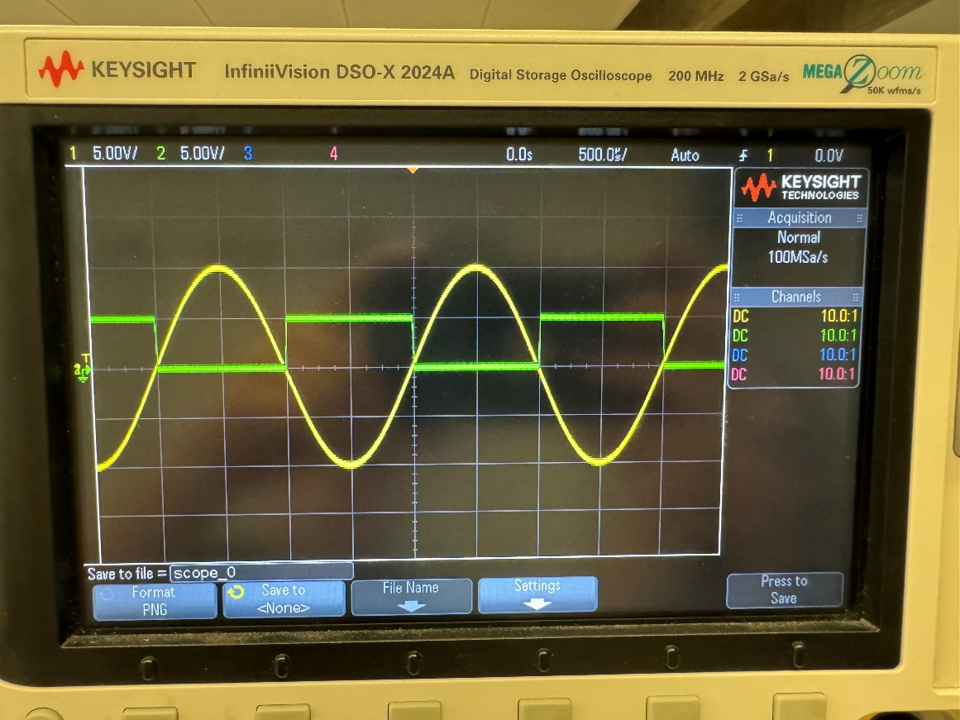
Figure 10: Oscilloscope trace of $v_{i}$ (yellow) and $v_{o}$(green) for sine-wave input
Discuss the results of Figure 8-10. Describe how the outputs are integrated versions of the inputs.

For the outputs for the 3 different wave forms the output changed its y-value every time the input crossed the x axis. Additionally, there were similarities between the input’s waveform and the outputs; the output seemed to be related to the input through a derivative or antiderivative. For the sin wave the output was a square wave and it mimicked the acceleration of the sin wave. It also looked like had a similar amount of area bounded between the square to x-axis and the x-axis and sin wave.
This is somewhat similar for the ramp waveform.
For the square waveform the output seemed to invert it on the oscilloscope.

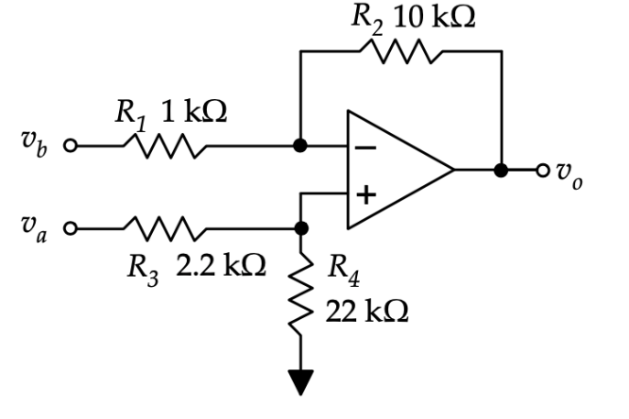
Simple Difference Amplifier
Give the expected output function $v_{o}=$

The table below lists the measurement results:

Vb grounded: input: 0.25 V output: 2.561 V
Va grounded: Input: 0.25V output: 2.45 V
Va = Vb: input: 0.25V output: 7 mV

Description | Value ($v_{a}$ grounded) | Value ($v_{b}$ grounded) | Value ($v_{a}=v_{b}$)
Calculated Gain | $${G_{a}}_{calc}=$$ | $${G_{b}}_{calc}=$$ | $${G_{c}}_{calc}=$$
Measured Gain | ${G_{a}}_{mes}=$ 9.8 | ${G_{b}}_{mes}=$ 10.244 | $${G_{c}}_{mes}=0.028$$

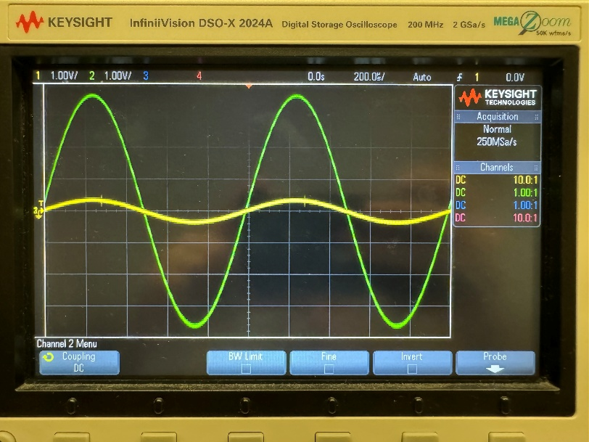
Figure 11: Oscilloscope trace of $v_{i}$ (yellow) and $v_{o}$(green) for $v_{a}$ grounded

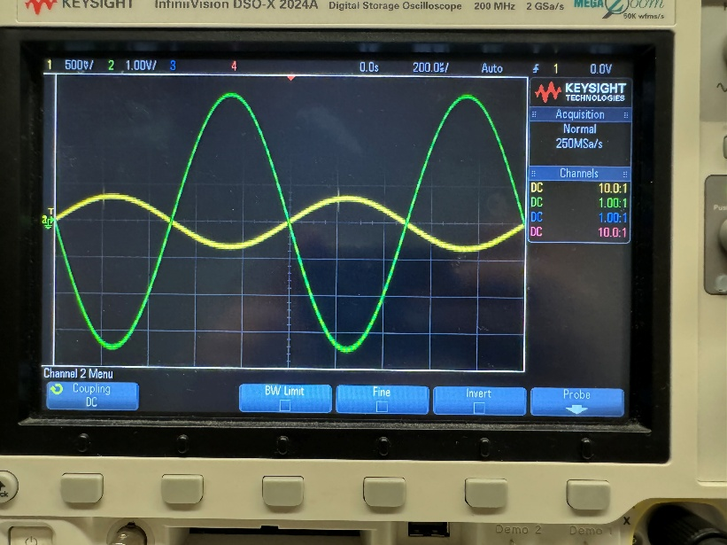
Figure 12: Oscilloscope trace of $v_{i}$ (yellow) and $v_{o}$(green) for $v_{b}$ grounded

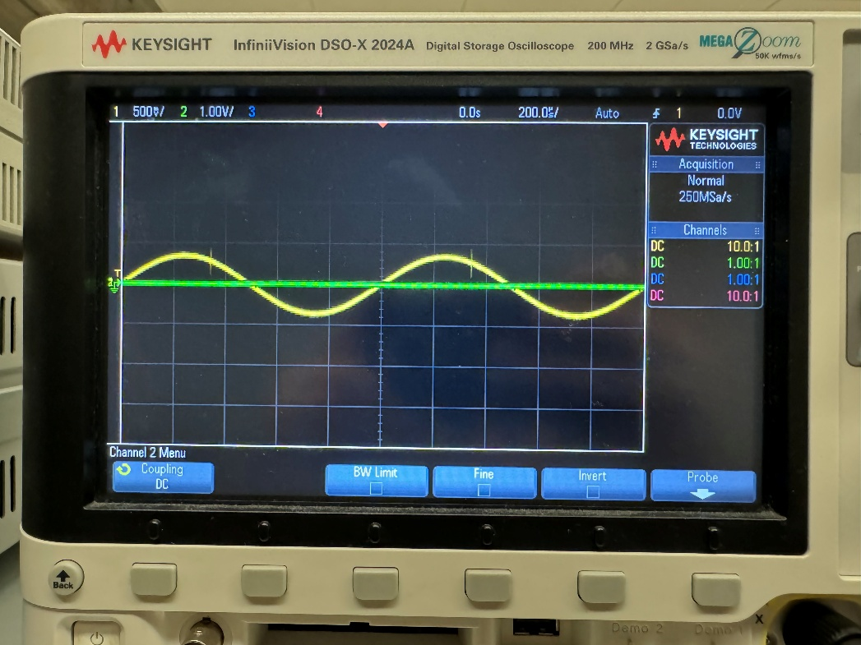
Figure 13: Oscilloscope trace of $v_{i}$ (yellow) and $v_{o}$(green) for $v_{a}=v_{b}$

Discuss why the output is not zero when the inputs are common.

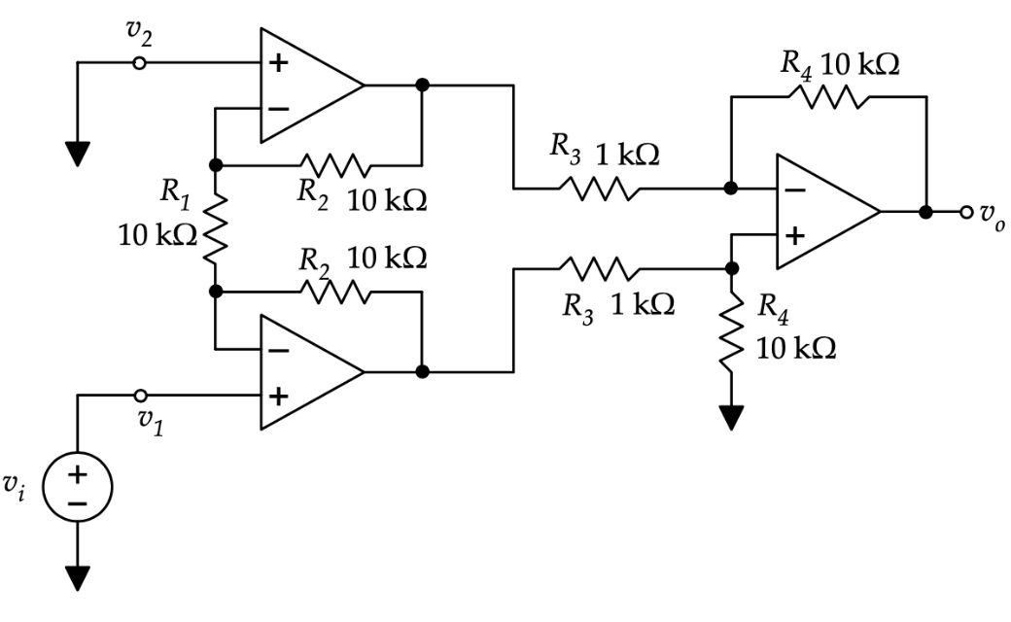
Instrumentation Amplifier

The table below lists the measurement results:

Description | Value
Calculated Differential Gain | $G_{calc}=$
Measured Differential Gain | $$G_{mes}=26.1$$
Measured Common-Mode Gain | $G_{c}=$ 0.98

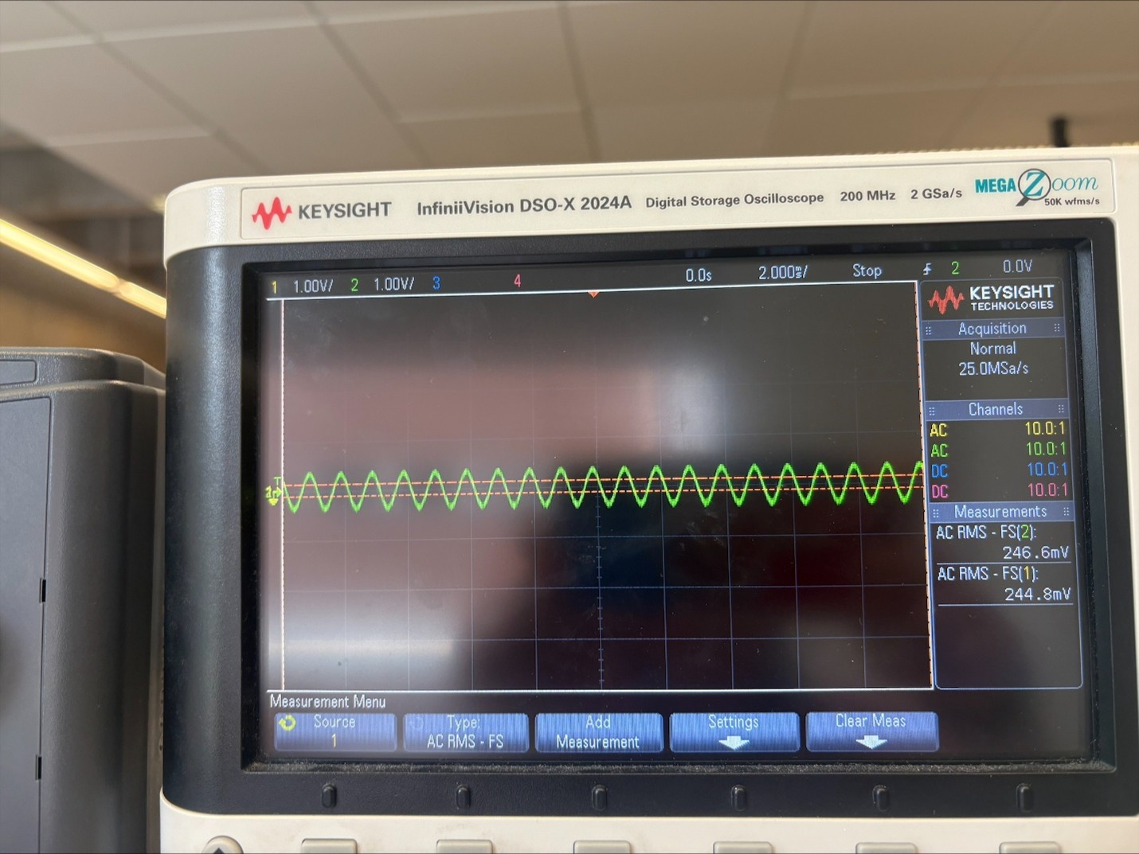
Figure 14: Oscilloscope trace of $v_{i}$ (yellow) and $v_{o}$(green) for instrumentation amplifier

Conclusion
Provide a summary of your design choices, issues, results, and achievements in this lab.

