Iowa State University
Electrical And Computer Engineering

EE 2300
LAB 1 REPORT

January 19, 2022

Partner 1: Isaiah Pridie
Partner 2: Josh Wolff

Introduction
Provide an overview of what you did in this lab.

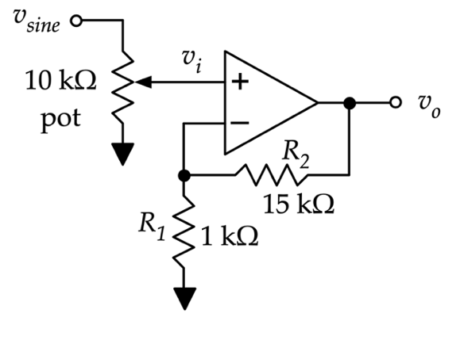
Non-Inverting Amplifier

The table below lists the measurement results:

Description | Value
Calculated Gain | $$G_{calc}=$$
Measured $v_{i}$ | $$v_{i}=$$
Measured $v_{o}$ | $$v_{o}=$$
Measured Gain | $$G_{mes}=$$

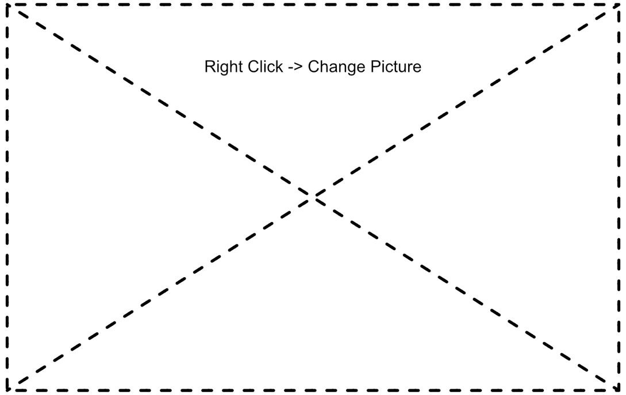
Figure 1: Oscilloscope trace of undistorted $v_{i}$ (yellow) and $v_{o}$(green)

Non-Inverting Amplifier Transfer Characteristics


Figure 2: X-Y mode capture of non-inverting amplifier showing $v_{o}$ vs. $v_{i}$ (no clipping)


Figure 3: X-Y mode capture of non-inverting amplifier showing $v_{o}$ vs. $v_{i}$ (clipped)
Explain the behavior observed in Figures 2 and 3

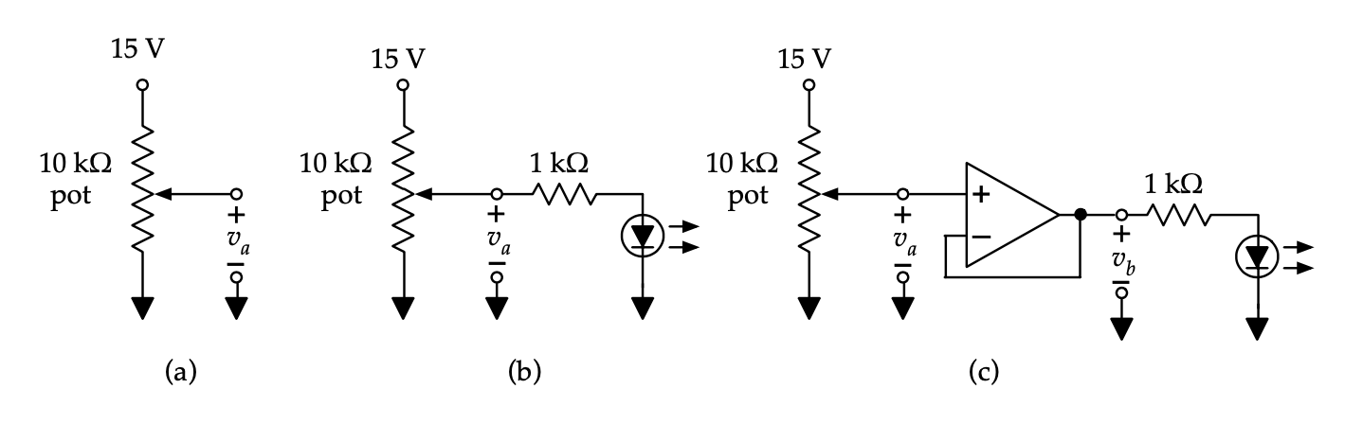
Unity-Gain Buffer
The table below lists the measurement results:

Circuit | Pot ~ $25\%$ | Pot ~ $50\%$ | Pot ~ $75\%$
(a) No Load | $$V$$ | $$V$$ | $$V$$
(b) Resistor and diode ($v_{diode}=$) | $$V$$ | $$V$$ | $$V$$
(c) Buffer, resistor, and diode ($v_{a})$ | $$V$$ | $$V$$ | $$V$$
(c) Buffer, resistor, and diode ($v_{b})$ | $$V$$ | $$V$$ | $$V$$

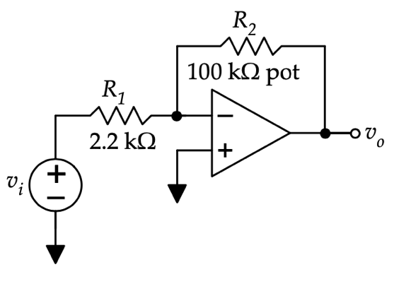
Inverting Amplifier
The table below lists the measurement results:

Description | Value ($R_{2}=50 kΩ$) | Value ($Max Gain$)
Calculated Gain | $$G_{calc}=$$ | $$G_{calc}=$$
Measured $v_{i}$ | $$v_{i}=$$ | $$v_{i}=$$
Measured $v_{o}$ | $$v_{o}=$$ | $$v_{o}=$$
Measured Gain | $$G_{mes}=$$ | $$G_{mes}=$$


Figure 4: Oscilloscope trace of undistorted $v_{i}$ (yellow) and $v_{o}$(green)


Figure 5: X-Y mode capture of inverting amplifier showing $v_{o}$ vs. $v_{i}$ (no clipping)


Figure 6: X-Y mode capture of inverting amplifier showing $v_{o}$ vs. $v_{i}$ (clipped)
Discuss what you think would happen if you used a potentiometer at the input of this circuit to attenuate $v_{i}$ before it enters the amplifier.

Design Challenge: Summing Amplifier As DAC
Give the expression for $v_{o}$ in terms of the inputs $D_{2}$, $D_{1}$, and $D_{0}$.

The required resistor ratios are given below:

$$\frac{R_{f}}{R_{D_{2}}}=$$
$$\frac{R_{f}}{R_{D_{1}}}=$$
$$\frac{R_{f}}{R_{D_{0}}}=$$
To obtain these ratios, the following resistor values were chosen:
$$R_{f}=$$
$$R_{D_{2}}=$$
$$R_{D_{1}}=$$
$$R_{D_{0}}=$$

The table below lists the output $v_{o}$ for all 8 input combinations:
$D_{2}$ (V) | $D_{1}$ (V) | $D_{0}$ (V) | $v_{0}$ (V)
$$0$$ | $$0$$ | $$0$$ | $$Type equation here.$$
$$0$$ | $$0$$ | $$1$$ | $$Type equation here.$$
$$0$$ | $$1$$ | $$0$$ | $$Type equation here.$$
$$0$$ | $$1$$ | $$1$$ | $$Type equation here.$$
$$1$$ | $$0$$ | $$0$$ | $$Type equation here.$$
$$1$$ | $$0$$ | $$1$$ | $$Type equation here.$$
$$1$$ | $$1$$ | $$0$$ | $$Type equation here.$$
$$1$$ | $$1$$ | $$1$$ | $$Type equation here.$$

Integrating Amplifier
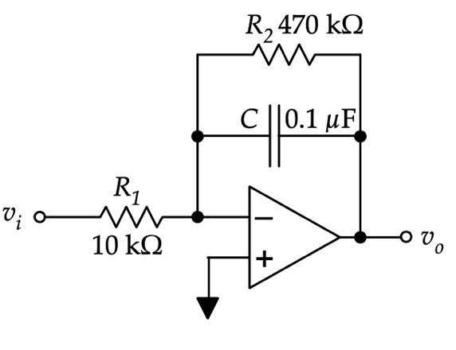


Figure 7: Sketch of expected integrator output for square-wave input


Figure 8: Oscilloscope trace of $v_{i}$ (yellow) and $v_{o}$(green) for square-wave input


Figure 9: Oscilloscope trace of $v_{i}$ (yellow) and $v_{o}$(green) for ramp input


Figure 10: Oscilloscope trace of $v_{i}$ (yellow) and $v_{o}$(green) for sine-wave input
Discuss the results of Figure 8-10. Describe how the outputs are integrated versions of the inputs.

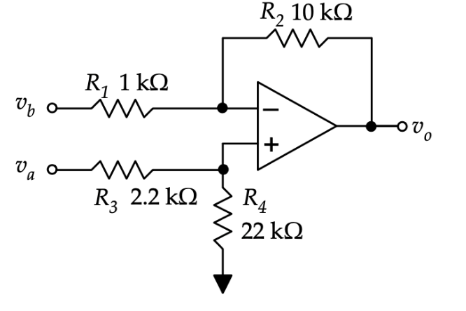
Simple Difference Amplifier
Give the expected output function $v_{o}=$

The table below lists the measurement results:

Description | Value ($v_{a}$ grounded) | Value ($v_{b}$ grounded) | Value ($v_{a}=v_{b}$)
Calculated Gain | $${G_{a}}_{calc}=$$ | $${G_{b}}_{calc}=$$ | $${G_{c}}_{calc}=$$
Measured Gain | $${G_{a}}_{mes}=$$ | $${G_{b}}_{mes}=$$ | $${G_{c}}_{mes}=$$

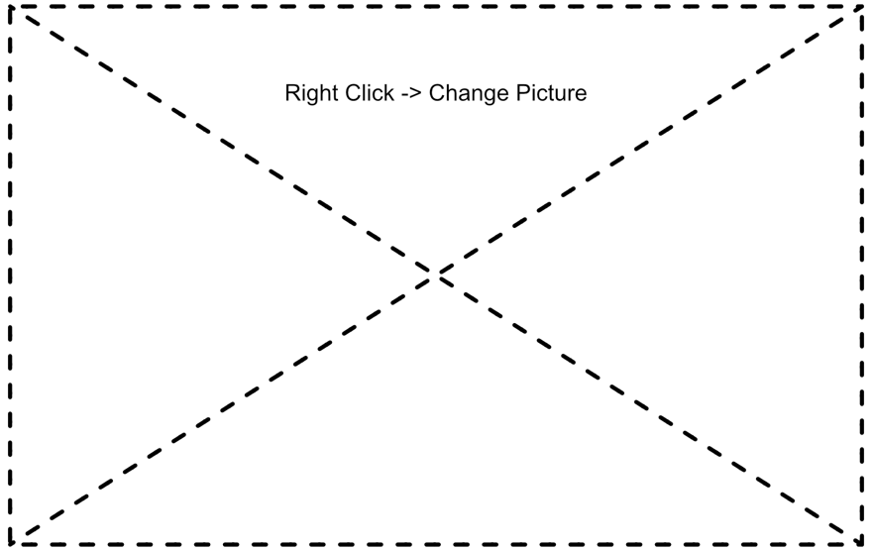
Figure 11: Oscilloscope trace of $v_{i}$ (yellow) and $v_{o}$(green) for $v_{a}$ grounded


Figure 12: Oscilloscope trace of $v_{i}$ (yellow) and $v_{o}$(green) for $v_{b}$ grounded


Figure 13: Oscilloscope trace of $v_{i}$ (yellow) and $v_{o}$(green) for $v_{a}=v_{b}$

Discuss why the output is not zero when the inputs are common.

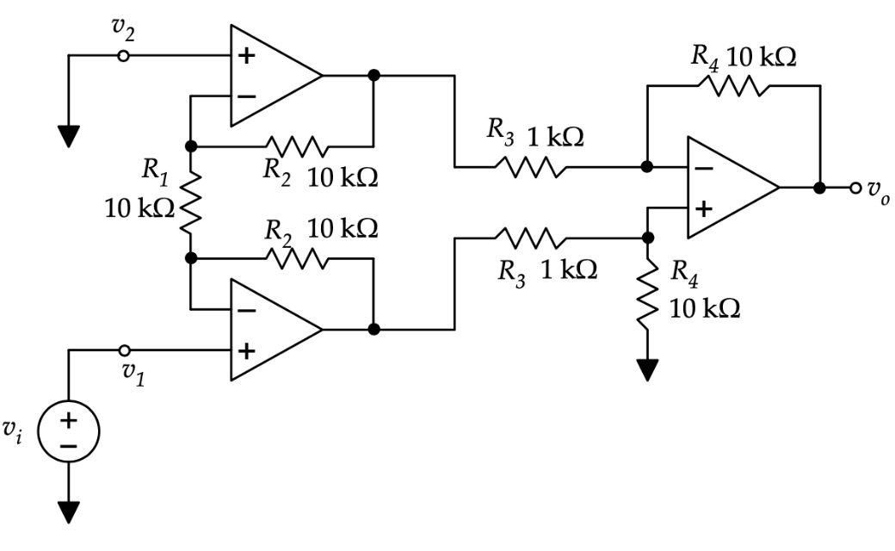
Instrumentation Amplifier

The table below lists the measurement results:

Description | Value
Calculated Differential Gain | $$G_{calc}=$$
Measured Differential Gain | $$G_{mes}=$$
Measured Common-Mode Gain | $$G_{c}=$$


Figure 14: Oscilloscope trace of $v_{i}$ (yellow) and $v_{o}$(green) for instrumentation amplifier

Conclusion
Provide a summary of your design choices, issues, results, and achievements in this lab.

