Iowa State University
Electrical And Computer Engineering

EE 230
LAB 8 REPORT

April __, 2022

Partner 1
Partner 2

Introduction
Provide an overview of what you did in this lab.

A Quick measure of β_{F} and i_{C} – v_{CE} characteristics with the parameter analyzer

Circuits | Calculated Values
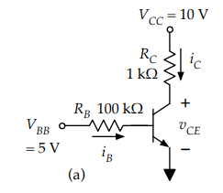 | Collector Current, i_{C} =  Base Current, i_{B} =  Forward current gain, B_{F} =  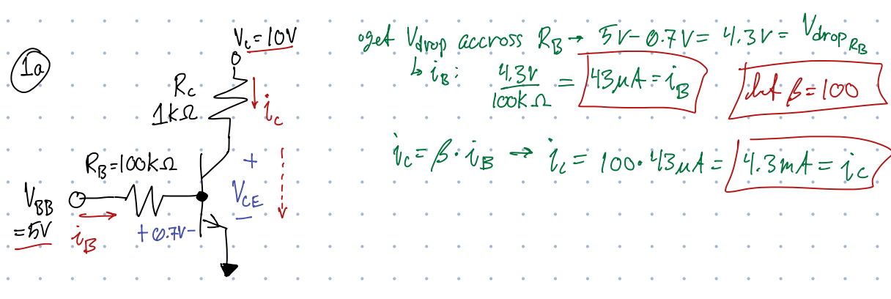
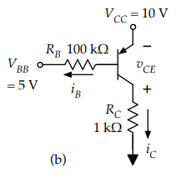 | Collector Current, i_{C} =  Base Current, i_{B} =  Forward current gain, B_{F} =  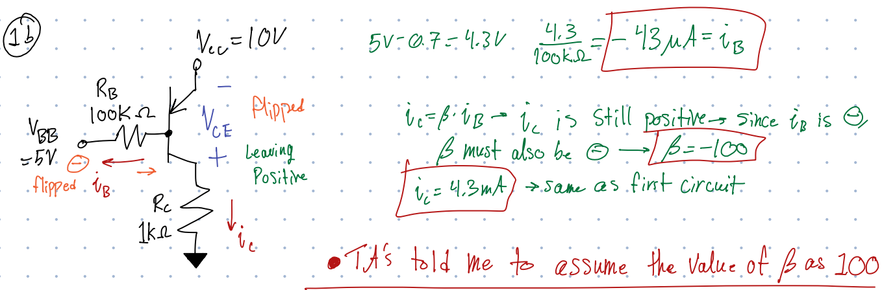

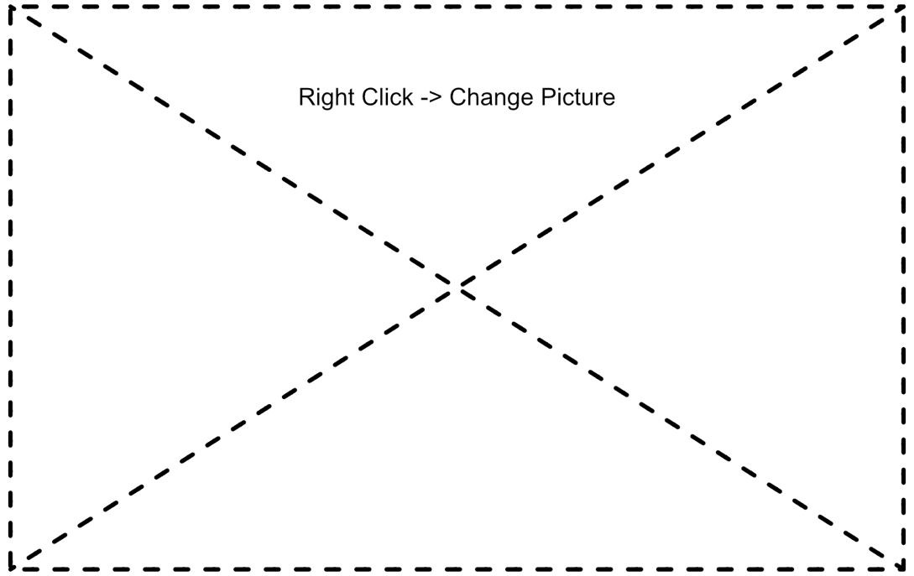
Figure 1: i_{C} –v_{CE} curves for PN2222


Figure 2: i_{C} –v_{CE} curves for PN2906

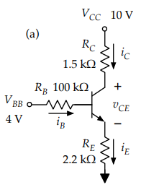
Simple BJT Circuits

 | i_{B} | i_{C} | i_{E} | v_{BE} | v_{CE}
Measured
Calculated | 10.242uA | 1.03mA | 1.03mA | 0.6998V | 6.1723V

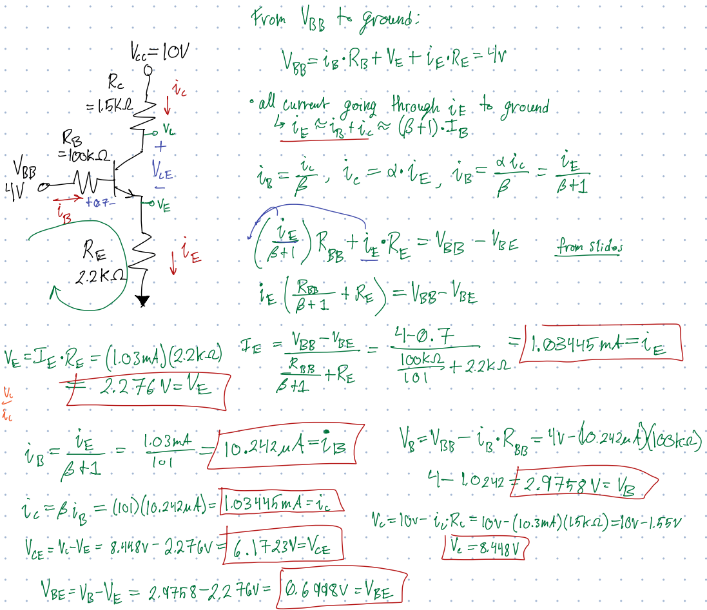
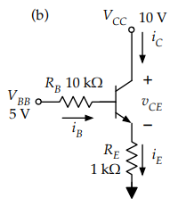
 | i_{B} | i_{C} | i_{E} | v_{BE} | v_{CE}
Measured
Calculated

Insert calculations

 | i_{B} | i_{C} | i_{E} | v_{BE} | v_{CE}
Measured
Calculated
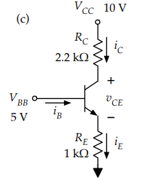

Insert calculations

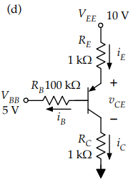
 | i_{B} | i_{C} | i_{E} | v_{BE} | v_{CE}
Measured
Calculated

Insert calculations

C BJT as a switch


Figure 4: Transfer Characteristics, plot of v_{o} vs v_{i}


Figure 5: Plot of i_{c} vs v_{i}


Figure 6: Plot of P_{R} vs v_{i}



Figure 7: Plot of P_{npn} vs v_{i}



Figure 8: Plot of P_{R} vs P_{npn}

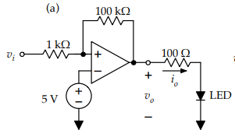

Measured Output Voltage, v_{o} =

Measured Output Current, i_{o} =

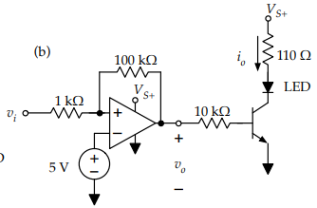

Measured Output Voltage, v_{o} =

Measured Output Current, i_{o} =

Explain voltage and current as high as they should be


Figure 9: Oscilloscope Trace

D BJT as an amplifier
Figure 10: Oscilloscope Trace


Gain =

Conclusion
Provide a summary of your design choices, issues, results, and achievements in this lab.

