CS 148 Database Design for the Web

Isaiah Simon

Final Project

Quick Computing Repairs

Version <1.2>

|  |  |  |  |
| --- | --- | --- | --- |
| Time Log | | | |
| Date | Time Spent (in hours) | Description | Author |
| 10/7/13 | 3.0 | First Version of Software Requirements | Robert Erickson |
| 11/5/13 |  | Your estimated time to complete assignment ____35___ hours | Isaiah Simon |
| 11/5/13 | 5 | Project Specifications | Isaiah Simon |
|  |  |  |  |
|  |  |  |  |
|  |  |  |  |
|  |  |  |  |
|  |  |  |  |
|  |  |  |  |
|  |  |  |  |
|  |  |  |  |
|  |  |  |  |
|  |  |  |  |
|  |  |  |  |
|  |  |  |  |
|  |  |  |  |
|  |  |  |  |
|  |  |  |  |
|  |  |  |  |
|  |  |  |  |
|  |  |  |  |
|  |  |  |  |
|  |  |  |  |
|  |  |  |  |
|  |  |  |  |
|  |  |  |  |
|  |  |  |  |

Table Of Contents

Software Requirements Specifications 4

Introduction 4

Purpose 4

Definitions, acronyms, and abbreviations 4

Overview 4

Overall Description 5

Data Dictionary 5

E-R Diagram 7

Schema 8

Story Board 9

Specific requirements 10

# Software Requirements Specifications

## Introduction

### Purpose

The purpose of this document is to describe the requirement specification for the web site “Quick Computing Repairs”.

The intended audience for this document is the prospective developers of this site and the owner of Quick Computing Repairs.

### Scope

The web site to be created is a site designed to give visitors information about the company and about the employees. This site also lets the visitor know the services that Quick Computing provides. Lastly, it provides a form for visitors to request computer technical support.

### Definitions, acronyms, and abbreviations

HTML – Hypertext markup language – used to define your conent.

PHP – Personal Home Page – language that helps to customize html.

CSS – Cascading Style Sheets – used to define the look of a web site.

SQL – Structured Query Language – used to hold data in tables.

W3 Validation – refers to both Html and CSS validation tool provided by the W3c.org. the html validator is located at:

<http://validator.w3.org/>

with the CSS validator located at:

<http://jigsaw.w3.org/css-validator/>

### Overview

The rest of this document contains an overall description of the Quick Computing Repairs web site.

## Overall Description

This site will be used for the clients and technicians of Quick Computing. The site will allow clients to request computer technical support. The site will also allow the technicians create and edit service requests.

When the client submits the form for computer technical support, they will put in their name, email address, physical address and phone number. They can also input a short description and long description for their issue.

In addition to that, the client will be able to look up the updates to their ticket using the ticket number they are given when the form is submitted.

The website will have a technician only page that has authentication by UVM authentication. From there they will be able to edit the technical support orders, such as the device type, short description, and also add updates to the support ticket. They will also be able to search records by client Email Address, Name, or Service ID number.

### Data Dictionary

Email Address

First Name

Last Name

Phone Number

Address

City

State

Zip

Service Ticket #

Submitted By (Technician or client)

Issue Status (Request, assisting, closed)

Issue Priority(Emergency, Immediate, Normal)

Platform (Mobile, Desktop/Laptop, etc)

Operating System (OSX, iOS, Android, Windows)

Problem due to (Network, Hardware, Software)

Specific point of failure (Textbox)

Short Description

Date Created

Update Texted

Updated By (Using UVM Authentication)

Updated Emailed (yes or no)

Time Updated

pkEmailAddress

fldFirstName

fldLastName

fldPhoneNumber

fldAddress

fldCity

fldState

fldZip

pkServiceNum

fldSubmittedBy

fldStatus

fldPriority

fldPlatform

fldOperatingSystem

fldProblemDueTo

fldSpecificPointOfFailure

fldShortDescription

fldDateCreated

fldUpdateText

fldUpdatedBy

fldUpdateEmailed

fldTimeEdited

### E-R Diagram

### 

### Schema

Create table tblPerson (

pkEmailAddress VARCHAR(25) Primary key,

fldFirstName VARCHAR(20),

fldLastName VARCHAR(20),

fldPhoneNumber VARCHAR (15),

fldStreet VARCHAR(25),

fldCity VARCHAR(25),

fldState VARCHAR(25),

fldZip VARCHAR (10)

);

Create table tblService(

pkServiceNum int (10) not null AUTO_INCREMENT primary key,

fldSubmittedBy VARCHAR(25),

fldStatus VARCHAR(15),

fldPriority VARCHAR(15),

fldPlatform VARCHAR(15),

fldOperatingSystem VARCHAR(15),

fldProblemDueTo VARCHAR(15),

fldSpecificPointOfFailure VARCHAR(25),

fldShortDescription VARCHAR(40),

fldDateCreated timestamp not null default CURRENT_TIMESTAMP

);

Create table tblUpdate(

pkUpdatedID int (10) not null AUTO_INCREMENT primary key,

fkServiceNum int (10) not null references tblService(pkServiceNum),

fldUpdateText VARCHAR(1000),

fldUpdatedBy VARCHAR(8),

fldUpdateEmailed tinyint(1) not null default '0',

fldTimeEdited timestamp not null default CURRENT_TIMESTAMP

);

### Story Board

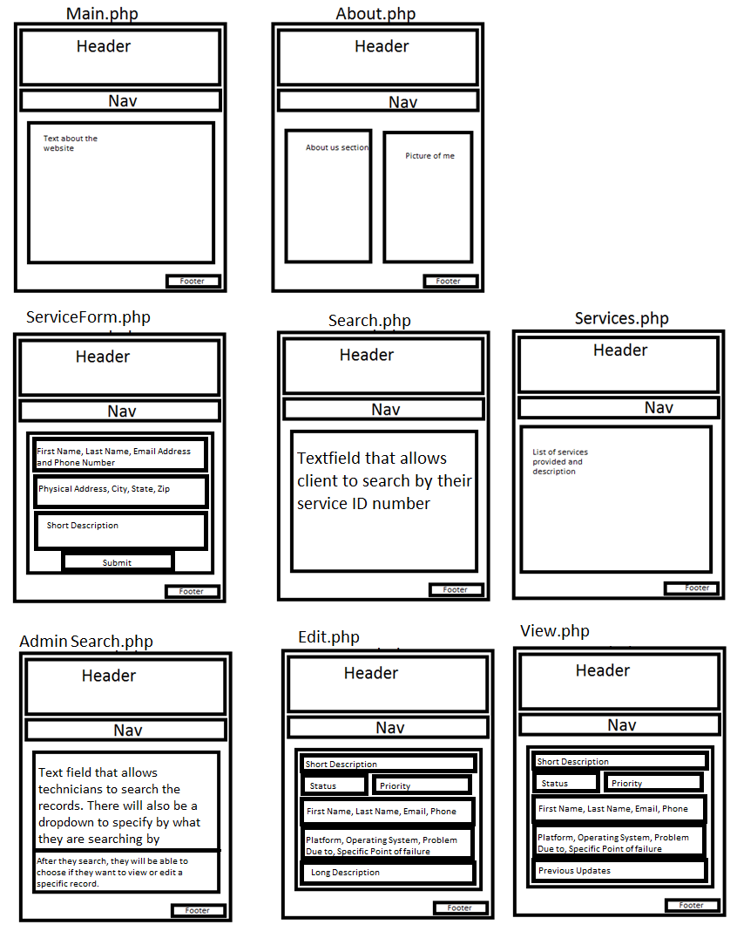

## Specific requirements

Here is just a list of things I will require you really need to write the specific requirements as they relate to your project.

1. *Location* – all files will be located in the public folder of your uvm account. The assignment web page and the submit process will detail the exact location. Failure to have your site located in the correct folder by the due dates will result in a zero on the assignment. Be sure to pay attention to the lowercase letters.
2. *Html Validation* – All pages will pass W3C Html validation for html 5.
3. *CSS Validation* – All pages will pass W3C 3.0 CSS validation.
4. *Meta Information* – All pages will contain a proper title tag, Meta tags (author, character set and description).
5. *CSS* – all pages will have a linked style sheet.
6. *Navigation* – All pages will contain navigation to all other pages on the site using an ordered list. Be sure to enclose the navigation in the correct element.
7. *Content* – Each page will have a minimum of 150 words not counting titles, lists or links. Be sure to use the correct elements to hold your content.
8. *Browser compatibility* - This site will be checked on Firefox, Safari, Chrome and Internet Explorer.
9. *File Names* – the main home page will be called home.php with the rest of the file names up to you (be sure to use .php, .css for the respective files).
10. *Data Retrieval* - Form to fill out (with php validation of course) and all information will be placed into database tables via php).
11. *Form* - must include at least one text box, two check boxes, two radio buttons and one list box.
12. *Error Checking* - Form will do error checking, be sticky and allow for both insert and update, it should submit to itself.
13. Information should be able to be stored and retrieved later for future statistical analysis.
14. Must have the ability for technicians to edit and create new service records.
15. Must have the ability for clients to search for their service record using their service ID number.
16. Must have the ability for technicians to search records by client Email Address, Name, or Service ID number.