FINAL IMPLEMENTATION REVIEW · STUDY GUIDE
Bengaluru Pulse V2
Urban traffic intelligence and decision support for Bengaluru
Purpose of this document. To teach the project from first principles, show where every important part is implemented in the repository, separate verified facts from historical claims and plans, and prepare honest answers for the implementation review and viva.
Who it is for. A final-year Computer Science (AI & ML) student presenting the project. Simple English first; technical terms, equations and code follow.
Item | Value
Repository | C:\Users\IZY\OneDrive\Desktop\BengaluruPulseLite (GitHub: Isaiah7779/bengaluru-pulse-lite)
Branch / commit inspected | v2-build at 02f2f03 (working tree clean before this document was added)
Evidence collected | 23 October 2026 (read-only inspection of code, configuration, result files, and read-only status/count queries)
Subject | Final-year major project, B.E. Computer Science & Engineering (AI & ML)
Output | docs/FINAL_REVIEW_STUDY_GUIDE.docx — the only file created in the project
Contents
How to Use This Guide 6
Project snapshot (one page) 6
What the Previous Review Challenged — and How I Should Answer Now 8
Challenge 1 — “Is this more than a mini-project or a Google Maps clone?” 8
Challenge 2 — “What is your distinctive contribution?” 9
Challenge 3 — “You need a real forecasting pipeline, not synthetic predictions” 9
Challenge 4 — “Which experiment produced your metrics?” 10
Challenge 5 — “Is that live, historical, predicted, or your model?” 10
Challenge 6 — “Show evidence of functionality, testing, documentation and deployment” 10
Challenge 7 — “Are all final deliverables ready?” 11
Chapter 1 Understand the Project from Zero 12
1.1 What Bengaluru Pulse V2 is 12
1.2 The real-world problem 12
1.3 Why Bengaluru is a suitable domain 12
1.4 Intended users 13
1.5 Objectives and scope 13
1.6 The complete user journey 13
1.7 What the application does today — and what it does not 14
1.8 Software product vs AI/ML system vs decision-support system 14
1.9 Three explanations to memorise 15
Chapter 2 Defending the Project's Novelty Against Google Maps 17
2.1 The positioning statement (adapted to what is built) 18
2.2 Product functionality vs research novelty 18
2.3 Hard questions and honest answers 18
Chapter 3 Complete Architecture and Data Flow 20
3.1 A request, step by step 21
3.2 Seven kinds of data — never mix them up 22
Chapter 4 File-by-File Source-Code Guide 24
4.1 Backend entry point, configuration and errors 24
4.2 API routers (backend/api/) 24
4.3 Routing (backend/routing/) 25
4.4 Traffic, providers, weather, geocoding, community 26
4.5 Database and authentication 27
4.6 Machine learning files 27
4.7 Frontend (frontend/src/) 28
4.8 Mobile, Firebase, deployment and CI 28
Chapter 5 Machine Learning from the Basics 30
5.1 Core concepts in simple terms 30
5.2 Every model in the repository 30
Chapter 6 Model Comparison and Evaluation Metrics 33
6.1 Experiment 1 — V1 same-day estimation (legacy) 33
6.2 Experiment 2 — V1-style check on the full dataset (V2 re-examination) 33
6.3 Experiment 3 — V2 day-ahead forecasting on the public dataset 34
6.4 Experiment 4 — prospective baselines on our own data 35
6.5 Tracing the historical numbers from earlier discussions 35
6.6 Metric equations with a worked example 36
6.7 Seven points examiners test 36
Chapter 7 Is the Model Actually Forecasting Future Traffic? 38
7.1 Eight things that are often confused 38
7.2 The earlier concern, re-checked 38
7.3 Requirements for a defensible forecaster — checklist 38
7.4 Feasibility of +15, +30 and +60 minute horizons 39
Chapter 8 Datasets and Data Quality 41
8.1 The public dataset in detail 41
8.2 Bias, size, representativeness, leakage 42
Chapter 9 External Integrations 43
9.1 TomTom 43
9.2 Open-Meteo 44
9.3 OpenStreetMap and OSRM 44
9.4 Firebase Authentication and Firestore 44
Chapter 10 Routing and the Road Network 45
10.1 Road graph basics 45
10.2 How alternatives are generated 45
10.3 Does live traffic change the route costs? 46
10.4 Profiles and modes 46
10.5 Shortcuts and user confirmations 46
10.6 Likely viva questions on routing 47
Chapter 11 Database and Persistence 48
11.1 Four words that are often confused 48
11.2 Engine, sessions and persistence 48
11.3 The 17 tables 48
11.4 PostgreSQL vs Firestore 49
11.5 Migration history 49
Chapter 12 Frontend and Backend Request Flow 50
12.1 React and FastAPI in plain words 50
12.2 Traced examples 50
12.3 Endpoint reference 51
Chapter 13 Docker and Deployment 52
13.1 Concepts 52
13.2 Access modes 53
13.3 The collector migration incident (verified) 53
13.4 Safe read-only commands for the review 54
Chapter 14 Testing and Evidence 55
14.1 Live demonstration checklist 56
Chapter 15 Limitations, Risks and Future Work 57
15.1 Current limitations (facts) 57
15.2 Future work, prioritised 57
Chapter 16 Complete Viva Question Bank 59
16.1 Basic project understanding 59
16.2 Problem statement and objectives 59
16.3 Novelty and comparison with Google Maps 60
16.4 System architecture 60
16.5 File structure and code responsibilities 60
16.6 React and frontend 61
16.7 FastAPI and backend 61
16.8 Database and migrations 62
16.9 Machine-learning fundamentals 62
16.10 Actual model algorithms 63
16.11 Dataset and preprocessing 63
16.12 Model comparison 63
16.13 Evaluation metrics 64
16.14 Time-series forecasting 64
16.15 Live data integrations 65
16.16 OSRM and road-network routing 65
16.17 Authentication and security 65
16.18 Docker and deployment 66
16.19 Testing and debugging 66
16.20 Limitations and future work 67
16.21 Research methodology and evidence 67
16.22 Difficult examiner challenges 68
Chapter 17 Presentation and Live Demonstration Script 69
17.1 30-second introduction 69
17.2 Two-minute overview 69
17.3 Five-minute live demonstration 69
17.4 Ten-minute technical presentation (outline with transitions) 70
17.5 Short scripts by topic 70
Chapter 18 Final Quick-Revision Sheet 71

If the contents list above is empty, right-click it in Word and choose Update Field.

How to Use This Guide
This guide was written from a read-only inspection of the repository on 23 October 2026 (branch v2-build, commit 02f2f03). Every important claim carries an evidence label so that you always know how strong the claim is before you say it aloud. Read Chapter 1, Chapter 2 and the previous-review section first; then Chapters 5–7 (machine learning), because that is where the hardest questions will come from.
Table 1. Evidence labels used throughout this guide
Label | Meaning | How you can use it in the viva
[VERIFIED IN CODE] | Read directly in the source code (path and function given). | Say it confidently; open the file if asked.
[VERIFIED IN CONFIGURATION] | Read in Docker Compose, Dockerfile, nginx, settings defaults, or checked in the running containers without printing values. | Say it confidently; show the config file.
[VERIFIED IN EXPERIMENT RESULTS] | Numbers stored in a result file in the repository (for example backend/evaluation/v2/*.json). | Quote with the file name, dataset, split and target.
[VERIFIED BY TEST OR LOG] | Seen in a test file, CI workflow, container status, log line, or a read-only database count taken on 23 Oct 2026. | Quote with the date; numbers that grow (row counts) will be larger on review day.
[HISTORICAL RESULT — NOT REPRODUCED] | A number that exists in older files or older discussions but was not reproduced for this guide. | Mention only with the qualification attached.
[DOCUMENTED BUT NOT VERIFIED] | Stated in project documentation, not re-checked for this guide. | Say “our test report records…”, not “it works”.
[PLANNED / NOT IMPLEMENTED] | Proposed or future work; not in the code. | Present only as future work.
[UNKNOWN — NEEDS CONFIRMATION] | Could not be traced to any file. | Do not quote it.

Project snapshot (one page)
Table 2. What Bengaluru Pulse V2 is, in numbers
Aspect | Fact | Evidence
Purpose | Compare several realistic routes for a Bengaluru trip, explain why one is recommended (time, distance, traffic delay, incidents, weather), show live and collected traffic conditions, and run an honest forecasting pipeline on our own collected data. | [VERIFIED IN CODE] backend/routing/engine.py
Clients | React web app (8 pages) and an Expo / React Native Android app (4 screens). | [VERIFIED IN CODE] frontend/src/pages/, mobile/src/screens/
Backend | FastAPI (Python 3.12) with 10 router modules; every non-health, non-sign-in endpoint requires a signed-in user. | [VERIFIED IN CODE] backend/main.py
Database | PostgreSQL 16 + PostGIS 3.4; 17 application tables; Alembic head 0003. | [VERIFIED IN CODE] backend/db/models.py; [VERIFIED BY TEST OR LOG] alembic_version = 0003
Routing | Three OSRM servers (car, foot, bicycle) built from OpenStreetMap; motorcycle uses the car graph and says so. | [VERIFIED IN CONFIGURATION] docker-compose.yml; [VERIFIED IN CODE] backend/routing/route_profiles.py
Live data | TomTom flow (26 points), incidents, route timing; Open-Meteo weather (6 areas). | [VERIFIED IN CODE] backend/providers/
Collected data (23 Oct 2026, 07:09 UTC) | 883 traffic observations since 22 Oct 03:16 UTC; 203 weather observations; 2,497 incident records; 1,947 logged baseline forecasts (1,374 with actuals). | [VERIFIED BY TEST OR LOG] read-only SQL counts
Forecasting | Pipeline with chronological split, three baselines, ridge and gradient-boosting candidates and an activation gate. No model is active: the public-dataset model did not beat the historical average, and our own data is shorter than the 14-day minimum. | [VERIFIED IN EXPERIMENT RESULTS] backend/evaluation/v2/*.json
Deployment | Docker Compose: postgres, osrm-car, osrm-foot, osrm-bicycle, backend, collector, frontend (+ optional tunnel profile). Public HTTPS through a Cloudflare tunnel. | [VERIFIED IN CONFIGURATION] docker-compose.yml

NEVER CLAIM — The three sentences you must never say
- “Our AI predicts future traffic.” — No forecasting model is active today; future ETAs come from TomTom.
- “Our model has 96% accuracy.” — R² is not accuracy, and the 0.96 figure is same-day estimation, not forecasting.
- “We are better than Google Maps.” — We have no comparative study.

What the Previous Review Challenged — and How I Should Answer Now
This section separates history (what examiners questioned earlier) from current facts (what the repository shows today). The concerns below come from the earlier review discussions; they are used here only as questions to investigate, not as proof of anything.
Table 3. Status of each earlier challenge (current repository)
# | Earlier challenge (history) | Current status | Main evidence
1 | Not enough novelty beyond a mini-project or a Google Maps-like app | Partly addressed | Route generation + classification + evidence labelling in backend/routing/; no user study
2 | Distinctive contribution not explained | Addressed in wording; needs your delivery | Chapter 2 of this guide; docs/RESEARCH.md
3 | Needs a genuine automatic forecasting pipeline, not synthetic predictions | Pipeline built; no validated model yet | backend/forecasting/pipeline.py, daily retrain task, 410 on old /forecast
4 | Metrics must be tied to target, dataset, split, experiment | Addressed | backend/evaluation/v2/research-daily-congestion.json stores all four
5 | Live data, history, inference and forecasting must be distinguished | Addressed in code and UI | eta_basis, sources[], pulse_forecast status in backend/routing/engine.py
6 | Evidence of functionality, testing, documentation, deployment | Addressed | backend/tests/ (13 files), .github/workflows/ci.yml, docs/TEST_REPORT.md, running containers
7 | Final deliverables (code, deployment steps, report, README, slides, demo) | Mostly present | README.md, QUICKSTART.md, docs/USER_GUIDE.md, docs/DEPLOYMENT_GUIDE.md, docs/PRESENTATION_OUTLINE.md, docs/DEMO_SCRIPT.md; formatted report in git-ignored dist/report/

Challenge 1 — “Is this more than a mini-project or a Google Maps clone?”
Aspect | Answer
Likely examiner concern | The app draws routes on a map and shows traffic colours, which Google Maps already does. Where is the engineering depth?
Evidence found now | [VERIFIED IN CODE] RoutingEngine.plan() builds 1 reference route, up to 3 OSRM alternatives and 10 corridor candidates (corridor_waypoints), filters impractical detours and near-duplicates (85% overlap), times each surviving geometry with TomTom only if TomTom's reconstruction is within 8% of our length, then classifies each route as shortcut / longcut / alternative against the reference with explicit tolerances (backend/routing/classification.py). Every response lists its data sources and their status. Community traces go through map-matching and three independent confirmations before an admin can verify a shortcut (backend/community/service.py).
Correct answer | “Google Maps gives one answer. Bengaluru Pulse is a decision-support system: it generates several genuinely different routes, labels each one with how it compares to the reference, and shows the evidence behind every number — which provider, live or predicted, and how fresh. It also runs a forecasting pipeline that is honest about whether it beats simple baselines.”
Limitation to acknowledge | We have not measured whether users make better decisions with it, and we do not claim it is more accurate than Google Maps.
Show live | Navigate page → one trip with 3–5 routes; open a route card to show its classification badge, ETA basis and data-source list.

Challenge 2 — “What is your distinctive contribution?”
Aspect | Answer
Likely examiner concern | The student cannot state in one sentence what they built that is not simply a library or API.
Evidence found now | [VERIFIED IN CODE] Our own code: candidate generation, geometric de-duplication (backend/routing/geometry.py), timing validation, classification, scoring and explanations (backend/routing/scoring.py), the collector and quota guard (backend/traffic/collector.py, backend/providers/quota.py), the forecasting pipeline and activation gate, prospective forecast logging (backend/forecasting/online.py), community trace validation, authentication and role checks.
Correct answer | “Our contribution is an evidence-labelled route decision-support engine for Bengaluru plus an evaluation-first forecasting pipeline. We reuse OSRM for shortest paths and TomTom for traffic timing; everything that combines, validates, compares, classifies and explains them is our code.”
Limitation to acknowledge | It is an engineering contribution, not a new algorithm. Scoring weights (60/20/10/10) are a documented design choice, not learned.
Show live | Open backend/routing/classification.py and backend/routing/engine.py and point to the tolerances and the 8% length check.

Challenge 3 — “You need a real forecasting pipeline, not synthetic predictions”
Aspect | Answer
Likely examiner concern | The earlier 12-hour forecast was not a trained temporal model.
Historical fact (V1) | [VERIFIED IN CODE] In commit 211e231 (V1), forecast() in backend/services.py produced 13 hourly points from compute_congestion() in backend/domain.py: a base value plus two Gaussian rush-hour bumps (8:30 and 18:30), a weather constant, a weekend constant and random.uniform(-1.5, 1.5) noise. That was a heuristic with random noise, not a model. The examiners' concern was correct.
Evidence found now | [VERIFIED IN CODE] The old /forecast, /analytics, /historical-trends and /commute-advisor endpoints now return 410 Gone (backend/api/legacy.py, _gone). [VERIFIED IN CODE] A real pipeline exists in backend/forecasting/pipeline.py; the collector retrains daily (retrain task in backend/traffic/collector.py). [VERIFIED IN EXPERIMENT RESULTS] Public-dataset run: the selected ridge model was 0.6% worse than the historical-average baseline, so it stays candidate. [VERIFIED IN EXPERIMENT RESULTS] Own-data run: insufficient_data (needs ≥ 14 days).
Correct answer | “We removed the synthetic forecast. We now have an automated, reproducible pipeline with time-ordered splits and baselines, and a rule that no model is used unless it beats the best baseline by 5% on every horizon. Today no model passes that rule, so the app does not show our own forecasts; future-departure ETAs come from TomTom and are labelled as provider predictions.”
Limitation to acknowledge | We do not yet have a validated forecasting model. Our own collected data started on 22 Oct 2026.
Show live | Insights page → model registry card showing status candidate; GET /v1/forecast/models note text; the persistence-baseline error table (Chapter 7).

Challenge 4 — “Which experiment produced your metrics?”
Aspect | Answer
Likely examiner concern | Earlier slides showed MAE/R² without saying which target, dataset or split.
Evidence found now | [VERIFIED IN EXPERIMENT RESULTS] backend/evaluation/v2/research-daily-congestion.json records task, dataset, row checks, train/validation/test date ranges and sizes, every candidate's MAE/RMSE/MAPE/sMAPE/R²/bias/n, the selected model and the activation decision. [VERIFIED IN EXPERIMENT RESULTS] The V1 files in backend/evaluation/ record model, rows (492), split (random 80/20, seed 42) and metrics.
Correct answer | Quote every number with four tags: target, dataset, split, n. Example: “Congestion level, public daily dataset, chronological test 1 Feb–9 Aug 2024, n = 1,791: historical average MAE 15.99, ridge 16.08.”
Limitation to acknowledge | Several older numbers (MAE ≈ 4.301, accuracy 11.11%) cannot be traced to any file — see Chapter 6.
Show live | Open the JSON file in the editor; show the splits block.

Challenge 5 — “Is that live, historical, predicted, or your model?”
Aspect | Answer
Likely examiner concern | The UI might mix provider data, stored data and model output without saying which is which.
Evidence found now | [VERIFIED IN CODE] Every route has eta_basis = traffic_live, traffic_predicted or free_flow; the response carries sources[] with status for osrm, tomtom_traffic, incidents, observations_db, weather and pulse_forecast (“no forecasting model has passed evaluation; predictions come only from the provider”). Segment observations carry age_minutes and become stale after 90 minutes (observation_stale_minutes).
Correct answer | “Each number on screen says where it came from. Live and predicted ETAs come from TomTom, free-flow times from OSRM, map colours from our stored observations with their age, and our own model output is shown only if a model is active — currently none is.”
Limitation to acknowledge | Observation timestamps are the collector's fetch time, because TomTom flow responses carry no measurement time.
Show live | Route detail panel → “Data sources” list; Traffic page → age of each point.

Challenge 6 — “Show evidence of functionality, testing, documentation and deployment”
Aspect | Answer
Evidence found now | [VERIFIED IN CODE] 13 backend test files (116 test functions, some parametrised); [DOCUMENTED BUT NOT VERIFIED] docs/TEST_REPORT.md records 134 backend tests passing, 15 frontend tests, 7 Firestore-rules tests; [VERIFIED IN CONFIGURATION] .github/workflows/ci.yml has four jobs (backend, frontend, mobile, docker); [VERIFIED BY TEST OR LOG] all seven Compose services up on 23 Oct 2026, backend and OSRM healthy, collector restart count 0.
Correct answer | “We have automated unit and integration tests in CI, a test report, and the system is running now — I can show docker compose ps and the collector log.”
Limitation to acknowledge | No load testing and no user study. Forecasting tests use clearly labelled synthetic fixtures to test the machinery only.
Show live | docker compose ps; docker compose logs --tail=20 collector; the CI page on GitHub.

Challenge 7 — “Are all final deliverables ready?”
Deliverable | Where
Source code | Repository, branch v2-build [VERIFIED BY TEST OR LOG] (clean tree before this guide)
Deployment instructions | docs/DEPLOYMENT_GUIDE.md, QUICKSTART.md
Project report | docs/FINAL_PROJECT_REPORT.md; formatted Word/PDF report in dist/report/ (git-ignored, local)
README / user guide | README.md, docs/USER_GUIDE.md
Presentation material | docs/PRESENTATION_OUTLINE.md (slides themselves not in the repository) [UNKNOWN — NEEDS CONFIRMATION]
Demo evidence | docs/DEMO_SCRIPT.md, running stack, Chapter 17 of this guide

Chapter 1 Understand the Project from Zero

1.1 What Bengaluru Pulse V2 is
Bengaluru Pulse V2 is a web and mobile application that helps a person decide how to travel across Bengaluru. You enter a start, a destination, a vehicle (car, motorcycle, bicycle or walking) and optionally a departure time. The system produces several different realistic routes, attaches live or predicted travel times from TomTom where available, marks which routes are shortcuts or longcuts compared with the normal route, adds incidents and weather along the way, and recommends one route with a written reason.
Alongside routing, a background collector records traffic speed at 26 monitored road points every 30 minutes, weather for 6 areas every 30 minutes and city-wide incidents every 60 minutes into PostgreSQL. That stored history feeds the Traffic and Insights pages and a forecasting pipeline that trains and evaluates models against simple baselines.
SIMPLE ANALOGY — A careful travel advisor
Think of a friend who knows the city's roads (OSRM), phones a traffic-reporting service for current conditions (TomTom), checks the weather (Open-Meteo), keeps a notebook of how busy each junction was every half hour (the collector and database), and only tells you “it will be busy at 6 pm” if their notebook has proved better than a simple rule of thumb (the activation gate). Technically: a FastAPI service that orchestrates a road-graph engine and external providers, persists time-series observations, and gates ML inference behind measured evaluation.

1.2 The real-world problem
- Bengaluru commuters face long, highly variable travel times; the same trip can differ by tens of minutes depending on the route and departure time.
- Navigation apps usually present one recommended route and an ETA, but rarely explain why, how the alternatives compare, or how confident the number is.
- Locally useful knowledge — a quieter parallel road, a junction that is always slow — is rarely captured in a verifiable way.
- Academic traffic-prediction work often reports high accuracy that turns out to come from information leakage (using same-time measurements as inputs). Our project treats that as a problem to avoid.

1.3 Why Bengaluru is a suitable domain
Bengaluru has a dense, irregular road network (flyovers, one-ways, service roads), strong peak-hour congestion and frequent incidents — conditions where several candidate routes genuinely differ. The routing graph covers a bounding box of 77.00–78.00 °E, 12.45–13.42 °N [VERIFIED IN CODE] infrastructure/osrm/prepare_graphs.sh; TomTom incidents are requested for 77.35–77.90 °E, 12.75–13.26 °N [VERIFIED IN CODE] BENGALURU_BBOX in backend/providers/tomtom.py.

1.4 Intended users
Table 4. User roles
User | What they do | Where in code
Commuter (signed-in user) | Plan and compare routes, view traffic and insights, keep a trip journal, save favourites, submit GPS traces of shortcuts, report incidents. | frontend/src/pages/, backend/api/me.py, backend/api/community.py
Administrator | Manage user roles, review shortcut candidates and user-reported incidents, check data freshness, model registry and system health, read the audit log. | backend/api/admin.py (router-level require_admin), frontend/src/pages/AdminPage.js
Examiner / researcher | Inspect evaluation reports and the model registry. | GET /v1/forecast/models, backend/evaluation/v2/

1.5 Objectives and scope
- Generate multiple practical routes per trip for four vehicle types on a Bengaluru road graph. [VERIFIED IN CODE]
- Attach traffic-aware travel times from a provider, validated against each route's geometry. [VERIFIED IN CODE]
- Classify every alternative as shortcut, longcut or alternative relative to a reference route, with explicit tolerances. [VERIFIED IN CODE]
- Explain recommendations with evidence (incidents, weather, collected observations, data-source status). [VERIFIED IN CODE]
- Collect our own traffic, weather and incident history within the free API quota. [VERIFIED IN CODE] [VERIFIED BY TEST OR LOG]
- Build an evaluation-first forecasting pipeline and activate a model only if it beats baselines. [VERIFIED IN CODE] — no model active yet [VERIFIED IN EXPERIMENT RESULTS]
- Provide secure sign-in, roles and per-user data. [VERIFIED IN CODE]
- Deploy reproducibly with Docker Compose and expose it publicly over HTTPS. [VERIFIED IN CONFIGURATION]

Out of scope: turn-by-turn voice navigation, traffic-adjusted edge weights inside the routing graph, city-wide sensor coverage, and any claim of superiority over commercial navigation.

1.6 The complete user journey
- Open the site (public URL or http://localhost:8080) → sign-in screen (frontend/src/components/AuthScreen.js). Every page requires a signed-in account.
- Home page (HomePage.js) → a strip of live figures from /v1/traffic/segments, /v1/incidents, /v1/weather/current (InsightStrip.js).
- Navigate page (NavigatePage.js) → search places (/v1/geocode/search, local OpenStreetMap gazetteer), choose vehicle, preference and departure → POST /v1/routes.
- Results (RouteResults.js, MapView.js) → 1–5 routes with ETA, basis, classification, incidents, weather advisories and a recommendation reason; optionally saved as a trip.
- Traffic page (TrafficPage.js) → 26 monitored points coloured by congestion level, with history per point.
- Insights page (InsightsPage.js) → city-level summaries from stored data plus the model registry.
- Journal / Account pages → saved trips (/v1/me/trips), favourites, shortcut submissions, incident reports, profile and account deletion.

1.7 What the application does today — and what it does not
Table 5. Feature status
Feature | Status | Evidence
Multi-route planning, 4 vehicle types | Working | [VERIFIED IN CODE] backend/routing/engine.py; [VERIFIED BY TEST OR LOG] backend/tests/test_engine.py
TomTom live and departure-time traffic ETAs | Working when TOMTOM_API_KEY is set (it is set in the running backend) | [VERIFIED IN CODE] _apply_traffic; [VERIFIED IN CONFIGURATION] key present (value not read)
Shortcut / longcut classification | Working | [VERIFIED IN CODE] backend/routing/classification.py; [VERIFIED BY TEST OR LOG] test_classification.py
Collector (flow, weather, incidents) | Running | [VERIFIED BY TEST OR LOG] collector log 23 Oct 07:08–07:09 UTC: 26 flow points stored, 6 weather areas stored
Traffic map and history | Working | [VERIFIED IN CODE] backend/api/traffic_api.py
Prospective baseline forecast logging | Running | [VERIFIED BY TEST OR LOG] 1,947 rows in prediction_records
Own forecasting model in the product | Not active — none has passed evaluation | [VERIFIED IN EXPERIMENT RESULTS] registry status candidate / baseline
Community shortcut submissions | Implemented with admin verification | [VERIFIED IN CODE] backend/community/service.py; [VERIFIED BY TEST OR LOG] test_community.py
Firebase sign-in + Firestore personal data | Implemented; not configured in the running deployment (built-in accounts in use) | [VERIFIED IN CODE] backend/auth/firebase.py; [VERIFIED IN CONFIGURATION] FIREBASE_PROJECT_ID empty in backend container
Android app | Implemented (Expo SDK); release signing configured locally | [VERIFIED IN CODE] mobile/; [DOCUMENTED BUT NOT VERIFIED] docs/TEST_REPORT.md
Legacy V1 /predict estimator | Kept, clearly labelled legacy, not used for routing | [VERIFIED IN CODE] backend/services.py
Graph neural networks, anomaly detection, scenario simulation | Not built | [PLANNED / NOT IMPLEMENTED] docs/ML_PIPELINE.md (“Not built”)

1.8 Software product vs AI/ML system vs decision-support system
Term | Meaning | Where Bengaluru Pulse fits
Software product | An application that performs defined functions for users. | The web/mobile app, API, auth, database and deployment.
AI/ML system | A system whose outputs come from models learned from data, with training, evaluation and inference. | The forecasting pipeline and the legacy V1 estimator. The pipeline is complete, but no model currently serves predictions.
Decision-support system (DSS) | A system that gathers evidence, compares options and recommends, leaving the decision to a human. | The routing engine: candidates, comparable ETAs, classification, scoring and written explanations.

KEY IDEA — Why it qualifies as a major project
It integrates five external or self-hosted systems (OSRM ×3, TomTom, Open-Meteo, OpenStreetMap data, Firebase), a spatial database with migrations, a continuously running data collector, an ML pipeline with a defensible evaluation protocol, role-based security, two client applications, automated tests with CI, and a containerised public deployment. The engineering depth is in combining these correctly and honestly — not in any single library call.

1.9 Three explanations to memorise

1.9.1 30-second introduction
VIVA ANSWER
“Bengaluru Pulse V2 is a traffic decision-support system for Bengaluru. For any trip it builds several genuinely different routes on an OpenStreetMap road graph, times them with TomTom live or predicted traffic, labels each as a shortcut, longcut or alternative, and explains its recommendation with incidents, weather and our own collected traffic data. In the background it collects traffic every 30 minutes and runs a forecasting pipeline that only switches a model on if it beats simple baselines — and I can show you exactly where each number comes from.”

1.9.2 Two-minute explanation
VIVA ANSWER
“The problem is that a commuter usually gets one route and one ETA without knowing why, or how good the alternatives are.
Our system has a React web app and an Android app talking to a FastAPI backend. When you ask for a route, the backend asks our own OSRM server — built from OpenStreetMap — for the normal best route and its alternatives, then generates extra candidate routes by forcing the path through via-points on either side of the straight line. It removes detours and near-duplicates, sends each remaining route geometry to TomTom for a traffic-aware time, and accepts that time only if TomTom's route length matches ours within 8%.
Then it classifies each route against the reference — shortcut if shorter and faster, longcut if longer but faster — scores them by your preference and writes the reason.
Separately, a collector stores TomTom speeds at 26 points, weather for 6 areas and incidents into PostgreSQL. A forecasting pipeline trains ridge and gradient-boosting models with a time-ordered split and compares them with persistence, seasonal-naive and historical-average baselines. A model is activated only if it is 5% better than the best baseline on every horizon. Right now none is, so we use TomTom's predictions and say so in the response.”

1.9.3 Five-minute technical explanation
VIVA ANSWER
“Architecture. Seven Docker Compose services: PostgreSQL with PostGIS, three OSRM routing servers for car, foot and bicycle, the FastAPI backend, a collector that shares the backend image, and an nginx container serving the React build and proxying /api. Public access is through a Cloudflare tunnel.
Routing pipeline. RoutingEngine.plan validates the request, gets the reference route and up to three alternatives from OSRM, adds ten corridor candidates, filters routes longer than 1.5× the reference plus 1 km or slower than 1.5× plus 3 minutes, removes U-turn spurs and routes that overlap an already-kept route by 85% or more, and keeps up to five. TomTom times each kept route for the departure time; an 8% length mismatch rejects the timing. Incidents within 20–25 m of the route, our latest segment observations, weather at the origin and the forecast-model status are attached. Routes are classified with tolerances of 50 m or 1% for distance and 30 s or 2% for time, and scored — balanced mode uses 60% time, 20% distance, 10% delay and 10% incidents.
Data collection. Every 30 minutes the collector reads TomTom flow at 26 points and Open-Meteo for 6 areas; every 60 minutes TomTom incidents. A quota guard caps TomTom at 2,000 calls a day and reserves 500 for interactive users.
Machine learning. The pipeline converts observations to a regular grid, builds features only from information known at the forecast origin — lags, rolling statistics, a seasonal value, target-time calendar features and a training-only historical average — splits chronologically 65/15/20 by target time, selects on validation MAE and tests once. On the public daily dataset no model beat the historical average, because that dataset has no temporal signal; on our own data we need 14 days. Meanwhile we log persistence forecasts prospectively and score them when the actual arrives.
Security. All API routes except health and sign-in need a token; roles come from our database, not from token claims; the admin router requires the admin role.
Honesty. The old V1 model's R² of 0.96 is real but measures same-day estimation, because it used same-day traffic volume and speed as inputs; without them R² falls to 0.23.”

Chapter 2 Defending the Project's Novelty Against Google Maps
The HOD's question — “Why not just use Google Maps?” — deserves a calm, evidence-based answer. The goal of this chapter is not to claim superiority. It is to show that Bengaluru Pulse solves a different problem (transparent decision support and honest evaluation), and to be precise about what we have and have not built.
CAUTION — About the Google Maps column
The Google Maps column below describes only widely known, publicly visible features in general terms. We did not test Google Maps, and none of its internal methods are known to us. Never quote numbers for it.

Table 6. Capability comparison (fair and evidence-based)
Capability | Bengaluru Pulse V2 implementation | Google Maps (general) | Evidence in our code | Limitation / qualification
Navigation & route generation | Reference + up to 3 OSRM alternatives + 10 corridor candidates; filtered, de-duplicated, up to 5 returned | Turn-by-turn navigation with alternatives | backend/routing/engine.py plan, corridor_waypoints, _filter_and_dedup | No turn-by-turn voice guidance; OSRM graph is static
Traffic visualisation | 26 monitored points coloured FREE/MODERATE/HEAVY/SEVERE/CLOSED from speed ratio | City-wide traffic layer | backend/traffic/state_engine.py congestion_level | Sparse sample points, not road-by-road coverage
Live external traffic | TomTom flow (collector) and TomTom route timing per candidate | Own traffic data | backend/providers/tomtom.py | Depends on TomTom key and 2,000/day budget
Weather | Open-Meteo current and hourly; wet-road and visibility advisories on routes | Shows weather in some views | backend/providers/openmeteo.py, backend/weather/service.py | Weather does not change ETAs; advisory only
Historical traffic data | Own observations stored every 30 min since 22 Oct 2026; history per point via API | Uses historical data internally (not exposed) | backend/api/traffic_api.py history endpoint | Only ~1 day of history at time of writing
Future traffic forecasting | Future ETAs from TomTom departAt prediction; own model not active | Predicts future travel times | _apply_traffic (basis traffic_predicted); forecasting/predictor.py | Our own forecaster is not validated yet
Prediction horizons | Pipeline defines 30/60/120 min (own data) and 1/7 days (public data) | — | SEGMENTS, RESEARCH in backend/forecasting/pipeline.py | Horizons are evaluated, not served
Model evaluation | Chronological split, 3 baselines, activation gate, stored reports and registry | Not public | backend/forecasting/pipeline.py, evaluation_records table | Evaluation exists; a winning model does not
Explainability | Per-route classification, score components, written reasons, data-source status | Short labels (e.g. “fastest”) | backend/routing/scoring.py explain, recommendation_text | Rule-based explanations, not ML explainability (no SHAP etc.)
Traffic anomaly analysis | Not implemented | — | none | [PLANNED / NOT IMPLEMENTED]
Localized congestion analysis | Per-point history and city insights from stored observations | — | InsightsPage.js, /v1/traffic/segments/{id}/history | 26 points only
Scenario analysis | Only “depart at a future time” comparison (via TomTom) | Depart-at / arrive-by planning | RouteRequestV2.depart_at | No what-if simulation (road closure, rain) [PLANNED / NOT IMPLEMENTED]
Community shortcuts | GPS trace → validation → map-matching → 3 confirmations → admin verification | User edits and reports exist in general | backend/community/service.py | No real community data collected yet [UNKNOWN — NEEDS CONFIRMATION]
Insights & analytics | City summaries, registry status, incident counts from our database | Limited | frontend/src/pages/InsightsPage.js | Short history; descriptive, not predictive

2.1 The positioning statement (adapted to what is built)
KEY IDEA — Proposed statement — adapted
Original proposal: “Google Maps solves navigation. Bengaluru Pulse aims to study and predict localized urban traffic behavior and provide explainable decision support.”
Version you can defend today: “Google Maps solves navigation. Bengaluru Pulse is a transparent decision-support system for Bengaluru trips: it compares several genuinely different routes, labels each with how it differs from the normal route and where every number comes from, collects its own local traffic history, and evaluates forecasting models honestly against baselines before ever using them.”
Do not say “predict localized traffic” as a current capability — prediction is a pipeline in progress, not a served feature.

2.2 Product functionality vs research novelty
Product functionality is what a user can do (plan a route, see traffic). Research novelty is new knowledge or a new method, demonstrated with evidence. Bengaluru Pulse's product functionality overlaps with navigation apps. Its defensible novelty is methodological and engineering: (1) a transparent multi-candidate route comparison with explicit classification rules and timing validation; (2) an evaluation-first forecasting process that refuses to activate a model that does not beat baselines, plus prospective (truly future) evaluation; (3) the finding — measured on the public dataset — that the high V1 accuracy came from same-day inputs and that the dataset itself has no temporal signal (lag-1 autocorrelation −0.008). That last point is a genuine, reproducible analytical result.

2.3 Hard questions and honest answers
Q1. Why would anyone use Bengaluru Pulse if Google Maps already exists?
For a different job. Google Maps tells you where to go. Bengaluru Pulse shows you several distinct options side by side, tells you which are shortcuts or longcuts relative to the normal route, and shows the evidence and its freshness. It is aimed at commuters who want to understand their choices, and at planners or researchers who want local, stored, inspectable data. We have not run a user study, so I cannot claim people prefer it.
Q2. What is your actual research contribution?
An evaluation-first approach: every forecasting claim is tied to a target, dataset and time-ordered split, compared with three baselines, and gated. Applying this showed that the earlier R² of 0.96 measured same-day estimation, not forecasting — without same-day inputs R² falls to 0.23 — and that the public dataset behaves like independent draws. On the engineering side, the route-candidate generation, timing validation and classification are our own.
Q3. What is new in your implementation?
Corridor via-point candidate generation with geometric de-duplication; per-geometry traffic timing with an 8% length check; tolerance-based shortcut/longcut classification; evidence and data-source status on every response; prospective forecast logging; a community trace pipeline with map-matching and multi-confirmation.
Q4. Is this merely an API integration project?
No. APIs supply raw ingredients — a shortest path, a travel time, a weather reading. The candidate generation, filtering, validation, classification, scoring, explanation, data collection with quota control, storage schema, forecasting pipeline and security are our code (73 tracked backend Python source files outside the tests). I can show any of them.
Q5. How did you establish that your system provides value beyond a conventional map?
Through capability, not superiority: it exposes comparisons and evidence a conventional map hides, and our benchmark trips show it finds genuinely different routes — for example a shortcut of 21.4 km / 66 min against a 24.7 km / 77 min reference on one live run (docs/RESULTS_AND_LIMITATIONS.md, [DOCUMENTED BUT NOT VERIFIED] ). Whether this improves decisions would need a user study.
Q6. What evidence would be needed to demonstrate superiority over an existing platform?
A pre-registered comparison on the same trips and departure times: record each system's predicted ETA, then the actual travel time (for example from GPS traces), and compare error (MAE) per system with enough trips for a confidence interval; plus a user study on decision quality. We have done neither, so we make no superiority claim.

Chapter 3 Complete Architecture and Data Flow
SIMPLE ANALOGY — A restaurant
The React app is the dining room where you order. nginx is the waiter who carries orders to the kitchen (/api). FastAPI is the kitchen; it uses suppliers — OSRM for roads, TomTom for traffic, Open-Meteo for weather — and a pantry (PostgreSQL). The collector is a supplier van that restocks the pantry every 30 minutes, whether or not anyone is ordering. The forecasting pipeline is the chef testing a new recipe; it is served only after it beats the old one in a blind tasting (the activation gate).

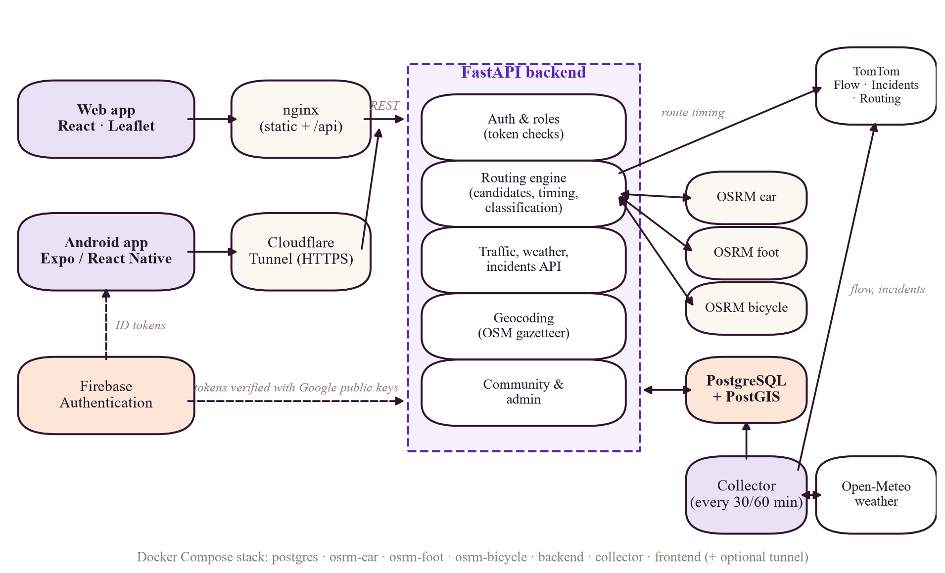
Figure 1. Verified deployment architecture (Docker Compose services and external providers). Both the web and Android clients reach nginx through the Cloudflare tunnel when used publicly; on the LAN the web app is served directly on port 8080. The backend also calls Open-Meteo directly for route-time weather.
Table 7. Verified components and connections
Component | Technology | Talks to | Evidence
Web client | React 19 (Create React App), Leaflet / react-leaflet, Recharts | nginx /api (same origin) | [VERIFIED IN CODE] frontend/src/config.js, frontend/package.json
Mobile client | Expo SDK 58 / React Native 0.88, WebView map, SecureStore | Backend URL from EXPO_PUBLIC_API_BASE_URL | [VERIFIED IN CODE] mobile/src/api.ts
nginx (frontend container) | Serves the React build; proxies /api/* to backend:8000 resolved at request time | backend | [VERIFIED IN CONFIGURATION] infrastructure/nginx/default.conf (resolver 127.0.0.11, rewrite ^/api/(.*)$ /$1)
Backend | FastAPI, SQLAlchemy 2, Alembic, httpx | PostgreSQL, OSRM ×3, TomTom, Open-Meteo, Firebase (token verification only when configured) | [VERIFIED IN CODE] backend/main.py
Collector | Same image as backend, python -m traffic.collector | TomTom, Open-Meteo, PostgreSQL (direct, not via HTTP API) | [VERIFIED IN CONFIGURATION] docker-compose.yml lines 99–123
Database | PostgreSQL 16 + PostGIS 3.4, volume bp_pgdata | backend, collector | [VERIFIED IN CONFIGURATION] docker-compose.yml
Routing engines | OSRM MLD, --max-alternatives 3, graphs mounted read-only | backend | [VERIFIED IN CONFIGURATION] docker-compose.yml; [VERIFIED IN CODE] backend/routing/osrm_client.py

3.1 A request, step by step
Table 8. Ten stages of the system with the files involved
# | Stage | What happens | Files
1 | User opens the app | Browser loads the static React bundle from nginx; App.js reads the hash (#/navigate) and, if no session exists, shows the sign-in screen. | frontend/src/App.js, components/AuthScreen.js, auth/AuthContext.js
2 | Frontend renders the page | The page component mounts and starts its data requests (e.g. Navigate loads vehicles, segments, incidents, verified shortcuts). | pages/NavigatePage.js
3 | Frontend sends a request | api(path, options) prefixes API_BASE_URL (/api), attaches Authorization: Bearer <token> from the token provider, sends JSON. | frontend/src/api/client.js, config.js
4 | Backend validates | nginx strips /api; FastAPI's router-level dependency app_access resolves the user from the token; Pydantic validates the body (e.g. RouteRequestV2: max_routes 1–8, departure ≤ 7 days ahead). | backend/main.py, api/deps.py, routing/schemas.py
5 | Backend works | Depending on the endpoint: SQL queries (observations, trips), OSRM HTTP calls, TomTom/Open-Meteo calls (with quota guard and caching), model registry lookup. | routing/engine.py, providers/*.py, traffic/state_engine.py, forecasting/predictor.py
6 | Response returns | Pydantic response model serialised to JSON; errors use one JSON shape {error:{code,message}}. | routing/schemas.py, core/errors.py
7 | UI displays | React state updates; Leaflet draws polylines and markers; cards show ETA, basis, classification, sources. | components/RouteResults.js, components/MapView.js
8 | Collector obtains observations | Independent loop: flow every 30 min, weather every 30 min, incidents every 60 min, maintenance and retrain daily; resumes its schedule from the last stored timestamps after a restart. | backend/traffic/collector.py (build_tasks, resume_schedule, run_forever)
9 | Collector persists | Readings are validated and stored with minute-bucket de-duplication; incidents are created/updated/deactivated; every provider call is logged in provider_calls. | backend/traffic/ingest.py, providers/quota.py
10 | Training / inference | After each flow sweep, baseline forecasts are logged and earlier ones resolved; daily, the pipeline retrains and evaluates; inference uses only an active model (none today). | forecasting/online.py, forecasting/pipeline.py, forecasting/predictor.py, forecasting/segment_model.py

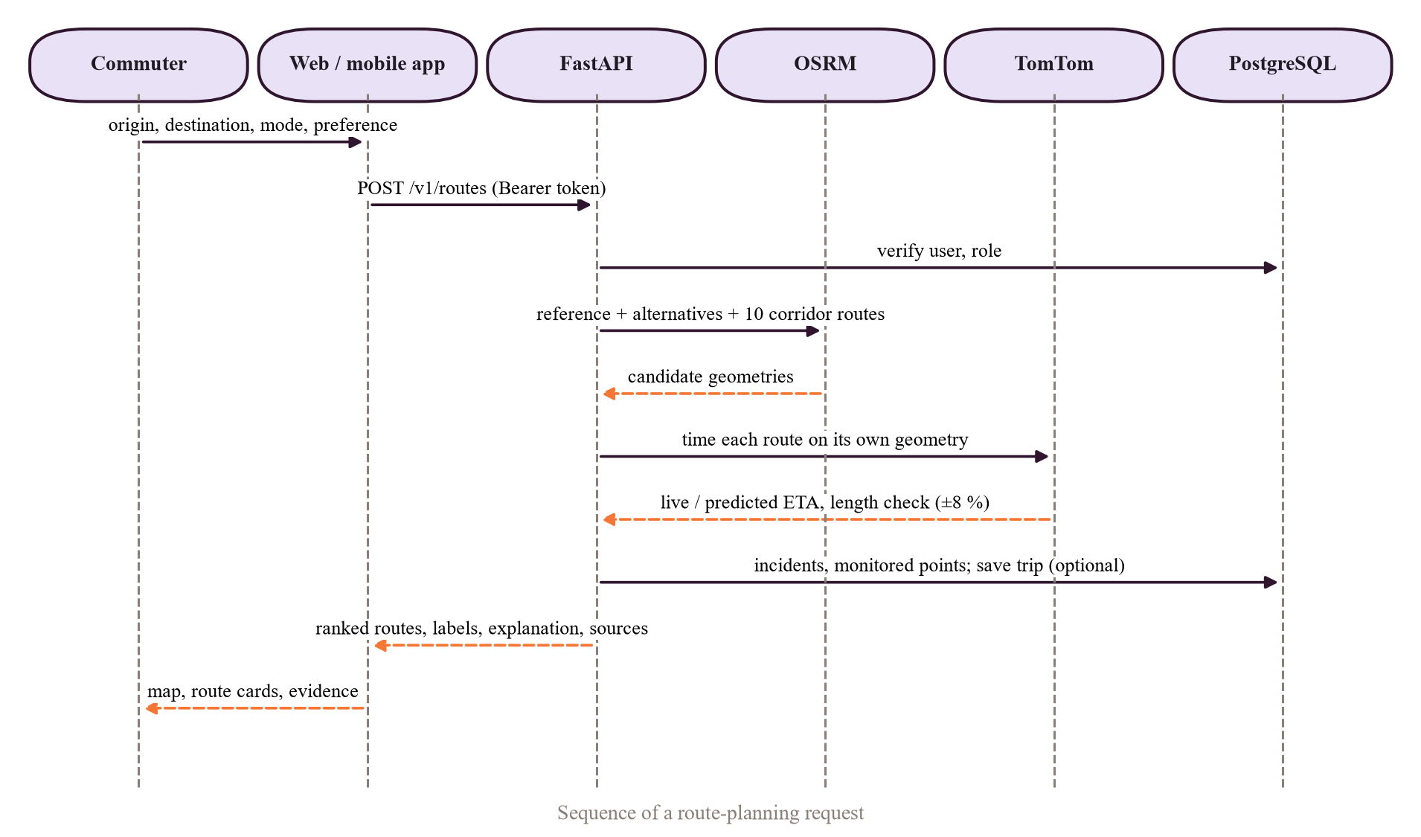
Figure 2. Sequence of a route request (web client → backend → OSRM / TomTom / database / Open-Meteo).
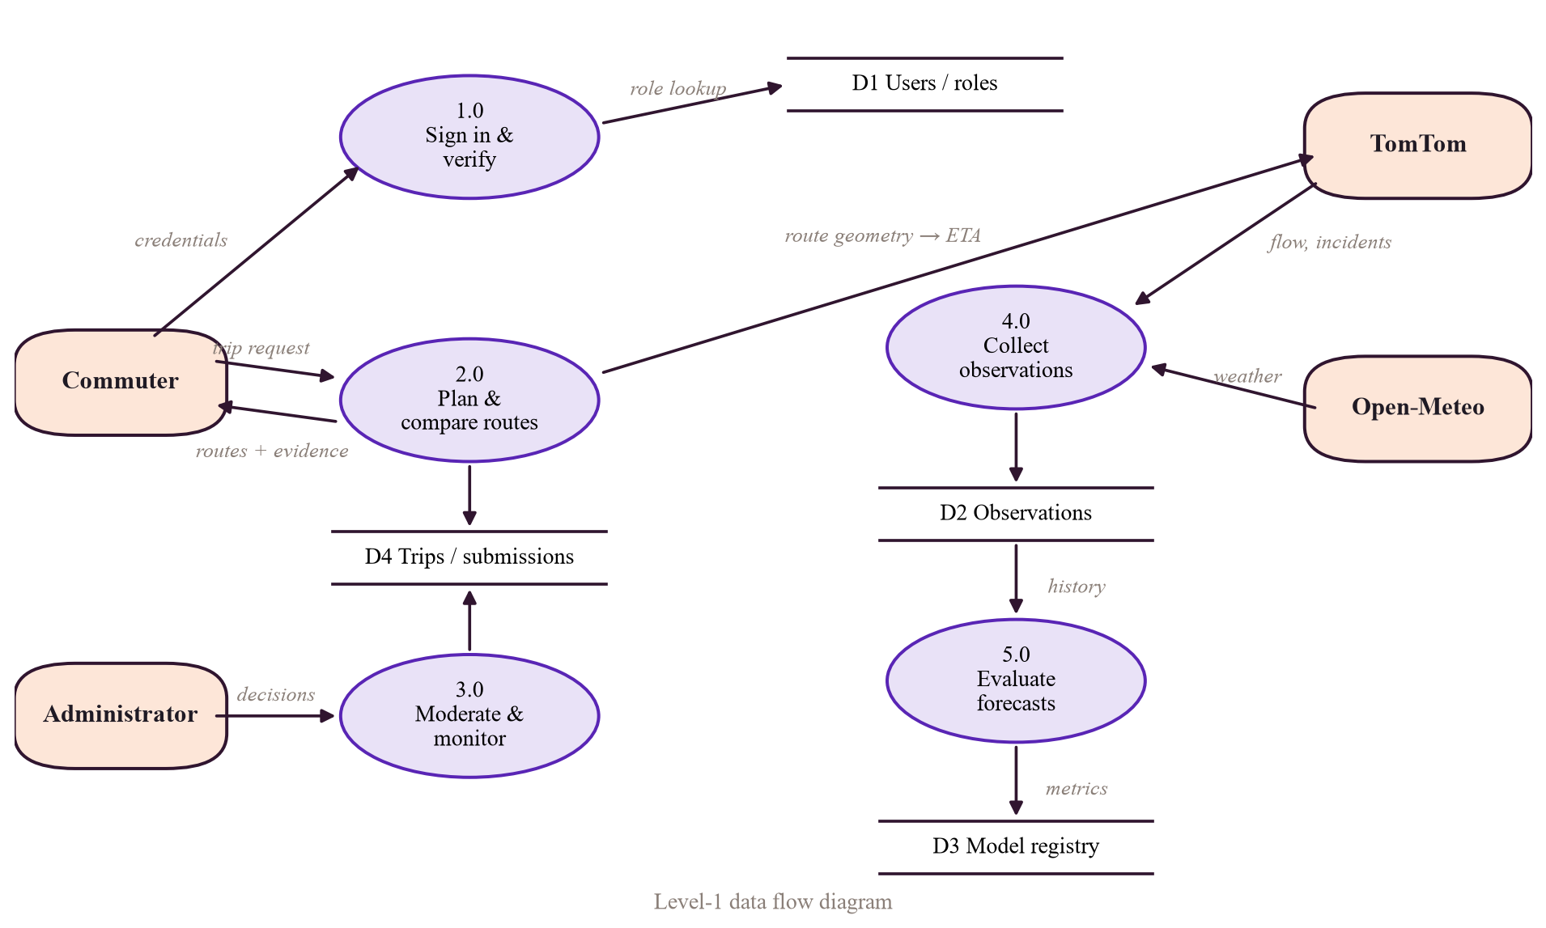
Figure 3. Level-1 data-flow diagram: processes 1.0–5.0 and data stores D1–D4.

3.2 Seven kinds of data — never mix them up
Table 9. Data provenance categories
Kind | Example in the app | Produced by | Label in responses / evidence
External live observation | Current speed at a monitored point; current weather | TomTom flow API; Open-Meteo current | observation.source, age_minutes [VERIFIED IN CODE] state_engine.py
Historical stored observation | Speed history chart for a point; insights | Our collector → PostgreSQL | /v1/traffic/segments/{id}/history [VERIFIED IN CODE]
Cached value | TomTom route timing reused for 5 min; quota counts | Backend in-memory cache _TIMING_CACHE (TTL 300 s) | [VERIFIED IN CODE] engine.py _TIMING_TTL_S
Synthetic / generated data | Only in tests (backend/tests/fakes.py, forecasting fixtures). The V1 random generators were removed. | Test code | [VERIFIED IN CODE] backend/services.py docstring; 410 responses in api/legacy.py
Third-party travel-time estimate | Route ETA with traffic, now or at a future departure | TomTom Routing (departAt for future) | eta_basis = traffic_live / traffic_predicted [VERIFIED IN CODE]
OSRM route estimate | Free-flow duration and distance of every candidate | Our OSRM servers (static speeds from the Lua profile) | eta_basis = free_flow [VERIFIED IN CODE]
Our own model's prediction | Segment forecast — only if an active model exists | SegmentForecaster.predict_for | sources[pulse_forecast] status; today “unavailable” [VERIFIED IN CODE] [VERIFIED BY TEST OR LOG]

VIVA ANSWER — Architecture in 40 seconds
“Clients talk only to nginx, which serves the React build and forwards /api to FastAPI. FastAPI checks the user's token, then uses three self-hosted OSRM servers for road routing, TomTom for traffic timing and incidents, Open-Meteo for weather and PostgreSQL with PostGIS for everything stored. A separate collector container, built from the same image, writes observations to the database on a schedule and retrains the forecasting pipeline daily. All of it is one Docker Compose file, exposed publicly through a Cloudflare tunnel.”

Chapter 4 File-by-File Source-Code Guide
Generated and vendored folders (node_modules, .git, .venv, __pycache__, build, dist, OSM graphs under data/) are excluded. Every path below was checked to exist. “Runtime” means used while the deployed system runs; “offline” means a script run by hand; “test” means only by the test suite.

4.1 Backend entry point, configuration and errors
Path | Purpose (simple) | Key items | Inputs → outputs | Used by / uses | Kind
backend/main.py | Starts the API and plugs in all routers | create_app(); routers health/auth/admin unguarded; me, routing_api, geocode, traffic_api, forecast_api, community, legacy behind Depends(app_access) | settings → FastAPI app | uvicorn (Dockerfile CMD) / all api/*.py | Runtime
backend/core/settings.py | All configuration in one typed object | Settings (pydantic-settings): tomtom_daily_budget=2000, collector_*_interval_minutes 30/30/60, observation_stale_minutes=90, api_auth_required, firebase_project_id, traffic_model_path | env vars → Settings | everything | Runtime
backend/core/errors.py | Uniform error responses | AppError, NotFound, UpstreamUnavailable | exceptions → JSON {error} | routers, engine | Runtime
backend/core/http.py, core/log_config.py | Shared HTTP client; JSON logging | — | — | providers, main | Runtime
backend/Dockerfile | Builds the backend image | Python 3.12-slim, non-root appuser, HEALTHCHECK /health, CMD alembic upgrade head && uvicorn | source → image | backend + collector services | Deployment

4.2 API routers (backend/api/)
Path | Purpose | Key functions | Uses
api/deps.py | Who is the caller? Are they allowed? | _resolve_user (legacy JWT or Firebase ID token), firebase_identity, _user_for_firebase (409 account_link_required), app_access, require_admin | auth/security.py, auth/firebase.py, db/models.User
api/auth.py | Register, log in, link, log out, profile, delete | /v1/auth/*; link_existing_account; delete requires confirm and a sign-in within 300 s (RECENT_SIGN_IN_SECONDS) | bcrypt, JWT, AuditLog
api/routing_api.py | Plan routes; list vehicles | plan_route (POST /v1/routes, optional save_trip → Trip row) | routing/engine.RoutingEngine
api/traffic_api.py | Segments, history, weather, incidents | /v1/traffic/segments, /history, /v1/weather/*, /v1/incidents, report and mine | traffic/state_engine.py, weather/service.py
api/forecast_api.py | Model registry and segment forecast | models() (registry + metrics + note), segment_forecast() (503 forecast_unavailable when no active model) | forecasting/predictor.py
api/geocode.py | Place search and reverse geocoding | /v1/geocode/search, /reverse | geocoding/service.py (places table)
api/me.py | A user's own trips and favourites | list/get/delete trips filtered by Trip.user_id == user.id | db/models.Trip, FavouritePlace
api/community.py | Shortcut trace submissions; verified shortcuts | /v1/community/submissions, /mine, /shortcuts | community/service.py
api/admin.py | Admin console | users, candidates, incidents, data-freshness, models, forecast/online, system-health, audit-log | require_admin
api/health.py | Liveness and readiness | /health, /health/ready (dependency report; database and car OSRM are critical, others may be degraded) | —
api/legacy.py | V1 compatibility | /predict (legacy RF), /locations, /history, /hotspots, /incidents, /api/live-traffic*; 410 for /forecast, /analytics, /historical-trends, /commute-advisor | services.ModelBundle

4.3 Routing (backend/routing/)
Path | Purpose | Key items
routing/engine.py | The route decision engine | RoutingEngine.plan, corridor_waypoints, _filter_and_dedup, _apply_traffic, _attach_incidents, _attach_segments, _assemble; constants LENGTH_MATCH_TOLERANCE=0.08, DUPLICATE_SIMILARITY=0.85, MAX_BACKTRACK_M=120, FUTURE_THRESHOLD=15 min, MAX_DEPART_AHEAD=7 days
routing/osrm_client.py | Talks to OSRM over HTTP | OSRMClient.route_points, route, match (map-matching), nearest, health; simple circuit breaker; maneuver text
routing/route_profiles.py | Vehicle → OSRM server mapping | car→car.lua, motorcycle→car.lua (car_graph_approximation), bicycle→bicycle.lua, walk→foot.lua; excludable classes (toll, motorway, ferry) for motor vehicles
routing/classification.py | Shortcut / longcut / alternative rules | DISTANCE_ABS_M=50, DISTANCE_REL=0.01, TIME_ABS_S=30, TIME_REL=0.02, _relation, classify
routing/scoring.py | Ranking and explanations | BALANCED_WEIGHTS time 0.60, distance 0.20, delay 0.10, incidents 0.10; resolve_preference, score_routes, explain, recommendation_text
routing/geometry.py | Distances and overlap | haversine_m, resample, PointIndex (grid spatial index), route_similarity, backtrack_length_m
routing/schemas.py | Request/response shapes | RouteRequestV2, RouteResponseV2, RoutePreference (fastest, shortest, least_traffic_now, least_traffic_predicted, balanced)

4.3.1 Example: how one route request travels through the code
- NavigatePage.js calls api("/v1/routes", {method: "POST", body}).
- nginx → POST /v1/routes → app_access → plan_route in backend/api/routing_api.py.
- RoutingEngine.plan: get_profile(vehicle) → OSRMClient.route_points([o, d], alternatives=3) → corridor_waypoints → 10 parallel OSRM calls (semaphore 5).
- _filter_and_dedup keeps ≤ 5; _apply_traffic calls TomTomProvider.route_timing per route (semaphore 4, cache 300 s).
- _attach_incidents (stored incidents matched to the route with a Python grid index), _attach_segments (latest observations), WeatherService.at, advisories.
- _assemble → classify + score_routes + explain → RouteResponseV2 → JSON → RouteResults.js renders.

Shortcut classification rule [VERIFIED IN CODE]
# backend/routing/classification.py (excerpt)
DISTANCE_ABS_M = 50.0
DISTANCE_REL = 0.01
TIME_ABS_S = 30.0
TIME_REL = 0.02

def _relation(value, reference, abs_tol, rel_tol, lower, higher):
diff = value - reference
if abs(diff) <= max(abs_tol, rel_tol * reference):
return "equal"
return lower if diff < 0 else higher
# classify(): shorter + faster -> "shortcut"; longer + faster -> "longcut";
# anything else -> "alternative"; different time bases -> "unclassified"

4.4 Traffic, providers, weather, geocoding, community
Path | Purpose | Key items | Kind
traffic/collector.py | Background data collection loop | collect_flow, collect_weather, collect_incidents, collect_flow_and_log (also logs baseline forecasts), build_tasks, resume_schedule, run_forever; exponential back-off on failure; --once flag | Runtime (collector)
traffic/ingest.py | Store readings safely | ensure_segments, store_flow (minute bucket de-dup, confidence), store_weather, store_incidents (create/update/deactivate) | Runtime
traffic/segments.py | The 26 monitored points | MONITORED_POINTS (code → name, lat, lon) | Runtime
traffic/state_engine.py | Turn observations into map state | congestion_level (≥0.85 FREE, ≥0.65 MODERATE, ≥0.45 HEAVY, else SEVERE; CLOSED if closure), latest_segment_state, active_incidents | Runtime
traffic/maintenance.py | Daily housekeeping | run_retention (daily data retention) and run_retrain (daily pipeline run), called by the collector | Runtime
providers/tomtom.py | TomTom client | flow_segment (/traffic/services/4/flowSegmentData/absolute/10/json), incidents (/traffic/services/5/incidentDetails), route_timing (/routing/1/calculateRoute/..., departAt for future) | Runtime
providers/quota.py | Daily budget guard | QuotaGuard: daily_budget, background_reserve=500, acquire, finish (rows in provider_calls) | Runtime
providers/openmeteo.py | Weather client | WEATHER_AREAS (central, east, north, south, west, airport), fetch, current, parse_hourly, WMO code descriptions | Runtime
weather/service.py | Weather for a place and time; advisories | WeatherService.at, advisories (wet roads for two-wheelers/walkers, visibility < 1 km, thunderstorm) | Runtime
geocoding/gazetteer.py, service.py, text.py | Local place search from OpenStreetMap | gazetteer builder loads places (68,761 rows [VERIFIED BY TEST OR LOG] ); search with text normalisation | Offline build + runtime
community/service.py | Validate shortcut traces | clean_trace, map-matching, REQUIRED_CONFIRMATIONS=3, decide, mark_stale, purge_old_traces | Runtime

4.5 Database and authentication
Path | Purpose | Key items
db/models.py | ORM models for all 17 tables | User, RevokedToken, AuditLog, FavouritePlace, Trip, TrafficSegment, TrafficObservation, WeatherObservation, Incident, ProviderCall, Place, ShortcutCandidate, RouteSubmission, ModelVersion, EvaluationRecord, PredictionRecord, LegacyPrediction
db/session.py | Database sessions | get_db (request-scoped), session_scope (collector / background)
migrations/versions/0001_initial_schema.py → 0002_evaluation_candidate.py → 0003_firebase_identity.py | Schema history | Alembic chain; head 0003 [VERIFIED BY TEST OR LOG]
auth/security.py | Built-in accounts | bcrypt (12 rounds) password hashing; HS256 JWT, 60-minute expiry, jti revocation list
auth/firebase.py | Firebase ID-token verification | verify_id_token → Admin SDK verify_id_token(..., clock_skew_seconds=5); project ID only, no service-account key
auth/bootstrap.py | Create or promote an account from the command line (e.g. the first admin) | bootstrap(email, name, password, promote, force), main(); no credentials stored in code

4.6 Machine learning files
Path | Purpose | Kind
forecasting/pipeline.py | V2 train / evaluate / register pipeline: TaskConfig, RESEARCH, SEGMENTS, supervised, chronological_split, candidates, run_horizon, run, _register, legacy_nowcast_check, metrics | Offline + daily retrain
forecasting/online.py | Prospective baseline logging: log_forecasts, resolve_actuals, report, run_cycle | Runtime (collector)
forecasting/predictor.py | active_model, forecast_lookup — returns None unless a model is active | Runtime
forecasting/segment_model.py | SegmentForecaster.load, predict_for — serving an active segment model | Runtime (dormant)
forecasting/features.py, forecasting/baseline.py | Empty files (0 lines) — feature and baseline logic lives in pipeline.py | Unused
train_model.py | V1: trains 4 regressors on the full public CSV with a random split; saves traffic_model.pkl and encoders | Offline (legacy)
filter_data.py | V1 preprocessing → processed_dataset.csv | Offline (legacy)
evaluation/evaluate_model.py, tune_model.py, final_evaluation.py, generate_plots.py | V1 evaluation on traffic_dataset.csv (492 rows); grid search; plots | Offline (legacy)
services.py | ModelBundle loads traffic_model_tuned.pkl + 3 encoders for legacy /predict | Runtime (legacy)
*.pkl (backend root) | traffic_model.pkl (38 MB), traffic_model_tuned.pkl, area/road/weather_encoder.pkl; traffic_encoder.pkl is not referenced by any code | Artifacts
backend/models/*.joblib | V2 artifacts (git-ignored, Docker volume models) | Artifacts

4.7 Frontend (frontend/src/)
Path | Purpose | Key items / API calls
index.js, App.js | Bootstraps React; hash router; sign-in gate; navigation rail | useHashPage reads #/home … #/admin
api/client.js | One fetch wrapper for every call | api(path, options), setTokenProvider, setUnauthorizedHandler; wrong-password 401 does not end the session
auth/AuthContext.js, auth/firebase.js | Session state; Firebase lazy-loaded only when configured | /v1/auth/login, /register, /link, /logout, /me
data/personal.js | Firestore personal data | users/{uid}/favorites, journal, preferences/app
pages/NavigatePage.js | Trip planner | /v1/vehicles, /v1/traffic/segments, /v1/incidents, /v1/community/shortcuts, /v1/geocode/reverse, POST /v1/routes
pages/TrafficPage.js | Traffic map | /v1/traffic/segments, /v1/incidents, /v1/weather/areas, /v1/forecast/models, segment history
pages/InsightsPage.js | City insights (Recharts) | segments, weather areas, forecast models, incidents, history
pages/HomePage.js, AboutPage.js, JournalPage.js, AccountPage.js, AdminPage.js | Landing, project explanation, saved trips, account tools, admin console | /v1/me/trips, /v1/me/favourites, /v1/community/submissions, /v1/incidents/report, /v1/admin/*
components/MapView.js | Leaflet map with OSM tiles, routes, markers | react-leaflet
components/RouteResults.js, PlaceSearch.js, InsightStrip.js, AuthScreen.js | Route cards; place autocomplete; live strip; sign-in | /v1/geocode/search
content/team.js | Team profiles for About page | Empty list — team details not supplied [UNKNOWN — NEEDS CONFIRMATION]

4.8 Mobile, Firebase, deployment and CI
Path | Purpose
mobile/App.tsx, mobile/src/screens/{RouteScreen,TrafficScreen,AccountScreen,AuthScreen}.tsx | Android app screens
mobile/src/api.ts, auth.tsx, firebase.ts, MapWebView.tsx | API client (base URL from EXPO_PUBLIC_API_BASE_URL), session in SecureStore, Google sign-in, Leaflet map inside a WebView
mobile/app.config.js, mobile/plugins/withReleaseSigning.js, mobile/eas.json | Build configuration; release signing reads keystore settings from the developer's local Gradle properties (never committed)
firebase/firestore.rules, firebase/tests/firestore.rules.test.mjs | Owner-only Firestore rules (signedInOwner: same UID and verified e-mail) and their emulator tests
docker-compose.yml, docker-compose.prod.yml | Default stack (used now); production variant that adds a Caddy HTTPS proxy
infrastructure/nginx/default.conf | Static hosting + /api proxy
infrastructure/osrm/prepare_graphs.sh, build_osrm.sh | Download Geofabrik Southern-Zone extract, clip to Bengaluru box, build MLD graphs per profile
infrastructure/caddy/Caddyfile | HTTPS reverse proxy (Caddy) used only by docker-compose.prod.yml for a server with its own domain; the default stack uses nginx + Cloudflare tunnel [VERIFIED IN CONFIGURATION]
.github/workflows/ci.yml | CI jobs: backend (pytest + migrations match models), frontend (tests + build), mobile, docker (image runs as non-root, serves /health)

Chapter 5 Machine Learning from the Basics

5.1 Core concepts in simple terms
Table 10. ML vocabulary with a project example for each
Concept | Simple meaning | In this project
Artificial intelligence | Computers doing tasks that normally need human judgement. | Umbrella term; our system is mostly decision support plus ML.
Machine learning | Learning a rule from examples instead of writing it by hand. | Ridge / gradient boosting learn congestion or speed-ratio patterns.
Supervised learning | Examples come with the correct answer (label). | Each row has a known future value (target).
Regression | Predict a number. | Congestion level 0–100; speed ratio 0–1.5.
Classification | Predict a category. | Our congestion labels (FREE…SEVERE) are rule-based thresholds, not an ML classifier.
Time-series forecasting | Predict a future value from past values in time order. | Speed ratio 30/60/120 min ahead; congestion 1/7 days ahead.
Features / target | Inputs / the value to predict. | Features: last_value, lag_k, roll_mean_w …; target: value h steps later.
Training / inference | Fitting the model / using it on new inputs. | run_horizon fits; SegmentForecaster.predict_for infers (only if active).
Feature engineering | Creating informative inputs. | Lags, rolling mean/std, seasonal value, sine/cosine of time of day.
Encoding categorical data | Turning words into numbers. | V1 uses LabelEncoder for area, road, weather (integer codes).
Normalisation / scaling | Putting features on similar scales. | StandardScaler before Ridge in V2.
Overfitting / underfitting | Memorising noise / too simple to learn. | Grid search and validation selection guard against overfitting.
Generalisation | Doing well on unseen data. | Measured on a later time period (test split).
Data leakage | Inputs secretly contain the answer or future information. | V1 used same-day volume/speed to estimate same-day congestion.
Train / validation / test | Learn / choose / final exam. | 65% / 15% / 20% by target time.
Baseline model | A simple reference a real model must beat. | Persistence, seasonal naive, historical average.
Hyperparameters | Settings chosen before training. | Ridge α = 1.0; HGB learning rate 0.05/0.1, leaves 15/31.
Model artifact | The saved trained model. | .pkl (V1), .joblib (V2).
Model drift | The world changes, model gets worse. | Daily retraining and prospective logging are designed to detect it.

5.2 Every model in the repository
Three groups exist: (A) the V1 legacy estimator (Random Forest), (B) the V2 research pipeline on the public daily dataset (ridge selected; not activated), and (C) the V2 segment pipeline on our own observations (not yet trainable), plus (D) baselines that are logged prospectively. Nothing else — no neural network, no GNN, no anomaly detector — exists in the code.

5.2.1 Model A — V1 Random Forest congestion estimator (legacy)
Item | Detail
Algorithm | RandomForestRegressor (scikit-learn). train_model.py also tries LinearRegression, DecisionTree, GradientBoosting and keeps the best by R². [VERIFIED IN CODE]
Source | backend/train_model.py; tuning backend/evaluation/tune_model.py (GridSearchCV, cv=3, scoring R²)
Artifacts | backend/traffic_model.pkl (from train_model.py), backend/traffic_model_tuned.pkl (from tune_model.py), encoders area_encoder.pkl, road_encoder.pkl, weather_encoder.pkl (joblib)
Purpose | Estimate the same-day congestion level of a road from that day's measured volume and speed. Not a forecast.
Target | Congestion Level (0–100)
Features | Area Name, Road/Intersection Name, Traffic Volume, Average Speed, Weather Conditions
Data | train_model.py: full Banglore_traffic_Dataset.csv (8,936 rows). Tuning/final evaluation: traffic_dataset.csv — 492 rows of one road only (Whitefield, Marathahalli Bridge) [VERIFIED BY TEST OR LOG] (read-only pandas check)
Cleaning | drop duplicates, drop rows missing required columns; filter_data.py also title-cases text
Encoding / scaling | LabelEncoder per categorical column; no scaling (trees do not need it)
Split | train_test_split(test_size=0.2, random_state=42) — random, not time-ordered
Tuned hyperparameters | n_estimators=100, max_depth=None, max_features=1.0, min_samples_leaf=4, min_samples_split=10 [VERIFIED IN EXPERIMENT RESULTS] evaluation/tuning_results.json
Saving / loading | joblib.dump / joblib.load in services.ModelBundle._load_artifact; path from Settings.traffic_model_path = traffic_model_tuned.pkl
Inference | POST /predict → ModelBundle.predict → response flagged "legacy": true with a notice
Output | Congestion index (same 0–100 scale); not used by routing
Limitations | Same-day inputs (leakage for forecasting), random split, tuned on a single road, 99 test rows
Illustrative example | Input: Whitefield / Marathahalli Bridge, volume 30,000, speed 35 km/h, Clear → output: a congestion value on the 0–100 scale. (Illustration only; not a recorded result.)

5.2.2 Model B — V2 research pipeline, public daily data
Item | Detail
Algorithms | Ridge regression (StandardScaler + Ridge(alpha=1.0)), HistGradientBoostingRegressor in four settings (learning rate 0.05/0.1 × max leaf nodes 15/31, 300 iterations, L2 = 1.0); baselines persistence, seasonal naive, historical average [VERIFIED IN CODE] candidates()
Task / target | road_congestion_day_ahead: congestion level per road 1 day and 7 days ahead
Features (at forecast origin only) | last_value, last_age_steps, lag_0, lag_1, lag_2, lag_6, roll_mean_7, roll_std_7, roll_mean_28, roll_std_28, seasonal_value, target-date calendar t_dow, t_month, t_doy_sin, t_doy_cos, plus hist_avg (training data only). Same-day volume and speed are excluded.
Split | Chronological by target time: train 2022-01-02 → 2023-09-11 (5,765), validation 2023-09-12 → 2024-01-31 (1,364), test 2024-02-01 → 2024-08-09 (1,791) for 1 d [VERIFIED IN EXPERIMENT RESULTS]
Selection | Lowest validation MAE → refit on train+validation → evaluated once on test
Artifact / registry | backend/models/research-daily-congestion-20261022043007.joblib; model_versions id 2, status candidate [VERIFIED BY TEST OR LOG]
Result | Ridge selected for both horizons; test MAE 16.08 (1 d) vs historical-average 15.98 → 0.6% worse → not activated [VERIFIED IN EXPERIMENT RESULTS]

5.2.3 Model C — V2 segment pipeline, our own observations
Item | Detail
Task / target | segment_speed_ratio: current ÷ free-flow speed at each of 26 points, 30, 60, 120 minutes ahead (1, 2, 4 steps of 30 min)
Features | lags 0, 1, 2, 47 (≈ 1 day), 335 (≈ 1 week); rolling 4 (2 h) and 48 (24 h) mean/std; seasonal value one week earlier; t_hod_sin, t_hod_cos, t_dow, t_weekend (Asia/Kolkata); hist_avg per weekday × half-hour slot
Gate | ≥ 14 days of data (min_span_days) before any evaluation; then ≥ 5% MAE improvement over the best baseline on every horizon with ≥ 500 test samples
Status | insufficient_data (78 observations over 0.04 day at the 22 Oct run) [VERIFIED IN EXPERIMENT RESULTS] evaluation/v2/segment-speed-ratio.json. Earliest possible evaluation ≈ 5 Nov 2026 if collection is continuous [DOCUMENTED BUT NOT VERIFIED] docs/ML_PIPELINE.md
Inference path | forecast_lookup() → SegmentForecaster.predict_for — exists, tested on synthetic fixtures, dormant until a model is active

Activation threshold and the time-ordered split [VERIFIED IN CODE]
# backend/forecasting/pipeline.py (excerpts)
ACTIVATION_MIN_IMPROVEMENT = 0.05 # 5% lower test MAE than the best baseline

def chronological_split(data, cfg):
times = np.sort(data["target_time"].unique())
n = len(times)
val_start = times[int(n * (1 - cfg.test_fraction - cfg.val_fraction))]
test_start = times[int(n * (1 - cfg.test_fraction))]
train = data[data["target_time"] < val_start]
val = data[(data["target_time"] >= val_start) & (data["target_time"] < test_start)]
test = data[data["target_time"] >= test_start]

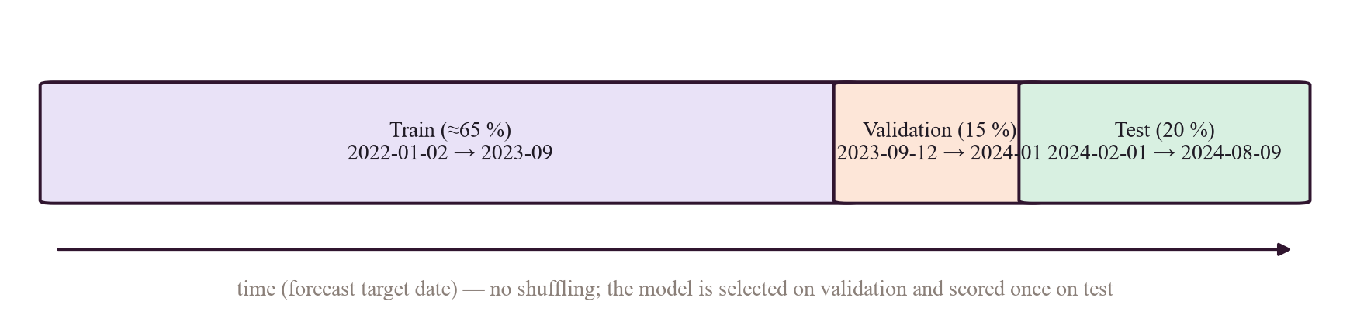
Figure 4. Chronological split by target time: the model never trains on a period later than the one it is tested on.

Chapter 6 Model Comparison and Evaluation Metrics
The single most important rule of this chapter: only compare numbers that share the same target, dataset, split and units. The repository contains four separate experiments. They are therefore shown in four separate tables, never in one ranking.

6.1 Experiment 1 — V1 same-day estimation (legacy)
Table 11. V1 Random Forest results — target: same-day Congestion Level (0–100); dataset: backend/traffic_dataset.csv, 492 rows of one road; random 80/20 split, seed 42; n(test) = 99
Model | MAE | RMSE | R² | Other | Source file | Reproducible? | Caveat
Random Forest (traffic_model.pkl) | 2.037 | 2.749 | 0.988 | expl. var. 0.988 | evaluation/evaluation_metrics.json | Script present; not re-run | Model trained by train_model.py on the full dataset, then scored on a split of a subset — 479 of the 492 rows are identical rows of the full dataset, so most “test” rows were very likely seen in training. Not a held-out result.
Baseline RF, 200 trees | 4.412 | 5.710 | 0.948 | expl. var. 0.948 | evaluation/tuning_results.json, model_comparison.csv | Script present; not re-run | Random split; single road
Tuned RF (traffic_model_tuned.pkl) | 4.043 | 5.145 | 0.958 | CV R² 0.944; median AE 3.476; max AE 13.215 | evaluation/final_evaluation_metrics.json, final_evaluation_report.txt | Script present; not re-run | Same-day inputs; random split; 99 test rows; single road

Label: [VERIFIED IN EXPERIMENT RESULTS] for the numbers (they are in result files), but they are not forecasting evidence. Feature importance confirms why: Traffic Volume 0.979 (feature_importance.csv) and 0.990 (final_feature_importance.csv); Area Name and Road/Intersection Name are exactly 0.0 in the tuned model because the 492-row file contains one area and one road, so those columns are constant.

6.2 Experiment 2 — V1-style check on the full dataset (V2 re-examination)
Table 12. legacy_nowcast_check — target: same-day congestion; dataset: full public CSV (8,936 rows); RandomForest inside forecasting/pipeline.py
Setting | MAE | RMSE | R² | n | Meaning
Same-day volume + speed, random split | 3.002 | 4.665 | 0.960 | 1,788 | High score because inputs are measured on the same day as the target
Same-day volume + speed, chronological split (test from 2024-02-01) | 2.976 | 4.596 | 0.962 | 1,791 | Still high: the leakage is in the inputs, not the split
Chronological, without same-day measurements | 16.028 | 20.565 | 0.232 | 1,791 | What remains when you cannot see the day you are predicting

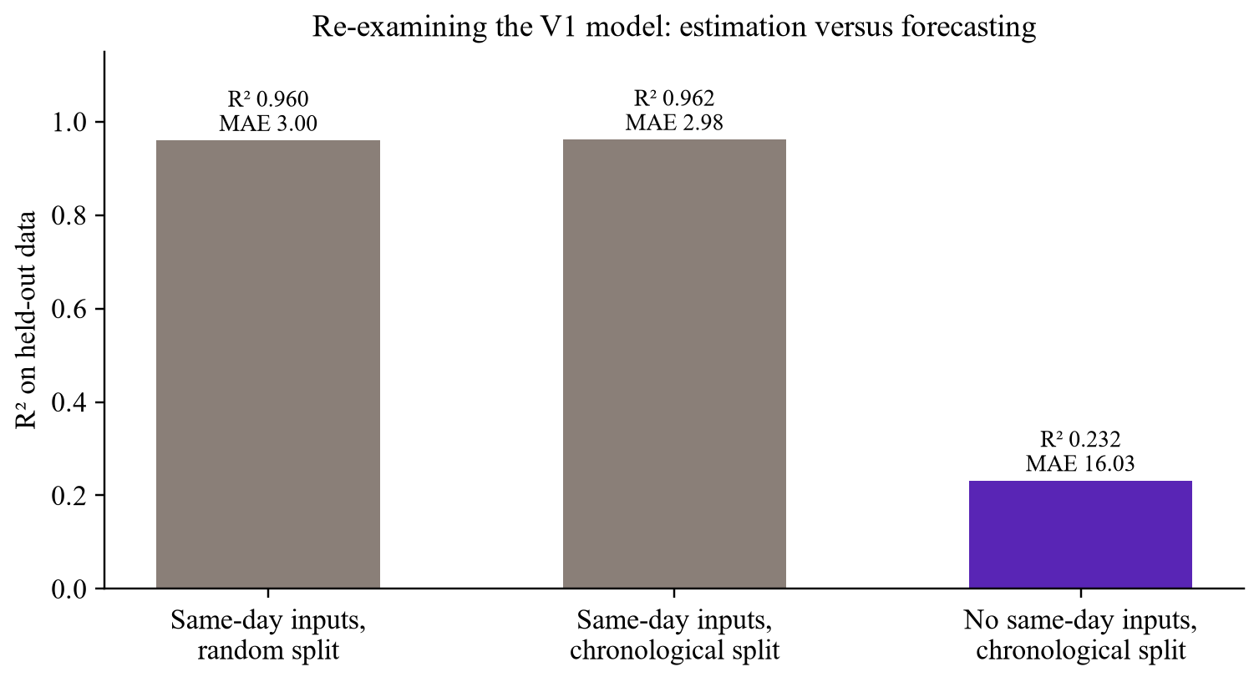
Figure 5. The V1 score collapses once same-day measurements are removed [VERIFIED IN EXPERIMENT RESULTS: backend/evaluation/v2/research-daily-congestion.json → legacy_nowcast_check].

6.3 Experiment 3 — V2 day-ahead forecasting on the public dataset
Table 13. Test results — target: congestion level per road; dataset: public daily CSV; chronological test 2024-02-01 → 2024-08-09
Horizon | Candidate | MAE | RMSE | sMAPE % | R² | n
1 day | Persistence (yesterday's value) | 20.217 | 29.124 | 30.12 | −0.541 | 1,791
1 day | Seasonal naive (same weekday last week) | 19.737 | 28.529 | 29.54 | −0.478 | 1,791
1 day | Historical average (best baseline) | 15.985 | 20.492 | 22.73 | 0.237 | 1,791
1 day | Ridge (selected on validation) | 16.079 | 20.606 | 22.84 | 0.229 | 1,791
7 days | Persistence = seasonal naive | 19.661 | 28.414 | 29.17 | −0.462 | 1,774
7 days | Historical average (best baseline) | 16.008 | 20.528 | 22.78 | 0.237 | 1,774
7 days | Ridge (selected) | 16.097 | 20.612 | 22.91 | 0.230 | 1,774

Validation MAE (1 day): ridge 16.015, historical average 16.042, HistGradientBoosting 16.52–17.28; so HGB was never selected. Improvement of ridge over the best baseline on test: −0.59% (1 d) and −0.56% (7 d). Activation rule for this task: ≥ 5% better and ≥ 200 test samples on every horizon → not activated [VERIFIED IN EXPERIMENT RESULTS] .
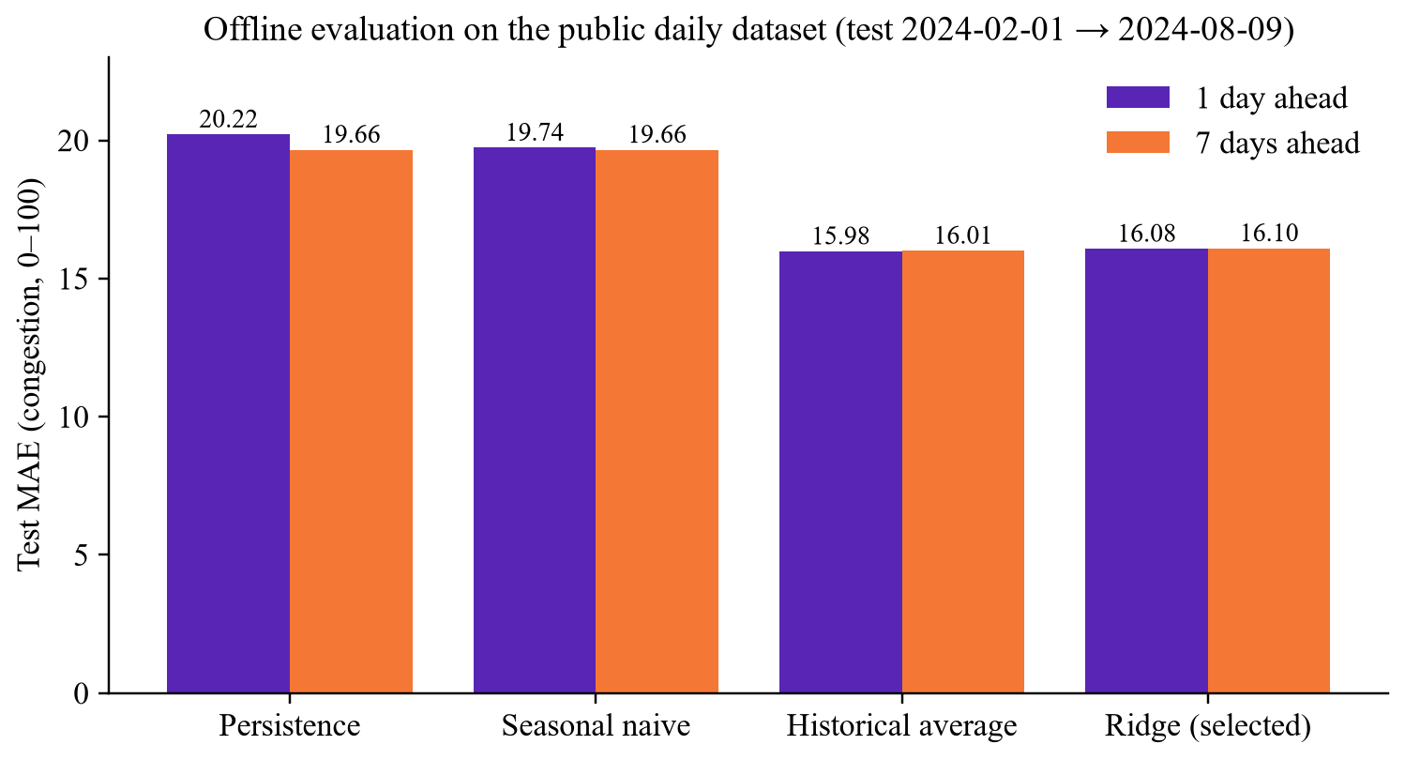
Figure 6. Day-ahead test MAE by candidate: no learned model beats the historical average.

6.4 Experiment 4 — prospective baselines on our own data
Table 14. Persistence baseline, truly future predictions — target: speed ratio (0–1.5); data: our TomTom observations; forecasts made 22 Oct 07:58 → 23 Oct 07:09 UTC
Horizon | n (resolved) | MAE | RMSE | Evidence
30 min | 519 | 0.0566 | 0.0994 | [VERIFIED BY TEST OR LOG] read-only SQL on prediction_records, 23 Oct 2026
60 min | 441 | 0.0718 | 0.1200 | same
120 min | 414 | 0.1027 | 0.1569 | same

Error grows with horizon, as expected. Only persistence has resolved forecasts so far: seasonal naive needs one week of history and the historical average needs earlier slots. These numbers are preliminary (about one day) and describe a baseline, not a model. The figure in Chapter 7 shows an earlier snapshot of the same measurement.

6.5 Tracing the historical numbers from earlier discussions
Table 15. Historical metric leads and what the repository shows
Lead | Traced to | Verdict
MAE ≈ 4.301, R² ≈ 0.9500 | No file contains 4.301. Nearest: baseline RF MAE 4.412 / R² 0.948 (tuning_results.json), tuned RF MAE 4.043 / R² 0.958. | [HISTORICAL RESULT — NOT REPRODUCED] / [UNKNOWN — NEEDS CONFIRMATION] — do not quote 4.301
MAE ≈ 2.9719, R² ≈ 0.9616 | R² 0.9616 matches legacy_nowcast_check → chronological split (R² 0.96164, MAE 2.976) in research-daily-congestion.json. MAE 2.9719 itself is not in any file. | Partly traced. Quote “MAE 2.98, R² 0.962, same-day estimation, chronological split”.
“Accuracy” ≈ 11.11% | Not found in any tracked file. | [UNKNOWN — NEEDS CONFIRMATION] — never quote
492 daily observations | traffic_dataset.csv (492 rows; one road; 2022-01-01 → 2024-08-08) used by evaluate_model.py, tune_model.py, final_evaluation.py. | Still applicable to V1 metrics
Traffic volume dominates importance | 0.979 / 0.990 in the V1 importance files. | Still applicable to V1; V2 does not use volume

6.6 Metric equations with a worked example
Take three actual values y = (10, 20, 30) and predictions ŷ = (12, 18, 36). Errors e = ŷ − y = (+2, −2, +6).
Table 16. Regression metrics
Metric | Formula | Worked example | Meaning
MAE | (1/n) Σ |yᵢ − ŷᵢ| | (2 + 2 + 6) / 3 = 3.33 | Average size of an error, in the target's units (congestion points, or speed-ratio units).
RMSE | √[(1/n) Σ (yᵢ − ŷᵢ)²] | √[(4 + 4 + 36) / 3] = √14.67 = 3.83 | Squares errors first, so the single 6-point error weighs heavily. RMSE ≥ MAE always.
R² | 1 − Σ(yᵢ − ŷᵢ)² / Σ(yᵢ − ȳ)² | ȳ = 20; SS_res = 44; SS_tot = 100 + 0 + 100 = 200; R² = 1 − 44/200 = 0.78 | Share of variance explained compared with always predicting the mean. Can be negative (worse than the mean), as persistence is above.
sMAPE | (100/n) Σ 2|e| / (|y| + |ŷ|) | (2·2/22 + 2·2/38 + 2·6/66)/3 × 100 = 16.6% | Scale-free percentage error; used in metrics().
Bias | (1/n) Σ (ŷᵢ − yᵢ) | (2 − 2 + 6)/3 = +2.0 | Systematic over- or under-prediction.

Table 17. Classification metrics — for understanding only (the project has no ML classifier)
Metric | Formula | Example: TP 4, FP 1, FN 2, TN 3 | Meaning
Accuracy | (TP + TN) / all | 7 / 10 = 0.70 | Share of correct labels.
Precision | TP / (TP + FP) | 4 / 5 = 0.80 | When we say “heavy”, how often are we right?
Recall | TP / (TP + FN) | 4 / 6 = 0.67 | Of all truly heavy cases, how many did we catch?
F1 | 2PR / (P + R) | 2·0.8·0.67/1.47 = 0.73 | Balance of precision and recall.

6.7 Seven points examiners test
- MAE is in the target's units. MAE 16 on congestion means “16 points out of 100 on average”; MAE 0.057 on speed ratio means about 5.7% of free-flow speed.
- RMSE punishes big misses. Because errors are squared, one large error raises RMSE much more than MAE; a big RMSE–MAE gap signals occasional large errors.
- R² is not accuracy. It compares with predicting the mean; it has no “percent correct” meaning. Saying “96% accuracy” for R² 0.96 is wrong.
- High R² does not prove forecasting. V1's R² 0.96 used same-day volume and speed; the target was effectively visible in the inputs.
- Regression and classification metrics do not mix. You cannot compare an MAE with an F1 or an accuracy.
- Fair comparison needs identical conditions. Same target, rows, split and horizon — which is why the four experiments above are kept apart.
- Random splits leak time. In time series, a random split lets the model train on days after the test days and on near-duplicates of neighbouring days; a chronological split prevents that. Leakage can produce misleadingly high scores.

VIVA ANSWER — “Which is your best model?”
“For forecasting, the honest answer is the historical-average baseline: on the public data's chronological test set its MAE was 15.99 against ridge's 16.08, so we did not activate ridge. The V1 Random Forest scores R² 0.96, but that is same-day estimation using same-day volume and speed, so I don't present it as a forecaster.”

Chapter 7 Is the Model Actually Forecasting Future Traffic?

7.1 Eight things that are often confused
Table 18. What the system implements today
Category | Definition | In Bengaluru Pulse? | Evidence
Current-condition estimation | Describing traffic now from current measurements | Yes — speed ratio from TomTom flow at 26 points | [VERIFIED IN CODE] providers/tomtom.py speed_ratio
Congestion classification | Putting conditions into categories | Yes, rule-based thresholds on speed ratio (not ML) | [VERIFIED IN CODE] state_engine.congestion_level
Traffic regression | Learning a numeric mapping from inputs | Yes, legacy V1 RF (same-day estimation) | [VERIFIED IN CODE] services.ModelBundle
Time-series forecasting | Predicting a future value from past values | Pipeline yes; served model no | [VERIFIED IN CODE] forecasting/pipeline.py; [VERIFIED IN EXPERIMENT RESULTS] not activated
Multi-horizon forecasting | Several horizons with separate evaluation | Defined (30/60/120 min; 1/7 days); evaluated only on public data | [VERIFIED IN CODE] SEGMENTS, RESEARCH
Third-party traffic estimates | Provider's live or predicted travel times | Yes — TomTom routing, departAt for future | [VERIFIED IN CODE] _apply_traffic
Heuristic future predictions | Hand-written formula pretending to forecast | Removed (V1 12-hour Gaussian + random noise → 410) | [VERIFIED IN CODE] api/legacy.py forecast_gone
Synthetic / simulated values | Random or invented data shown as real | Not in the product; only labelled test fixtures | [VERIFIED IN CODE] backend/tests/

7.2 The earlier concern, re-checked
Historical concern: “the 12-hour forecast was based on a synthetic heuristic, and the reported R² did not establish forecasting performance.” Both parts were true for V1 [VERIFIED IN CODE] (git show 211e231:backend/services.py → forecast() loops 13 hours calling compute_congestion(..., random.uniform(-1.5, 1.5))). Both are resolved as concerns in the current code: the heuristic is gone (410 Gone), and the R² is re-labelled as same-day estimation in backend/services.py and docs/ML_PIPELINE.md. What is not resolved is the positive goal: a validated forecaster.
Removed V1 heuristic [VERIFIED IN CODE, git history]
# V1 (commit 211e231) backend/domain.py — what the old "forecast" really was
morning_peak = 8 * math.exp(-0.5 * ((hour - 8.5) / 1.2) ** 2)
evening_peak = 9 * math.exp(-0.5 * ((hour - 18.5) / 1.5) ** 2)
raw = base_congestion + morning_peak + evening_peak + weather_impact + weekend_factor + noise
# noise = random.uniform(-1.5, 1.5) -> a hand-made curve plus randomness, not a model

7.3 Requirements for a defensible forecaster — checklist
Requirement | Status in repository | Evidence
Time-ordered observations | Yes — 30-min grid from collector timestamps | to_grid, traffic_observations
Defined future target and horizon | Yes — speed ratio at +30/+60/+120 min | SEGMENTS.horizons
Valid temporal split | Yes — by target time, 65/15/20 | chronological_split
Persistence / seasonal-naive baselines | Yes — plus historical average | run_horizon → baseline_preds
Multi-horizon evaluation | Yes — per horizon, with n | evaluation_records rows
Prediction-vs-actual plots | Only for V1 (evaluation/plots/actual_vs_predicted.png); none for V2 yet | [PLANNED / NOT IMPLEMENTED] for V2
Per-horizon error metrics | Yes — MAE, RMSE, MAPE, sMAPE, R², bias, n | metrics()
No target leakage | Features use only values at or before the origin; historical average from training rows only | supervised, historical_average_table
Automated, reproducible pipeline | Yes — daily retrain task; python -m forecasting.pipeline segments | traffic/collector.py, pipeline.main
Enough data | No — collection began 22 Oct 2026; minimum 14 days | [VERIFIED IN EXPERIMENT RESULTS] insufficient_data

7.4 Feasibility of +15, +30 and +60 minute horizons
- +30 and +60 min are already defined (1 and 2 steps on the 30-minute grid) [VERIFIED IN CODE] . They become evaluable after 14 days of continuous collection.
- +15 min is not possible with the current grid. It would need flow sampling every 15 minutes: 26 points × 96 sweeps = 2,496 calls per day, above the 2,000-call daily budget (today: 26 × 48 = 1,248 flow calls plus 24 incident calls). This is our calculation from the configured values, not a measured result.
- TomTom flow responses carry no measurement timestamp, so the target time is the fetch time — a known source of small timing error.

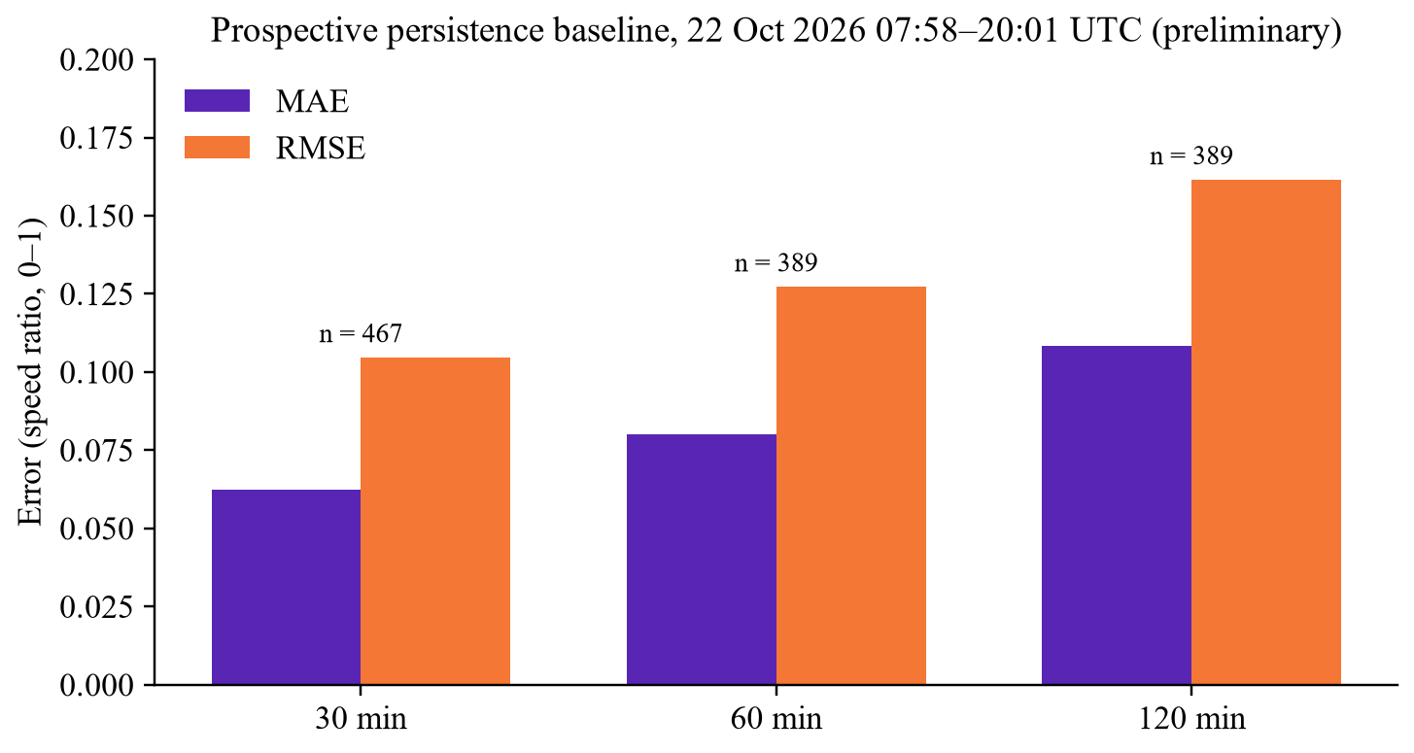
Figure 7. Earlier snapshot (22 Oct 2026, 07:58–20:01 UTC) of the prospective persistence baseline; the 23 Oct figures are in the Experiment 4 table of Chapter 6.
VIVA ANSWER — “Does your AI predict future traffic or only estimate current congestion?”
“Today our own models do not predict future traffic in the product. The system estimates current conditions from TomTom measurements, and future-departure travel times come from TomTom's prediction, labelled as such.
What we built is the forecasting pipeline that would decide whether our own model is good enough: time-ordered splits, three baselines, and a rule that a model must be 5% better than the best baseline at every horizon. On the public dataset no model passed, and on our own data we need 14 days. We are already logging real future baseline forecasts and scoring them — for example, persistence MAE is about 0.057 speed-ratio at 30 minutes.”

Chapter 8 Datasets and Data Quality
Table 19. Every dataset in the repository or database
Dataset | Location | Records / span | Provenance | Used for
Public daily traffic CSV | backend/Banglore_traffic_Dataset.csv | 8,936 rows × 16 columns; 2022-01-01 → 2024-08-09; 8 areas, 16 roads | Public, Kaggle-style; provenance undocumented [DOCUMENTED BUT NOT VERIFIED] docs/PROJECT_AUDIT.md | V1 training; V2 research task
Processed V1 CSV | backend/processed_dataset.csv | 8,936 rows × 6 columns | Output of filter_data.py | Not read by any current training script [VERIFIED IN CODE]
V1 evaluation subset | backend/traffic_dataset.csv | 492 rows; one road (Whitefield / Marathahalli Bridge); 2022-01-01 → 2024-08-08 | Subset; 479 rows identical to rows of the full CSV [VERIFIED BY TEST OR LOG] | V1 evaluation and tuning
Collected traffic | traffic_observations table | 883 rows (23 Oct 07:09 UTC), from 22 Oct 03:16 UTC; 26 points | TomTom Flow API, our collector | Map, history, insights, segment pipeline, prospective logging
Collected weather | weather_observations | 203 rows; 6 areas | Open-Meteo | Weather cards, route advisories
Incidents | incidents | 2,497 records (created/updated/deactivated over time) | TomTom Incident API + user reports | Map, route evidence, scoring
Gazetteer | places | 68,761 places | OpenStreetMap extract (ODbL) | Place search
Legacy SQLite file | backend/traffic.db | 12 KB; table predictions | Old V1 runtime file | Not referenced by current code [VERIFIED IN CODE]

8.1 The public dataset in detail
Columns (verified): Date, Area Name, Road/Intersection Name, Traffic Volume, Average Speed, Travel Time Index, Congestion Level, Road Capacity Utilization, Incident Reports, Environmental Impact, Public Transport Usage, Traffic Signal Compliance, Parking Usage, Pedestrian and Cyclist Count, Weather Conditions, Roadwork and Construction Activity. These match the field list from the earlier discussions. The title “Bangalore's traffic pulse (Insights into Urban Congestion and Commuter Behavior)” does not appear anywhere in the repository, so the exact source cannot be confirmed [UNKNOWN — NEEDS CONFIRMATION] .
Property | Value | Evidence
Areas → roads | Electronic City (Silk Board Junction, Hosur Road), Hebbal (Hebbal Flyover, Ballari Road), Indiranagar (100 Feet Road, CMH Road), Jayanagar (Jayanagar 4th Block, South End Circle), Koramangala (Sony World Junction, Sarjapur Road), M.G. Road (Trinity Circle, Anil Kumble Circle), Whitefield (Marathahalli Bridge, ITPL Main Road), Yeshwanthpur (Yeshwanthpur Circle, Tumkur Road) | [VERIFIED BY TEST OR LOG] pandas read
Types | Date and three text columns; integers (volume, incidents, pedestrian count); floats for the rest; Roadwork is Yes/No text | [VERIFIED BY TEST OR LOG]
Missing / duplicates / out of range | 0 / 0 / 0 | [VERIFIED IN EXPERIMENT RESULTS] data_validation
Target Congestion Level | mean 80.8, median 92.4, min 5.2, max 100; 43.5% of rows exactly 100 (capped) | [VERIFIED BY TEST OR LOG] / [VERIFIED IN EXPERIMENT RESULTS]
Traffic Volume / Average Speed | 4,233 – 72,039 (median 27,600) / 20.0 – 89.8 km/h | [VERIFIED BY TEST OR LOG]
Weather Conditions | Clear 5,426; Overcast 1,296; Fog 959; Rain 827; Windy 428 | [VERIFIED BY TEST OR LOG]
Temporal signal | lag-1 autocorrelation mean −0.008 (range −0.074 … 0.068); day-of-week spread 1.15 points | [VERIFIED IN EXPERIMENT RESULTS]
Correlation | Congestion vs same-day volume r = 0.84 | [VERIFIED BY TEST OR LOG]

KEY IDEA — What the quality checks mean
Real city traffic repeats daily and weekly and is strongly autocorrelated. This dataset shows essentially none of that — it behaves like independent draws around road-specific averages, consistent with synthetic generation. That explains why no forecaster beats the historical average on it, and it is why our real forecasting work moved to our own collected data.

8.2 Bias, size, representativeness, leakage
- Sample size. 16 roads × ~560 days, but only ~9 roads per day; the V1 evaluation set is 492 rows of one road with 99 test rows — far too small to generalise.
- Representativeness. 8 areas of a city with thousands of road segments; daily values cannot represent hourly peaks.
- Capped target. 43.5% at 100 means the model cannot distinguish “very bad” from “extremely bad”.
- Leakage. Same-day volume and speed make the target almost observable (r = 0.84).
- Training data vs live data. The public CSV trained V1 and the research task; the live collector data is the only data with real temporal structure, and it is still short. The two are never mixed.
- Live-data bias. 26 points chosen by us; one provider (TomTom); fetch-time timestamps; gaps when the host computer is off.

Chapter 9 External Integrations
“Configured” means a setting exists; “used” means our code calls it at runtime. Configuration names are listed; values are never shown.
Table 20. Integrations — configured vs actually used (23 Oct 2026)
Integration | Code | Config names | Status
TomTom Traffic Flow | TomTomProvider.flow_segment | TOMTOM_API_KEY, TOMTOM_DAILY_BUDGET | Used by collector every 30 min [VERIFIED BY TEST OR LOG]
TomTom Incidents | TomTomProvider.incidents | same | Used every 60 min [VERIFIED BY TEST OR LOG]
TomTom Routing | TomTomProvider.route_timing | same + TOMTOM_ROUTE_EVAL_MAX (5) | Used per route request [VERIFIED IN CODE]
Open-Meteo | OpenMeteoProvider.fetch/current | OPENMETEO_URL | Used by collector and routes [VERIFIED BY TEST OR LOG]
OSRM car / foot / bicycle | OSRMClient | OSRM_URL, OSRM_FOOT_URL, OSRM_BICYCLE_URL | Used; all three containers healthy [VERIFIED BY TEST OR LOG]
OpenStreetMap | Graph build scripts; gazetteer; map tiles | REACT_APP_TILE_URL (optional) | Used (data and tiles)
Firebase Authentication | auth/firebase.py; frontend/src/auth/firebase.js; mobile/src/firebase.ts | FIREBASE_PROJECT_ID, REACT_APP_FIREBASE_* | Implemented; not configured in running backend [VERIFIED IN CONFIGURATION]
Cloud Firestore | frontend/src/data/personal.js; firebase/firestore.rules | Firebase web config | Implemented; inactive without Firebase [VERIFIED IN CONFIGURATION]
Google Sign-In (mobile) | @react-native-google-signin/google-signin | Firebase / Google client IDs | Implemented; depends on Firebase setup [VERIFIED IN CODE]
Cloudflare Tunnel | tunnel service (profile) or a manually started quick tunnel | CLOUDFLARE_TUNNEL_TOKEN | Named tunnel prepared, not enabled; quick tunnel used for testing [VERIFIED IN CONFIGURATION] [DOCUMENTED BUT NOT VERIFIED]

9.1 TomTom
- Purpose: current speed and free-flow speed at 26 points; incidents in the Bengaluru box; traffic-aware travel time for each candidate route.
- Endpoints [VERIFIED IN CODE] : GET /traffic/services/4/flowSegmentData/absolute/10/json (point), GET /traffic/services/5/incidentDetails (bbox 77.35, 12.75, 77.90, 13.26), POST /routing/1/calculateRoute/{locations}/json with our route geometry as supporting points and departAt when departure is > 15 min ahead.
- Fields used: current and free-flow speed, confidence, road closure (flow); type, severity, geometry, start/end (incidents); travel time, traffic delay, no-traffic, historic and live times, length, departure/arrival (routing).
- Data nature: live at fetch; stored as history by the collector; route timings cached 5 minutes.
- Errors and fallback: every call passes QuotaGuard.acquire (2,000/day; background work cannot use the last 500). Missing key, 401/403 or exhausted quota → ProviderUnavailable; timeouts, network or bad JSON → ProviderError. Routes then fall back to OSRM free-flow time with a traffic_note; the collector retries with back-off ×2, ×4, ×8.
- Is TomTom connected to ML inference? No. TomTom flow is stored and becomes training/evaluation data for the segment pipeline and the prospective baselines. The legacy /predict takes user-typed volume and speed (TrafficInput), not TomTom data. TomTom route times are displayed and used for ranking, separately from any model [VERIFIED IN CODE] .
- Demo: route a car trip and show eta_basis: traffic_live and the TomTom source line; Admin → data freshness.

9.2 Open-Meteo
- Purpose: current weather for 6 areas (central, east, north, south, west, airport) and hourly weather for a route's departure time.
- Fields: temperature, precipitation, rain, weather code (WMO), wind speed, visibility.
- Use: stored by the collector; WeatherService.at for routes; advisories adds wet-road, low-visibility and thunderstorm notes. Weather does not change ETAs.
- Fallback: if unreachable, the route's weather source shows unavailable and the route is still returned.

9.3 OpenStreetMap and OSRM
- Data: Geofabrik India Southern-Zone extract clipped to 77.00–78.00 °E, 12.45–13.42 °N with osmium; built once per profile with osrm-extract, osrm-partition, osrm-customize (MLD) [VERIFIED IN CODE] infrastructure/osrm/prepare_graphs.sh.
- Servers: osrm-car (5000), osrm-foot (5001), osrm-bicycle (5002), each --max-alternatives 3, graphs read-only.
- Operations used: route (with alternatives and exclude toll/motorway/ferry), match (community traces), nearest (health check).
- Fallback: OSRM down → 503 routing_engine_unavailable; no road between points → 422 no_route.

9.4 Firebase Authentication and Firestore
- Purpose: optional managed sign-in (e-mail with verification, Google) and per-user personal data (favourites, journal, preferences).
- Backend: verifies ID tokens with the Admin SDK using only the project ID; requires verified e-mail; looks users up by Firebase UID; never auto-links by e-mail — /v1/auth/link needs the old password; roles come from our database, not token claims.
- Firestore rules: signedInOwner(uid) = signed in, same UID, email_verified == true.
- Status: FIREBASE_PROJECT_ID is empty in the running backend, so built-in accounts (bcrypt + JWT) are in use [VERIFIED IN CONFIGURATION] . Emulator tests are recorded in docs/TEST_REPORT.md [DOCUMENTED BUT NOT VERIFIED] .

Chapter 10 Routing and the Road Network

10.1 Road graph basics
A road network is a graph: junctions are nodes, road pieces are edges, and each edge has a weight (cost) such as travel time. A shortest-path algorithm (Dijkstra and its speed-ups) finds the path with the lowest total weight. OSRM pre-processes the graph with Multi-Level Dijkstra (MLD): it partitions the graph into cells (osrm-partition) and pre-computes costs inside cells (osrm-customize), so each query takes milliseconds. A profile (Lua script) decides which ways a vehicle may use and how fast — that is why car, foot and bicycle need separate graphs.
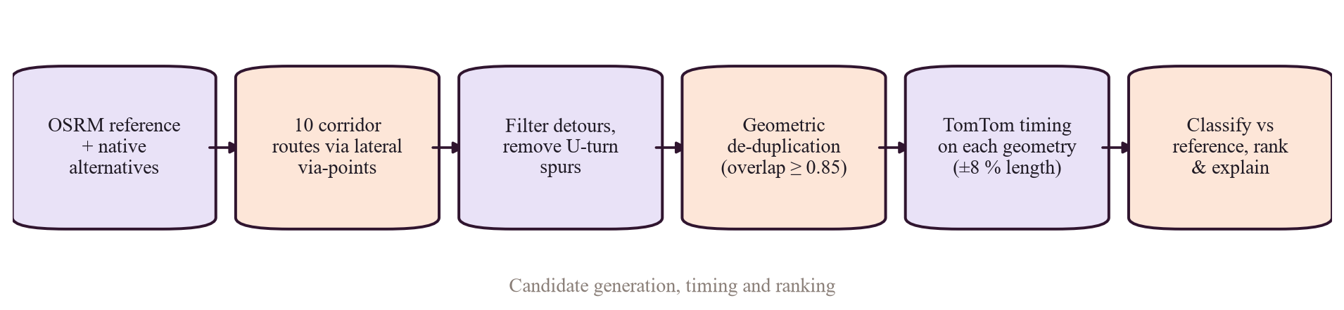
Figure 8. Route generation pipeline in RoutingEngine.plan.

10.2 How alternatives are generated
- OSRM returns the reference route plus up to 3 native alternatives.
- corridor_waypoints adds 10 candidates: for offsets of 7%, 14%, 24% and 34% of the trip length (min 300 m, max 7 km) on each side, via-points at 30% and 70% of the way; plus one midpoint via-point on each side at 18% (300 m – 6 km). Trips under 400 m get none.
- _filter_and_dedup sorts by duration and keeps up to min(max_routes, 5): it drops routes longer than 1.5 × reference + 1 km or slower than 1.5 × reference + 180 s, corridor routes with a U-turn spur > 120 m, and any route ≥ 85% similar to an already-kept one.
- Live benchmark trips considered 10–13 candidates and returned up to 5 [DOCUMENTED BUT NOT VERIFIED] docs/RESULTS_AND_LIMITATIONS.md.

Practicality and duplicate filters [VERIFIED IN CODE]
# backend/routing/engine.py — _filter_and_dedup (excerpt)
if cand.distance_m > 1.5 * ref_d + 1000 or cand.duration_s > 1.5 * ref_t + 180:
continue # impractical detour
if cand.origin_kind == "corridor" and backtrack_length_m(cand.coords) > MAX_BACKTRACK_M:
continue # via-point produced a U-turn spur
if any(route_similarity(cand.coords, k.coords) >= DUPLICATE_SIMILARITY for k in kept):
continue

10.3 Does live traffic change the route costs?
KEY IDEA — Important distinction
OSRM's edge weights are static (from the Lua profile's speeds). Live traffic does not change OSRM's weights, so OSRM by itself never avoids congestion.
Traffic enters after route generation: each finished candidate geometry is re-timed by TomTom (live, or predicted for a future departure). Ranking by “fastest”, “least traffic” or “balanced” then uses those traffic-aware times. So the choice among candidates is traffic-aware, but the candidates themselves come from a static graph.
A full traffic-aware navigation system would update edge weights continuously (e.g. OSRM customize with live speeds); that is [PLANNED / NOT IMPLEMENTED] .

10.4 Profiles and modes
Vehicle | OSRM server / Lua | Traffic timing | Avoid options | Note
Car | osrm-car / car.lua | TomTom (car) | toll, motorway, ferry | Dedicated
Motorcycle | osrm-car / car.lua | TomTom (motorcycle mode) | toll, motorway, ferry | car_graph_approximation disclosed in every response
Bicycle | osrm-bicycle / bicycle.lua | Not applied | — | Cycling speeds
Walk | osrm-foot / foot.lua | Not applied | — | ~5 km/h

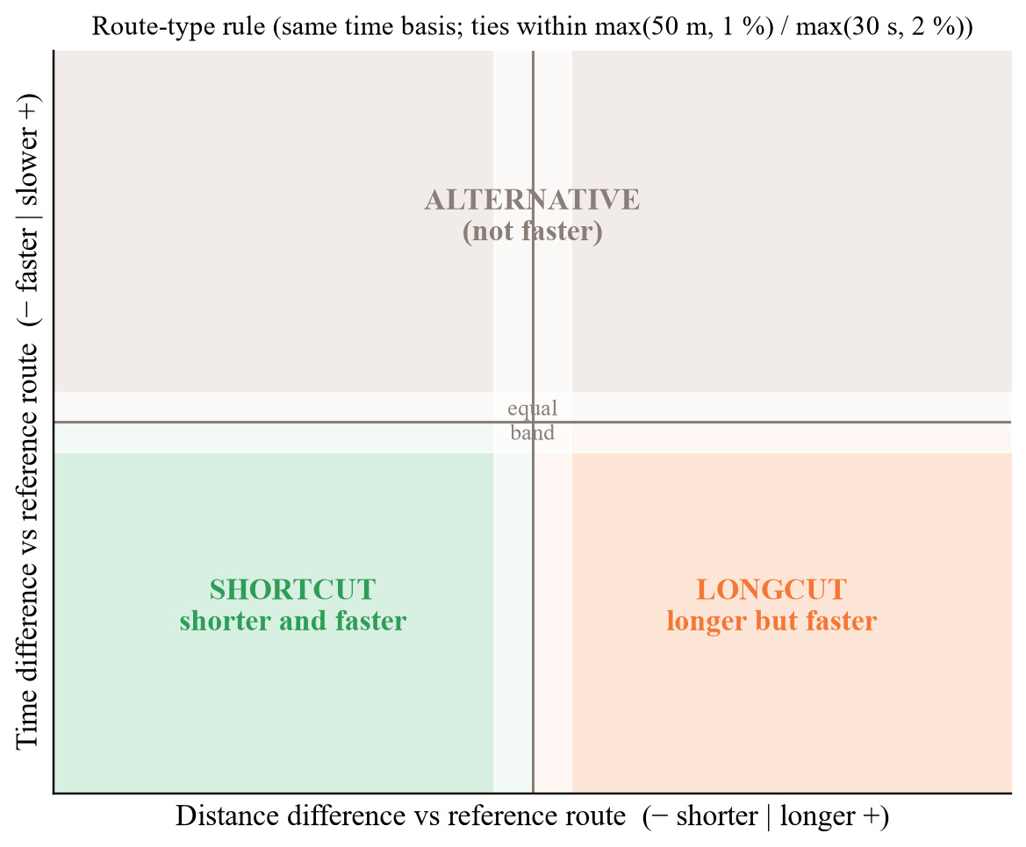
Figure 9. Shortcut / longcut decision on distance and time relative to the reference.

10.5 Shortcuts and user confirmations
Algorithmic shortcuts come from classify on every request. User-confirmed shortcuts are a separate pipeline [VERIFIED IN CODE] backend/community/service.py: a signed-in user submits a GPS trace (10–5,000 points, 2 min – 3 h, accuracy ≤ 50 m); the service removes GPS jumps, map-matches the trace on that vehicle's OSRM graph (confidence ≥ 0.5, coverage ≥ 90%), checks length consistency (0.8–1.3×) and plausible speed, and compares it with the reference route on one time basis. Matching submissions accumulate on a ShortcutCandidate; after 3 independent confirmations it moves to under_review, and only an admin can verify it. Verified shortcuts are shown on the Navigate map (/v1/community/shortcuts). They are not injected into route generation. No real community submissions are documented [UNKNOWN — NEEDS CONFIRMATION] .

10.6 Likely viva questions on routing
Q7. What is the difference between a routing engine and a traffic-aware navigation system?
A routing engine finds the cheapest path on a graph with given weights. A traffic-aware navigation system keeps those weights in sync with live traffic and re-routes while driving. OSRM is the former; we add traffic awareness by re-timing candidate routes with TomTom, not by changing the graph.
Q8. Which shortest-path algorithm do you use?
OSRM's Multi-Level Dijkstra: Dijkstra's algorithm on a graph partitioned into nested cells with pre-computed cell costs, which makes queries fast while still allowing weights to be re-customised.
Q9. What happens if a TomTom route does not follow our geometry?
We compare lengths; if they differ by more than 8% we reject TomTom's time for that route and say so in the route note, because it would be the time of a different route.
Q10. Why is the motorcycle routed on the car graph?
OSRM ships no motorcycle profile. We disclose car_graph_approximation in every motorcycle response instead of pretending.
Q11. Is your routing Bengaluru-wide?
The graph covers 77.00–78.00 °E, 12.45–13.42 °N, which contains the whole city; any two points with a road connection inside it can be routed. Traffic sampling (26 points) is much sparser than the routing coverage.

Chapter 11 Database and Persistence

11.1 Four words that are often confused
Term | Meaning | Example in this project
Database schema | The actual tables, columns, keys and indexes inside PostgreSQL. | Table trips with FK user_id → users.id
Migration | A versioned script that changes the schema from one version to the next. | 0003_firebase_identity.py adds Firebase identity columns
ORM model | A Python class mapped to a table. | class Trip(Base) in backend/db/models.py
API schema | The JSON shape the API accepts or returns (Pydantic). | TripOut, RouteRequestV2

11.2 Engine, sessions and persistence
- PostgreSQL 16 with PostGIS 3.4 (postgis/postgis:16-3.4), database pulse, bound to 127.0.0.1:5433 on the host only [VERIFIED IN CONFIGURATION] .
- Data lives in the named volume bp_pgdata, so it survives container restarts and rebuilds; only deleting the volume would erase it.
- Sessions: get_db gives each request its own session; session_scope wraps collector and background work in a commit/rollback block [VERIFIED IN CODE] backend/db/session.py.
- Migration ownership: only the backend runs alembic upgrade head (Dockerfile CMD), before it reports healthy; the collector waits for that [VERIFIED IN CONFIGURATION] .

11.3 The 17 tables
Table 21. Application tables (from backend/db/models.py)
Table | Holds | Key relationships
users | Accounts: e-mail, name, password hash (built-in), Firebase UID, role, active flag | PK id; referenced by trips, favourites, submissions, audit
revoked_tokens | JWT IDs revoked at logout | —
audit_log | Security-relevant actions (details JSON) | FK user
favourite_places | Saved places (built-in accounts) | FK user
trips | Saved route plans with chosen route summary | FK user
traffic_segments | The 26 monitored points (code, name, lat/lon, geometry) | referenced by observations, predictions
traffic_observations | Speed, free-flow speed, ratio, confidence, closure, observed_at | FK segment
weather_observations | Weather per area and time | —
incidents | TomTom and user-reported incidents, active flag, geometry | optional FK reporter
provider_calls | Every external API call: provider, endpoint, purpose, status | used by the quota guard
places | Gazetteer for search | —
shortcut_candidates | Community shortcut lifecycle and confirmations | referenced by submissions
route_submissions | Uploaded GPS traces and validation results | FK user, FK candidate
model_versions | Registry: task, algorithm, status (candidate/active/baseline), dataset, splits | referenced by evaluations, predictions
evaluation_records | One row per horizon × split × candidate × metric | FK model_version
prediction_records | Logged forecasts and later actuals | FK model_version, FK segment (cascade)
legacy_predictions | Outputs of the legacy /predict | —

Example index: ix_pred_segment_target on prediction_records(segment_id, target_time) speeds up attaching actuals [VERIFIED BY TEST OR LOG] (\d prediction_records).

11.4 PostgreSQL vs Firestore
Store | Responsibility | Access rule
PostgreSQL | Users and roles, trips, built-in favourites, observations, incidents, community data, model registry, logs | Only via the backend; every user query filters by user.id (e.g. Trip.user_id == user.id in api/me.py)
Firestore (when Firebase is configured) | Personal notes: favourites, journal entries, preferences under users/{uid}/… | Security rules: owner with verified e-mail only; no role or profile documents

11.5 Migration history
- 0001_initial_schema — all core tables.
- 0002_evaluation_candidate — candidate field for evaluation records.
- 0003_firebase_identity — Firebase identity on users. Current head; CI checks that migrations match the models.

Chapter 12 Frontend and Backend Request Flow

12.1 React and FastAPI in plain words
React builds the screen from components (small reusable pieces such as a route card). Each component keeps state; when state changes (for example, a route response arrives), React re-draws only what changed. Our app is a single-page app: the URL hash (#/traffic) decides which page component to show without reloading. FastAPI is a Python web framework: each function decorated with @router.get(...) or @router.post(...) becomes an HTTP endpoint; Pydantic models validate incoming JSON and shape outgoing JSON automatically; dependencies (Depends(...)) run before the function — we use them for authentication, database sessions and settings.

12.2 Traced examples
Table 22. Eight user actions traced through the code
Action | UI component | API client → HTTP | Endpoint | Validation / auth | Work done | Response → UI
Open homepage | HomePage.js, InsightStrip.js | api() → GET ×3 | /v1/traffic/segments, /v1/incidents, /v1/weather/current | app_access | Latest observation per point; active incidents; weather | Figures in the live strip
Load traffic map | TrafficPage.js, MapView.js | GET | /v1/traffic/segments | app_access | latest_segment_state SQL join; congestion_level; stale after 90 min | Coloured markers with age
Point history | TrafficPage.js | GET | /v1/traffic/segments/{id}/history | app_access; 404 if unknown | Observations for that segment | Chart
Weather | TrafficPage.js / InsightsPage.js | GET | /v1/weather/areas | app_access | Latest stored weather per area | Area cards
Request a route | NavigatePage.js → RouteResults.js | POST JSON body | /v1/routes | app_access; RouteRequestV2 (vehicle, preference, avoid, depart_at ≤ 7 d, max_routes 1–8) | RoutingEngine.plan (OSRM, TomTom, DB, Open-Meteo) | Polylines + cards + recommendation
Insights | InsightsPage.js | GET ×4 | segments, weather areas, /v1/forecast/models, incidents | app_access | Registry with stored metrics and note | Charts, registry status
Make a prediction | No current UI | POST | /predict (legacy) | app_access; TrafficInput (volume 0–500, speed 0–120) | ModelBundle.predict | JSON with legacy: true notice
Log in | AuthScreen.js → AuthContext.js | POST | /v1/auth/login | bcrypt check; legacy auth enabled | Issues HS256 JWT (60 min) | Token stored; pages unlocked
Save a trip | NavigatePage.js (save option) | POST with save_trip: true | /v1/routes | Signed-in user required | Inserts Trip with chosen route summary | Appears in Journal (/v1/me/trips)

CAUTION — Discrepancy found in the legacy endpoint
TrafficInput in backend/schemas.py allows traffic_volume only from 0 to 500, but the V1 model was trained on volumes of 4,233–72,039. Every legacy /predict call is therefore far outside the training range. No current UI calls /predict, so this does not affect the product, but do not demonstrate /predict as meaningful. [VERIFIED IN CODE] [VERIFIED BY TEST OR LOG]

12.3 Endpoint reference
Table 23. Backend endpoints (verified decorators in backend/api/*.py)
Method & path | Purpose | Auth
GET /health, /health/ready | Liveness; dependency readiness | Public
POST /v1/auth/register, /v1/auth/login | Built-in accounts | Public (when legacy auth enabled)
POST /v1/auth/link, /v1/auth/logout; GET/PATCH /v1/auth/me; POST /v1/auth/me/delete | Link Firebase to old account; sign out; profile; delete (confirm + recent sign-in) | Token
GET /v1/vehicles; POST /v1/routes | Vehicle profiles; plan routes (optionally save trip) | Signed-in
POST /routing/route (deprecated) | Old route API | Signed-in
GET /v1/traffic/segments, /v1/traffic/segments/{id}/history | Map state; history | Signed-in
GET /v1/weather/current, /v1/weather/at, /v1/weather/areas | Weather | Signed-in
GET /v1/incidents; POST /v1/incidents/report; GET /v1/incidents/mine | Incidents; user reports | Signed-in
GET /v1/forecast/models, /v1/forecast/segments/{id} | Registry; forecast (503 if no active model) | Signed-in
GET /v1/geocode/search, /v1/geocode/reverse | Place search | Signed-in
GET/POST /v1/me/favourites, DELETE /v1/me/favourites/{id}; GET/DELETE /v1/me/trips, /v1/me/trips/{id} | Own favourites and trips | Signed-in (own rows only)
POST /v1/community/submissions; GET /submissions/mine, /submissions/{id}, /shortcuts | Shortcut traces; verified shortcuts | Signed-in
/v1/admin/* (users, community candidates & decisions, mark-stale, submissions, pending incidents & decisions, data-freshness, models, forecast/online, system-health, audit-log) | Administration | Admin role
GET /, /locations, /history, /dashboard, /database-analytics, /hotspots, /incidents, /api/live-traffic, /api/live-traffic/bengaluru; POST /predict | V1 compatibility (stored data or legacy model) | Signed-in
/forecast, /analytics, /historical-trends, /commute-advisor | Removed simulated endpoints → 410 Gone | Signed-in

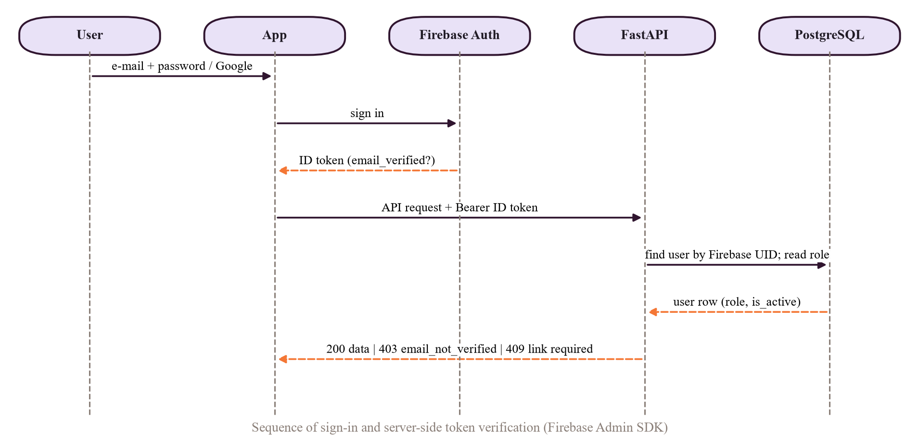
Figure 10. Sign-in sequence (built-in JWT and the optional Firebase ID-token path).

Chapter 13 Docker and Deployment

13.1 Concepts
- Image — a packaged, read-only snapshot of an application and its dependencies (built from a Dockerfile).
- Container — a running instance of an image.
- Docker Compose — one YAML file that defines all services, their network, ports, volumes and start order.
- Network — Compose puts all services on one private network where each is reachable by its service name (e.g. http://osrm-car:5000).
- Volume — storage that outlives containers (database files, model artifacts).
- Health check — a command Docker runs periodically to decide if a service is healthy; other services can wait for it.

Table 24. Services in docker-compose.yml [VERIFIED IN CONFIGURATION]
Service | Image / build | Port (host) | Health check | Depends on | Volumes
postgres | postgis/postgis:16-3.4 | 127.0.0.1:5433 | pg_isready | — | pgdata (bp_pgdata)
osrm-car | ghcr.io/project-osrm/osrm-backend:latest | 127.0.0.1:5000 | bash /dev/tcp nearest query | — | ./data/osm (ro)
osrm-foot | same | 127.0.0.1:5001 | same | — | ./data/osrm-foot (ro)
osrm-bicycle | same | 127.0.0.1:5002 | same | — | ./data/osrm-bicycle (ro)
backend | build ./backend → bengalurupulselite-backend | 127.0.0.1:8000 | Dockerfile HEALTHCHECK GET /health | postgres healthy | models, evaluations
collector | same image bengalurupulselite-backend; python -m traffic.collector | none | disabled | postgres healthy, backend healthy | models, evaluations
frontend | build frontend/Dockerfile (React build + nginx) | 8080 (all interfaces) | — | backend healthy | —
tunnel (profile tunnel) | cloudflare/cloudflared:2026.9.3 | none | — | frontend | —

- Environment: shared block x-backend-env (database URL, OSRM URLs, CORS, Firebase project ID, API_AUTH_REQUIRED, LEGACY_AUTH_ENABLED) plus secrets from the git-ignored backend/.env. Only variable names appear in the repository.
- Restart: every service has restart: unless-stopped, so they come back after a reboot of Docker.
- Migration ownership: the backend container runs python -m alembic upgrade head && uvicorn …; because its health check needs the server running, “backend healthy” implies “schema up to date”.
- Exposure: database, OSRM and backend bind to 127.0.0.1 only; only the frontend (8080) is reachable from the LAN, and it proxies /api.

13.2 Access modes
Mode | URL | Notes
Localhost | http://localhost:8080 | Web app; API at /api. Swagger docs at http://localhost:8000/docs on the host.
LAN | http://<computer-LAN-IP>:8080 | Same build works because the API base is relative (/api).
Public HTTPS (now) | A Cloudflare quick tunnel started by hand; it prints a random *.trycloudflare.com URL | Free, no account; the URL changes every restart, so it is never hard-coded [DOCUMENTED BUT NOT VERIFIED] docs/DEPLOYMENT_GUIDE.md.
Public HTTPS (prepared) | Named tunnel via the tunnel profile + CLOUDFLARE_TUNNEL_TOKEN | Stable hostname; requires a domain on Cloudflare — not enabled [VERIFIED IN CONFIGURATION] .

CAUTION — If the tunnel stops
The public URL stops working immediately (Cloudflare error page) and a restarted quick tunnel gets a new URL; the app itself keeps running on localhost/LAN. The Android build must point at a reachable URL. During the demo keep running: Docker Desktop with all 7 services, the tunnel terminal, and the host computer awake (the collector also needs it awake).

13.3 The collector migration incident (verified)
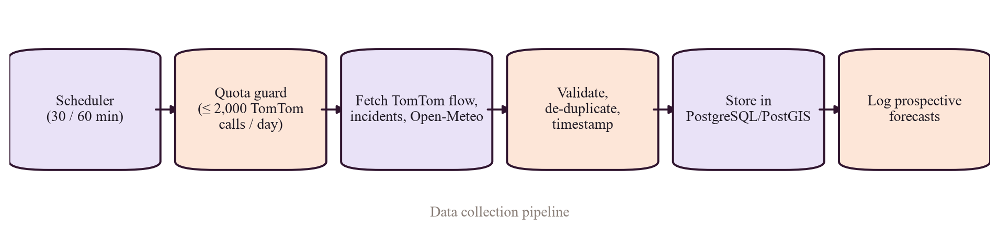
Figure 11. Collector data path: scheduler → quota guard → TomTom / Open-Meteo fetch → validation and de-duplication → PostgreSQL → prospective forecast logging.
Question | Answer | Evidence
What failed? | The collector container restarted in a loop: its start command ran alembic upgrade head, and Alembic in its image could not find revision 0003. | [VERIFIED BY TEST OR LOG] commit message 02f2f03
Why? | The collector had its own image tag built from ./backend. After migration 0003 was added, only the backend image was rebuilt and migrated the database to 0003; the collector kept an older image (still present locally as bengalurupulselite-collector, created 22 Oct 13:28 IST) whose code had no 0003 file. | [VERIFIED BY TEST OR LOG] git show 02f2f03; docker images
Fix | Collector now uses image: bengalurupulselite-backend, runs only python -m traffic.collector, and waits for backend: service_healthy. One image ⇒ code and schema can never diverge; one migration owner ⇒ no race. | [VERIFIED IN CONFIGURATION] docker-compose.yml lines 99–123
Validation | Collector restart count 0, running since 23 Oct 06:38 UTC; log shows flow sweep stored: 26, weather stored: 6, incident sweep, forecast logging; Alembic version 0003. | [VERIFIED BY TEST OR LOG] docker inspect, docker compose logs, SQL
Git state | HEAD 02f2f03 on v2-build; working tree clean before this guide. | [VERIFIED BY TEST OR LOG] git status --short, git log -1

13.4 Safe read-only commands for the review
Command | What it shows
docker compose ps | Every service, its image and status (Up / healthy).
docker compose logs --tail=100 collector | Last 100 collector lines: sweeps stored, quota messages, errors.
docker compose logs --tail=100 backend | Migration step at startup and recent API requests/errors.
git status --short | Uncommitted changes (should list only the new study guide).
git log -1 --oneline | The commit currently checked out (02f2f03 Compose: collector shares …).

NEVER CLAIM — Do not run during the review
docker compose down -v (deletes the database volume), any alembic downgrade, or anything that prints .env contents.

Chapter 14 Testing and Evidence
Table 25. Testing matrix
Component | Test performed | Evidence source | Expected | Verified result | Remaining gap
API surface | Status codes, auth guard, error shape | backend/tests/test_api.py (12 tests) | Correct codes; 401 unsigned | [DOCUMENTED BUT NOT VERIFIED] passing in docs/TEST_REPORT.md | No load test
Auth & roles | JWT revocation, expiry, forgery; admin-only routes | test_auth_rbac.py (14) | 401/403 correctly | [DOCUMENTED BUT NOT VERIFIED] | No penetration test
Firebase auth | Real RS256 tokens; wrong audience/issuer; unverified e-mail; linking; isolation | test_firebase_auth.py (16 functions) | Reject bad tokens; 403 unverified | [DOCUMENTED BUT NOT VERIFIED] 19 new tests passing | Live Firebase project not configured
Firestore rules | Ownership, cross-user denial, field validation | firebase/tests/firestore.rules.test.mjs | Deny non-owners | [DOCUMENTED BUT NOT VERIFIED] 7 passing (emulator) | Not run against production
Classification | Tolerances, basis mismatch | test_classification.py (8) | Correct labels | [DOCUMENTED BUT NOT VERIFIED] | —
Engine & geometry | Candidates, filters, timing rejection, scoring | test_engine.py (15), test_geometry_scoring.py (9) | Practical, distinct routes | [DOCUMENTED BUT NOT VERIFIED] | OSRM-dependent tests skip without graphs (CI)
Community | Trace cleaning, matching, confirmations | test_community.py (9) | Reject bad traces | [DOCUMENTED BUT NOT VERIFIED] | No real community data
Providers & ingest | Parsing, quota, de-duplication | test_providers_ingest.py (15) | Robust parsing; budget enforced | [DOCUMENTED BUT NOT VERIFIED] | —
Forecasting | Splits, leakage, baselines, gating, serving | test_forecasting.py (6), test_forecast_online.py (8) | No activation without beating baselines | [DOCUMENTED BUT NOT VERIFIED] synthetic fixtures only | No real model to test
Live integration | Real OSRM/PostGIS | test_integration_live.py (4) | Routes returned | [DOCUMENTED BUT NOT VERIFIED] | Needs local stack
Frontend | Sign-in gate, token handling, pages | App.test.js, AuthFirebase.test.js, Pages.test.js | Render and guard | 19 test cases in files [VERIFIED IN CODE] ; 15 recorded passing in docs/TEST_REPORT.md [DOCUMENTED BUT NOT VERIFIED] | No end-to-end browser suite in CI
CI | 4 jobs incl. migrations-match-models and non-root image | .github/workflows/ci.yml | Green | [UNKNOWN — NEEDS CONFIRMATION] not re-checked for this guide — open the GitHub Actions page before the review | —
Running system | Container health, collector activity | docker compose ps, logs, SQL counts | Healthy; data growing | [VERIFIED BY TEST OR LOG] 23 Oct 2026 | Uptime depends on host PC

KEY IDEA — HTTP 200 is not a test
A 200 response only proves the server answered. Our evidence is the assertions in the test files (correct values, rejected tokens, rejected traces) and the measured results files. Say “134 automated backend tests pass in CI, recorded in the test report”, not “everything works”.

14.1 Live demonstration checklist
Item | What to show | Evidence that supports you
Homepage | Live strip numbers | They match /v1/traffic/segments counts
Authentication | Sign in; try a page while signed out (blocked); wrong password keeps you on the form | app_access; 401 without token
Traffic map | 26 points, colours, age in minutes; click one for history | observed_at ≤ 90 min ⇒ fresh
Weather | Area weather; a route's weather advisory | Open-Meteo source line
Routing modes | Same trip as car, bicycle, walk; motorcycle note | Different OSRM servers; profile_status
Shortcut / longcut | A trip with a classified alternative (e.g. Whitefield → Electronic City) | Classification badge + reason
Insights | Registry card: research model candidate | /v1/forecast/models note
ML / forecasting | Explain “no active model”; show research-daily-congestion.json | Experiment tables (Chapter 6)
Data collection | docker compose logs --tail=20 collector | “Flow sweep: stored 26”
Persistence | Trip saved yesterday still in Journal after restarts | bp_pgdata volume
Mobile | Android app: route and traffic screens | Same API, same results
Public link | Open the current tunnel URL on a phone | HTTPS padlock; URL is temporary — check it on the morning of the review

Chapter 15 Limitations, Risks and Future Work

15.1 Current limitations (facts)
Table 26. Honest assessment
Area | Limitation now | Effect
Dataset quality and volume | Public CSV has no temporal signal, 43.5% capped target, undocumented source; V1 evaluation set is one road, 492 rows | No credible forecaster from it
Traffic-data availability | 26 points, one provider; history since 22 Oct 2026 | Sparse, short
Model generalisation | No active model; V1 is same-day estimation | No ML predictions in product
Temporal validation | Implemented, but own-data evaluation needs ≥ 14 days | Pending
Forecast horizons | +30/+60/+120 min defined; +15 min infeasible within budget | Horizon choice constrained
Data freshness | Observations stale after 90 min; fetch-time timestamps | Small timing error
Geographic coverage | Routing city-wide; traffic sampling only 26 points | Map colours are samples, not coverage
Route costs | OSRM weights are static; traffic applied after candidate generation; TomTom times ≤ 5 routes | Candidates may miss a traffic-optimal path
API limits | TomTom 2,000/day cap, 500 reserved for users; storage terms of provider data not confirmed | Throttled growth; licensing question
Collector reliability | Runs on a personal computer; gaps when it sleeps; restart loop happened once (fixed) | Gaps in history
Authentication & security | Firebase not configured live; built-in JWT with 60-min tokens; no external security audit | Adequate for demo, not audited
Temporary public hosting | Quick-tunnel URL changes on restart; no uptime guarantee | Link must be re-checked
Mobile deployment | Android only; not on Play Store; depends on a reachable backend URL | Install via APK
Reproducibility | OSM graphs and .env are not in Git (by design); V1 numbers not re-run; features.py/baseline.py empty | Setup requires the guide
Novelty evidence | No user study, no ETA accuracy comparison with other platforms | No superiority claim possible

15.2 Future work, prioritised
Priority | Work | Impact | Feasibility
1 | Keep the collector running ≥ 14 days, then run the segment evaluation and publish per-horizon results (already automated) | High | High
2 | Add prediction-vs-actual plots for V2 and the prospective log | High | High
3 | Host the stack on an always-on machine / VM to remove collection gaps; enable the named tunnel | High | Medium (cost)
4 | Measure ETA accuracy: record predicted vs actual trip times from submitted GPS traces | High | Medium
5 | Configure Firebase in production; external security review | Medium | High
6 | Traffic-adjusted OSRM weights (periodic customize with observed speeds) | Medium | Low–Medium
7 | Anomaly detection on segment residuals; scenario (what-if) analysis | Medium | Medium — only after a validated model
8 | Spatiotemporal / graph neural models | Unknown | Low — needs months of dense data

VIVA ANSWER — When the examiner finds a real weakness
1. Agree plainly: “Yes, that is a limitation.”
2. Show you measured it: “We know it because … (number / file).”
3. Explain the safeguard: “That is why the product does X instead of claiming Y.”
4. Give the next step: “The fix is …, and it is already automated / planned.”
Example: “Yes, we have no validated forecaster. The pipeline refused to activate ridge because it was 0.6% worse than the historical average, so the app uses TomTom predictions and labels them. After 14 days of collection the same pipeline evaluates our own data automatically.”

Chapter 16 Complete Viva Question Bank
Questions are numbered continuously through the whole guide (earlier chapters contain a few already). Answers are short on purpose: say the answer, then offer to show the file.

16.1 Basic project understanding
Q12. What is Bengaluru Pulse V2 in one sentence?
A traffic decision-support system for Bengaluru that compares several realistic routes with evidence-labelled travel times and explanations, collects its own traffic history, and evaluates forecasting models honestly before using them.
Q13. What does V2 change compared with V1?
V1 had a same-day Random Forest estimator and simulated dashboards (random forecasts, hotspots, trends). V2 removed the simulations (410 Gone), added OSRM multi-route planning, TomTom timing, classification, a collector, PostgreSQL/PostGIS, authentication, a mobile app and an evaluation-first forecasting pipeline.
Q14. Who are the users?
Commuters (plan and compare routes, see traffic), administrators (moderate community data, manage roles, monitor data and models), and researchers/examiners (inspect evaluation reports).
Q15. What can a user do today?
Sign in; plan routes for car, motorcycle, bicycle or walking; see shortcut/longcut labels, incidents and weather; view the traffic map and history; read insights; save trips; submit shortcut traces and incident reports.
Q16. What can it not do today?
Serve our own traffic forecasts (no model has passed evaluation), re-route during a drive, or cover every road with traffic sensors.

16.2 Problem statement and objectives
Q17. What problem are you solving?
Commuters get one route and one ETA without reasons or comparison; and traffic-ML projects often over-claim accuracy. We provide transparent route comparison and a methodologically honest forecasting process.
Q18. List your main objectives.
Multi-route planning, validated traffic timing, shortcut classification, evidence-based explanations, own data collection within quota, evaluation-gated forecasting, secure accounts, reproducible deployment.
Q19. Which objectives are fully met?
All except a validated forecasting model; that one is limited by data volume, not by missing code.
Q20. Why Bengaluru?
Severe, variable congestion and a complex road network where alternative routes genuinely differ, plus local relevance for us.
Q21. What is the scope boundary?
Bengaluru bounding box; four vehicle types; no turn-by-turn navigation; no traffic-weighted graph; no superiority claims.

16.3 Novelty and comparison with Google Maps
Q22. Is your app better than Google Maps?
We have not compared them experimentally, so I don't claim that. Our aim is different: transparent comparison of alternatives with evidence, and honest evaluation of forecasting.
Q23. What do you show that a normal map app does not?
Several distinct routes side by side, each labelled shortcut, longcut or alternative against the reference with tolerances, the ETA basis (live, predicted, free-flow), data-source status and freshness, and a written reason.
Q24. Why is this not just a mini-project?
It integrates three routing servers, two providers, a spatial database with migrations, a continuous collector with quota control, an ML pipeline with temporal validation and gating, auth with roles, two clients, CI and a containerised public deployment.
Q25. What would prove your system adds value?
A study comparing predicted and actual travel times across systems on the same trips, and a user study on decision quality. Neither has been done yet.
Q26. What is the single most defensible contribution?
The evaluation-first discipline: we showed the V1 R² of 0.96 came from same-day inputs (0.23 without them) and built a pipeline that will not activate a model unless it beats baselines by 5% at every horizon.

16.4 System architecture
Q27. Name your Docker services.
postgres, osrm-car, osrm-foot, osrm-bicycle, backend, collector, frontend, plus an optional tunnel profile.
Q28. Why three OSRM servers?
OSRM builds one graph per Lua profile and ignores the profile name in the URL, so car, foot and bicycle each need their own server.
Q29. How does the frontend reach the backend?
Same origin: nginx serves the React build and proxies /api/* to backend:8000, stripping the /api prefix.
Q30. Does the collector call the API?
No. It shares the backend code and writes to PostgreSQL directly.
Q31. Where is the system's state stored?
PostgreSQL (volume bp_pgdata), model artifacts and reports in the models and evaluations volumes; Firestore only for personal notes when Firebase is configured.

16.5 File structure and code responsibilities
Q32. Where is the routing logic?
backend/routing/engine.py (RoutingEngine.plan), with classification.py, scoring.py, geometry.py, osrm_client.py, route_profiles.py.
Q33. Where are the endpoints registered?
backend/main.py create_app(); routers live in backend/api/.
Q34. Where is the collector?
backend/traffic/collector.py; storage helpers in traffic/ingest.py.
Q35. Where is the ML pipeline?
backend/forecasting/pipeline.py; prospective logging online.py; serving predictor.py and segment_model.py.
Q36. Which files are legacy?
train_model.py, filter_data.py, services.py, api/legacy.py, backend/evaluation/*.py and the .pkl artifacts.

16.6 React and frontend
Q37. How does page navigation work?
A hash router in App.js (useHashPage) maps #/home, #/navigate, … to page components; unsigned users see the sign-in screen.
Q38. How are API calls made?
Through one wrapper, api(path, options) in frontend/src/api/client.js, which adds the base URL and the bearer token.
Q39. Which map library do you use?
Leaflet via react-leaflet with OpenStreetMap tiles (components/MapView.js).
Q40. How are charts drawn?
Recharts on the Traffic and Insights pages.
Q41. How is the API base URL chosen?
frontend/src/config.js: /api in production builds, http://localhost:8000 in development, overridable by REACT_APP_API_BASE_URL at build time.

16.7 FastAPI and backend
Q42. Why FastAPI?
Typed request/response validation with Pydantic, async support for parallel OSRM/TomTom calls, dependency injection for auth and sessions, and automatic OpenAPI docs.
Q43. How do you call OSRM in parallel?
asyncio.gather with a semaphore of 5 for corridor routes; TomTom timing uses a semaphore of 4.
Q44. How are errors returned?
As {"error": {"code", "message"}} via AppError subclasses in core/errors.py.
Q45. What validates a route request?
RouteRequestV2: vehicle enum, preference enum, avoid options supported by that profile, departure not in the past and within 7 days, max_routes 1–8, origin ≠ destination (≥ 30 m).
Q46. What does /health/ready check?
A dependency report; it is critical only if the database or the car OSRM fails, otherwise it reports degraded components.

16.8 Database and migrations
Q47. Why PostgreSQL with PostGIS?
Reliable relational storage with spatial types and functions for geographic data, in one well-supported image.
Q48. How many tables, and which are most important?
17. Most important: users, trips, traffic_segments, traffic_observations, incidents, model_versions, evaluation_records, prediction_records.
Q49. What is Alembic?
A migration tool for SQLAlchemy: versioned scripts (0001 → 0002 → 0003) that change the schema in order; the current head is 0003.
Q50. Who runs migrations?
Only the backend container, before serving. The collector waits for the backend to be healthy.
Q51. How is one user's data kept from another?
Every query on personal tables filters by the authenticated user's id, e.g. Trip.user_id == user.id; Firestore rules require the same UID and a verified e-mail.

16.9 Machine-learning fundamentals
Q52. What is overfitting?
When a model memorises training noise and performs worse on new data; we detect it by evaluating on later, unseen time periods.
Q53. What is data leakage?
When inputs contain information unavailable at prediction time, such as same-day volume when predicting same-day congestion; it inflates scores.
Q54. Why use a validation set as well as a test set?
Validation chooses the model and settings; the test set is used once at the end so the final number is not tuned to it.
Q55. What is a baseline and why is it essential?
A simple predictor (yesterday's value, last week's value, the historical average). If a learned model cannot beat it, the model adds nothing.
Q56. What is the difference between regression and classification?
Regression predicts numbers (speed ratio); classification predicts categories. Our congestion categories are threshold rules, not a classifier.

16.10 Actual model algorithms
Q57. Which algorithms exist in your code?
V1: Random Forest (with Linear Regression, Decision Tree, Gradient Boosting compared in train_model.py). V2: Ridge regression and HistGradientBoosting, plus three baselines.
Q58. How does a Random Forest work?
It trains many decision trees on bootstrap samples with random feature subsets and averages their predictions, which reduces variance.
Q59. Why Ridge?
A linear model with L2 regularisation: stable with correlated lag features, fast, interpretable, and a strong sanity check against complex models.
Q60. What is HistGradientBoosting?
Gradient-boosted trees on binned features: each tree corrects the previous trees' errors; fast on tabular data and handles missing values.
Q61. Which model is active today?
None. The research model is candidate; the segment task has insufficient data; only baselines are logged.

16.11 Dataset and preprocessing
Q62. Describe the public dataset.
8,936 daily rows, 16 columns, 8 areas and 16 roads, 1 Jan 2022 – 9 Aug 2024, no missing values; target congestion level 0–100, 43.5% capped at 100.
Q63. Is it real data?
Its source is undocumented. It shows no autocorrelation (−0.008) and almost no weekly pattern (1.15 points), which is consistent with synthetic data, so we treat results on it cautiously.
Q64. What is the 492-row file?
traffic_dataset.csv: one road (Whitefield, Marathahalli Bridge). The V1 tuning and final evaluation used it — so area and road features were constant.
Q65. How were categorical features encoded?
V1 used LabelEncoder (integer codes). V2 does not use the public categorical columns; road identity enters through the historical-average feature.
Q66. How does V2 handle missing values?
Training-set medians fill missing feature values (_fit_predict); missing actuals are never interpolated — they are counted as missing.

16.12 Model comparison
Q67. Compare your models fairly in one sentence.
On the same chronological test set (1 day ahead, n = 1,791), the historical average had MAE 15.99, ridge 16.08, seasonal naive 19.74 and persistence 20.22.
Q68. Why did the more complex model not win?
The dataset has no temporal signal, so there is nothing for lags and trees to learn beyond each road's average.
Q69. Can you compare V1's R² 0.96 with V2's R² 0.23?
Not directly: V1 estimated same-day congestion from same-day measurements; V2 forecasts the next day without them. Different tasks.
Q70. Why was HistGradientBoosting not selected?
Its validation MAE (16.52–17.28) was worse than ridge's (16.015).
Q71. What is your strongest baseline?
The historical average (per road and weekday, from training data only).

16.13 Evaluation metrics
Q72. Why MAE as the selection metric?
It is in the target's units and robust to occasional large errors, so it is easy to interpret and compare with baselines.
Q73. Why also report RMSE?
It penalises large errors more; comparing RMSE with MAE shows whether errors are occasionally large.
Q74. Can R² be negative?
Yes — persistence had R² −0.54 on the test set, meaning worse than predicting the mean.
Q75. Is R² 0.96 equal to 96% accuracy?
No. R² is variance explained relative to the mean; accuracy is the share of correct class labels.
Q76. What is sMAPE?
Symmetric mean absolute percentage error: 2|e|/(|y|+|ŷ|) averaged and expressed in percent.

16.14 Time-series forecasting
Q77. What is a forecast origin and horizon?
The origin is the time the forecast is made; the horizon is how far ahead the target is (30, 60, 120 minutes).
Q78. Why split by target time?
So that every test target lies after every training target; this mimics real use and prevents learning from the future.
Q79. What are lag 47 and lag 335?
On a 30-minute grid, 47 steps ≈ one day earlier and 335 steps ≈ one week earlier, capturing daily and weekly patterns.
Q80. What is prospective evaluation?
Making forecasts now and scoring them when the future arrives — the strongest protection against leakage. forecasting/online.py does this.
Q81. Why need 14 days?
To have enough weekly cycles for train, validation and test periods with a meaningful number of test samples (≥ 500).

16.15 Live data integrations
Q82. What does TomTom provide?
Flow (current and free-flow speed) at our 26 points, incidents in the city box, and route travel times now or for a departure time.
Q83. What happens when TomTom is unavailable?
Routes fall back to OSRM free-flow times with a note; the data-source list shows unavailable; the collector backs off and retries.
Q84. How do you stay within the free tier?
A database-backed quota guard caps non-tile calls at 2,000 per UTC day and keeps 500 for interactive users; route timing is limited to 5 routes and cached for 5 minutes.
Q85. What does Open-Meteo provide?
Current and hourly temperature, precipitation, rain, weather code, wind and visibility; used for advisories, not ETAs.
Q86. Is TomTom data fed into your ML model?
Only as training and evaluation data for the segment pipeline and the prospective baselines. No model uses it for live inference yet.

16.16 OSRM and road-network routing
Q87. Does OSRM understand live traffic?
No. Its weights come from static profile speeds. We apply traffic afterwards by re-timing each candidate with TomTom.
Q88. What are edge weights?
The cost of traversing a road segment, typically travel time; the shortest path minimises their sum.
Q89. How do you avoid returning the same route five times?
Routes that overlap an already-kept route by ≥ 85% (resampled geometry within 40 m) are dropped.
Q90. What is a longcut?
A route that is longer in distance but faster in time than the reference, beyond the tolerances (50 m/1% distance, 30 s/2% time).
Q91. Why might a route be unclassified?
If its time basis differs from the reference's (for example TomTom timing rejected for one route), comparing them would be unfair.

16.17 Authentication and security
Q92. How is user data protected?
All non-health endpoints require a token; passwords are bcrypt-hashed (12 rounds); JWTs expire in 60 minutes and can be revoked; per-user queries; admin router requires the admin role; database and backend ports bind to localhost; secrets live in git-ignored .env files.
Q93. How does Firebase sign-in work with your backend?
The client gets a Firebase ID token; the backend verifies it with the Admin SDK for our project ID, requires a verified e-mail and finds the user by Firebase UID.
Q94. Can a token claim make someone admin?
No. Roles come from our users table; token claims are ignored.
Q95. How is account deletion protected?
It needs an explicit confirmation and a sign-in within the last 300 seconds.
Q96. Is Firebase active right now?
No — the backend's Firebase project ID is empty, so built-in accounts are used. The Firebase path is implemented and tested on the emulator.

16.18 Docker and deployment
Q97. How do you start the system?
docker compose up -d (with --build after code changes); OSRM graphs are pre-built once and mounted read-only.
Q98. What makes the backend healthy?
Its Dockerfile health check gets HTTP 200 from /health, which only happens after migrations ran and the server started.
Q99. What was the collector incident?
The collector had its own stale image and ran migrations at start; it could not find revision 0003 and looped. It now shares the backend image, does not migrate, and waits for the backend.
Q100. What happens if the public URL changes?
Nothing breaks locally; the web app uses relative /api, so it works on any URL. We share the new quick-tunnel URL; the stable named tunnel is prepared but needs a domain.
Q101. What must run during the demo?
Docker Desktop with the seven services, the tunnel process, and the laptop kept awake.

16.19 Testing and debugging
Q102. How many automated tests do you have?
13 backend test files; the test report records 134 backend tests passing, 7 Firestore-rules tests and frontend tests (15 recorded; 19 test cases now in the files).
Q103. How do you test forecasting without real data?
With clearly labelled synthetic fixtures that check the machinery — splits, leakage, baselines, gating — never to report results.
Q104. What runs in CI?
Four jobs: backend tests plus a check that migrations match the models, frontend tests and build, mobile checks, and Docker image checks (non-root, /health).
Q105. Describe a real bug you fixed.
nginx cached the backend's IP, so after a backend container was recreated the site returned 502. We made nginx resolve the backend at request time (resolver 127.0.0.11 and a variable proxy_pass).
Q106. How do you debug a failed route?
Check sources[] in the response, docker compose logs backend, and OSRM health; no_route means a point is off the road network.

16.20 Limitations and future work
Q107. What is the weakest part of the current system?
Forecasting: no validated model yet, because our own data is too short and the public data has no temporal signal.
Q108. What would you do with three more months?
Run collection continuously on an always-on host, evaluate 30/60/120-minute models against baselines, add prediction-vs-actual plots, and measure ETA accuracy from GPS traces.
Q109. Why only 26 monitored points?
The TomTom free tier: 26 points every 30 minutes is about 1,248 calls a day within a 2,000 cap that also serves users.
Q110. Is the dataset licence a concern?
TomTom storage terms for collected data are not confirmed; this is a listed limitation.
Q111. What would you change in the architecture?
Traffic-adjusted OSRM weights and a hosted deployment with a stable domain.

16.21 Research methodology and evidence
Q112. How do you know your evaluation is valid?
Chronological split by target time, features only from the origin, historical average from training data, selection on validation, a single test evaluation, and prospective scoring of truly future forecasts.
Q113. Is your test set truly unseen?
Yes for V2: test targets (Feb–Aug 2024) lie after all training and validation targets and were evaluated once. Not for the V1 evaluate_model.py numbers, which reuse training rows.
Q114. How did you prevent data leakage?
No same-day measurements in V2 features; lags only backward; historical average from training rows; split by target time.
Q115. Why should I trust your model?
You should not trust any model by default — that is why ours is gated. Today we do not ask you to trust one: no model is active, and the product says so.
Q116. How reproducible are your results?
The V2 report JSON stores the data checks, splits and all metrics, and python -m forecasting.pipeline research regenerates it; V1 scripts exist but their numbers were not re-run for this review.

16.22 Difficult examiner challenges
Q117. What exactly is the research contribution?
Demonstrating, with a reproducible pipeline, that the earlier high score was same-day estimation and that the public data cannot support forecasting; and building an evaluation-gated forecasting process on newly collected local data.
Q118. Why is this not just an API integration?
Because the value is in what we do with the API outputs: generating, filtering, validating, classifying, scoring and explaining routes, and collecting and evaluating data — all our own code.
Q119. Why did you choose these algorithms?
Ridge as a regularised linear benchmark and gradient boosting as a strong tabular learner — both standard and fast enough for daily retraining on a laptop; neural models are not justified by our data size.
Q120. Can your model predict future congestion?
Not yet in a validated way. The pipeline is ready; the data is not.
Q121. What happens if your collector stops?
History gets a gap (counted as missing, never interpolated); routing still works because it uses OSRM and live TomTom; on restart the collector resumes from the last stored timestamps.
Q122. What did you personally implement, and what comes from libraries or services?
Libraries/services: OSRM (shortest paths), TomTom and Open-Meteo (data), scikit-learn (algorithms), FastAPI/React/Leaflet (frameworks), Firebase (identity). Ours: route candidate generation and filtering, timing validation, classification, scoring and explanations, collector and quota guard, schema and migrations, forecasting pipeline and gate, prospective logging, community validation, auth integration, UI, deployment configuration.

Chapter 17 Presentation and Live Demonstration Script
CAUTION — Verify before you speak
Items marked ⚠ change over time. On the morning of the review: run docker compose ps, open the current tunnel URL on your phone, sign in, plan one car route and note its numbers, and re-read the collected row counts (they will be higher than in this guide).

17.1 30-second introduction
“Good morning. Our project is Bengaluru Pulse V2, a traffic decision-support system for Bengaluru. For any trip it builds several genuinely different routes on an OpenStreetMap road graph, times them with TomTom traffic, labels each as a shortcut, longcut or alternative, and explains the recommendation. In the background it collects its own traffic data and evaluates forecasting models against simple baselines before ever using them.”

17.2 Two-minute overview
“The problem: commuters usually get one route and one ETA, without reasons or comparison. Our system has a React web app and an Android app on a FastAPI backend. For a trip we get the normal route and alternatives from our own OSRM servers, add corridor routes, remove detours and duplicates, and time each with TomTom — accepting the time only if TomTom's route matches ours within 8%. Then we classify and rank them and explain the choice.
Separately, a collector stores speeds at 26 points, weather for 6 areas and incidents. Our forecasting pipeline uses time-ordered splits and three baselines, and a model is switched on only if it is 5% better than the best baseline at every horizon. Today none is, so future ETAs come from TomTom and are labelled that way. Let me show you.”

17.3 Five-minute live demonstration
Time | Say | Point to on screen
0:00 | “This is the public HTTPS link; every page requires sign-in.” | Address bar ⚠ (current tunnel URL); sign-in screen
0:30 | “The home page shows live figures from our database.” | Live strip: monitored points, incidents, weather
1:00 | “Let's plan Whitefield to Electronic City by car, leaving now.” | Navigate page: place search, vehicle, preference
1:30 | “We get several routes. This one is the reference; this one is a shortcut — shorter and faster beyond our tolerances. The ETA basis says live TomTom traffic.” | Route cards: classification badge, ETA basis ⚠ (numbers vary)
2:15 | “Here is why it was recommended, and every data source with its status — OSRM, TomTom, incidents, our observations, weather, and the forecast model, which is honestly ‘unavailable’.” | Route detail: reason, sources list
2:45 | “Same trip by bicycle uses a different road graph and does not apply car traffic.” | Switch vehicle; note text
3:15 | “The traffic page shows our 26 monitored points, coloured by speed ratio, with how old each reading is.” | Traffic page; click a point → history
3:45 | “The collector is running: here are its last sweeps.” | Terminal: docker compose logs --tail=20 collector
4:15 | “Insights shows the model registry: our research model is ‘candidate’ because it did not beat the historical average.” | Insights page: registry card
4:45 | “The same API powers the Android app.” | Phone: route screen

17.4 Ten-minute technical presentation (outline with transitions)
- Problem and goal (1 min) — “To explain why we built it this way, let me start with the problem…”
- Architecture (1.5 min) — show the architecture figure; “Each box is a container; let me follow one request through it.”
- Routing pipeline (2 min) — candidates → filter → timing validation → classification → scoring. “The key idea is that every number carries its source.”
- Data collection (1 min) — schedule, quota guard, storage. “This collected data is what our forecasting relies on.”
- ML pipeline (2 min) — features at origin, chronological split, baselines, gate; results table. “And here is the honest result.”
- Re-examining V1 (1 min) — R² 0.96 → 0.23 without same-day inputs. “This is why we now gate models.”
- Security and deployment (1 min) — auth classes, Compose, tunnel, CI.
- Limitations and next steps (0.5 min) — data length, sparse points, no user study.

17.5 Short scripts by topic
Topic | What to say
Architecture diagram | “From left: web and Android clients reach nginx through the tunnel; nginx serves the app and forwards /api to FastAPI. FastAPI uses three OSRM servers, TomTom, Open-Meteo and PostgreSQL. The collector, bottom right, fills the database on a schedule.”
ML model | “The target is the speed ratio at a point 30, 60 or 120 minutes ahead. Features use only what is known at the forecast time — recent values, the value a day and a week earlier, rolling statistics and time of day. Ridge and gradient boosting compete with three baselines on a later time period.”
Model comparison | “On the public dataset's chronological test, the historical average had MAE 15.99, ridge 16.08, persistence 20.22 — so no learned model was activated. The V1 forest's R² 0.96 was same-day estimation.”
External integrations | “TomTom gives flow, incidents and route times; Open-Meteo gives weather; OpenStreetMap gives the road graph and place names; Firebase is an optional sign-in path, currently not configured.”
Routing | “OSRM finds paths on a static graph; we generate extra corridor candidates, keep distinct practical ones, and re-time them with TomTom. So the choice is traffic-aware even though the graph is not.”
Database & deployment | “Seventeen tables in PostgreSQL with PostGIS, migrated by Alembic from the backend container only; seven Compose services with health checks and persistent volumes.”
Previous review feedback | “Last time you asked about novelty and the forecast. We removed the synthetic 12-hour forecast, tied every metric to its dataset and split, and built a gated pipeline. We still do not have a validated forecaster, and I'll show you why.”
Limitations | “Our own data started on 22 October, so we cannot yet evaluate our forecaster; traffic sampling is 26 points; we have not compared ETA accuracy with other apps.”
Conclusion | “Bengaluru Pulse V2 is a working, deployed decision-support system with transparent route comparison and an honest evaluation process. Its forecasting component is ready to be judged as soon as enough real data exists. Thank you.”

Chapter 18 Final Quick-Revision Sheet
Item | Remember
Purpose | Transparent, evidence-labelled route decision support for Bengaluru plus an evaluation-gated forecasting pipeline on our own collected data.
Architecture | React/Android → nginx /api → FastAPI → OSRM ×3, TomTom, Open-Meteo, PostgreSQL+PostGIS; collector (same image) fills the DB; Docker Compose; Cloudflare tunnel.
Key files | backend/main.py; routing/engine.py, classification.py, scoring.py; traffic/collector.py; providers/tomtom.py, quota.py, openmeteo.py; forecasting/pipeline.py, online.py, predictor.py; api/deps.py; db/models.py; frontend/src/pages/NavigatePage.js, api/client.js; docker-compose.yml; infrastructure/nginx/default.conf
ML algorithms | V1 Random Forest (legacy, same-day). V2 Ridge (α 1.0) and HistGradientBoosting (4 settings) vs persistence, seasonal naive, historical average.
Datasets & targets | Public daily CSV: 8,936 rows, 16 roads, congestion 0–100 (1 d / 7 d ahead). Own data: speed ratio at 26 points (30/60/120 min ahead). V1 subset: 492 rows, one road.
Verified metrics | Day-ahead test (n 1,791): hist-avg MAE 15.985, ridge 16.079, seasonal naive 19.737, persistence 20.217 → not activated. V1-style same-day: R² 0.962 (MAE 2.98) → 0.232 (MAE 16.03) without same-day inputs. Prospective persistence (23 Oct): MAE 0.057 / 0.072 / 0.103 at 30 / 60 / 120 min.
API roles | TomTom: flow, incidents, route timing. Open-Meteo: weather. OSRM: paths (static weights). OSM: graph, places, tiles. Firebase: optional sign-in (not configured).
Endpoints | POST /v1/routes; GET /v1/traffic/segments, /{id}/history; /v1/weather/*; /v1/incidents; /v1/forecast/models; /v1/auth/*; /v1/me/*; /v1/community/*; /v1/admin/*; /health
Tables (17) | users, revoked_tokens, audit_log, favourite_places, trips, traffic_segments, traffic_observations, weather_observations, incidents, provider_calls, places, shortcut_candidates, route_submissions, model_versions, evaluation_records, prediction_records, legacy_predictions
Services | postgres, osrm-car, osrm-foot, osrm-bicycle, backend, collector, frontend (+ tunnel profile)
Deployment now | Local Compose on the laptop; LAN on :8080; public via a Cloudflare quick tunnel (URL changes on restart); backend owns migrations; collector waits for backend.
5 strongest contributions | 1) Multi-candidate route generation with de-duplication. 2) 8% geometry check on provider timing. 3) Tolerance-based shortcut/longcut classification with explanations and source status. 4) Evaluation-gated forecasting with prospective logging. 5) Showing V1's R² came from same-day inputs.
5 limitations | 1) No validated forecaster. 2) Own data only since 22 Oct 2026. 3) 26 sample points, one provider. 4) Static OSRM weights. 5) No user study or ETA-accuracy comparison.
10 hard questions | Research contribution? · Not just API integration? · Can it predict the future? · Strongest baseline? · Is the test set unseen? · How is leakage prevented? · TomTom down? · Does OSRM know traffic? · Collector stops? · What did you build yourself?
Never claim | 1) Our AI predicts future traffic. 2) 96% accuracy. 3) Better than Google Maps. 4) City-wide live traffic coverage. 5) Anomaly detection, scenario simulation or GNNs exist.

