This report presents the solutions to Problem Set 3, focusing on finite element analysis for one-dimensional elements. The problems involve shape functions, displacements, strains, and stiffness matrices for 2-node and 3-node elements.

# Problem 1: Three 2-Node Elements

Consider a structure consisting of three 2-node elements with nodes at x = 0, 2, 4, 6. The displacements at nodes 1, 2, 3, and 4 are 1, 3, 4, and 6 respectively.

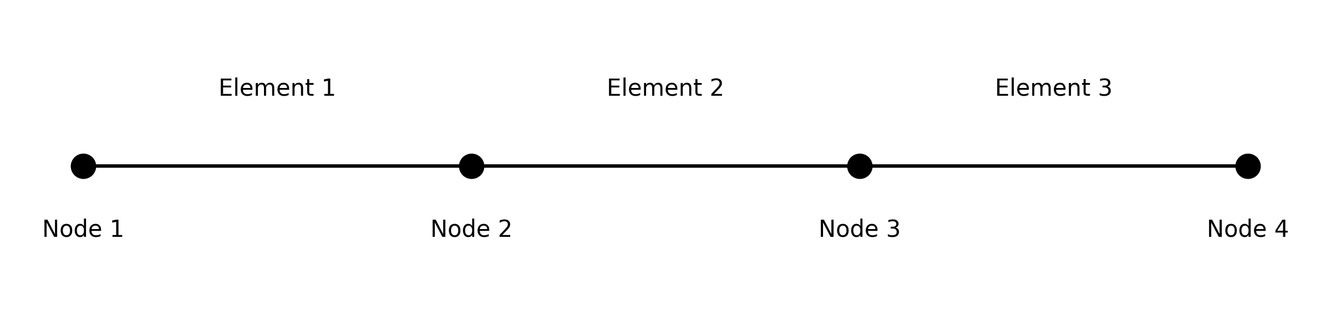

## 1. Shape Functions

For 2-node elements, the shape functions are:

N₁(ξ) = (1-ξ)/2

N₂(ξ) = (1+ξ)/2

where ξ is the local coordinate ranging from -1 to 1 within each element.

## 2. Displacements at ξ = 0.5

The displacement at ξ = 0.5 in each element is calculated using the shape functions:

u(ξ) = N₁(ξ)u₁ + N₂(ξ)u₂

For ξ = 0.5:

N₁(0.5) = 0.25

N₂(0.5) = 0.75

Element 1: u(ξ=0.5) = 0.25 × 1 + 0.75 × 3 = 2.5

Element 2: u(ξ=0.5) = 0.25 × 3 + 0.75 × 4 = 3.75

Element 3: u(ξ=0.5) = 0.25 × 4 + 0.75 × 6 = 5.5

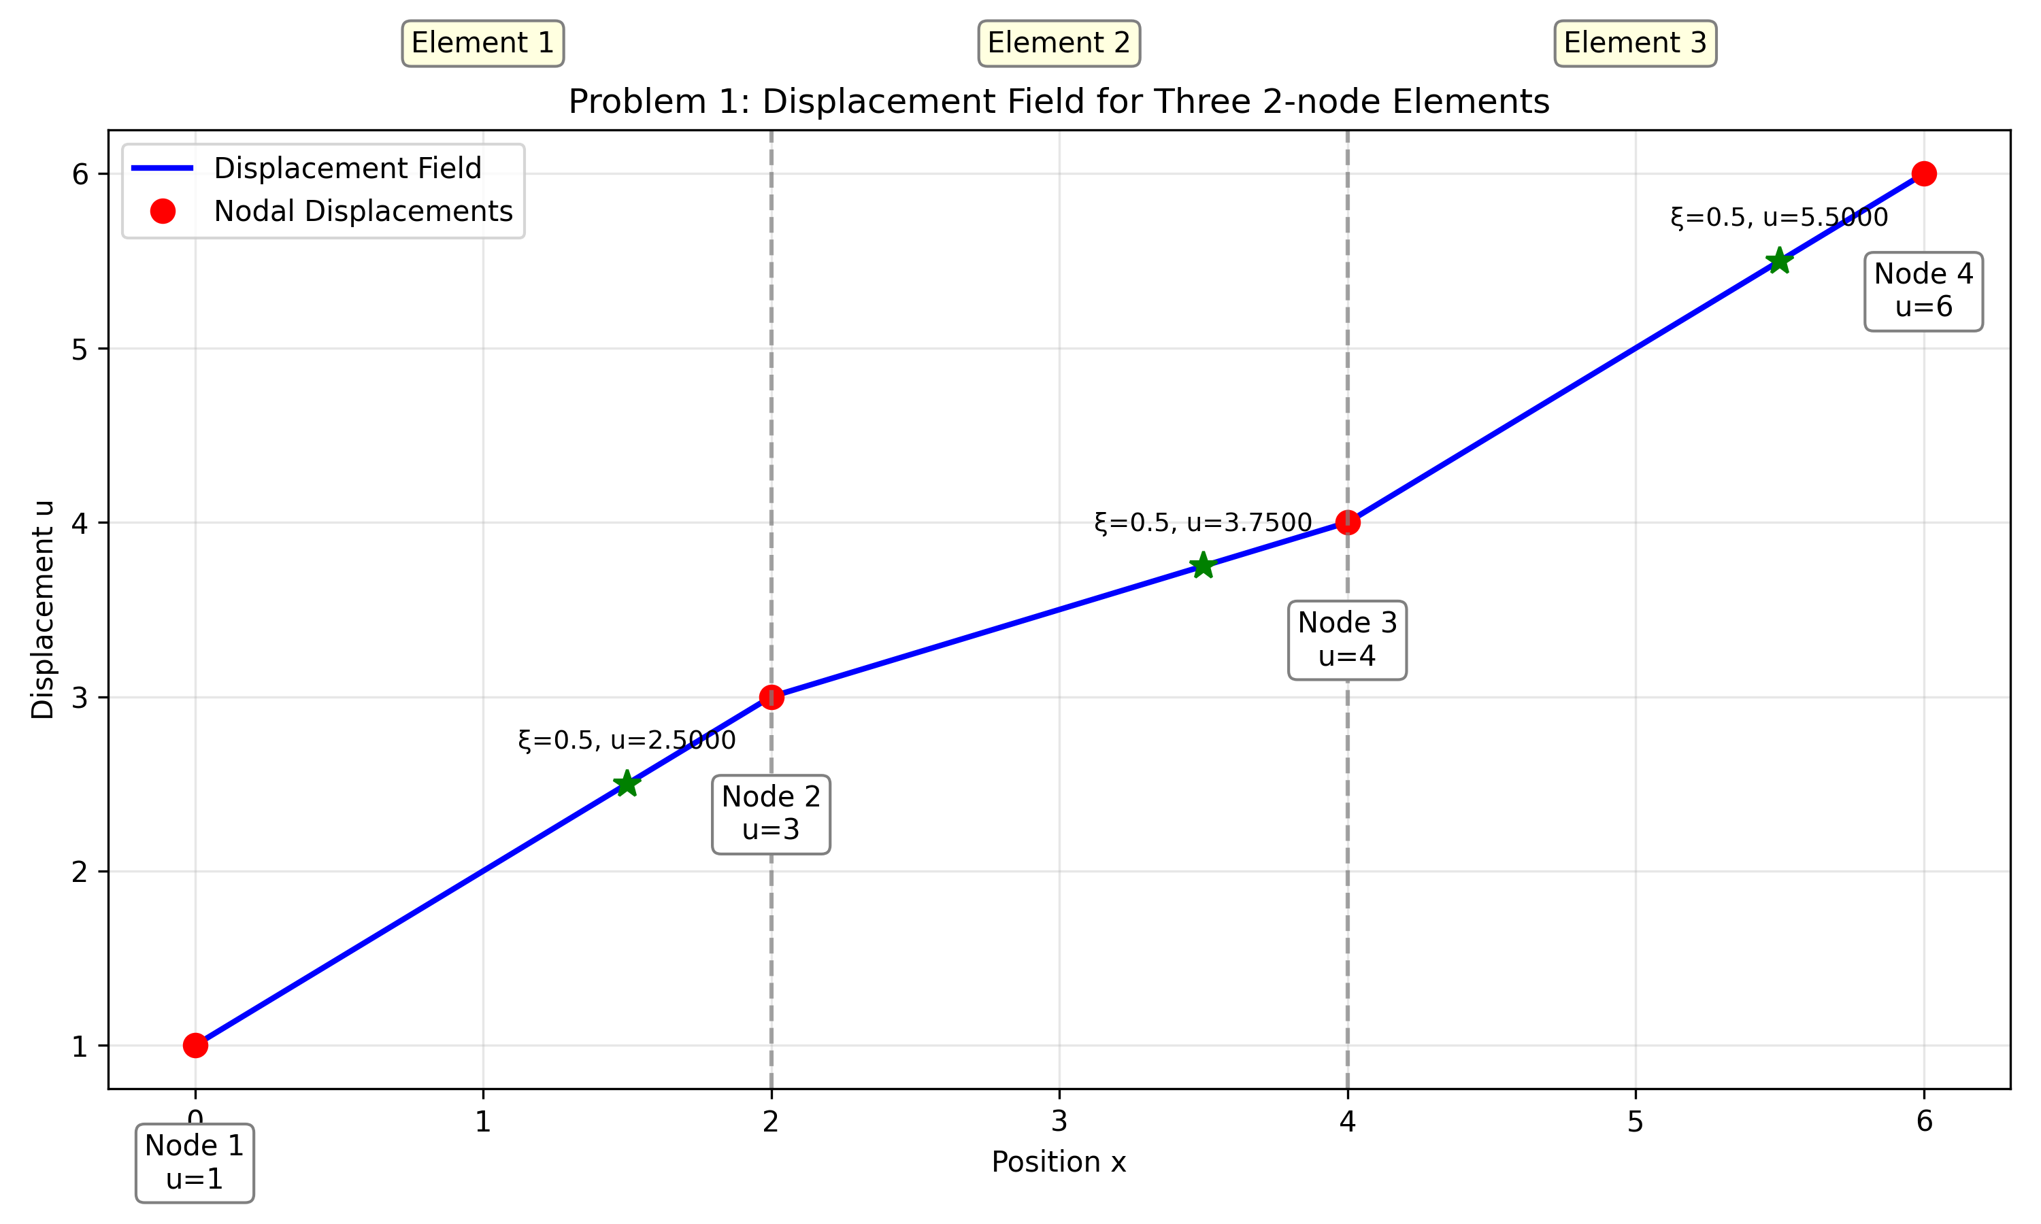

Figure 1: Displacement field for the three 2-node elements.

## 3. Strains at ξ = 0.5

For 2-node elements, the strain is constant throughout the element:

ε = (u₂ - u₁)/L

Element 1: ε = (3 - 1)/2 = 1.0

Element 2: ε = (4 - 3)/2 = 0.5

Element 3: ε = (6 - 4)/2 = 1.0

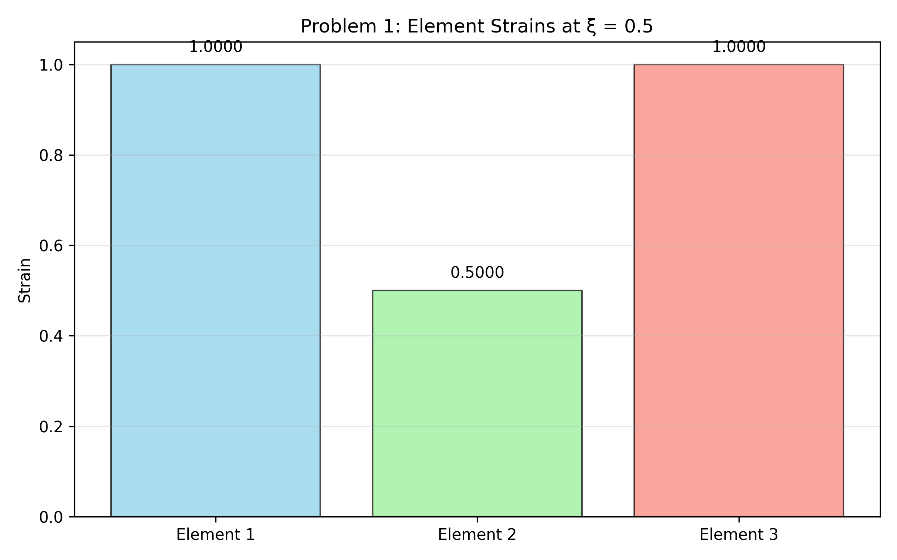

Figure 2: Element strains for the three 2-node elements.

## 4. Stiffness Matrices

For a 2-node element with Young's modulus E and cross-sectional area A, the stiffness matrix is:

k = (E·A/L) × [1, -1; -1, 1]

Assuming E = A = 1 for simplicity:

Element 1 (L=2): k₁ = 0.5 × [1, -1; -1, 1] = [0.5, -0.5; -0.5, 0.5]

Element 2 (L=2): k₂ = 0.5 × [1, -1; -1, 1] = [0.5, -0.5; -0.5, 0.5]

Element 3 (L=2): k₃ = 0.5 × [1, -1; -1, 1] = [0.5, -0.5; -0.5, 0.5]

# Problem 2: Two 3-Node Elements

Consider a structure consisting of two 3-node elements with nodes at x = 0, 2, 4, 6, 8. The displacements at nodes 1, 2, 3, 4, and 5 are 0, -1, 2, -1, and 4 respectively. Element 1 connects nodes 1, 2, and 3, while Element 2 connects nodes 3, 4, and 5.

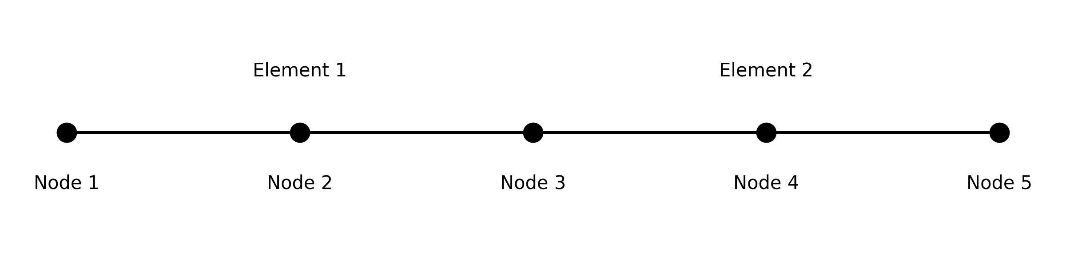

## 1. Shape Functions

For 3-node elements, the shape functions are:

N₁(ξ) = ξ(ξ-1)/2

N₂(ξ) = (1+ξ)(1-ξ)

N₃(ξ) = ξ(ξ+1)/2

where ξ is the local coordinate ranging from -1 to 1 within each element, with ξ = -1, 0, 1 corresponding to the three nodes.

## 2. Displacements at ξ = -0.5

The displacement at ξ = -0.5 in each element is calculated using the shape functions:

u(ξ) = N₁(ξ)u₁ + N₂(ξ)u₂ + N₃(ξ)u₃

For ξ = -0.5:

N₁(-0.5) = 0.125

N₂(-0.5) = 0.75

N₃(-0.5) = -0.125

Element 1: u(ξ=-0.5) = 0.125 × 0 + 0.75 × (-1) + (-0.125) × 2 = -1.0

Element 2: u(ξ=-0.5) = 0.125 × 2 + 0.75 × (-1) + (-0.125) × 4 = -0.75

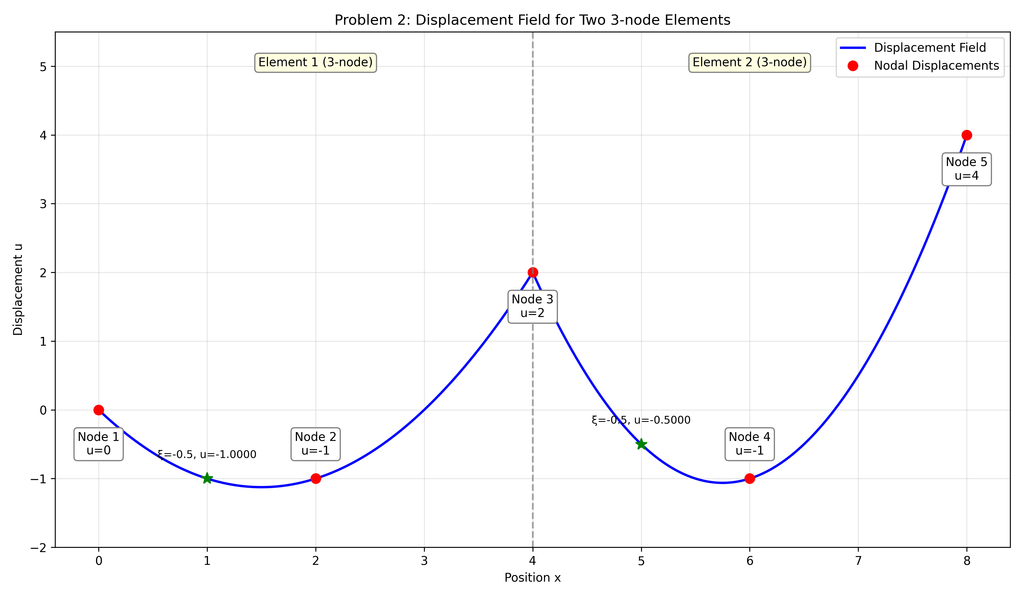

Figure 3: Displacement field for the two 3-node elements.

## 3. Strains at ξ = -0.5

For 3-node elements, the strain varies within the element and is calculated using:

ε = B·u, where B = [dN₁/dx, dN₂/dx, dN₃/dx]

At ξ = -0.5:

dN₁/dξ = ξ - 0.5 = -1.0

dN₂/dξ = -2ξ = 1.0

dN₃/dξ = ξ + 0.5 = 0.0

For Element 1 (L=4): J = L/2 = 2

For Element 2 (L=4): J = L/2 = 2

dN₁/dx = dN₁/dξ · dξ/dx = (-1.0)/2 = -0.5

dN₂/dx = dN₂/dξ · dξ/dx = (1.0)/2 = 0.5

dN₃/dx = dN₃/dξ · dξ/dx = (0.0)/2 = 0.0

Element 1: ε = -0.5 × 0 + 0.5 × (-1) + 0.0 × 2 = -0.5

Element 2: ε = -0.5 × 2 + 0.5 × (-1) + 0.0 × 4 = -1.5

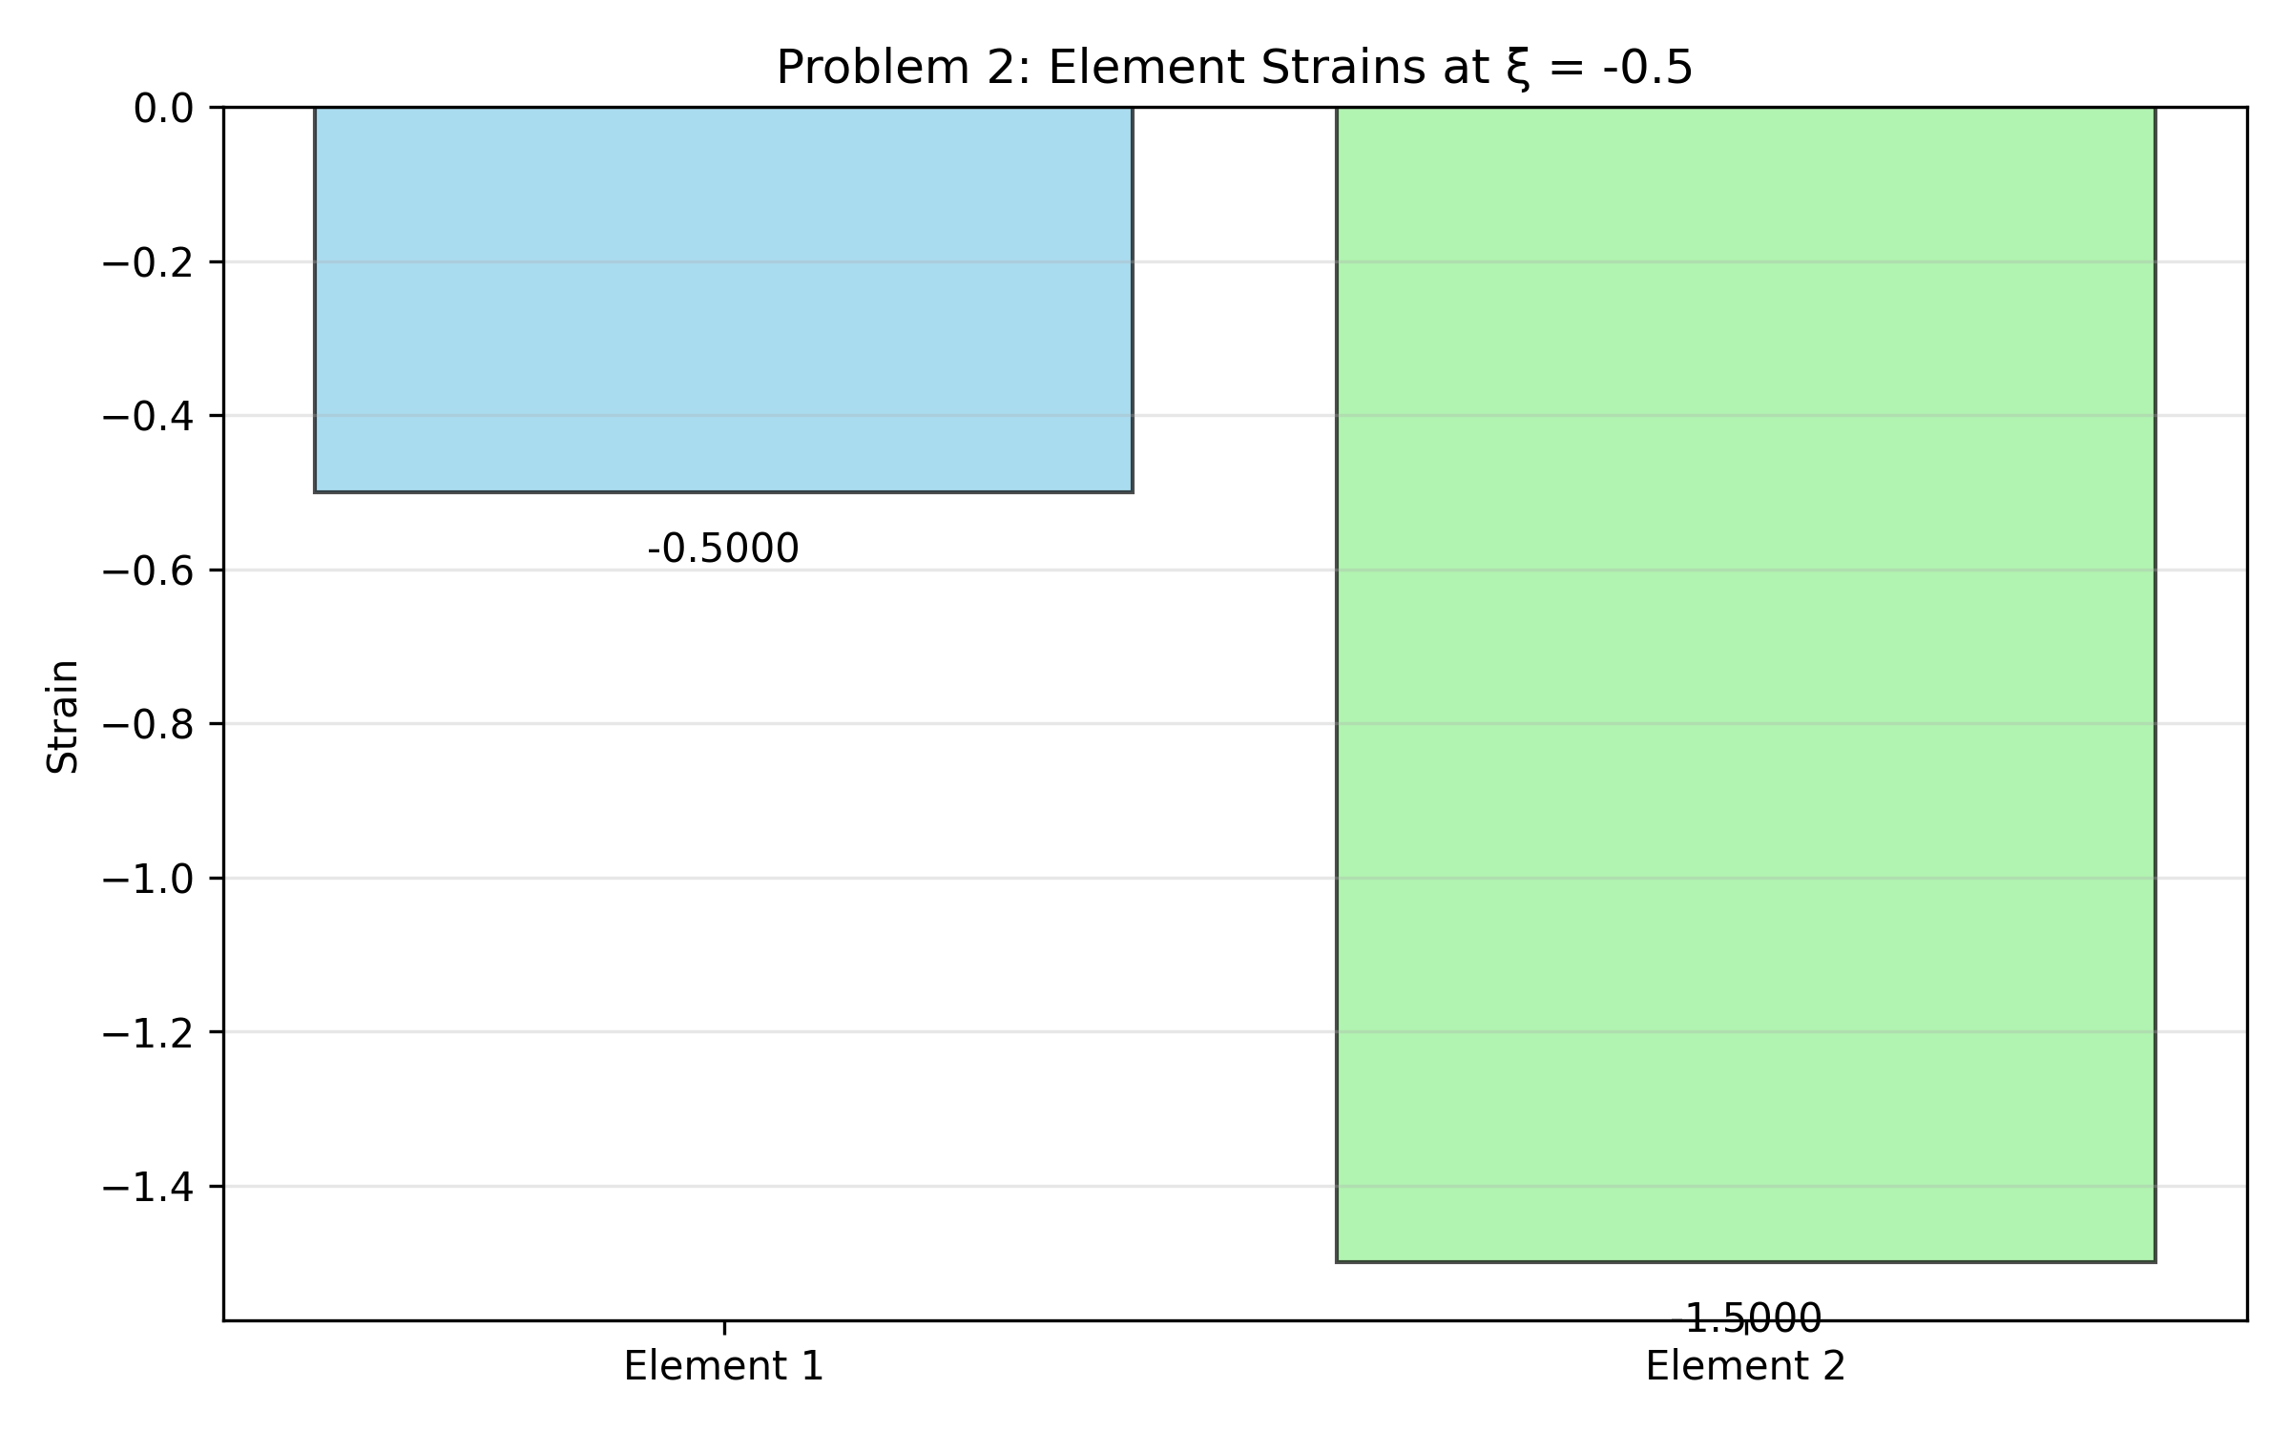

Figure 4: Element strains for the two 3-node elements.

## 4. Stiffness Matrices

For a 3-node element, the stiffness matrix is calculated using numerical integration:

k = ∫(B^T·E·B·A·det(J))dξ

Using integration points ξ = -0.5 and ξ = 0.5 with equal weights of 1.0:

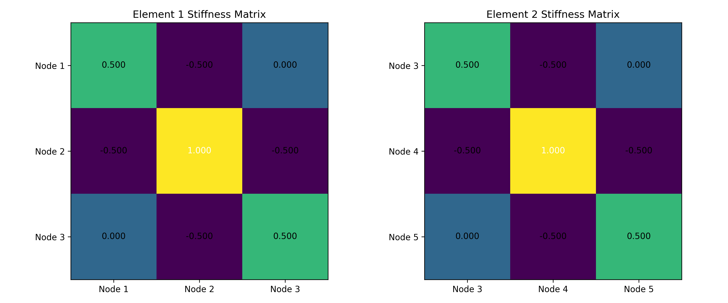

Figure 5: Stiffness matrices for the two 3-node elements.

# Conclusion

This report has presented solutions for two finite element problems involving 2-node and 3-node elements. We derived the shape functions, calculated displacements and strains at specific points in the elements, and computed element stiffness matrices using appropriate integration methods. The results demonstrate how the finite element method can effectively model displacement fields and strain distributions in one-dimensional structures.