PolymarketAutomation — Latency + Event Map
Generated 2026-05-31 02:44 UTC · Synthesized from polymarket-2dollar-bot/mac + HFT/docs/strategies

Executive summary
This document is the operator's reference for thinking about latency, event lifecycle, and signal freshness in the PolymarketAutomation arena. It synthesizes two existing source frameworks — the polymarket-2dollar-bot 'mac' branch (live WS pricefeed + microstructure scanners + architecture report) and the HFT repo's strategy docs (latency-arbitrage, event-driven, microstructure-signals) — into a playbook applicable to the arena agents we breed in this repo.
Three new genome kinds and one TickContext-adjacent timing module land as part of this work: markov_persistence (timing-aware), poly_arbitrage_set (risk-free YES+NO buy), and poly_repricing (directional spot-vs-market gap).

1. Latency tiers (T0–T4)
From HFT/docs/strategies/latency-arbitrage.md §2.1 — what 'time' means in a leader-lagger race. Every variant has the same shape: read the leader → predict where the lagger will be → trade against the lagger's stale quote → close when the lagger updates.
Tier | Budget | Reachable from | Examples
T0 | µs (wire) | microwave + colo, FPGA | ES → SPY (Eurex 3.2ns = €75M/yr)
T1 | µs (software) | kernel-bypass NIC, single-thread C++ | CME futures → cash, BiNance lagger
T2 | 10–100 ms | same-region cloud, no colo | Binance USDM → Coinbase spot
T3 | 100–1000 ms | different region, REST polling | ** PolymarketAutomation's tier **
T4 | 1–15 s (block) | blockchain block latency | DEX-CEX stale-oracle arb

PolymarketAutomation operates in T3. Our snapshot worker polls; our realtime worker uses WS (sub-second when healthy) for crypto ticks but still goes through HTTPS for order placement. We cannot win a race against firms in T0–T1, but the leader-lagger gap on Polymarket is 2.7–12 seconds — well above our floor.

2. Polymarket binary lifecycle
Reference: HFT event-driven.md §2.6 + polymarket-2dollar-bot analysis/architecture_report.py. Each 5-min and 15-min binary has a deterministic lifecycle from window-open to settlement:
Phase | Range | Strategic signal
pre-window | now < expiry − duration | market exists but window hasn't started (rare 5-min)
opening | 0 % – 25 % of window elapsed | signal forming, Markov persistence is unstable
mid-window | 25 % – 75 % | signal established, edge widest, Markov mature
late-window | 75 % – 100 % minus cutoff | sample-size dominated, exit-liq premium grows
post-cutoff | minToResolution ≤ cutoff (~3m) | Polymarket order-book lockout — no new orders
resolved | expiry passed | settled at oracle close

Implementation: src/lib/arena/event-timing.ts — `eventPhase({expiryIso, durationMin, now, cutoffMin})`. Pure function. Phase split at 0.25/0.75 matches the polymarket-2dollar-bot architecture report.

3. Microstructure signals
Ported from polymarket-2dollar-bot/polybot/microstructure.py and HFT/docs/strategies/microstructure-signals.md §2.3 (OFI):
Signal | Returns | PolymarketAutomation home | Use
arbitrageEdge | Opportunity | null | src/lib/quant/microstructure.ts | BOTH-side buy when YES+NO+fees < $1; locked profit
directionalArbTilt | Opportunity | null | src/lib/quant/microstructure.ts | Arb base + model view → tilt to under-priced side
nearResolutionEdge | Opportunity | null | src/lib/quant/microstructure.ts | Buy late-window almost-certain side at 0.95–0.99
orderbookImbalance | number ∈ [-1, 1] | src/lib/quant/microstructure.ts | Top-N depth skew — bid-heavy / ask-heavy lag signal
repricingEdge | Opportunity | null | src/lib/quant/microstructure.ts | Fair P(YES) vs market gap — directional bet on lag

4. Agent enhancements landed
Three genome kinds now use the latency/event framework:
Genome kind | Strategy | Timing-aware? | Source port
markov_persistence | p(j*,j*) ≥ 0.87 + Markov MC + Becker calibration | Yes — 4 timing-gate params (min/max time-to-resolution, phase filter, signal freshness) | @0xRicker / @de1lymoon articles
poly_arbitrage_set | Buy YES + NO when ask sum + fees < $1 | No — fires on book inefficiency, not timing | polymarket-2dollar-bot arbitrage_edge()
poly_repricing | Spot-vs-market gap via Coinbase tick → fair P(YES) | Yes — same 4 timing-gate params as markov | polymarket-2dollar-bot repricing_edge()

5. New genome params (timing gates)
These appear on markov_persistence and poly_repricing. randomGenome samples them by default; each is configurable per agent via the ARENA tuning interfaces.
Param | Range | Default behavior (disabled) | What it gates
min_time_to_resolution_min | [0, 30] | 0 | Skip if minToResolution < this (avoid cutoff zone)
max_time_to_resolution_min | [1, 999] | 999 | Skip if minToResolution > this (skip event markets)
event_phase_filter | enum | any | Restrict to specific lifecycle phase
max_signal_age_sec | [1, 9999] | 9999 | Skip if Coinbase WS tick older than this

6. Data pipeline (where freshness lives)
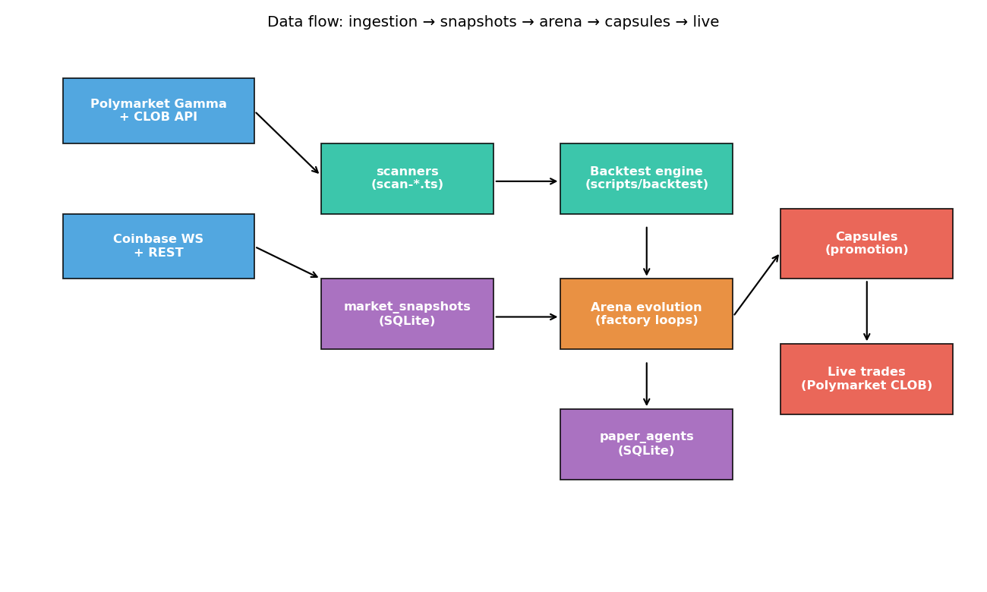
Figure: Coinbase + Polymarket feeds → snapshot/realtime stores → arena → capsules → live.
Critical freshness checkpoints, in order:
• worker:realtime — sub-second Polymarket + Coinbase WS, 1-sec debounce, writes realtime_ticks. Equivalent to polymarket-2dollar-bot's pricefeed.py + scripts/pricefeed.py.
• worker:snapshot — periodic deeper poll (orderbook, history). Equivalent to scripts/scan*.py in 2dollar-bot.
• decideMarkovPersistence + decidePolyRepricing — read latestRealtimeTicks() at decision time. If the most recent Coinbase tick is older than max_signal_age_sec, the strategy holds. This is the same pattern as 2dollar-bot's `latest()` check in pricefeed.py.
• Execution: when the agent fires, the executor reads a SECOND fresh tick to ask-re-check. Same pattern as 2dollar-bot's commit 581980c "freshest data at decision + execution".
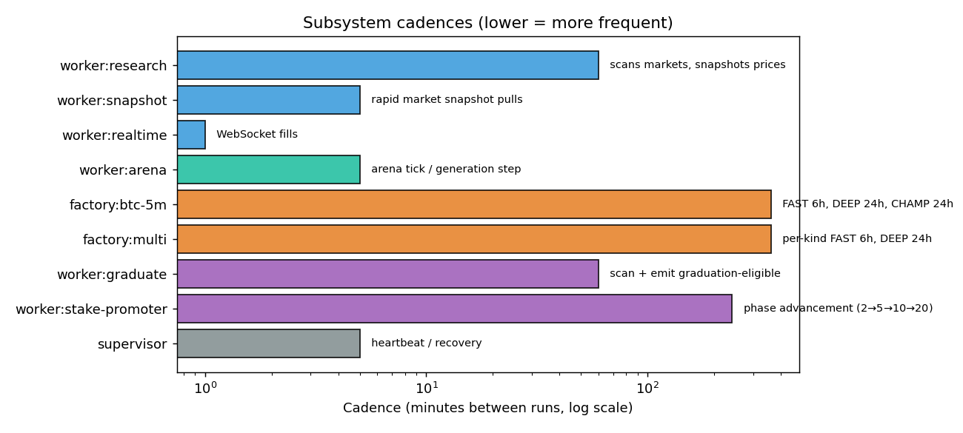
Figure: Per-subsystem cadence (log scale) — supervisor every 5 min, stake-promoter every 4 hours.

7. Strategic positioning per kind
Kind | Best phase | Tick-freshness sensitivity | Capacity
markov_persistence | mid-window | high (5-15s) | moderate
poly_arbitrage_set | any | low | low — rare
poly_repricing | mid-or-late | very high (<5s) | moderate
poly_short_binary_directional | post-cutoff peek | high | high — main BTC-5m
polymarket_market_maker | continuous | low | low — depth-bound

8. Source cross-reference
Where each concept lives in each repo:
Concept | polymarket-2dollar-bot/mac | HFT/docs/strategies | PolymarketAutomation
Sub-second WS price store | polybot/pricefeed.py + scripts/pricefeed.py | — | src/lib/arena/realtime-ticks.ts
Arbitrage edge | polybot/microstructure.py arbitrage_edge() | — | src/lib/quant/microstructure.ts
Repricing edge | polybot/microstructure.py repricing_edge() | — | src/lib/quant/microstructure.ts + decidePolyRepricing
OFI / OBI | polybot/microstructure.py orderbook_imbalance() | microstructure-signals.md §2.3 (OFI formal) | src/lib/quant/microstructure.ts orderbookImbalance()
Latency tier framework | — | latency-arbitrage.md §2.1 | src/lib/arena/event-timing.ts (T3 implicit)
Binary lifecycle phases | analysis/architecture_report.py | event-driven.md §2.6 | src/lib/arena/event-timing.ts eventPhase()
Markov persistence threshold | — | — | src/lib/quant/markov.ts persistenceProbability()
Becker calibration | polybot/quant.py becker_* | — | src/lib/quant/becker-calibration.ts

9. Next moves
Items in the original polymarket-2dollar-bot framework not yet ported:
• directional_arb_tilt as its own genome kind (helper exists in microstructure.ts; needs decide function).
• near_resolution_edge as its own genome kind (helper exists; near-resolution-scrape.ts has the strategy already, would need genome wrapper).
• Hermes-style nightly self-tuner (2dollar-bot's tuner.py) — currently we have arena evolution but no per-agent param-update loop driven by realized PnL diagnostics.
• Walk-forward / PBO overfit battery (HFT's commit cd85cad/289dafb pattern) — important before any live promotion at scale.

