PolymarketAutomation — Architecture & Strategic Timing Map
Generated 2026-05-31 02:02 UTC · live snapshot

Executive summary
At time of generation the population holds 192 alive agents and 2934 retired. 10 agents have cleared the 30-trade ranking floor. Best win rate among qualifying agents: 58.0 %. The system holds 131,463 market snapshots collected between 2026-05-25 19:22:50 and 2026-05-31 02:01:34.
Factory 'btc-5m': desired=running, pid=41328, started_at=2026-05-30T23:35:51.244Z, restarts=2.
Factory 'multi': desired=running, pid=5064, started_at=2026-05-30T23:35:51.260Z, restarts=1.

1. System architecture
Six layers, each owned by a distinct module and worker:
Layer | Owns | Workers / scripts | Persistence
Ingestion | Polymarket Gamma + CLOB, Coinbase REST + WS | worker:research, worker:realtime, worker:snapshot, scan:* | market_snapshots, paper_trades
Snapshot store | OHLC + orderbook + price-history per token | snapshot:cb-depth, snapshot:cb-trades, snapshot:cb-stats | polymarket.db, historical-candles.db
Backtesting | Replay snapshots through decision functions | scripts/backtest, src/lib/backtest/engine | performance_metrics, training_campaigns
Arena | Evolutionary search over genome kinds + params | factory:btc-5m, factory:multi, worker:arena, worker:graduate | paper_agents, training_campaigns, candidates
Capsules | Promotion to paper → live with risk caps | worker:stake-promoter, arena:promote-live | capsules
Live execution | Polymarket CLOB v2 fills, reconcile | worker:reconcile, worker:realtime, packages/adapters/polymarket | paper_trades (with venue=live)

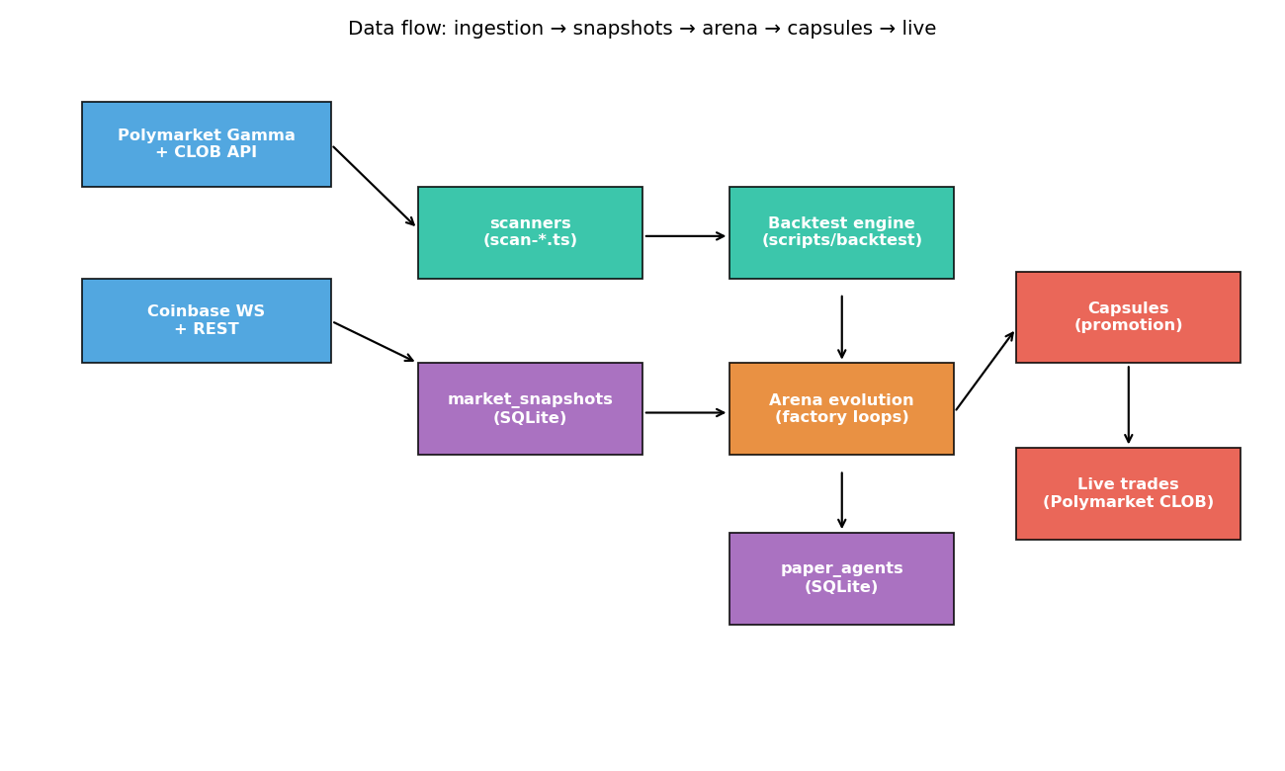
Figure: Data flow from venue feeds through snapshots, backtest, arena, capsules to live.

2. Subsystem cadences
The cadences below are documented defaults — override via env or --interval-* flags on each worker. Multiple workers can run in parallel; the supervisor ensures heartbeats.
Subsystem | Default cadence | What runs
supervisor | every 5 min (cron) | stale-heartbeat detection, recovery
worker:realtime | WebSocket (~1s) | live fills, real-time book updates
worker:snapshot | 5 min | rapid snapshot pulls during research-loop windows
worker:research | ~hourly | market sweep, signal evaluation, version proposals
worker:arena | 5 min tick (10 min backoff at trade cap) | arena step + generation evolve
factory:btc-5m | fast 6 h / deep 24 h / champ 24 h | consistent-winner BTC 5m binary directional
factory:multi | fast 6 h / deep 24 h per kind (12 kinds) | all non-BTC-5m genome kinds
worker:graduate | 60 min | emit graduation-eligible for paper capsules
worker:stake-promoter | 4 h | advance phases $2 → $5 → $10 → $20
worker:reconcile | ~5 min | venue + capsule state diff

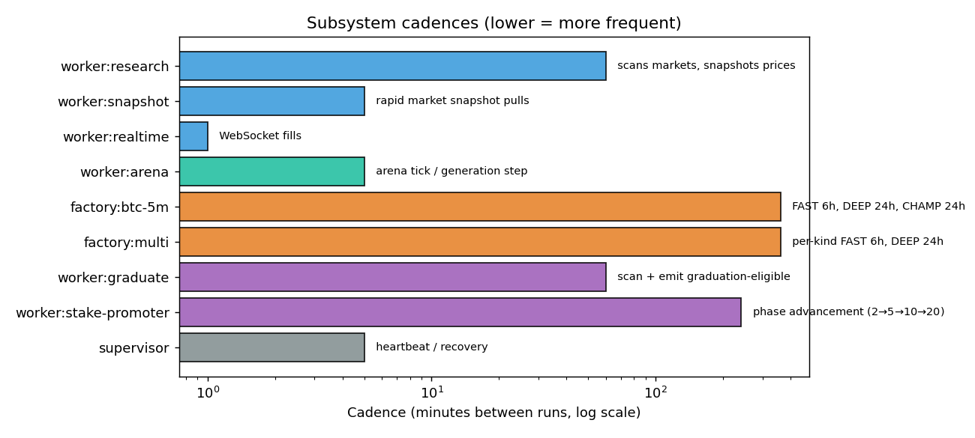
Figure: Cadence per subsystem on log scale — lower = more frequent.

3. Current population (live)
192 alive agents, 10 of which have cleared the 30-trade ranking floor.
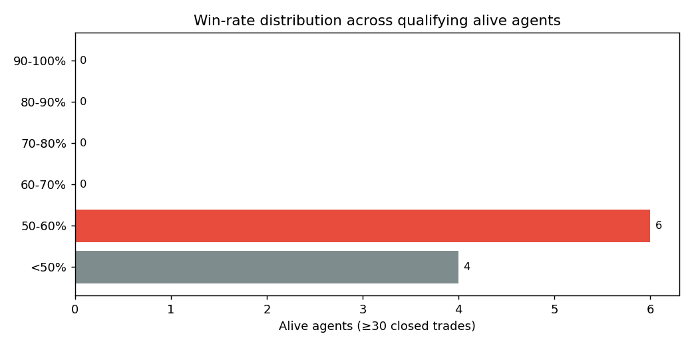
Figure: Win-rate distribution — current best 58.0% vs 90% gate.
Population by genome kind:
Kind | Alive count | Avg trades | Avg PnL
poly_fade_spike | 74 | 3.3 | $2.59
poly_short_binary_directional | 68 | 6.9 | $7.78
polymarket_market_maker | 7 | 0.4 | $0.00
multi_strategy | 7 | 2.7 | $20.81
poly_binary_arbitrage | 5 | 0.0 | $0.00
cb_momentum_burst | 5 | 0.0 | $0.00
category_specialist | 5 | 0.0 | $0.00
wallet_copy_filtered | 4 | 0.0 | $0.00
random_walk_baseline | 4 | 0.0 | $0.00
llm_probability_oracle | 4 | 0.0 | $0.00
cb_mean_reversion | 4 | 0.0 | $0.00
poly_cross_market_zscore | 3 | 0.0 | $0.00
poly_breakout | 2 | 0.0 | $0.00

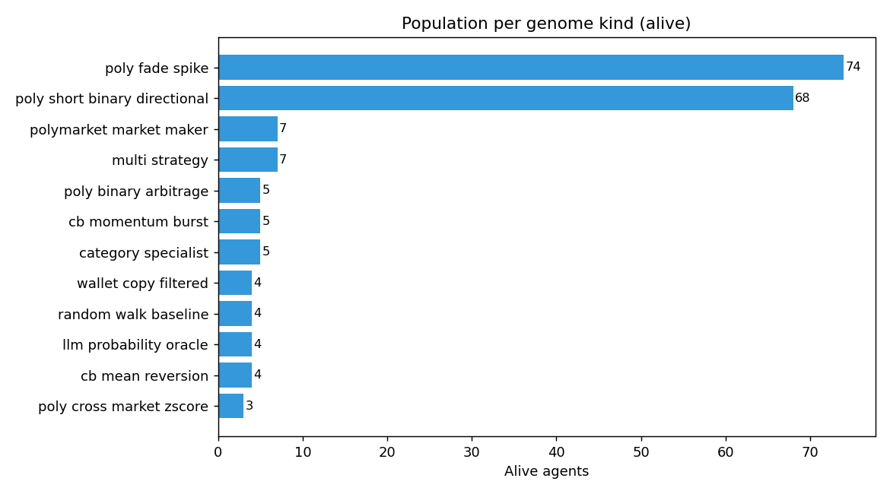
Figure: Alive population by genome kind — uneven coverage = work for the multi-factory.
Top 10 alive agents (≥30 trades, sorted by win rate):
# | Name | Kind | Trades | Wins | Win rate | PnL
1 | cw-p2937-c3-near-resolution- | poly_short_binary_direct | 50 | 29 | 58.0% | $1.03
2 | cw-p2937-c2-near-resolution- | poly_short_binary_direct | 42 | 24 | 57.1% | $1.52
3 | cw-p2928-c3-repricing-early- | poly_short_binary_direct | 51 | 29 | 56.9% | $29.96
4 | cw-p2929-c2-repricing-early- | poly_short_binary_direct | 38 | 20 | 52.6% | $0.79
5 | cw-p2928-c1-repricing-early- | poly_short_binary_direct | 35 | 18 | 51.4% | $57.44
6 | cw-p2153-c3-g66-p29-agg-5m-b | poly_short_binary_direct | 47 | 24 | 51.1% | $38.37
7 | cw-p2153-c2-g66-p29-agg-5m-b | poly_short_binary_direct | 31 | 14 | 45.2% | $51.03
8 | g78-s22-fade-spike | poly_fade_spike | 71 | 8 | 11.3% | $73.13
9 | g76-s17-fade-spike | poly_fade_spike | 66 | 3 | 4.5% | $51.47
10 | g78-c0-fade-spike | poly_fade_spike | 56 | 1 | 1.8% | $10.73

4. Recent factory output (last 24h)
11 training campaigns logged in the last 24 hours.
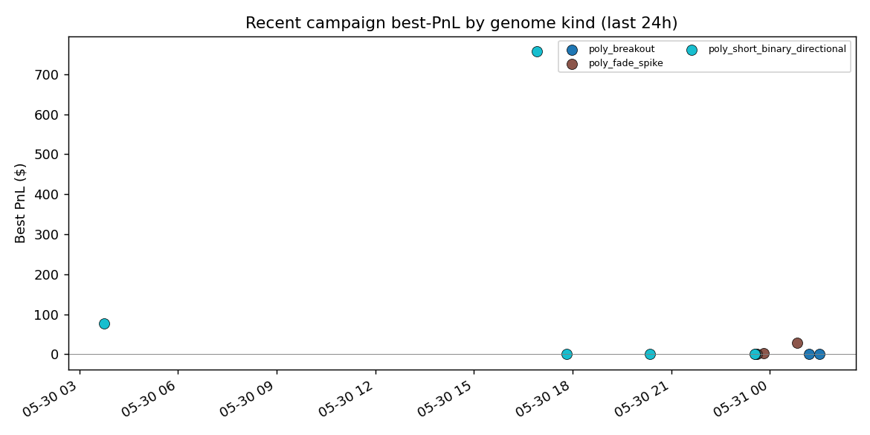
Figure: Best PnL per campaign, by genome kind — positive cluster = the strategies that are working.
When | Name | Kind | Produced | Best PnL
2026-05-31 01:30:59 | mk-polybreakout-deep-2026-05-31-01-30-59 | poly_breakout | 0 | -
2026-05-31 01:10:50 | mk-polybreakout-fast-2026-05-31-01-10-50 | poly_breakout | 8 | $0.00
2026-05-31 00:49:28 | mk-polyfadespik-champ-2448-2026-05-31-00-4 | poly_fade_spike | 12 | $28.18
2026-05-30 23:48:04 | mk-polyfadespik-deep-2026-05-30-23-48-04 | poly_fade_spike | 15 | $2.94
2026-05-30 23:35:55 | mk-polyfadespik-fast-2026-05-30-23-35-55 | poly_fade_spike | 8 | $0.00
2026-05-30 23:33:44 | btc-5m-champ-2929-2026-05-30-23-33-44 | poly_short_binary_dire | 0 | -
2026-05-30 23:31:51 | btc-5m-fast-2026-05-30-23-31-51 | poly_short_binary_dire | 0 | -
2026-05-30 20:21:22 | btc-5m-deep-2026-05-30-20-21-22 | poly_short_binary_dire | 0 | -
2026-05-30 17:48:43 | btc-5m-deep-2026-05-30-17-48-43 | poly_short_binary_dire | 0 | -
2026-05-30 16:54:58 | btc-5m-fast-2026-05-30-16-54-58 | poly_short_binary_dire | 20 | $757.49
2026-05-30 03:45:08 | e2e-verify-shortbinary-14d | poly_short_binary_dire | 3 | $77.68

5. Strategic positioning — where each strategy fits
Each strategy occupies a distinct slot in the timing + signal space. The matrix below shows the time horizon a strategy operates over, the venue, and the structural advantage it claims.
Strategy | Time horizon | Venue | Edge thesis | Capacity
poly_short_binary_directional | 5–15 min | Polymarket | Polymarket reprices slower than Coinbase by ~2.7s | High — many windows/day
polymarket_market_maker | continuous | Polymarket | Spread capture as inventory rotates | Moderate — limited by depth
llm_probability_oracle | minutes | Polymarket | LLM beats midpoint when news is in-context | Low — LLM cost-bound
poly_fade_spike | hours | Polymarket | Mean reversion after attention bursts | Moderate
poly_breakout | hours | Polymarket | Continuation after attention bursts | Moderate
cross_venue_arb | hours | Poly + CB | BS-implied vs Polymarket-implied mispricing | Low — narrow opportunity window
cb_breakout | 30 min – 24 h | Coinbase | Range break-out on liquid crypto | High
cb_mean_reversion | hours | Coinbase | Reversion from z-score extremes | High
cb_momentum_burst | 5–120 min | Coinbase | Acceleration spikes (news, halt-reopen) | Moderate
category_specialist | varies | Polymarket | Outperformance restricted to one tag | Low — one slice at a time
wallet_copy_filtered | minutes | Polymarket | Mirror a proven wallet's edge | Depends on source
multi_strategy | composite | Either | Stacked sub-strategies with priority selection | Moderate
random_walk_baseline | any | Polymarket | Control — any real edge must beat this | N/A

6. Gaps and recommended next moves
Things the architecture supports but isn't actively using:
• 5-min BTC Up/Down market discovery — the snapshot worker is currently pulling event-resolution markets, not the high-frequency crypto binary contracts that the BTC-5m factory was tuned for. Adding a discovery query against the Gamma API filtering for crypto 5/15-minute binaries would give the BTC-5m factory the data it needs to converge.
• Markov-persistence strategy seeding — the strategy code is in src/lib/strategies/ but no genome kind has been registered for it. Once registered, multi-factory will breed it like any other kind.
• Maker-only execution path — wired into packages/core/src/venue/router.ts but not yet enabled by default. Becker's data shows +1.12 % maker / −1.12 % taker, so flipping this on is roughly worth +2.24 pp on every fill.
• Live multi-coin fan-out — the factories operate on BTC + ETH + SOL via cb_* genomes. Adding XRP, DOGE, SHIB, etc. is a one-line change in PARAM_BOUNDS but should be paired with snapshot coverage.
• Win-rate progression telemetry — the dashboard tracks the 'best win rate' over the dashboard's uptime. Persisting that into a daily snapshots table would give a 30-day chart instead of a 24h linear projection.

7. What to watch
Three signals indicate whether the system is converging toward the 90 % win-rate goal.
Signal | Source | Healthy | Stuck
Best win rate (Δ per day) | factory dashboard | +1 to +3 pp/day | flat or negative for 3+ days
Population in 70-80 % bucket | factory dashboard | growing weekly | stays at 0 for 7+ days
Factory campaign best PnL | training_campaigns | consistently > $0 | consistently < $0 across kinds

