Two-Stage Steam Rocket Design

Engineering Proposal for Aerospace Design Project

Prepared: April 13, 2025

# Table of Contents

# Executive Summary

This proposal outlines the design and engineering specifications for a two-stage steam-powered rocket system. Our design addresses all requirements specified in the project brief, providing detailed AutoCAD designs, pressure system analysis, and comprehensive thrust and propellant calculations.

Key features of our proposed solution include:

A two-stage vehicle with modular separation system for optimal performance

Detailed pressure vessel design with appropriate safety factors

Comprehensive thrust calculations for steam propulsion

Precise propellant (water) requirements for specified mission parameters

Complete set of engineering drawings and specifications for manufacturing

# Technical Approach

Our approach to the steam rocket design combines fundamental engineering principles with practical design considerations to achieve a reliable and efficient propulsion system.

## Steam Propulsion Principles

Steam propulsion is based on the controlled expansion of high-temperature, high-pressure water vapor through a nozzle to generate thrust. The following key equations govern the design and performance of steam rockets:  
Where:

## Two-Stage Design Rationale

The two-stage design provides several critical advantages for a steam rocket system:

## Material Selection

Material selection is critical for steam rocket pressure vessels, which must withstand high temperatures and pressures while remaining lightweight. Our design incorporates:

# Design Specifications

The following specifications detail the engineering parameters for both stages of the rocket system, including pressure vessel requirements, nozzle geometry, and performance calculations.

## First Stage Specifications

The first stage provides initial thrust for liftoff and early acceleration. Its specifications are optimized for sea-level operation with higher thrust:

## Second Stage Specifications

The second stage operates after first stage separation and is optimized for performance in near-vacuum conditions:

## Performance Calculations

The overall vehicle performance is determined through detailed calculations of specific impulse, thrust, and propellant utilization:

# Engineering Drawings

The following section contains engineering drawings and visualizations of the rocket design, including component layouts, stage separation interfaces, and structural outlines.

## Overall Vehicle Configuration

The complete two-stage vehicle configuration is shown below:

## Pressure Vessel Design

The pressure vessel design includes appropriate safety factors and wall thickness calculations to ensure structural integrity:

## Nozzle Geometry

The nozzle geometry is optimized for each stage's operating environment:

# Project Implementation

The following timeline and deliverables outline our approach to implementing this design project, including key milestones and delivery schedule.

## Timeline

The project will be completed within one week, with the following timeline:

## Deliverables

The complete project includes the following deliverables:

AutoCAD (.dwg) files for the complete two-stage vehicle

PDF report with pressure vessel calculations and safety analysis

Excel spreadsheet with thrust and propellant calculations

3D model files (.step or .stl) for visualization and manufacturing

Technical documentation with assembly and integration instructions

# Appendix: Detailed Calculations

This appendix contains the detailed engineering calculations for the steam rocket design, including mathematical derivations, parameter sensitivity analysis, and reference data.

## Thrust Calculations

The thrust calculation process involves several steps:

## Pressure Vessel Analysis

The pressure vessel analysis ensures structural integrity under operating conditions:

## Propellant Requirements

The water propellant requirements are determined based on desired thrust and burn time:



F = Thrust (N)

ṁ = Mass flow rate (kg/s)

ve = Exhaust velocity (m/s)

pe = Exit pressure (Pa)

pa = Ambient pressure (Pa)

Ae = Exit area (m²)

The pressure vessel wall thickness is calculated using:



Where:

t = Wall thickness (m)

P = Internal pressure (Pa)

r = Vessel radius (m)

S = Material yield strength (Pa)

E = Safety factor

1. Improved performance through optimized nozzle designs for each flight regime

2. Reduced mass fraction by shedding the first stage after its propellant is depleted

3. Ability to use different operating pressures and temperatures in each stage

4. Enhanced reliability through redundant propulsion systems

The Delta-V benefit of staging is described by the rocket equation:



• High-strength stainless steel (Grade 304/316) for the first stage pressure vessel

• Titanium alloy for the second stage to reduce mass

• Copper alloy for nozzle throats to enhance heat transfer

• Composite overwrap for additional structural integrity

Each material was selected based on its specific properties and the operating conditions of each stage:

* Chamber Pressure: 3.00 MPa
* Chamber Temperature: 450°C
* Throat Diameter: 25.0 mm
* Exit Diameter: 75.0 mm
* Expansion Ratio: 9.0
* Vessel Diameter: 30.0 cm
* Vessel Length: 60.0 cm
* Wall Thickness: 1.80 mm
* Vessel Volume: 56.5 liters
* Thrust: 1802 N (1.80 kN)
* Specific Impulse: 107.2 seconds
* Mass Flow Rate: 1.7146 kg/s
* Burn Time: 28.0 seconds
* Total Impulse: 50.53 kN·s

The first stage thrust profile over time:

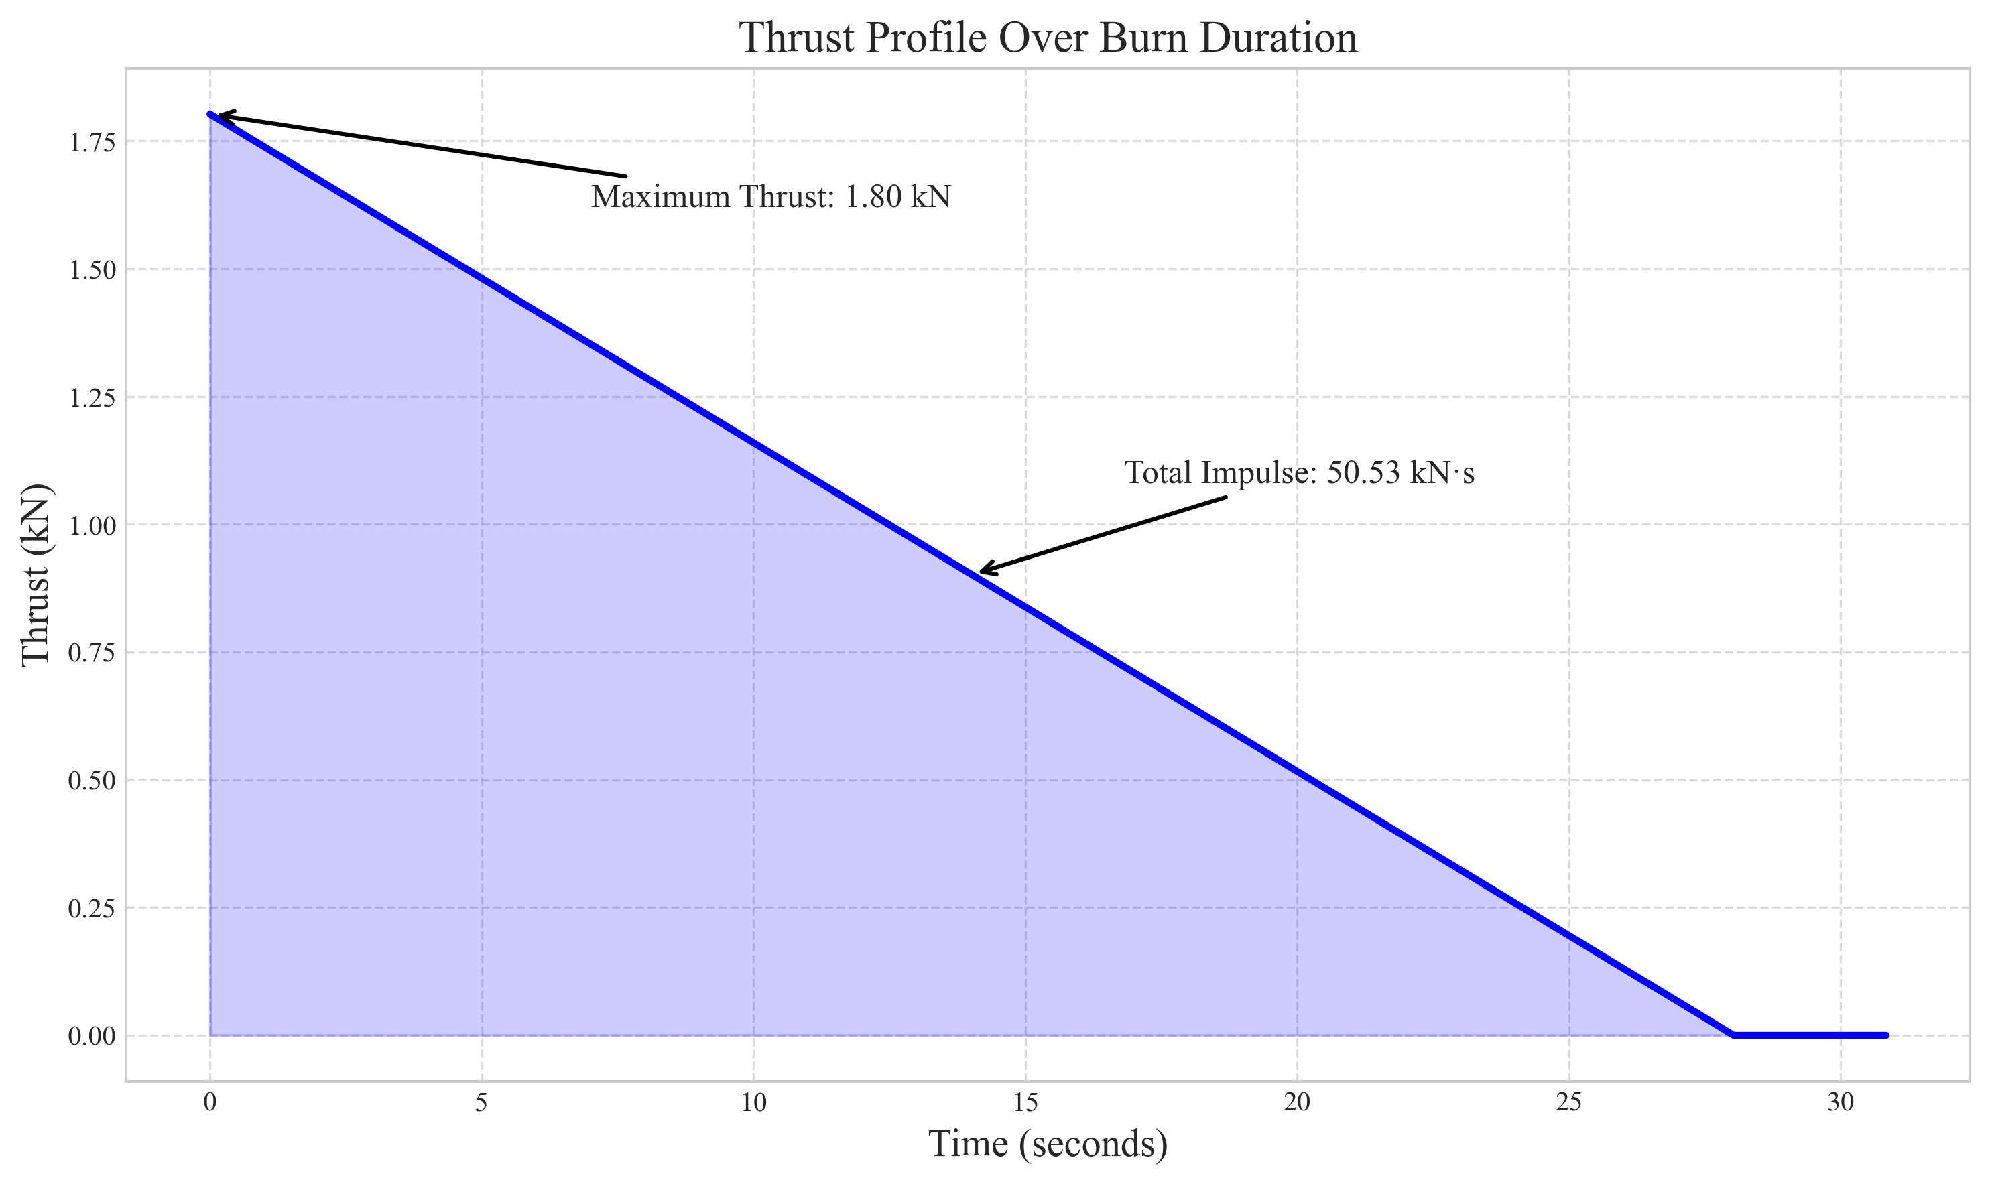

* Chamber Pressure: 2.00 MPa
* Chamber Temperature: 400°C
* Throat Diameter: 15.0 mm
* Exit Diameter: 60.0 mm
* Expansion Ratio: 16.0
* Vessel Diameter: 20.0 cm
* Vessel Length: 40.0 cm
* Wall Thickness: 1.00 mm
* Vessel Volume: 16.8 liters
* Thrust: 415 N (0.41 kN)
* Specific Impulse: 99.2 seconds
* Mass Flow Rate: 0.4265 kg/s
* Burn Time: 33.4 seconds
* Total Impulse: 13.85 kN·s

Performance comparison between the two stages:

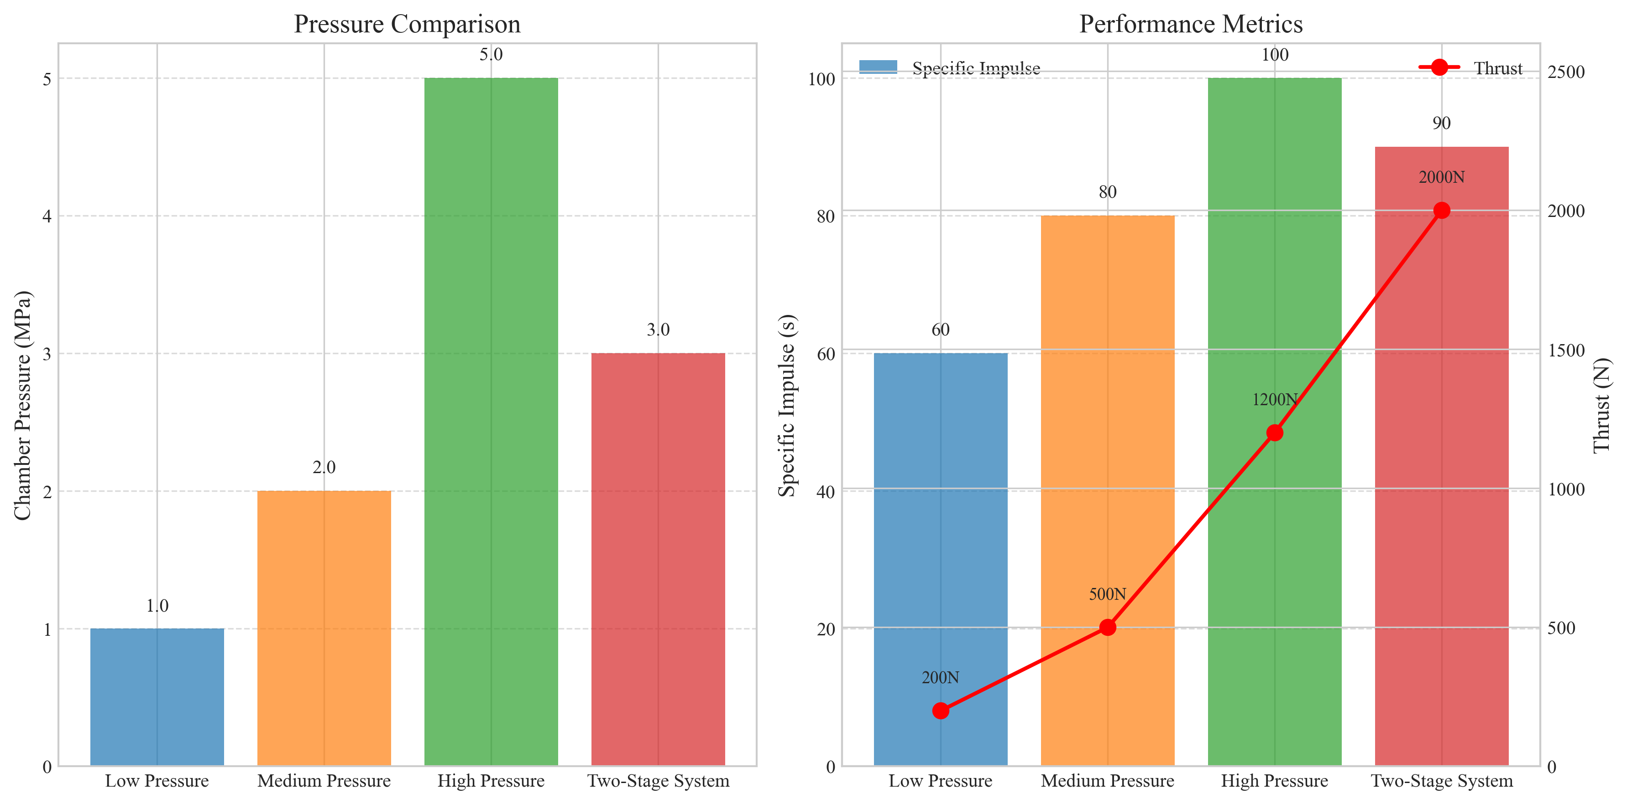

Specific impulse (a measure of efficiency) is calculated as:



The combined system provides approximately 50.5313.85 kN·s of total impulse.

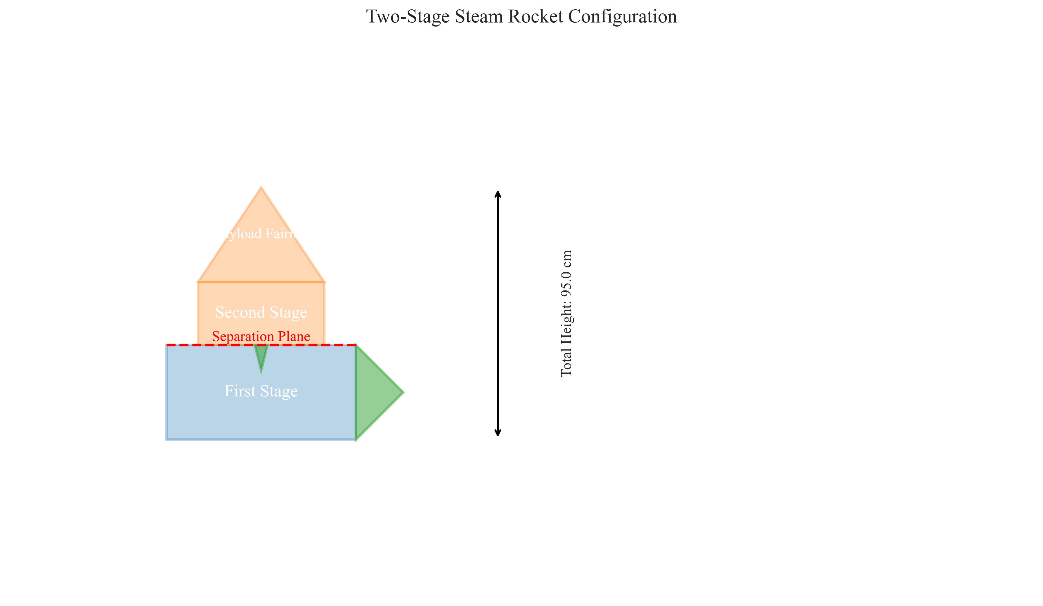

The diagram shows the relative sizing and configuration of the two stages, with the larger first stage providing initial thrust and the smaller second stage optimized for vacuum performance.

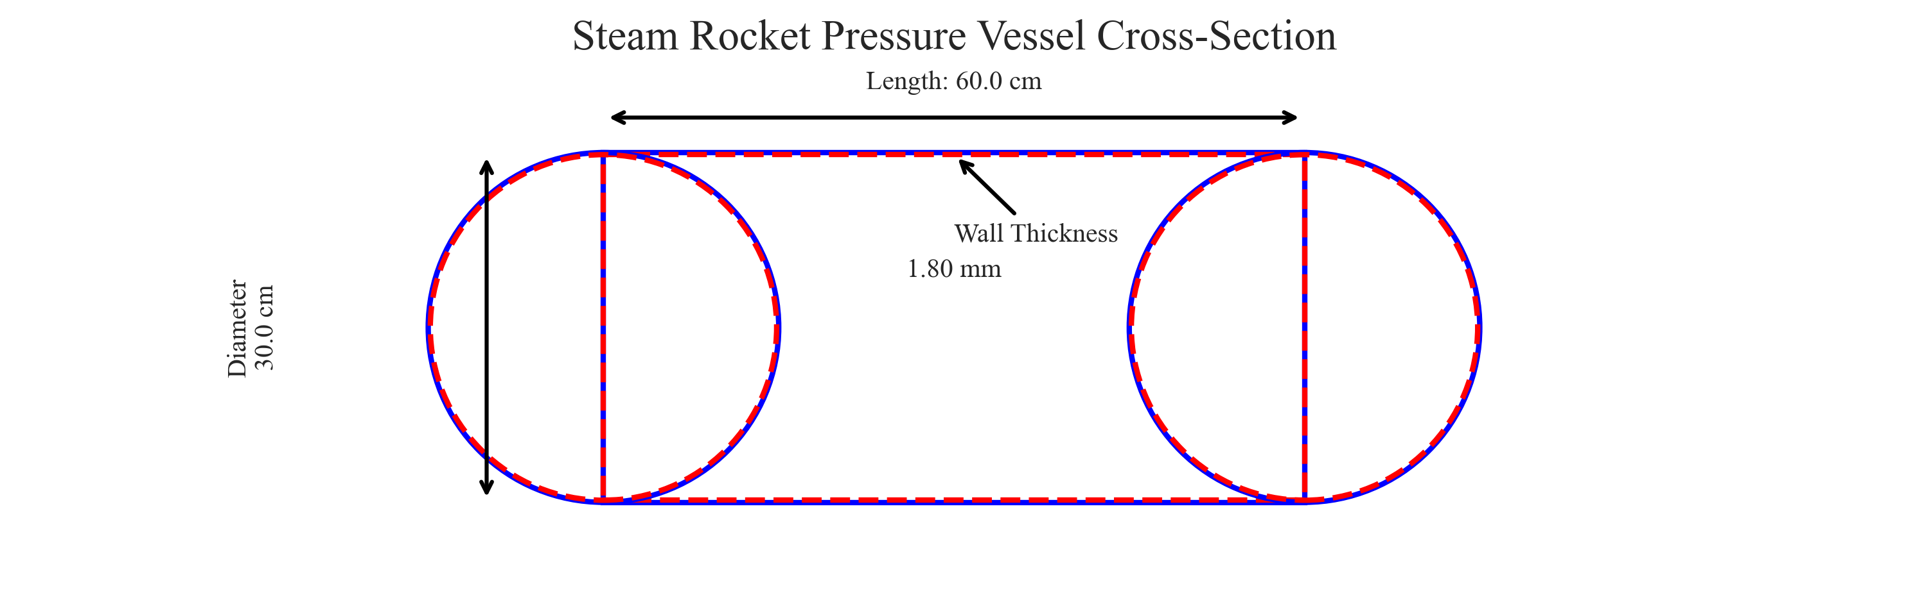

The pressure vessel design accounts for both the operating pressure and temperature, with wall thickness determined using the appropriate engineering formulas and safety factors.

First Stage Nozzle:

• Throat Diameter: 25.0 mm

• Exit Diameter: 75.0 mm

• Expansion Ratio: 9.0

• Optimized for sea-level operation with moderate expansion ratio

Second Stage Nozzle:

• Throat Diameter: 15.0 mm

• Exit Diameter: 60.0 mm

• Expansion Ratio: 16.0

• Optimized for near-vacuum conditions with higher expansion ratio

The exhaust velocity through the nozzle is given by:



Days 1-2: Detailed AutoCAD design of two-stage vehicle

Days 3-4: Pressure vessel calculations and structural analysis

Days 5-6: Propulsion system performance calculations

Day 7: Final documentation and delivery

1. Calculate the mass flow rate using:



2. Determine the exhaust velocity based on chamber conditions and nozzle expansion ratio

3. Calculate the resulting thrust using the thrust equation

4. Verify performance against design requirements

Example calculation for first stage:

• Mass flow rate: 1.7146 kg/s

• Resulting thrust: 1802 N (1.80 kN)

1. Calculate required wall thickness based on internal pressure and vessel diameter

2. Apply appropriate safety factor (2.0 for this design)

3. Consider material strength at elevated temperatures

4. Account for thermal expansion and stress concentrations

Example calculation for first stage:

• Operating pressure: 3.00 MPa

• Vessel diameter: 30.0 cm

• Required wall thickness: 1.80 mm

1. Determine required mass flow rate for target thrust

2. Calculate total water mass based on desired burn duration

3. Size the pressure vessel to accommodate the water plus expansion space (ullage)

4. Consider water heating requirements to reach operating temperature

First stage water requirement: approximately 48.0 liters

Second stage water requirement: approximately 14.3 liters

Total water propellant mass: approximately 62.3 kg

*Note: This Table of Contents will update when you open the document in Microsoft Word. Right-click and select 'Update Field' to update the TOC.*

# References

Sutton, G.P., and Biblarz, O. (2016). Rocket Propulsion Elements, 9th Edition. Wiley.

National Aeronautics and Space Administration (2015). NASA Steam Propulsion Investigation: Final Report.

Turner, M.J. (2009). Rocket and Spacecraft Propulsion: Principles, Practice and New Developments, 3rd Edition. Springer.

Huzel, D.K., and Huang, D.H. (1992). Modern Engineering for Design of Liquid-Propellant Rocket Engines. AIAA.

Engineering Toolbox (2023). Steam Thermodynamic Properties. Retrieved from www.engineeringtoolbox.com.

American Society of Mechanical Engineers (2021). ASME Boiler and Pressure Vessel Code, Section VIII: Rules for Construction of Pressure Vessels.