A+ Computer Science BlackJackGUI – THE CARD Lab Value - 100

Lab Goal : This lab was designed to teach you more object oriented programming and how to write a larger game.

Lab Description : Write a Card class and a BlackJackCard class. Show that Card and BlackjackCard work as intended by instantiating BlackJack cards in CardTestOne.java and in CardTestTwo.java. Draw each BlackJackCard on the graphics window in CardTestTwo.java. You will use CardDeckPlayerGraphicsRunner.java to test CardTestTwo.java. A BlackJack card is an extension of Card. Aces will count as 11 for now. We will discuss making aces 1 or 11 later.

public abstract class Card
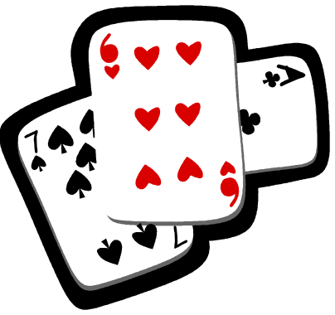
{
public static final String FACES[] = {"ZERO","ACE","TWO","THREE","FOUR",
"FIVE","SIX","SEVEN","EIGHT","NINE","TEN","JACK","QUEEN","KING"};

private String suit;
private int face;
private int width;
Files Needed ::
Card.java
BlackJackCard.java
CardTestOne.java
CardTestTwo.java
CardDeckPlayerGraphicsRunner.java
private int height;
private Image image;

//constructors

//set methods

Sample Output ( CardTestOne.java )
ZERO of | value = 0
ACE of DIAMONDS | value = 11
FOUR of CLUBS | value = 4
QUEEN of SPADES | value = 10
QUEEN of HEARTS | value = 10
NINE of SPADES | value = 9
false
true
false
false

//get methods

public abstract int getValue();

public String toString()
{
return FACES[face] + " of " + getSuit() + " | value = " + getValue();
}

public void drawCard(Graphics window, int x, int y)
{
window.drawImage(image,x,y,width,height,null);
}
}

public class BlackJackCard extends Card
{
//constructors

public int getValue()
{
//enables you to build the value for the game into the card
//this makes writing the whole program a little easier

return 0;
}
}

