A+ Computer Science BlackJackGUI – THE DECK Lab Value - 100

Lab Goal : This lab was designed to teach you more object oriented programming and how to write a larger game.

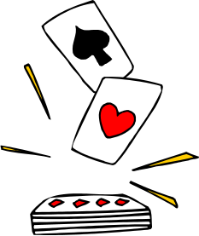
Lab Description : Write a Deck class that uses the Card class. Show that Deck works as intended by instantiating a deck of cards in DeckTestOne.java and DeckTwoTwo.java. You will use CardDeckPlayerGraphicsRunner.java to test DeckTestTwo.java. Display all of the cards in order and shuffled on the console window and graphics window.

public class Deck
{
public static final int NUMFACES = 13;
public static final int NUMSUITS = 4;
public static final int NUMCARDS = 52;
public static final String SUITS[] = {"CLUBS","SPADES","DIAMONDS","HEARTS"};

private int topCardIndex;
Files Needed ::
Card.java
BlackJackCard.java
Deck.java
DeckTestOne.java
DeckTestTwo.java
CardDeckPlayerGraphicsRunner.java

private ArrayList<Card> stackOfCards;

public Deck ()
{
//initialize the data

//populate stackOfCards with new cards

}

Sample Output ( DeckTestOne.java )
lots of cards

num cards left in the deck == 0

shuffling
num cards left in the deck == 52

lots of cards again
public void shuffle(){

}

//get methods

public Card nextCard()
{
return stackOfCards.get(topCardIndex--);
}

public String toString()
{
return stackOfCards + " topCardIndex = " + topCardIndex;
}



