A+ Computer Science BlackJackGUI – THE ABSTRACTPLAYER Lab Value - 100

Lab Goal : This lab was designed to teach you more object oriented programming and how to write a larger game.

Lab Description : Write an Abstract Player class that will be extended to create the Player class and Dealer class. AbstractPlayer will contain all of the common methods from Player and Dealer. Show that AbstractPlayer works as intended by creating Player and Dealer. You will create Player and Dealer in steps 4 and 5. You will not test AbstractPlayer until you make Player and Dealer.

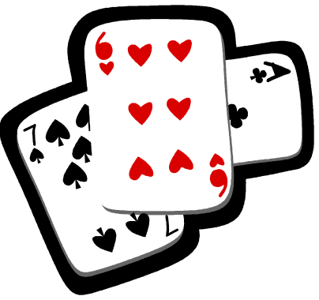
public abstract class AbstractPlayer implements Playerable
{
private ArrayList<Card> hand;
private int winCount;

public AbstractPlayer(){
}

public AbstractPlayer(int score){

}

public void addCardToHand(Card temp){

}

public void resetHand(){
hand.clear();
}

public abstract boolean hit(); //implemented at the local level

public void setWinCount(int numWins){

}

public int getWinCount() { return 0; }

public int getHandSize() { return 0 }

public ArrayList<Card> getHand(){
return hand;
}

public int getHandValue(){

}

public String toString() {
return "hand = " + hand.toString() + " \n- # wins " + winCount;
}

public void drawHand(Graphics window, int x, int y)
{

}
}

