A+ Computer Science BlackJackGUI – THE DEALER Lab Value - 100

Lab Goal : This lab was designed to teach you more object oriented programming and how to write a larger game.

Lab Description : Write a Dealer class that extends the AbstractPlayer class. Show that Dealer works as intended by instantiating a Dealer in the game class and using the Dealer to play a game of BlackJack.

public class Dealer extends AbstractPlayer
{
Files Needed ::
Card.java
BlackJackCard.java
Deck.java
AbstractPlayer.java
Player.java
Dealer.java
DealerTestOne.java

private Deck deckOfCards;

//constructor

public void shuffle()
{

}

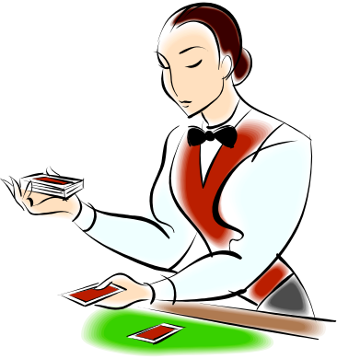
//deal Card method

public boolean hit()
{

return false;
}
}

Sample Output ( DealerTestOne.java )

PLAYER
Hand Value :: 16
Hand Size :: 2
Cards in Hand :: hand = [FIVE of DIAMONDS
ACE of HEARTS]
- # wins 0

DEALER
Hand Value :: 20
Hand Size :: 2
Cards in Hand :: hand = [TEN of DIAMONDS
KING of DIAMONDS]
- # wins 0

Dealer has bigger hand value!

