Lab Goal : This lab was designed to teach you more object oriented programming and how to write a larger game.
A+ Computer Science BlackJackGUI – THE GAME Lab Value - 100

Lab Description : Write the complete game logic for BlackJack. At this point, Card, BlackJackCard, Deck, AbstractPlayer, Player, and Dealer have all been thoroughly tested. Now, put all of the pieces together to play the game of black jack.

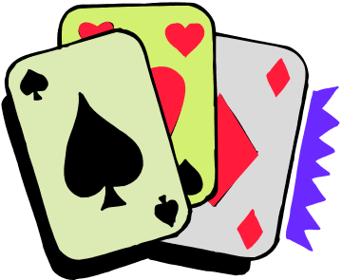
How do you play the game of BlackJack?

do{
1st – dealer shuffles the deck of cards

2nd – deal the player two cards one at a time
dealer deals himself two cards

3rd – print out player’s hand value and cards
while(hand value < 21 and the player wants to hit)
deal the player the next card
print out player’s hand value and cards

4th – print out dealer’s hand value and cards
while(dealer wants to hit)
code to add cards should be in dealer hit method
print out dealer’s hand value and cards

5th – determine which player won

6th – update the win total for the winner

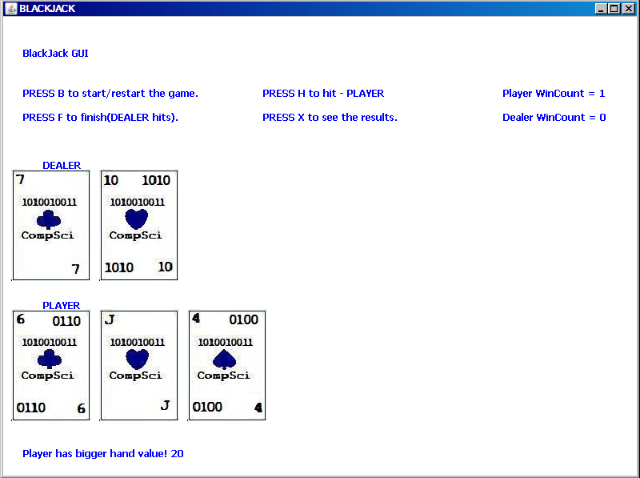
}while another game is to be played
Files Needed ::
Card.java
BlackJackCard.java
Deck.java
AbstractPlayer.java
Player.java
Dealer.java
BlackJack.java
TheGame.java

