Lab Goal : This lab was designed to teach you more object oriented programming and how to write a larger game.
A+ Computer Science BlackJackGUI – THE MULTI-PLAYER GAME Lab Value - 100

Lab Description : Write the game logic for multi-player BlackJack. At this point, Card, BlackJackCard, Deck, AbstractPlayer, Player, and Dealer have all been thoroughly tested. Now, put all of the pieces together to play the game of black jack with multiple players. All players including the dealer will be accessed through the players ArrayList. The dealer will be spot 0 and all other players will be in spots 1 through x.

Game logic for multiplayer Black Jack

do{

1st - the dealer shuffles the deck of cards

2nd - loop through all of the players including the dealer
deal each player two cards one at a time
deal to the dealer last

3rd - loop through the players - hit the dealer last
print out player’s hand value and cards
while( the player wants to hit and hand value < 21 )
deal the player the next card
print out player’s hand value and cards

4th - loop through all of the players including the dealer
print out each player’s cards and hand value

5th - loop through all of the players including the dealer
determine which player won

6th - update the win total for the winners

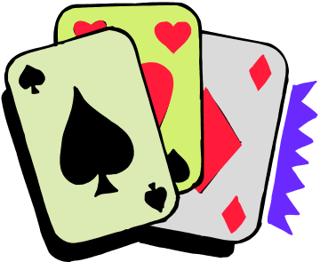
}while another game is to be played

