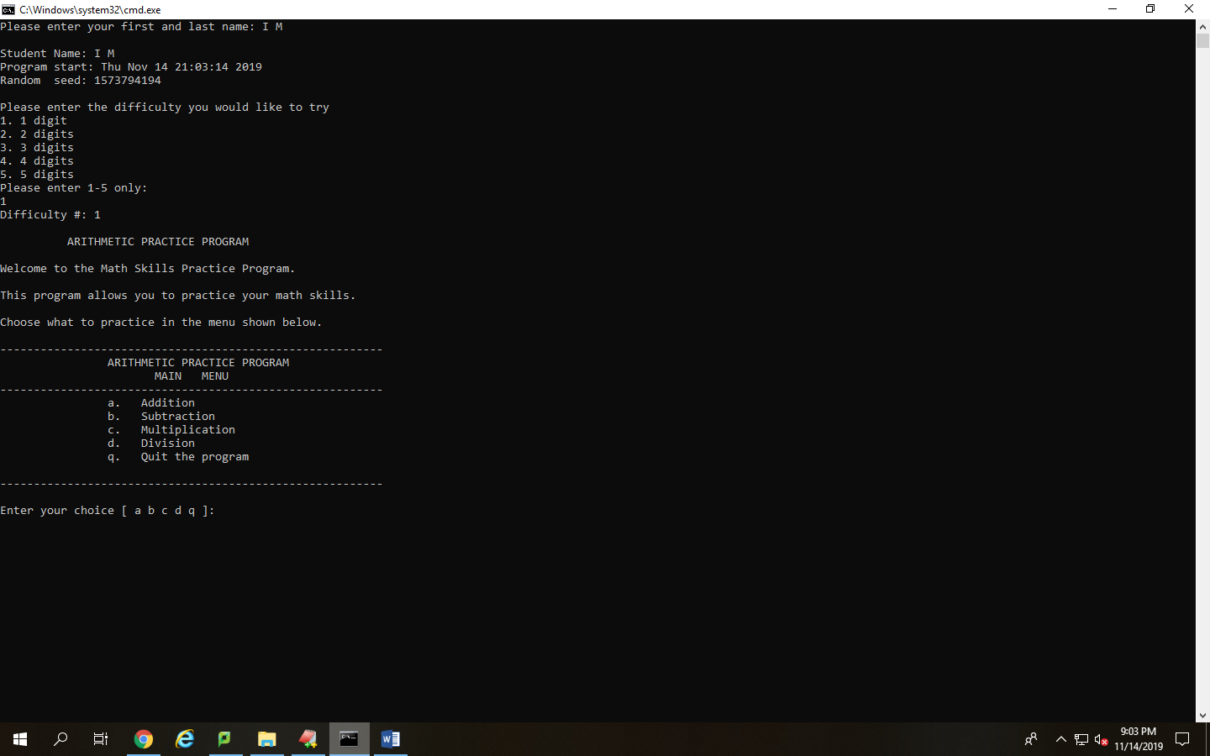

This screen shot shows the main menu that the user will see giving the option of difficulty as well as user name input, program start time, and the seed that the program generated for the programs use.

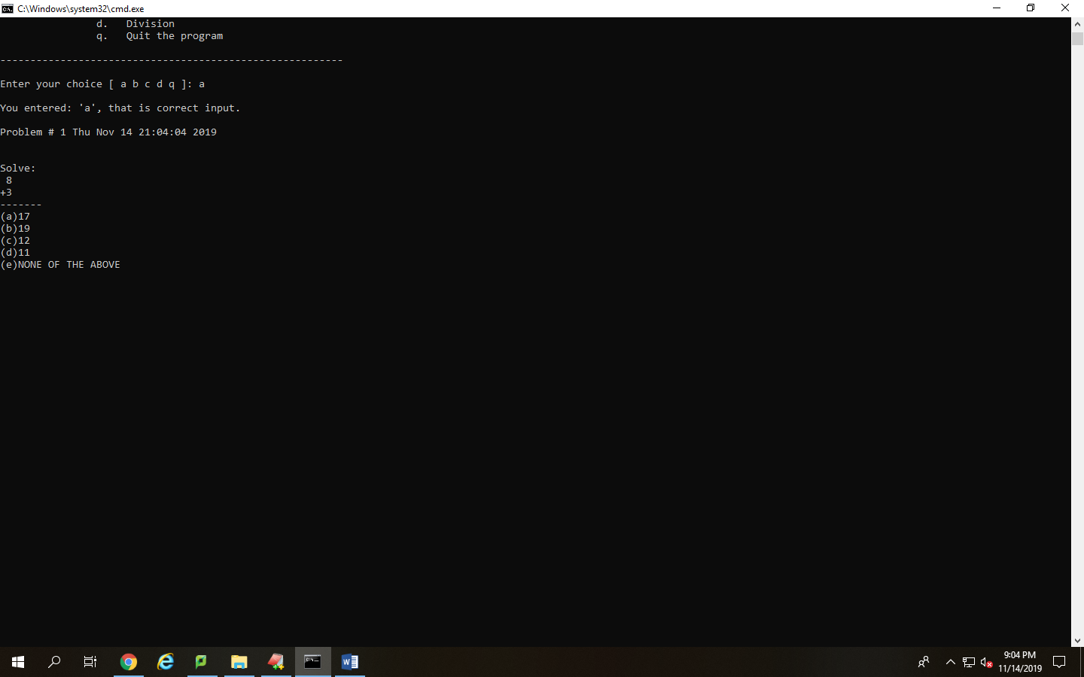

Displays the user choosing the addition problem from the menu and the multiple choice and problem output that comes with it.

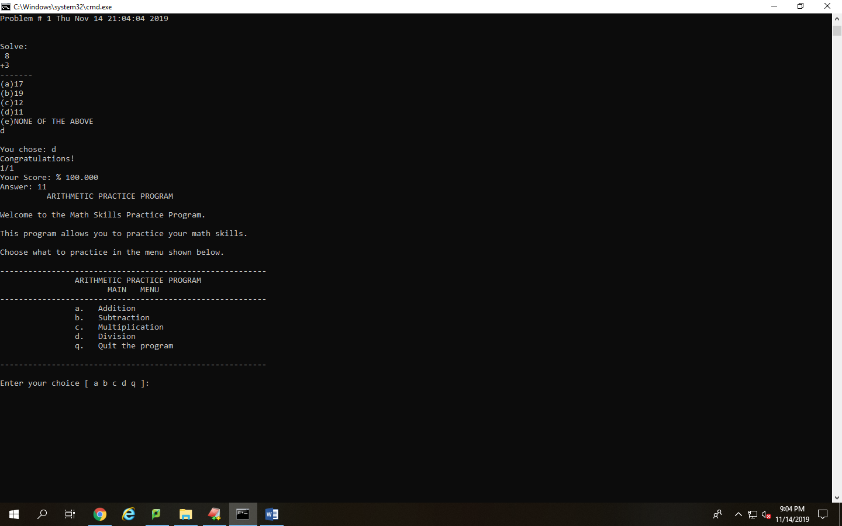

Displays the user’s choice, which was d in the case. The screenshot also displays a congratulations message as well as number of attempts successful and tried along with a score and the proper answer.

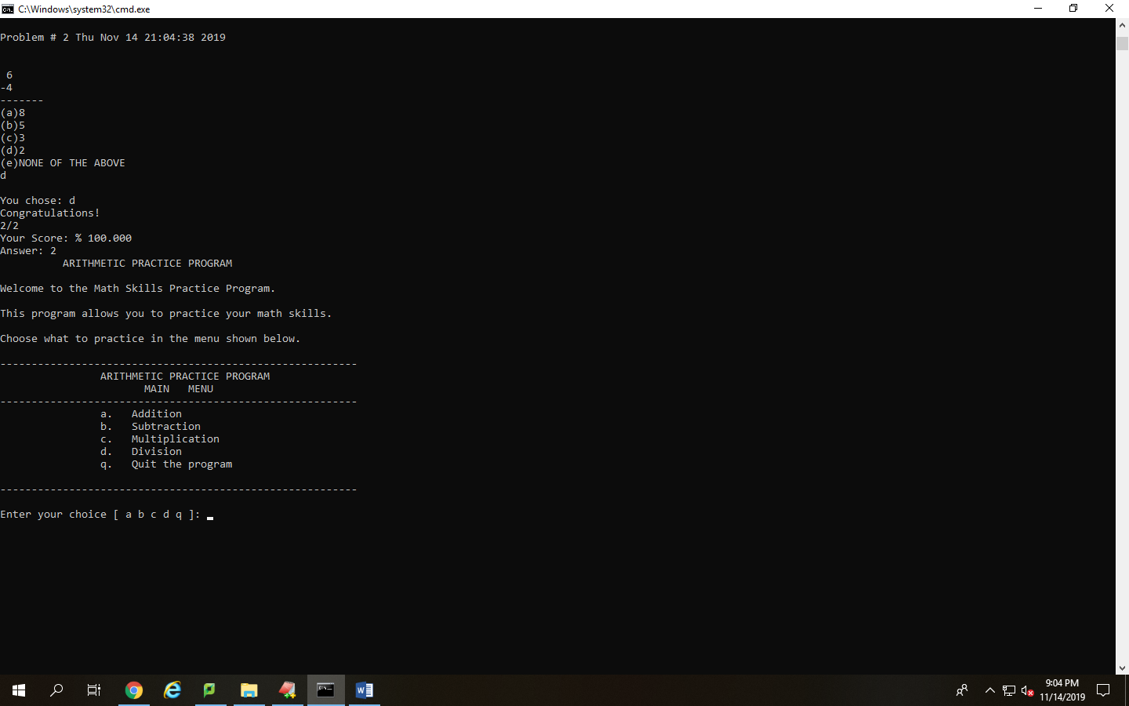

This screenshot shows the user continuing on with their attempt, which they got right the first try. The number of attempts and success are updated accordingly and the answer chosen and correct answer are still displayed.

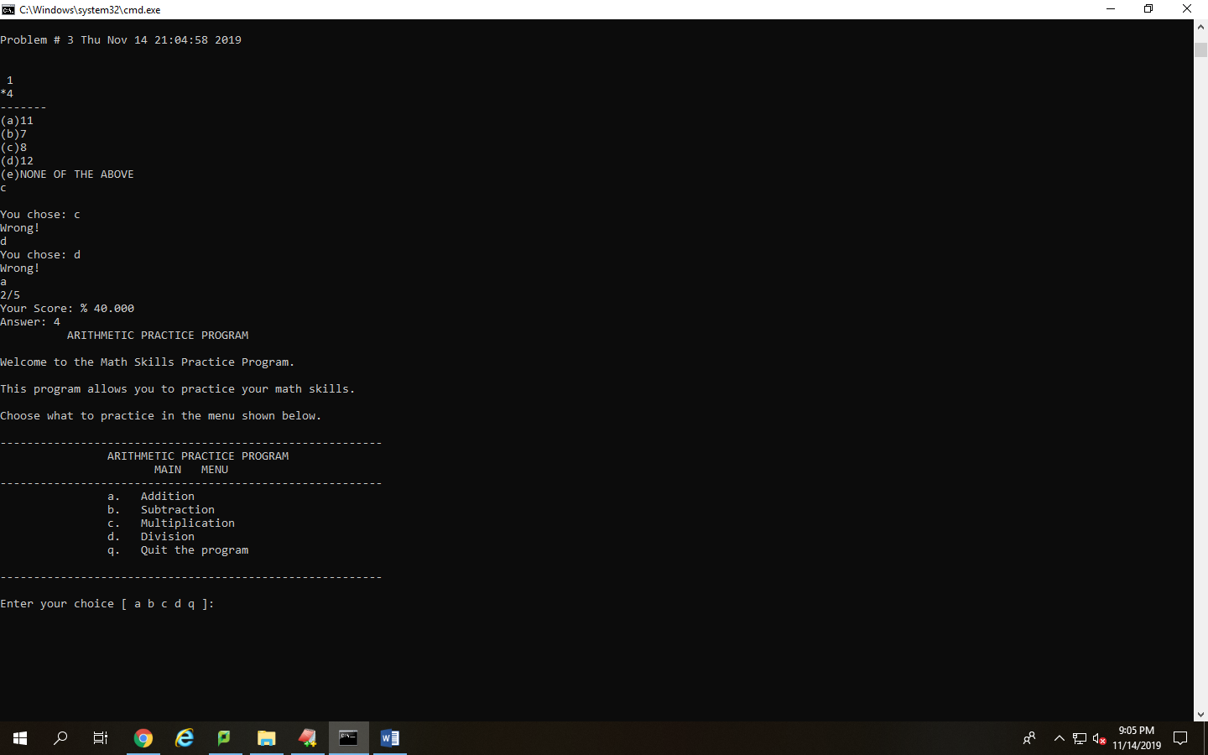

Displays what happens when a user starts to get answers wrong as well as the multiplication choice in the menu. The program remembers the number of attempts and the person’s percentage is updated as well. They are failing with a score of 40% now getting a score of 2/5.

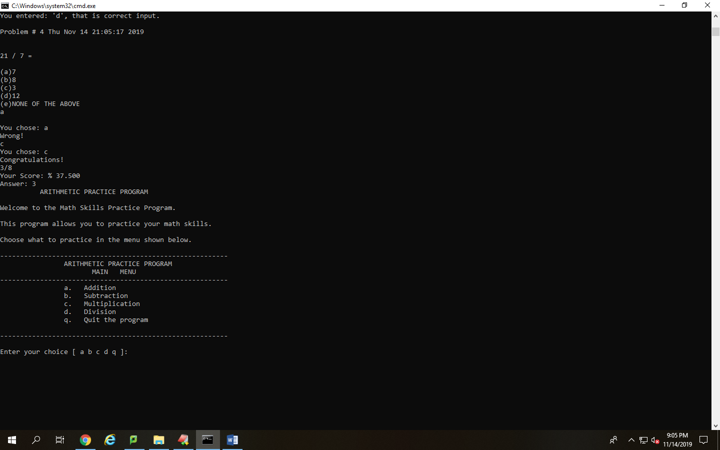

This screenshot displays the division output and the user’s choices. The true answer is placed and divided by the dividend so that no remainders occur. The user got the first choice wrong and the Wrong! message is displayed. The percentage is calculated again and is now 37.5%, a failing score.

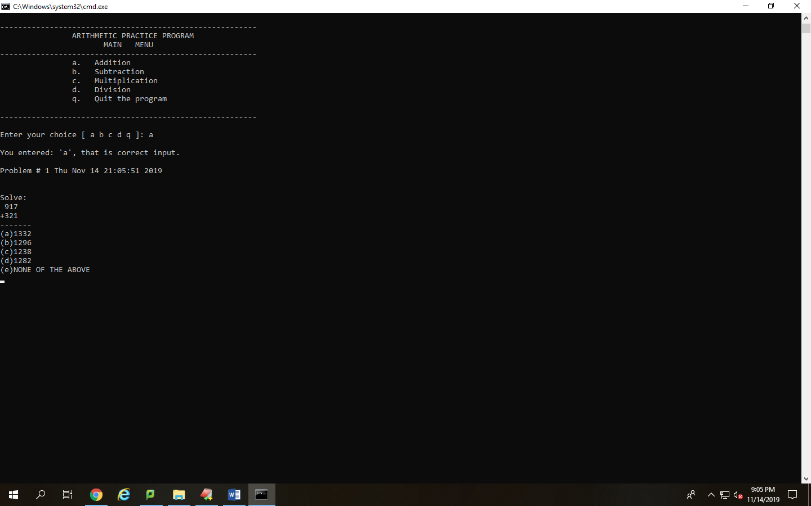

Displays that the program can work with different difficulty levels as well. In this case the difficulty level is 3. The answers are displayed accordingly and within the range of the answer so that the answer isn’t an obvious choice, this process was done for all difficulties.

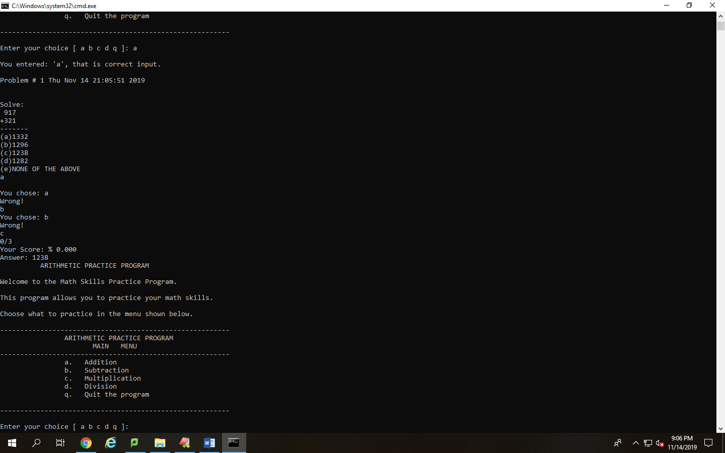

Displays how the users attempts at the problem and the score the user receives for getting all the attempts wrong.

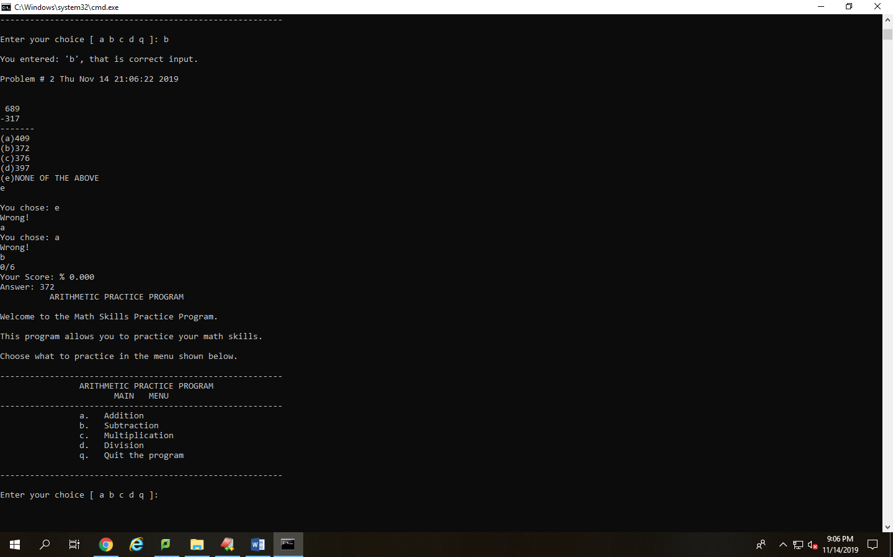

Displays the subtraction function with a higher-level difficulty and shows that the timestamp is placed on every problem attempted, the other screenshots show this as well.

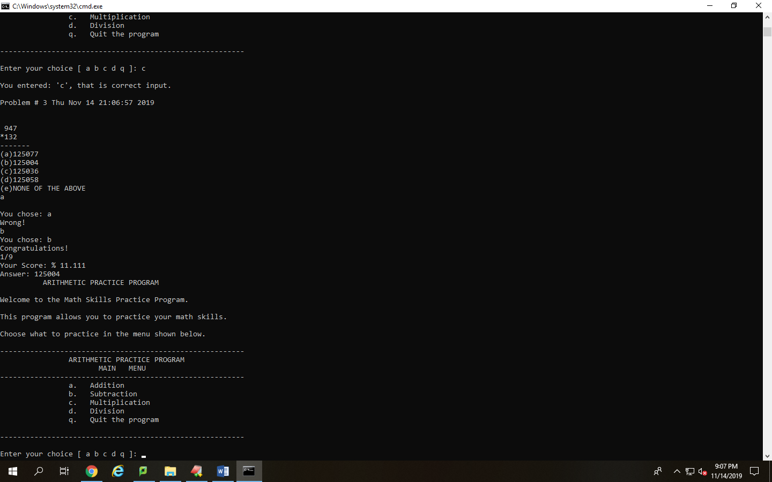

Displays the multiplication function with a difficulty of 3 and shows that all the answers, like they’re supposed to be, are 2 times the size of the digits being multiplied.

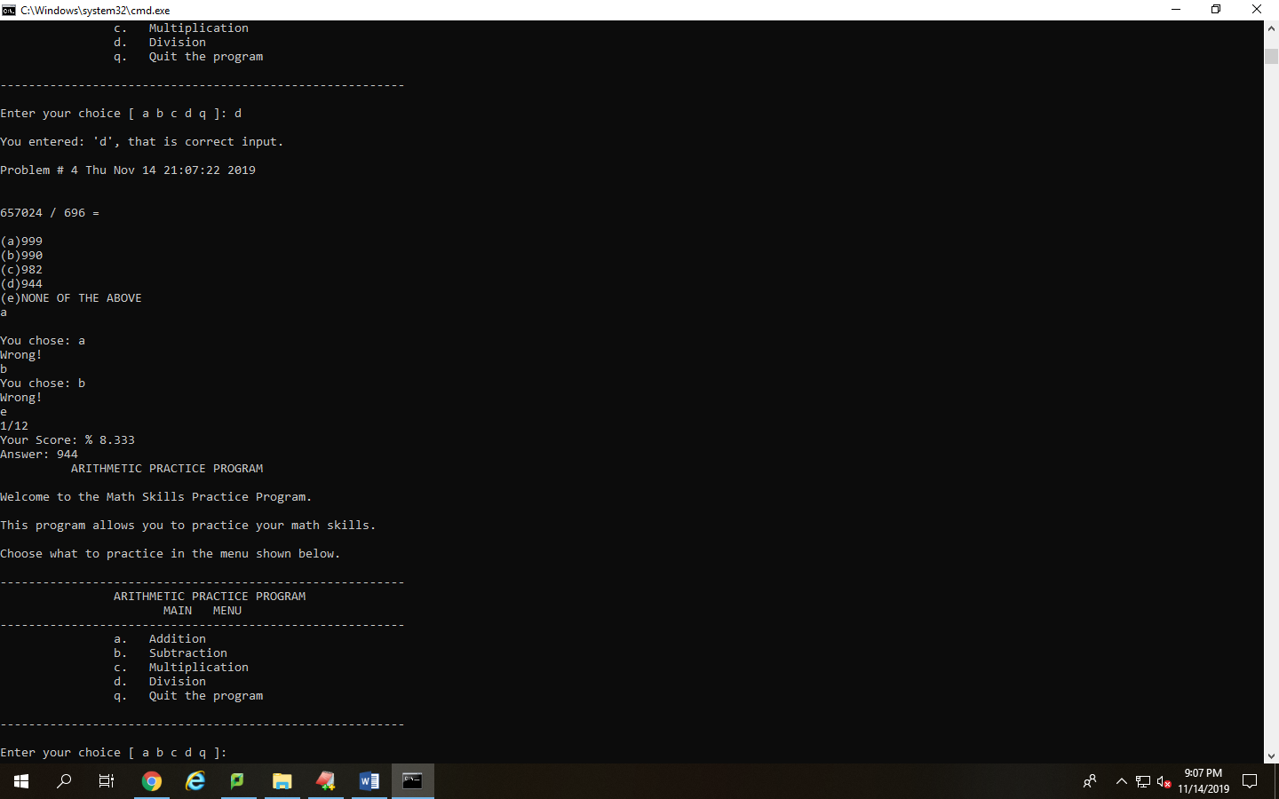

Displays that along with the timestamp at every problem, the amount of problems attempted, which is 4, is counted and displayed with every problem as well. This screenshot also shows that the division function works properly with no remainders.

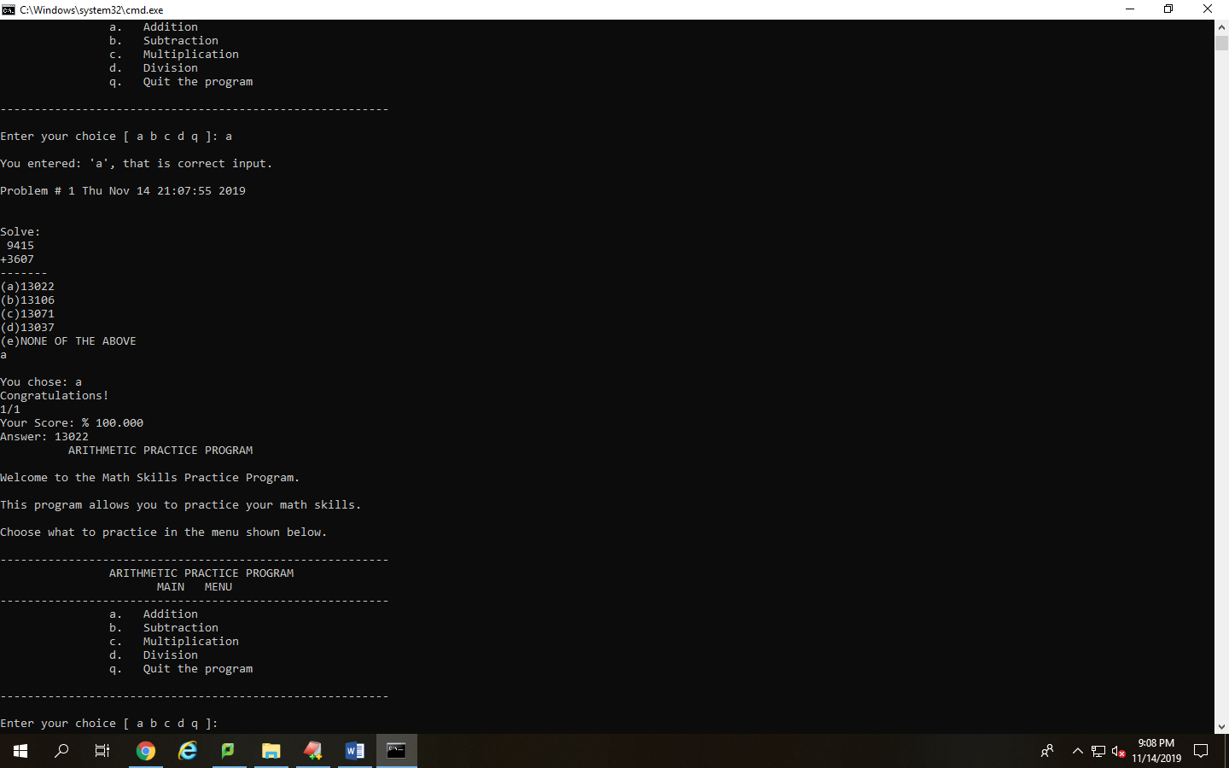

Displays the next level difficulty with the addition problem, being four digits now, the program still displays the right answer as well.

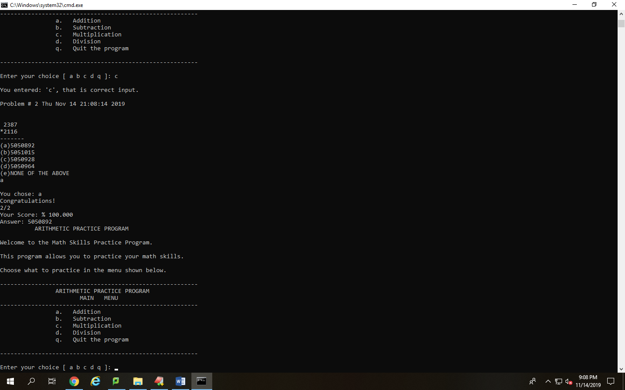

Displays the multiplication problem and that the answers are still 2 times the digits of the numbers being multiplied. It also exemplifies how even large numbers are closely in range with the correct answer.

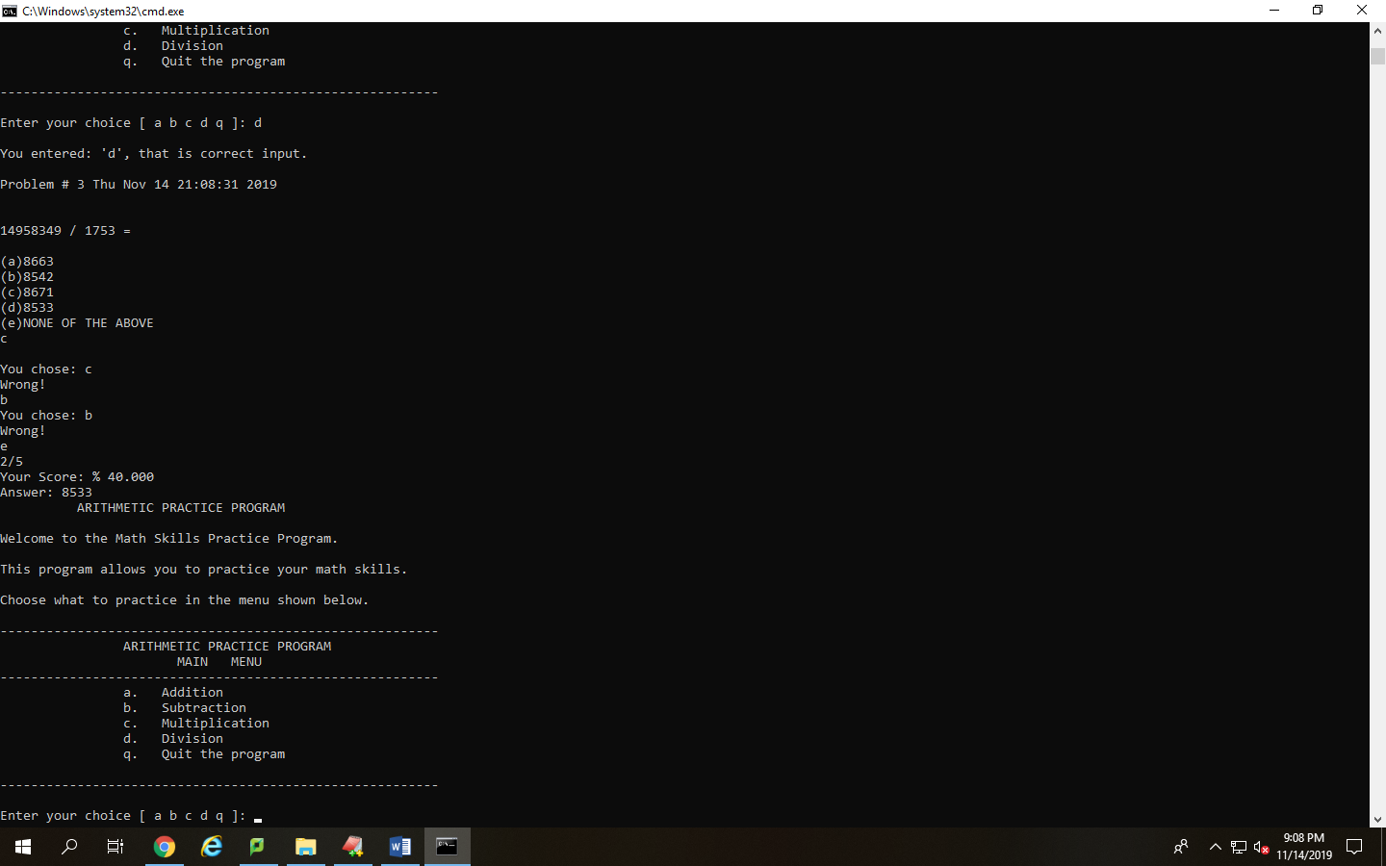

Displays that the division problem no matter the digits will still give you an answer with no remainder and that the quotient is 2 times the size of the value being divided into it.

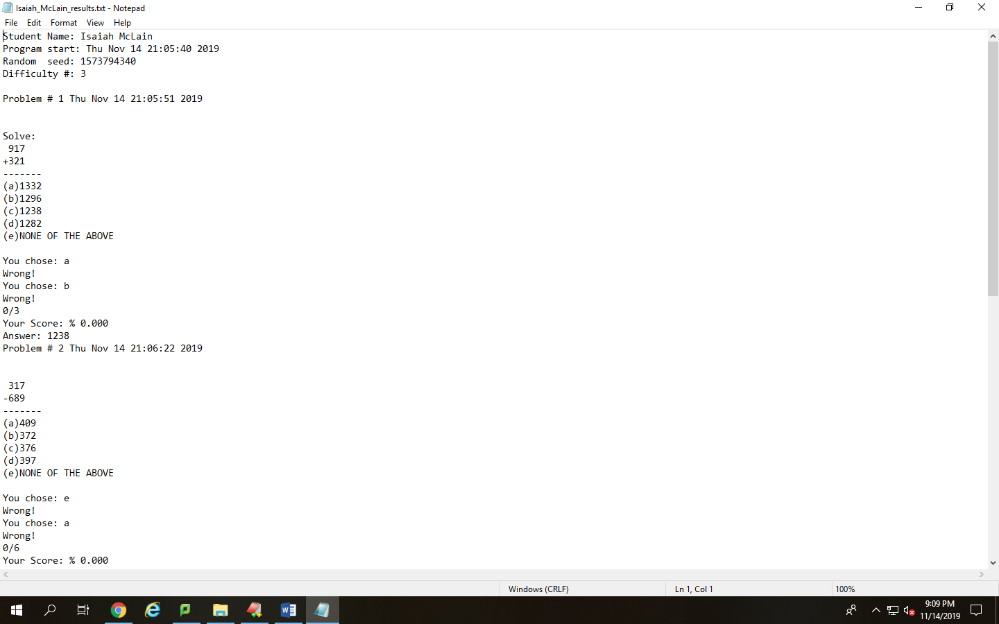

Displays the output file that the program writes to, with the student name, start time, difficulty, and problems attempted outputted to the file and that everything that is needed is written down to the file.

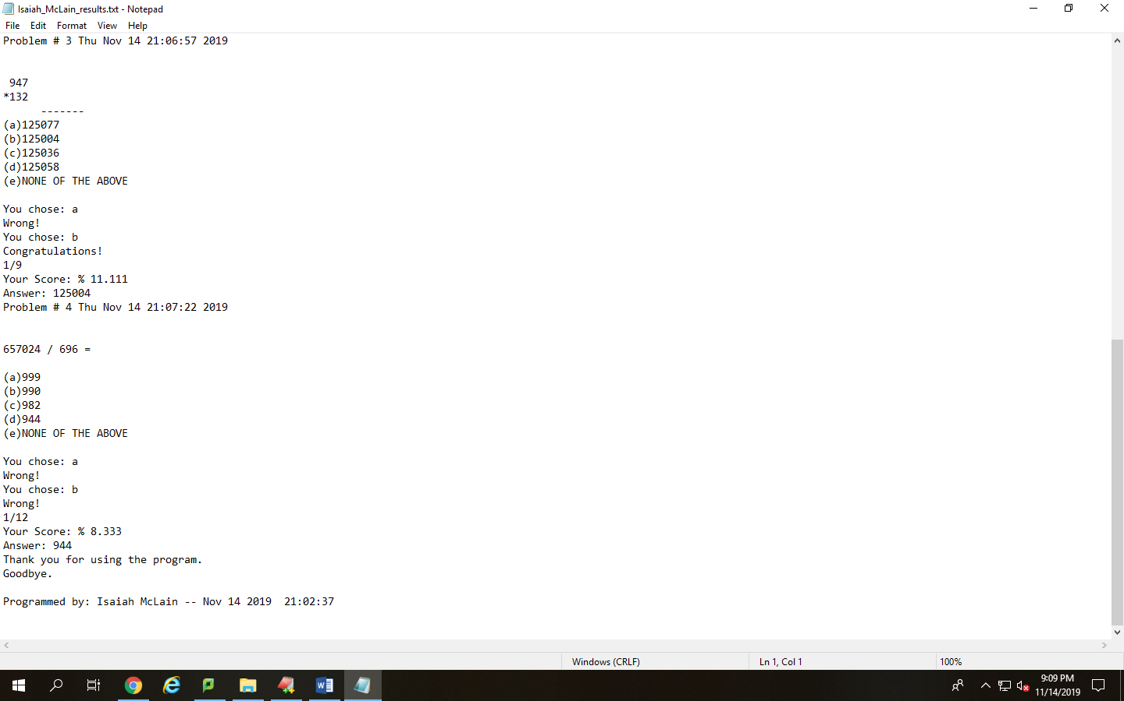

This second screenshot displays that the attempts are recorded in the file as well as the time stamps and the score the user gets after every problem. The problem being attempted is displayed as well. At the end the programmer name and compile date are displayed in the file just like in editplus.