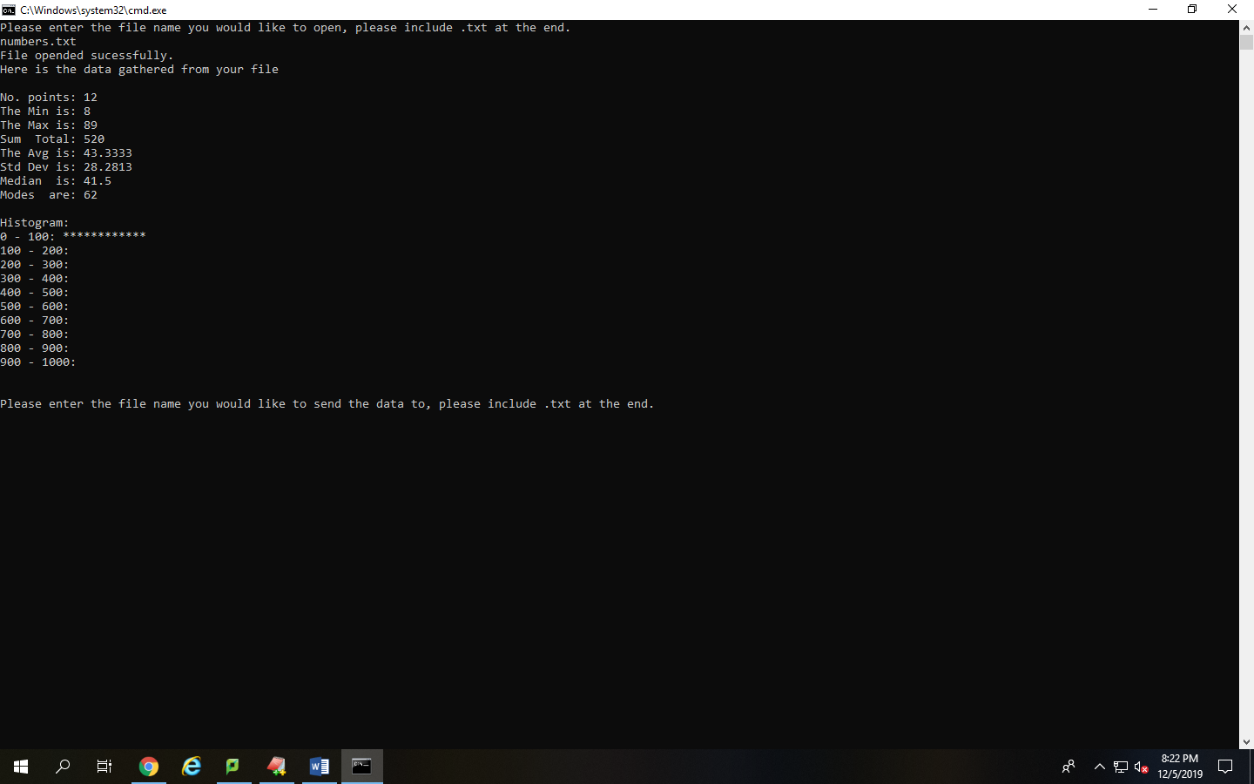

This screenshot displays the working program to the user with all the needed values. A histogram is included as well which show the user the range in which the values have fallen into. The data was taken from numbers.txt

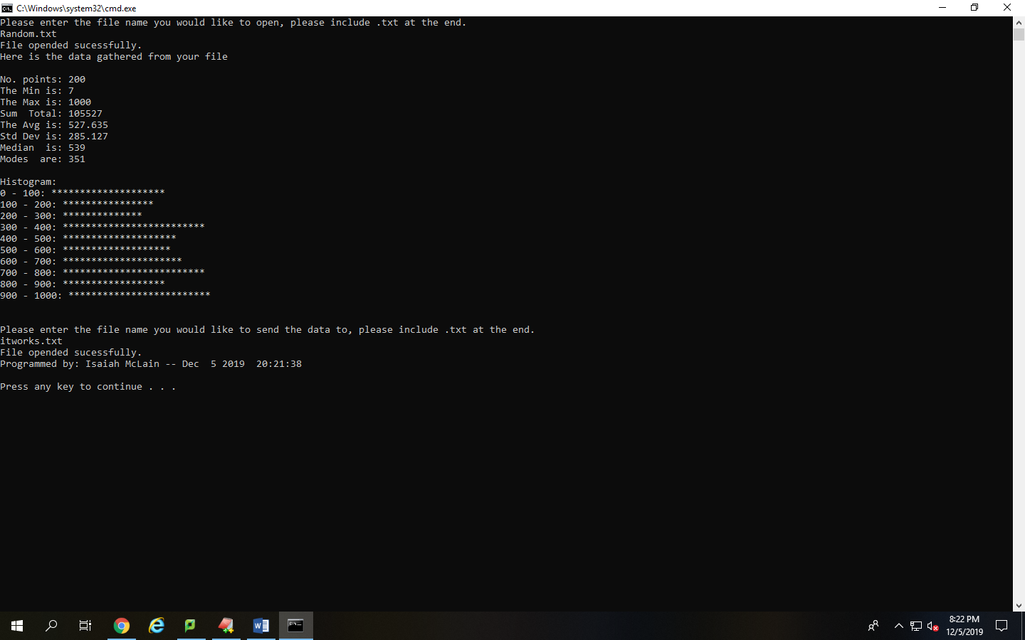

This screenshot displays that the program can work with many different numbers and that it can also allow the user to enter what file they want to save the data to. The data was taken from Random.txt

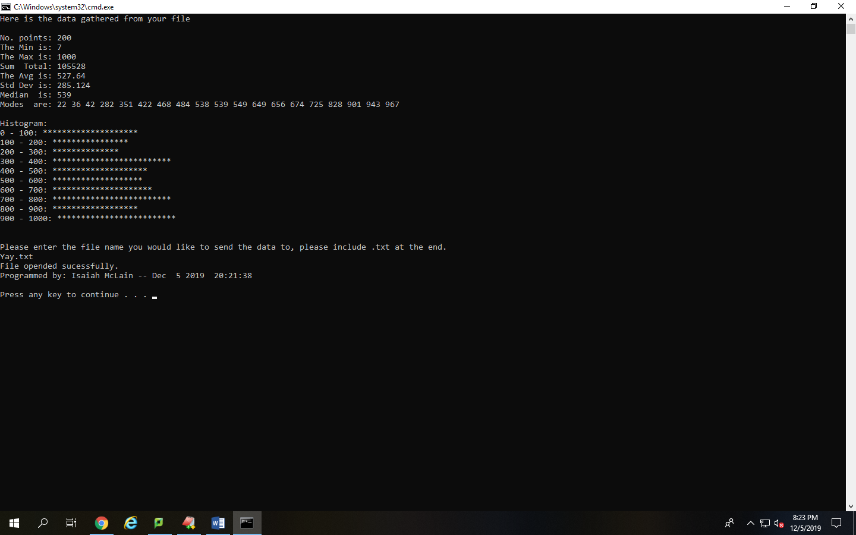

This screenshot displays that the mode function can operate with both single and multiple modes and that the median can be both a value within the array or in-between numbers in the array. Data taken from Random2.txt file.

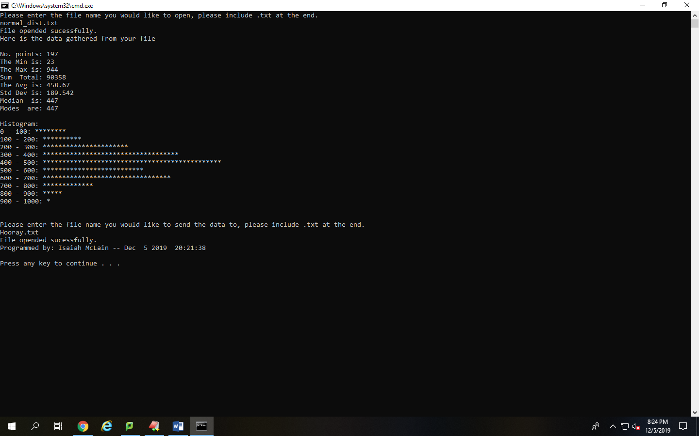

Displays that the histogram works with multiple different values and it correctly displays the standard distribution curve that was supposed to occur with the values entered from the normal_dist.txt file.

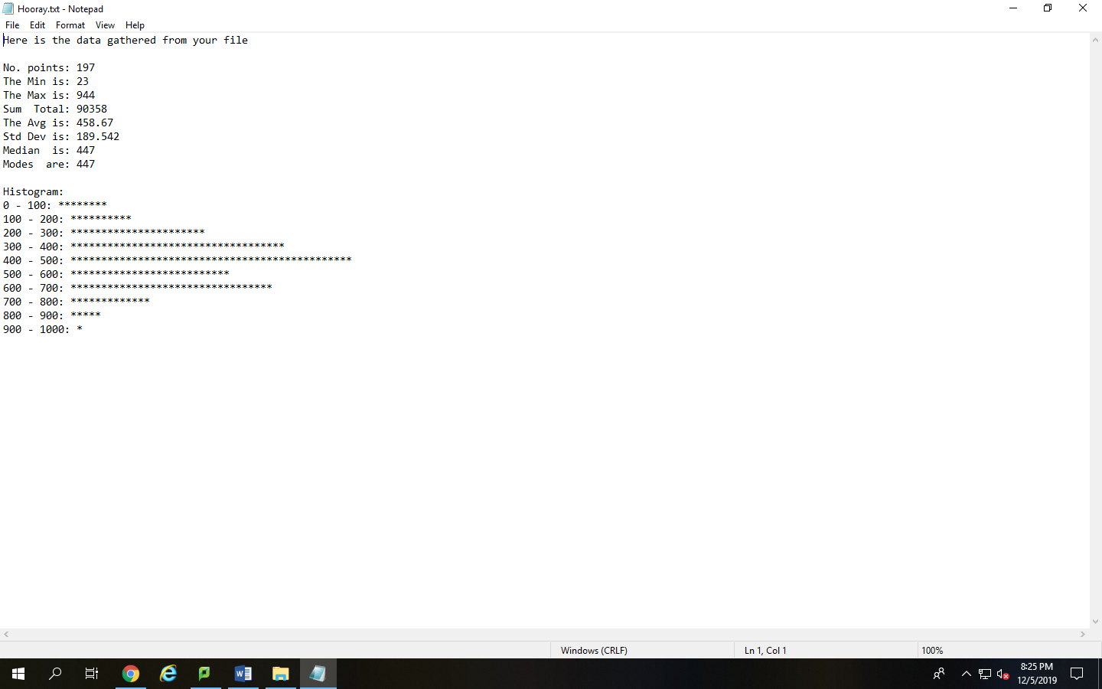

This screenshot displays that the output file function is working correctly and that the data is properly written to the file the user specified.

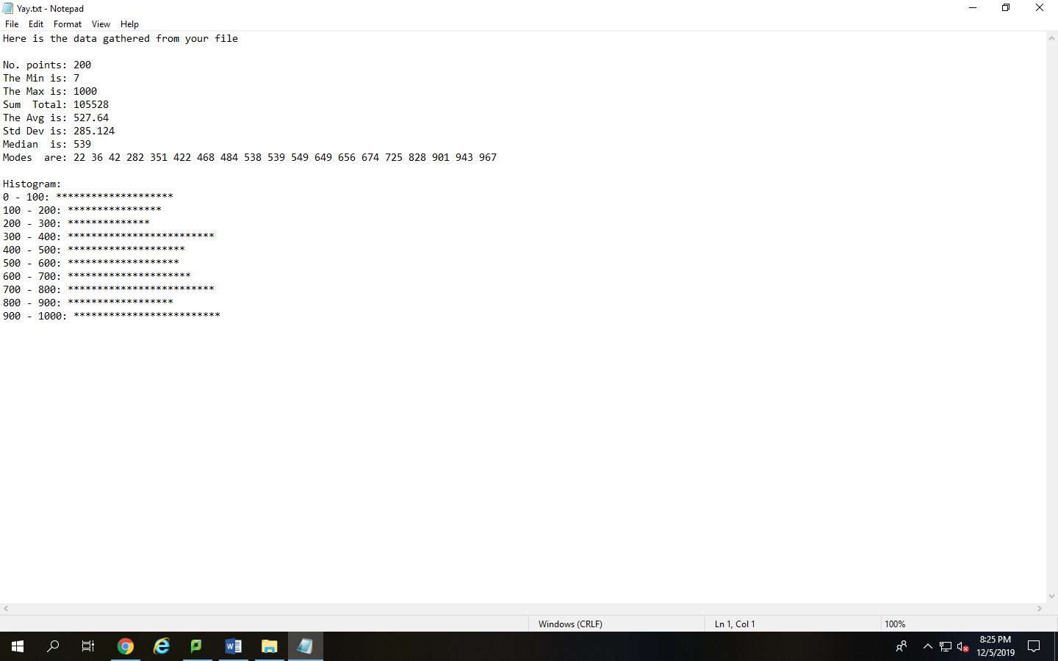

This Screenshot is another example of the program being able to output the data to a file that the user has specified with the same spacing and format as the console menu.