Journey to Fellowship
By Dr Aziz Noordin, Family Physician, Editorial Team Member (Team B)
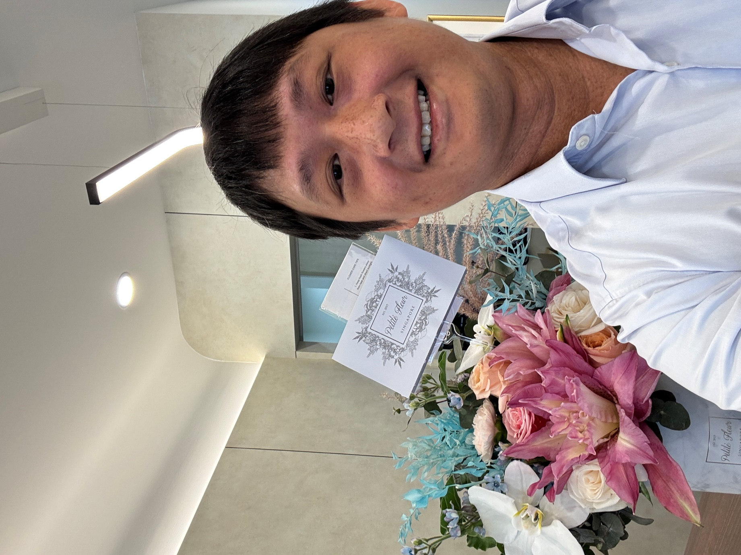
Dr Kenneth Tan at his new clinic

Dr Aziz: Hi Kenneth, thank for taking the time to speak with the College Mirror. Tell us a bit about yourself. What keeps you busy these days?

Dr Kenneth: Hi everyone, I’m Kenneth. I’m a family physician working at a solo GP practice in Punggol, and I have just recently opened a second branch. It is busy, but I’m very thankful to have colleagues and friends to help me juggle it all.

That’s great to hear. And congratulations on your Fellowship! Take us back to the beginning. What first drew you to Family Medicine?

Family Medicine has always been something I was very interested in since my Phase 3 clinical posting at NUS. I was attached to a Family Physician who told me something very precious: “You know, only in a GP clinic can you really see your patient’s smile.” That message really stuck with me.

When you work in a hospital setting, patients are more sick, whereas in primary care, you take care of them when they are well and possibly throughout their life. I was actually considering orthopaedic residency at the time. I was posted to SGH and was part of the team that performed an amputation for a patient due to poor diabetic control. After the amputation, the patient was very thankful to the team, but in my mind, I had the thought that if the primary care system had helped him control his diabetes, he would not have needed such a drastic, invasive surgery.

That planted the seed of me wanting to become a Family Physician.

Every journey has its rough patches. What were some of the moments when you questioned whether it was all worth it?

There were many moments where I doubted the purpose of this exercise. First, many people questioned why a solo GP and private practitioner would pursue further education and training. Second, when time was taken away from the clinic to attend courses, not only my patients but my staff also questioned me. They wondered why I was closing my clinic to attend these courses when we had such a busy practice.

As a result, we actually lost some patients and staff along the way, either because they found my opening hours erratic, or because they felt they could earn more in other clinics. But what helped me stay the course was the support of mentors like Dr Leong Choon Kit, my coach in the Fellowship course, and my close friends in GP+ cooperative, PCN, and other groups who really supported me with my research and deliverables needed for Fellowship.

Looking back at yourself before and after this training, how has it transformed the way you practise medicine?

Through the course, I now feel that I have received similar training to my specialist colleagues. In a sense, it gave me the confidence to manage patients of greater complexity.

We all have those pivotal moments that change everything. What’s one conversation or gesture from your support network that still resonates with you today?

I was not planning to take the Fellowship exam this year. At a Family Medicine dinner, some of my Fellowship colleagues asked me why I wasn’t taking the exam and encouraged me to give it a go. I did, I took the exams, and I made it. Their words really made a difference.

If you could sit down with a younger Family Physician just starting out, what wisdom would you want to pass on?

Carry on the training. Believe in yourself, and believe in the system that will form up around you as long as you try.

Finally, if a single word or phrase could define your Fellowship journey, what would it be?

I think it would be idealism. To better yourself is a noble thought, but not many of us are able to achieve it or devote time and attention to it because we’re busy with work and family. To take on a further education journey as a private practitioner really has to do with staying true to that ideal of wanting to better yourself as a physician.

