**Task 6**

**Group: Isaias Leos, David Amparan, and Alex Vasquez**

Add the Pistol Speed Shot Functionality Your task is to add the ability to toggle a functionality that decreases the time between shots of the pistol. * Navigate to the folder containing your solution file (.sln) and then delete any .sdf files (>20MB) and then zip the folder that contains your .sln (including all subfolders) and copy it to your local drive and name it deliverable6.zip. Also include your tutorial-style write-up for Task 6 (including a few test cases that helped you verify the functionality worked) in a file named deliverable6.doc

1. We fired the ammo on the pistol and monitored the hex memory viewer. Specifically, we monitored the ammo
2. We scan the current ammo for the pistol (50) then we scan again for (49).
3. From this we can access the address and add it to our code list (highlighted)

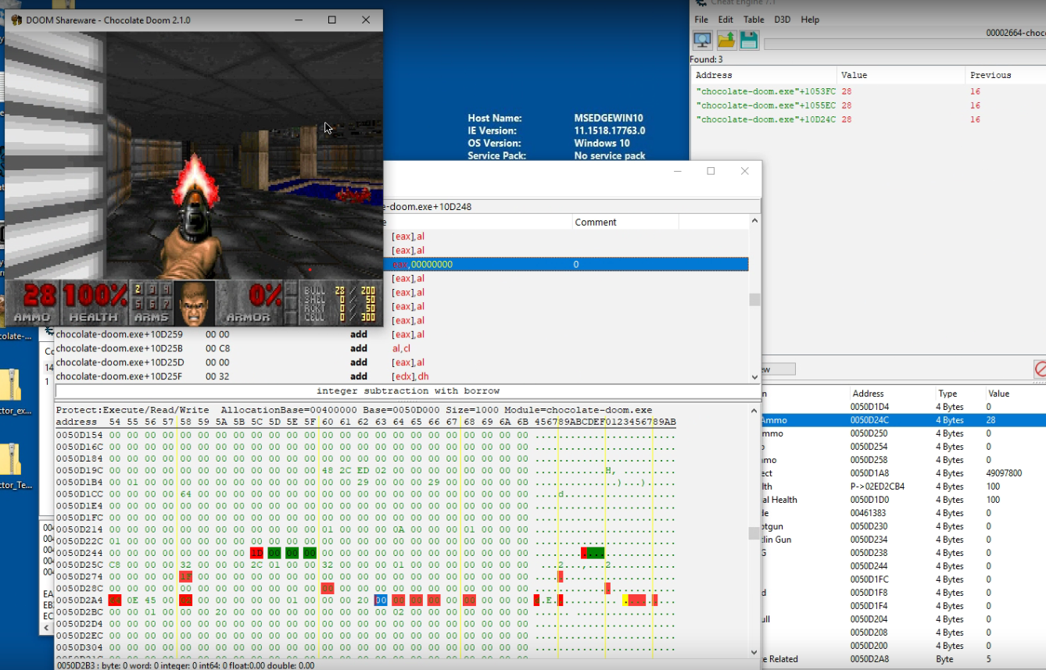

1. From here We see a value that will see a value that takes us to 0045DA09. At this address we see a jump which means jump if equal. We decided to change this to a jmp and magically the weapon fired at a faster rate.
2. **BEFORE**

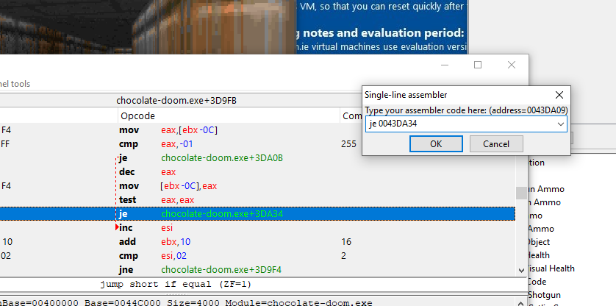



1. **AFTER**

