**Task 7**

**Group: Isaias Leos, David Amparan, and Alex Vasquez**

Add Another Functionality of your Choice Your task is to add the ability to toggle a functionality of your choice that empowers the player. You may receive extra credit if this functionality is considered above and beyond the call of duty. * Navigate to the folder containing your solution file (.sln) and then delete any .sdf files (>20MB) and then zip the folder that contains your .sln (including all subfolders) and copy it to your local drive and name it deliverable7.zip. Also include your tutorial-style write-up for Task 7 (including a few test cases that helped you verify the functionality worked) in a file named deliverable7.doc *

Functionality Implemented: Unlock All

1. We used a combination of the cheats in the previous tasks along with the memory addresses associated with them to Unlock all the cheats.
   1. Max Ammo
   2. Unlock all Guns
   3. Unlock Skulls
   4. Unluck Cards
   5. Unlock Armor
2. Below are the addresses that we labeled through the assignment, making it easier to access them.

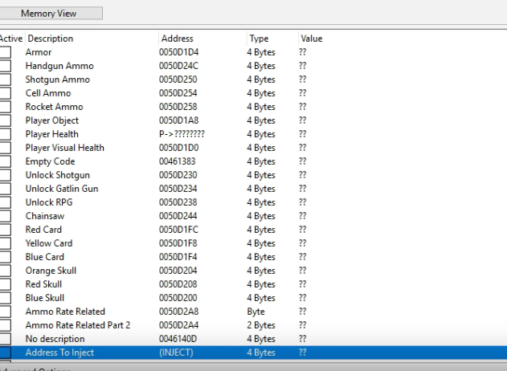

1. Below is the code we injected for each respective cheat. The cheat name is “unlock all”
2. First, we do Max Ammo for all the guns
   1. Obtain the address of the ammo for the weapon
   2. Set the ammo to the max value allowed
   3. Overwrite the memory to set the max ammo
3. Unlock all the weapons
   1. Obtain the address of the weapon
   2. Unlock the weapon
   3. Set the weapon as unlocked with Overwrite memory
4. Unlock Skulls
   1. Overwrite memory with “unlock” (This value is 1)
      1. Setting the value from 0 to 1 unlocks the skulls.
   2. Do for all three skulls
5. Repeat the same process as F with the addresses for Card
   1. Setting the value from 0 to 1 unlocks the skulls
6. Easter Egg Cheat
   1. Get the address of the armor
   2. Set char array to ‘420’ this will serve as the value we are going to set the armor at
   3. Overwrite the value at the address

