|  |  |  |  |  |  |  |  |  |  |
| --- | --- | --- | --- | --- | --- | --- | --- | --- | --- |
| Register | Hex | Bit 7 (MSB) | Bit 6 | Bit 5 | Bit 4 | Bit 3 | Bit 2 | Bit 1 | Bit 0  (LSB) |
| Noop | 0x00 | X | X | X | X | X | X | X | X |
| Digit 1 (Left) | 0x01 | DP | A | B | C | D | E | F | G |
| Digit 2 | 0x02 | DP | A | B | C | D | E | F | G |
| Digit 3 | 0x03 | DP | A | B | C | D | E | F | G |
| Digit 4 (Right) | 0x04 | DP | A | B | C | D | E | F | G |
| LED bar (bot) | 0x05 | 9 | 8 | 7 | 6 | 5 | 4 | 3 | 2 |
| LED bar (top) | 0x06 | 17 | 16 | 15 | 14 | 13 | 12 | 11 | 10 |
| LED Indicators | 0x07 | 21 | 20 | 19 | 18 | X | X | X | X |
| Noop | 0x08 | X | X | X | X | X | X | X | X |
| Decode mode | 0x09 | X | Indicators | BAR top | BAR bot | Digit 4 | Digit 3 | Digit 2 | Digit 1 |
| Intensity | 0x0A | X | X | X | X | 0x0F = MAX | | 0x00 = MIN | |
| Scan limit | 0x0B | X | X | X | X | X | Turn off register 1-7 by index | | |
| On/Off | 0x0C | X | X | X | X | X | X | X | On/Off |
| Noop | 0x0D | X | X | X | X | X | X | X | X |
| Noop | 0x0E | X | X | X | X | X | X | X | X |
| Display Test | 0x0F | X | X | X | X | X | X | X | On/Off |

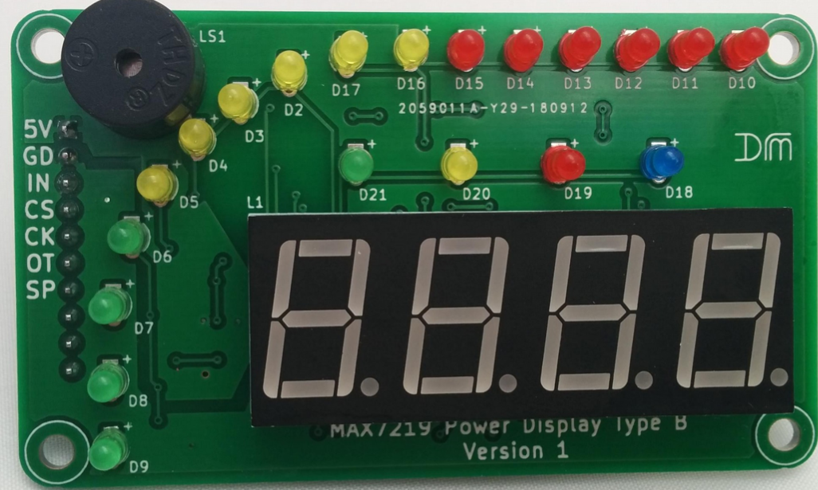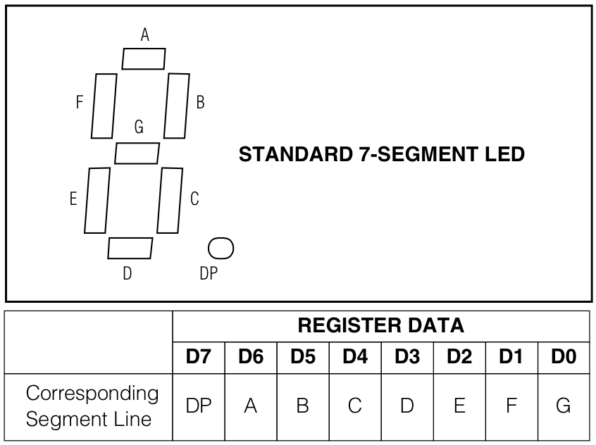

Digit 4

Digit 3

Digit 2

Digit 1