BUGEMA UNIVERSITY

**Main Campus**

32km, Gayaza - Zirobwe Road P.O.Box 6529

KAMPALA- UGANDA

Tel: 256-312-351400

. Fax: 256-312-351460

Email: [registrar@bugemauniv.ac.ug](mailto:registrar@bugemauniv.ac.ug) Website: [www.bugemauniv.ac.ug](http://www.bugemauniv.ac.ug/)

**Kampala Campus**

2 rniles Bombo Road Between Total Petrol Station

& Makerere Yellow Primary Sch. Muganzi-Awongerera Rd

P.O. Box 6529 KAMPALA- (U) Tel: +256 312 266 630 / 631

**OFFICE OF THE REGISTRAR**



**UN/t,r**

March 31, 2023

Isalanya

Dear Isalanya,

# RE: YOUR ADMISSION TO BUGEMA UNIVERSITY

**APPROVED FORBURSARYD**

**liCE 1**

I am pleased to inform you that your application to join Bugema University has been approved. You have been accepted as a **Holiday** student for the program:



Diploma in Theology

This is a Four- Year Degree program

**Enrollment started on: March 27, 2023**

School fees are payable at the bank see the bank accounts in the fee structure. No student will be registered without clearance from the Business Office. You are advised to pay by bank draft or wire transfer and in either way, ensure that you have enough documentary evidence for your payment.

For residents, only a bed is provided in the hostel. You are therefore advised to carry adequate bedding, clothes and pocket money. There is a bank in the campus and all students are advised to open an account to keep their pocket money. Students whose Secondary School Education was not done in English as a language of instruction, will be required to enroll for Intensive English program for one year. ·

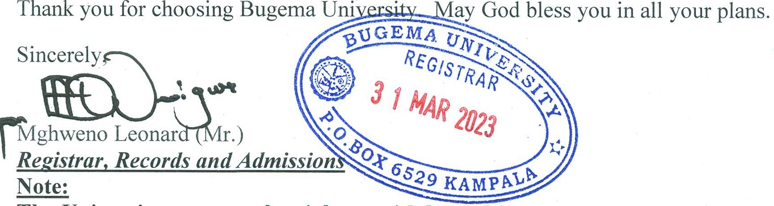On arrival, the Dean of Students will provide you with a student handbook, which you should endeavor to read and understand. The Dean will also advise you on your residential status.

# The University reserves the right to withdraw this admission and/or recall the award in case of any academic anomalies that may not be realized at the time of issuance.

**Please be sure to present your Original certificates/pass slips on registration**

**A CHARTERED SEVENTH-DAY ADVENTIST INSTITUTION**

**MISSION:** "To offer an excellent and distinctive holistic Christian education designed to prepare our students through

training, research and scholarship for productive lives of useful service to God and to Society with uncompromising integrity, honesty and loyalty