Q1.

Code:

***import javax.swing.*;  
  
public class Q_01 {  
 public static void main(String[] args) {  
 JFrame frame = new JFrame("Welcome to Java");  
 frame.setVisible(true);  
 frame.setSize(800,600);  
 }  
}***

Output:

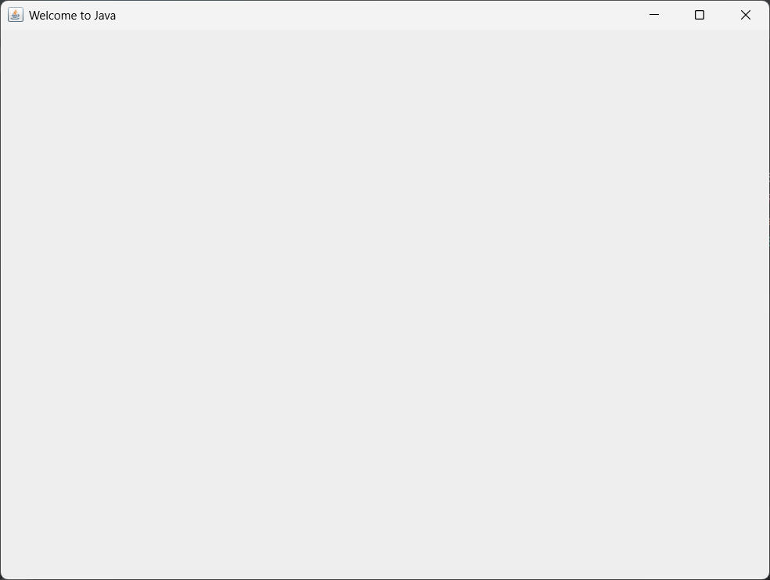

Q2.

Code:

***package Q_02;  
  
import javax.swing.*;  
import java.util.*;  
  
public class Q_02 {  
 public static void main(String[] args) {  
 Scanner scanner = new Scanner(System.in);  
 String fname; // Variable to store first name  
 String lname; // Variable to store last name  
 System.out.print("Enter your first name: ");  
 fname = scanner.nextLine();  
 System.out.print("Enter your last name: ");  
 lname = scanner.nextLine();  
 JFrame frame = new JFrame();  
 frame.setSize(300,200);  
 frame.setVisible(true);  
 frame.setTitle(fname+" "+lname);  
 }  
}***

Output:

Q3.

Code:

***package Q_03;  
  
import java.util.*;  
  
public class Q_03 {  
 public static void main(String[] args) {  
 Scanner scanner = new Scanner(System.in);  
 String fname; // Variable to store first name  
 String mname; // Variable to store middle name  
 String lname; // Variable to store last name  
 System.out.print("Enter your first name: ");  
 fname = scanner.nextLine();  
 System.out.print("Enter your middle name: ");  
 mname = scanner.nextLine();  
 System.out.print("Enter your last name: ");  
 lname = scanner.nextLine();  
 System.out.println(fname+" "+mname.charAt(0)+". "+lname+".");  
 }  
}***

Output:

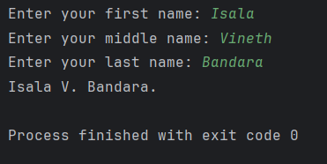

Q4.

Code:

***package Q_04;  
  
import java.text.SimpleDateFormat;  
import java.util.*;  
  
public class Q_04 {  
 public static void main(String[] args) {  
 Date date = new Date();  
 SimpleDateFormat sdf = new SimpleDateFormat("dd MMM yyyy");  
 System.out.println(sdf.format(date));  
 }  
}***

Output:

Q5.

Code:

***package Q_05;  
  
import java.text.SimpleDateFormat;  
import java.util.*;  
  
public class Q_05 {  
 public static void main(String[] args) {  
 Date date = new Date();  
 SimpleDateFormat sdf = new SimpleDateFormat("EEEE, MMM dd, yyyy");  
 System.out.println(sdf.format(date));  
 }  
}***

Output:

Q6.

Code:

***package Q_06;  
  
import javax.swing.*;  
import java.util.*;  
  
public class Q_06 {  
 public static void main(String[] args) {  
 Scanner scanner = new Scanner(System.in);  
 Integer H; // Variable to store height  
 Integer W; //  
 String title; //Variable to store title  
 System.out.print("Enter the title of the frame: ");  
 title = scanner.nextLine();  
 System.out.print("Enter the height of the frame: ");  
 H = scanner.nextInt();  
 System.out.print("Enter the width of the frame: ");  
 W = scanner.nextInt();  
  
 JFrame frame = new JFrame(title);  
 frame.setSize(W,H);  
 frame.setVisible(true);  
  
  
 }  
}***

Output:

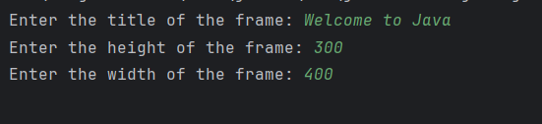

Q7.

Code:

***package Q_07;  
  
import javax.swing.*;  
import java.text.SimpleDateFormat;  
import java.util.Date;  
  
public class Q_07 {  
 public static void main(String[] args) {  
 Date date = new Date();  
 SimpleDateFormat sdf = new SimpleDateFormat("hh:mm:ss a");  
 JFrame frame = new JFrame(sdf.format(date));  
 frame.setVisible(true);  
 frame.setSize(400,300);  
 }  
}***

Output:

Q8.

Code:

***package Q_08;  
  
import java.util.*;  
  
public class Q_08 {  
 public static void main(String[] args) {  
 Scanner scanner = new Scanner(System.in);  
 String text; //text is the input string  
 Integer exclam; //exclam is the index of the exclamation mark  
 String firsttext; //firsttext is the string before the exclamation mark  
 String secondtext; //secondtext is the string after the exclamation mark  
 System.out.print("Enter a string: ");  
 text = scanner.nextLine();  
 exclam = text.indexOf("!");  
 firsttext = text.substring(0,exclam);  
 secondtext = text.substring(exclam+2); // +2 to skip the space after the exclamation mark  
 System.out.println(firsttext+"\n"+secondtext);  
 }  
}***

Output:

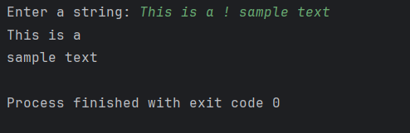

Q9.

Code:

***package Q_09;  
  
import java.util.*;  
  
public class Q_09 {  
 public static void main(String[] args) {  
 Scanner scanner = new Scanner(System.in);  
 String text; //text is the input string  
 System.out.print("Enter a string: ");  
 text = scanner.nextLine();  
 System.out.print(text.length()+"\n"+text.charAt(0)+"\n"+text.charAt(text.length()-1));  
 }  
}***

Output:

Q10.

Code:

***package Q_10;  
  
import java.util.*;  
  
public class Q_10 {  
 public static void main(String[] args) {  
 Scanner scanner = new Scanner(System.in);  
 String text; //text is the input string  
 System.out.print("Enter a string: ");  
 text = scanner.nextLine();  
 if (text.length() % 2 == 0) {  
 System.out.print("Entered string has even length."); //Prints this if the length of the string is even  
 } else {  
 System.out.print(text.charAt(text.length() / 2)); //Prints the middle character if the length of the string is odd  
 }  
 }  
}***

Output:

Q11.

Code:

***package Q_11;  
  
import java.util.*;  
  
public class Q_11 {  
 public static void main(String[] args) {  
 Scanner scanner = new Scanner(System.in);  
 String fname; // Variable to store first name  
 String mname; // Variable to store middle name  
 String lname; // Variable to store last name  
 System.out.print("Enter your first name: ");  
 fname = scanner.nextLine();  
 System.out.print("Enter your middle name: ");  
 mname = scanner.nextLine();  
 System.out.print("Enter your last name: ");  
 lname = scanner.nextLine();  
 System.out.println(lname+", "+fname+" "+mname.charAt(0)+".");  
 }  
}***

Output:

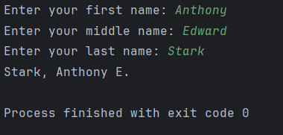

Q12.

Code:

***package Q_12;  
  
import javax.swing.*;  
  
public class Q_12 {  
 public static void main(String[] args) {  
 JFrame frame = new JFrame("My First Frame");  
 frame.setSize(300,200);  
 frame.setVisible(true);  
 frame.setLocation(100,50);  
 }  
}***

Output:

