Q1.

a)

Code:

***package Q_01;  
  
import java.text.DecimalFormat;  
import java.util.Scanner;  
  
public class Q_01_a {  
 public static void main(String[] args) {  
 DecimalFormat df = new DecimalFormat("#.##");  
 Scanner scanner = new Scanner(System.in);  
 double a,b,c;  
 System.out.print("Enter value for A:");  
 a = scanner.nextDouble();  
 System.out.print("Enter value for B:");  
 b = scanner.nextDouble();  
 System.out.print("Enter value for C:");  
 c = scanner.nextDouble();  
 System.out.print("The square root of (B^2 + 4AC) is : "+df.format(Math.sqrt(Math.pow(b,2)+4*a*c)));  
 }  
}***

Output:

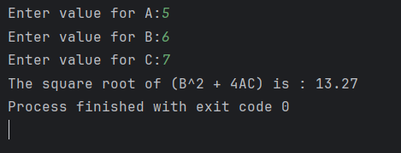

b)

Code:

***package Q_01;  
  
import java.text.DecimalFormat;  
import java.util.Scanner;  
  
public class Q_01_b {  
 public static void main(String[] args) {  
 DecimalFormat df = new DecimalFormat("#.##");  
 Scanner scanner = new Scanner(System.in);  
 double x,y;  
 System.out.print("Enter value for X: ");  
 x = scanner.nextDouble();  
 System.out.print("Enter value for Y: ");  
 y = scanner.nextDouble();  
 System.out.print("The square root of (X + 4Y^3) is: "+df.format(Math.sqrt(x+4*(Math.pow(y,3)))));  
 }  
}***

Output:

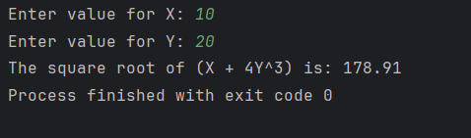

c)

Code:

***package Q_01;  
  
import java.text.DecimalFormat;  
import java.util.Scanner;  
  
public class Q_01_c {  
 public static void main(String[] args) {  
 DecimalFormat df = new DecimalFormat("#.##");  
 Scanner scanner = new Scanner(System.in);  
 double x,y;  
 System.out.print("Enter value for X: ");  
 x = scanner.nextDouble();  
 System.out.print("Enter value for Y: ");  
 y = scanner.nextDouble();  
 System.out.print("The cube root of the product of X and Y is: "+df.format(Math.cbrt(x*y)));  
 }  
}***

Output:

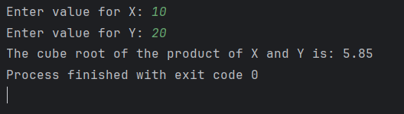

d)

Code:

***package Q_01;  
  
import java.text.DecimalFormat;  
import java.util.Scanner;  
  
public class Q_01_d {  
 public static void main(String[] args) {  
 DecimalFormat df = new DecimalFormat("#.##");  
 Scanner scanner = new Scanner(System.in);  
 final double PI = 3.1415926;  
 double r;  
 System.out.print("Enter the radius of the circle to calculate the area: ");  
 r = scanner.nextDouble();  
 System.out.print("The area of the circle is: "+df.format(PI*r*r));  
 }  
}***

Output:

Q2.

Code:

***package Q_02;  
  
import java.text.DecimalFormat;  
import java.util.Scanner;  
  
public class Q_02 {  
 public static void main(String[] args) {  
 DecimalFormat df = new DecimalFormat("#.#");  
 Scanner scanner = new Scanner(System.in);  
 double cm, in ,ft;  
 System.out.print("Enter the length in centimeters: ");  
 cm = scanner.nextDouble();  
 in = cm/2.54;  
 ft = Math.floor(in/12);  
 System.out.print("The length in feet and inches is: "+(int)ft+" feet "+df.format(in%12)+" inches");  
 }  
}***

Output:

Q3.

Code:

***package Q_03;  
  
import java.text.DecimalFormat;  
import java.util.Scanner;  
  
public class Q_03 {  
 public static void main(String[] args) {  
 DecimalFormat df = new DecimalFormat("#.#");  
 Scanner scanner = new Scanner(System.in);  
 double celsius, fahrenheit;  
 System.out.print("Enter the temperature in Celsius: ");  
 celsius = scanner.nextDouble();  
 fahrenheit = (celsius*1.8)+32;  
 System.out.print("The temperature in Fahrenheit is: "+df.format(fahrenheit)+" F");  
 }  
}***

Output:

Q4.

Code:

***package Q_04;  
  
import java.text.DecimalFormat;  
import java.util.Scanner;  
  
public class Q_04 {  
 public static void main(String[] args) {  
 DecimalFormat df = new DecimalFormat("#.#");  
 Scanner scanner = new Scanner(System.in);  
 double calories, weight;  
 System.out.print("Enter your weight in pounds: ");  
 weight = scanner.nextDouble();  
 calories = weight * 19;  
 System.out.print("The number of calories you need is: "+df.format(calories)+" kcal");  
 }  
}***

Output:

Q5.

Code:

***package Q_05;  
  
import java.text.DecimalFormat;  
import java.util.Scanner;  
  
public class Q_05 {  
 public static void main(String[] args) {  
 DecimalFormat df = new DecimalFormat("#.#");  
 Scanner scanner = new Scanner(System.in);  
 double celcius, fahrenheit;  
 System.out.print("Enter the temperature in Fahrenheit: ");  
 fahrenheit = scanner.nextDouble();  
 celcius = (fahrenheit-32)*5/9;  
 System.out.print("The temperature in Celsius is: "+df.format(celcius)+" C");  
 }  
}***

Output:

Q6.

Code:

***package Q_06;  
  
import java.util.Scanner;  
  
public class Q_06 {  
 public static void main(String[] args) {  
 Scanner scanner = new Scanner(System.in);  
 int year;  
 System.out.print("Enter your birth year: ");  
 year = scanner.nextInt();  
 System.out.print("You were born in "+year+" and will be(are) "+(2025-year)+" this year.");  
 }  
}***

Output:

Q7.

Code:

***package Q_07;  
  
import java.text.DecimalFormat;  
import java.util.Scanner;  
  
public class Q_07 {  
 public static void main(String[] args) {  
 DecimalFormat df = new DecimalFormat("#.#");  
 Scanner scanner = new Scanner(System.in);  
 double weight, height, bmi;  
 System.out.print("Enter your weight in Kilograms: ");  
 weight = scanner.nextDouble();  
 System.out.print("Enter your height in Centimeters: ");  
 height = scanner.nextDouble();  
 bmi = weight / Math.pow(height/100, 2);  
 System.out.println("Your BMI is: "+df.format(bmi));  
 if (bmi < 20){  
 System.out.print("You are underweight.");  
 } else if (bmi >= 20 && bmi < 25){  
 System.out.print("You are normal weight.");  
 } else{  
 System.out.print("You are overweight.");  
 }  
  
 }  
}***

Output:

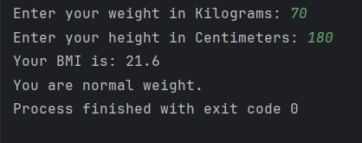

Q8.

Code:

***package Q_08;  
  
import java.text.DecimalFormat;  
import java.util.Scanner;  
  
public class Q_08 {  
 public static void main(String[] args) {  
 DecimalFormat df = new DecimalFormat("#.#");  
 Scanner scanner = new Scanner(System.in);  
 final double PI = 3.14;  
 double volume;  
 int radius;  
 System.out.print("Enter the radius of the sphere to calculate the volume: ");  
 radius = scanner.nextInt();  
 volume = (4.0/3.0)*PI*Math.pow(radius, 3);  
 System.out.print("The volume of the sphere is: "+df.format(volume));  
 }  
}***

Output:

Q9.

Code:

***package Q_09;  
  
import java.text.DecimalFormat;  
import java.util.Scanner;  
  
public class Q_09 {  
 public static void main(String[] args) {  
 DecimalFormat df = new DecimalFormat("#.##");  
 Scanner scanner = new Scanner(System.in);  
 int p,n;  
 double r;  
 System.out.print("Enter the investment amount in dollars: ");  
 p = scanner.nextInt();  
 System.out.print("Enter the annual interest rate in percentage: ");  
 r = scanner.nextDouble();  
 System.out.print("Enter the number of years: ");  
 n = scanner.nextInt();  
 System.out.print("The amount of money earned after "+n+" years in dollars is: "+df.format(p*Math.pow(1+r/100, n)));  
 }  
}***

Output:

Q10.

Code:

***package Q_10;  
  
import java.text.DecimalFormat;  
import java.util.Scanner;  
  
public class Q_10 {  
 public static void main(String[] args) {  
 DecimalFormat df = new DecimalFormat("#.##");  
 Scanner scanner = new Scanner(System.in);  
 final int MONTHS_IN_YEAR = 12;  
 int loanAmount, loanPeriod;  
 double annualInterestRate, monthlyPayment, totalPayment, monthlyInterestRate, numberOfPayments;  
 System.out.print("Enter the loan amount: ");  
 loanAmount = scanner.nextInt();  
 System.out.print("Enter the annual interest rate: ");  
 annualInterestRate = scanner.nextDouble();  
 System.out.print("Enter the loan period in years: ");  
 loanPeriod = scanner.nextInt();  
 monthlyInterestRate = annualInterestRate/100.0/MONTHS_IN_YEAR;  
 numberOfPayments = loanPeriod*MONTHS_IN_YEAR;  
 monthlyPayment = loanAmount*monthlyInterestRate/(1-Math.pow(1/(1+monthlyInterestRate), numberOfPayments));  
 totalPayment = monthlyPayment*numberOfPayments;  
 System.out.print("The monthly payment is: "+df.format(monthlyPayment)+"\nThe total payment is: "+df.format(totalPayment));  
 }  
}***

Output:

