Q1.

Code:

Q_01.java

package Q_01;  
  
public class Q_01 {  
 public static void main(String[] args) {  
 //creating cat object  
 Cat myCat = new Cat();  
 //creating dog object  
 Dog myDog = new Dog();  
 //setting name for cat  
 myCat.setName("Puff Puff");  
 System.*out*.println(myCat.getName() + " says " + myCat.speak());  
 //setting name for dog  
 myDog.setName("Fifi");  
 System.*out*.println(myDog.getName() + " says " + myDog.speak());  
 }  
}

Pet.java

package Q_01;  
  
public class Pet {  
 private String name;  
  
 public String getName() {  
 return name;  
 }  
  
 public void setName(String petName) {  
 name = petName;  
 }  
  
 public String speak() {  
 return "I'm your cuddly little pet.";  
 }  
}

Dog.java

package Q_01;  
  
public class Dog extends Pet{  
  
 @Override  
 public String speak() {  
 return " ";  
 }  
}

Cat.java

package Q_01;  
  
public class Cat extends Pet{  
  
 @Override  
 public String speak() {  
 return " ";  
 }  
}

Output:

Q2.

Code:

package Q_02;  
  
import java.util.ArrayList;  
import java.util.Scanner;  
  
//import the necessary classes  
import Q_01.Pet;  
import Q_01.Dog;  
import Q_01.Cat;  
  
public class Q_02 {  
 public static void main(String[] args) {  
 //create a Scanner object to read input  
 Scanner scanner = new Scanner(System.*in*);  
 //create an ArrayList to store the pets  
 ArrayList<Pet> petList = new ArrayList<>();  
 //create a Pet object  
 Pet pet;  
  
 while(true)  
 {  
 System.*out*.println("Enter pet name ('STOP' to stop)");  
 String name = scanner.nextLine();  
 //check if the user wants to stop  
 if(name.equals("STOP"))  
 {  
 break;  
 }  
 System.*out*.println("Enter pet type ('d' for Dog and 'c' for Cat)");  
 String type = scanner.nextLine();  
  
 //create a new Pet object based on the type  
 if(type.equals("d"))  
 {  
 pet = new Dog();  
 }  
 else if(type.equals("c"))  
 {  
 pet = new Cat();  
 }  
 else  
 {  
 System.*out*.println("Invalid type.");  
 continue;  
 }  
 //set the name of the pet  
 pet.setName(name);  
 //add the pet to the list  
 petList.add(pet);  
 }  
  
 for(Pet p : petList)  
 {  
 System.*out*.print("Name: "+p.getName());  
 //check the type of the pet  
 if (p instanceof Dog)  
 System.*out*.println("\tType: Dog");  
 else  
 System.*out*.println("\tType: Cat");  
 }  
 }  
}

Output:

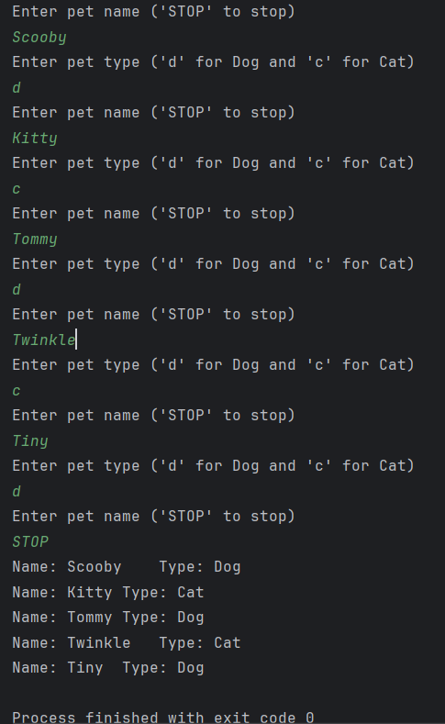

Q3.

Code:

package Q_03;  
  
import java.util.ArrayList;  
import java.util.Scanner;  
  
//import the necessary classes  
import Q_01.Pet;  
import Q_01.Cat;  
import Q_01.Dog;  
  
public class Q_03 {  
 public static void main(String[] args) {  
 //create scanner object for input  
 Scanner input = new Scanner(System.*in*);  
 //create an ArrayList to store pets  
 ArrayList<Pet> petList = new ArrayList<>();  
 //create a pet object  
 Pet pet;  
  
 while(true)  
 {  
 System.*out*.println("Enter pet name ('STOP' to stop)");  
 String name = input.nextLine();  
 //check if the user wants to stop  
 if(name.equals("STOP"))  
 {  
 break;  
 }  
 System.*out*.println("Enter pet type ('d' for Dog and 'c' for Cat)");  
 String type = input.nextLine();  
 //create a new Pet object based on the type  
 if(type.equals("d"))  
 {  
 pet = new Dog();  
 }  
 else if(type.equals("c"))  
 {  
 pet = new Cat();  
 }  
 else  
 {  
 System.*out*.println("Invalid type.");  
 continue;  
 }  
 //set the name of the pet  
 pet.setName(name);  
 //add the pet to the list  
 petList.add(pet);  
 }  
 System.*out*.println("Names of cats");  
   
 //print the names of cats  
 for(Pet p : petList)  
 {  
 if(p instanceof Cat)  
 System.*out*.println(p.getName());  
 }  
   
 System.*out*.println("\nNames of dogs");  
 //print the names of dogs  
 for(Pet p : petList)  
 {  
 if(p instanceof Dog)  
 System.*out*.println(p.getName());  
 }  
 }  
}

System.*out*.println("\nNames of dogs");  
 //print the names of dogs  
 for(Pet p : petList)  
 {  
 if(p instanceof Dog)  
 System.*out*.println(p.getName());  
 }  
 }  
}

Output:

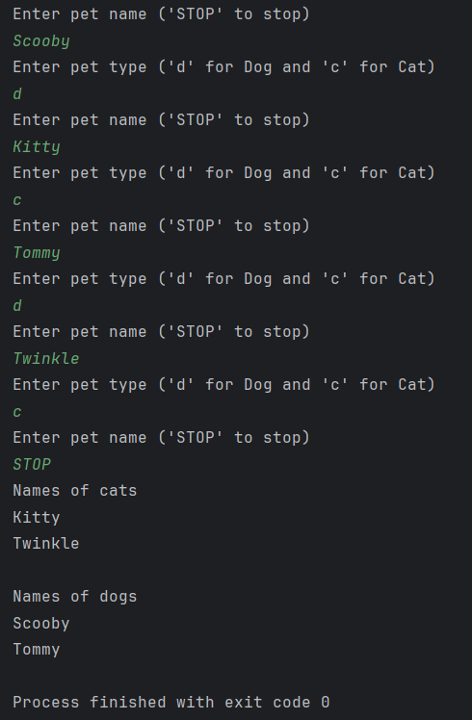

Q4.

Code:

Q_04.java

package Q_04;  
  
import java.util.ArrayList;  
import java.util.Scanner;  
  
//import Pet calss  
import Q_01.Pet;  
  
public class Q_04 {  
 public static void main(String[] args) {  
 //create scanner object for input  
 Scanner input = new Scanner(System.*in*);  
 //create an ArrayList to store pets  
 ArrayList<Pet> petList = new ArrayList<>();  
 //create a pet object  
 Pet pet;  
  
 while(true)  
 {  
 System.*out*.println("Enter pet name ('STOP' to stop)");  
 String name = input.nextLine();  
 //check if the user wants to stop  
 if(name.equals("STOP"))  
 {  
 break;  
 }  
 System.*out*.println("Enter pet type ('d' for Dog and 'c' for Cat)");  
 String type = input.nextLine();  
  
 //create a new Cat object based on the type  
 if(type.equals("c"))  
 {  
 System.*out*.println("Enter pet coat color");  
 String coatColor = input.nextLine();  
 pet = new Cat();  
 //set the name of the Cat  
 pet.setName(name);  
 //typecasting pet object to add coatcolor  
 ((Cat)pet).setCoatColor(coatColor);  
 }  
 //create a new Dog object based on the type  
 else if(type.equals("d"))  
 {  
 System.*out*.println("Enter pet weight (kg)");  
 double weight = input.nextDouble();  
 input.nextLine(); // Consume the newline character  
  
 pet = new Dog();  
 //set the name of the Dog  
 pet.setName(name);  
 //typecasting pet object to add weight  
 ((Dog)pet).setWeight(weight);  
 }  
 else  
 {  
 System.*out*.println("Invalid type.");  
 continue;  
 }  
 //add the pet to the list  
 petList.add(pet);  
 }  
 System.*out*.println("List of cats");  
 //print cats  
 for(Pet p : petList)  
 {  
 if(p instanceof Cat)  
 System.*out*.println("Name: "+p.getName()+"\tType: Cat "+"\tCoat Color: "+((Cat)p).getCoatColor());  
 }  
  
 System.*out*.println("\nList of dogs");  
 //print dogs  
 for(Pet p : petList)  
 {  
 if(p instanceof Dog)  
 System.*out*.println("Name: "+p.getName()+"\tType: Dog "+"\tWeight: "+((Dog)p).getWeight());  
 }  
 }  
}

Dog.java

package Q_04;  
//import Pet class  
import Q_01.Pet;  
  
public class Dog extends Pet {  
 private double weight;  
  
 public double getWeight() {  
 return weight;  
 }  
  
 public void setWeight(double weight) {  
 this.weight = weight;  
 }  
  
 @Override  
 public String speak() {  
 return " ";  
 }  
}

Cat.java

package Q_04;  
//import Pet class  
import Q_01.Pet;  
  
public class Cat extends Pet {  
 private String coatColor;  
  
 public String getCoatColor() {  
 return coatColor;  
 }  
  
 public void setCoatColor(String coatColor) {  
 this.coatColor = coatColor;  
 }  
  
 @Override  
 public String speak() {  
 return " ";  
 }  
}

Output:

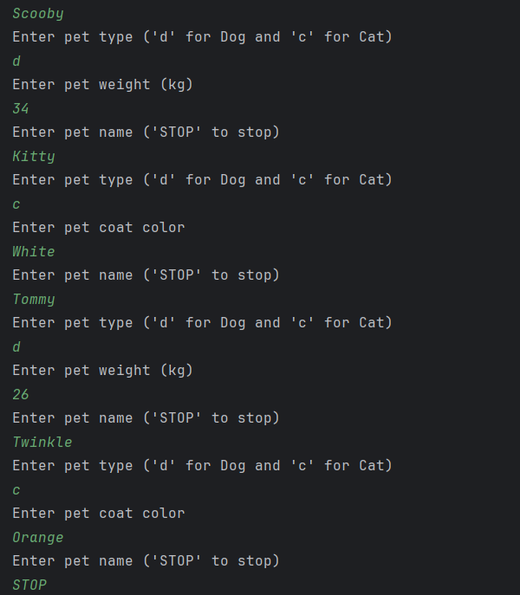

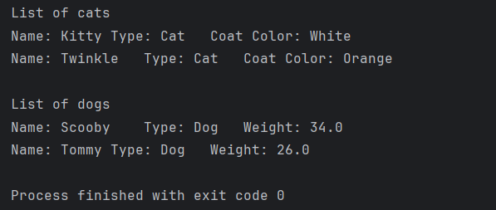

Q5.

Code:

package Q_05;  
  
import java.text.DecimalFormat;  
import java.util.ArrayList;  
import java.util.Scanner;  
  
//import necessary classes  
import Q_01.Pet;  
import Q_04.Dog;  
import Q_04.Cat;  
  
public class Q_05 {  
 public static void main(String[] args) {  
 //create scanner object for input  
 Scanner input = new Scanner(System.*in*);  
 //create decimal format object  
 DecimalFormat df = new DecimalFormat("#.##");  
 //create an ArrayList to store pets  
 ArrayList<Pet> petList = new ArrayList<>();  
 //create an ArrayList to store dog weight  
 ArrayList<Dog> dogList = new ArrayList<>();  
 //create a pet object  
 Pet pet;  
  
 while(true)  
 {  
 System.*out*.println("Enter pet name ('STOP' to stop)");  
 String name = input.nextLine();  
 //check if the user wants to stop  
 if(name.equals("STOP"))  
 {  
 break;  
 }  
 System.*out*.println("Enter pet type ('d' for Dog and 'c' for Cat)");  
 String type = input.nextLine();  
 //create a new Cat object based on the type  
 if(type.equals("c"))  
 {  
 System.*out*.println("Enter pet coat color");  
 String coatColor = input.nextLine();  
 pet = new Cat();  
 //set the name of the Cat  
 pet.setName(name);  
 //typecasting pet object to add coatcolor  
 ((Cat)pet).setCoatColor(coatColor);  
 }  
 //create a new Dog object based on the type  
 else if(type.equals("d"))  
 {  
 System.*out*.println("Enter pet weight (kg)");  
 double weight = input.nextDouble();  
 input.nextLine(); // Consume the newline character  
 pet = new Dog();  
 Dog dog = new Dog();  
 //set the name of the Dog  
 pet.setName(name);  
 //typecasting pet object to add weight  
 ((Dog)pet).setWeight(weight);  
 //set the name of the dog for the dogList Array  
 dog.setName(name);  
 //set the weight of the dog for the dogList Array  
 dog.setWeight(weight);  
 dogList.add(dog);  
 }  
 else  
 {  
 System.*out*.println("Invalid type.");  
 continue;  
 }  
 //add the pet to the list  
 petList.add(pet);  
 }  
 System.*out*.println("List of cats");  
 //print cats  
 for(Pet p : petList)  
 {  
 if(p instanceof Cat)  
 System.*out*.println("Name: "+p.getName()+"\tType: Cat "+"\tCoat Color: "+((Cat)p).getCoatColor());  
 }  
 System.*out*.println("\nList of dogs");  
 //print dogs  
 for(Pet p : petList)  
 {  
 if(p instanceof Dog)  
 System.*out*.println("Name: "+p.getName()+"\tType: Dog "+"\tWeight: "+((Dog)p).getWeight()+" kg");  
 }  
 double min = dogList.getFirst().getWeight();  
 double max = dogList.getFirst().getWeight();  
 double total = 0;  
 //calculate the min, max and total weight  
 for(Dog d : dogList)  
 {  
 double weight = d.getWeight();  
 total += weight;  
 if(weight < min)  
 min = weight;  
 if(weight > max)  
 max = weight;  
 }  
 double avg = total / dogList.size(); //calculate average weight  
 //print min, max and average weight  
 System.*out*.println("\nDog max weight: "+max+" kg\nMin weight: "+min+" kg\nAverage weight: "+df.format(avg)+" kg");  
 }  
  
}

Output:

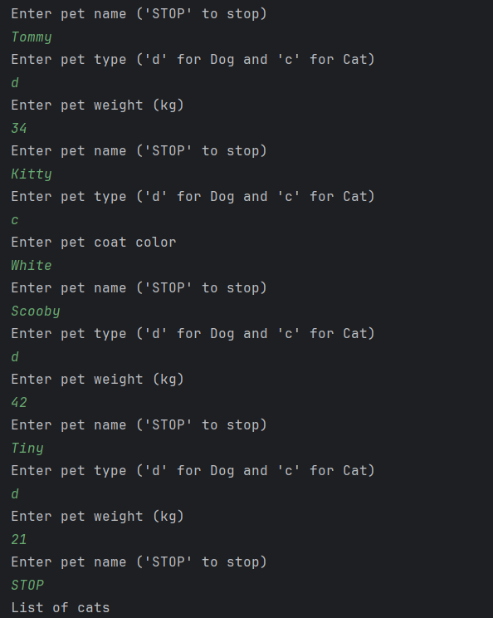

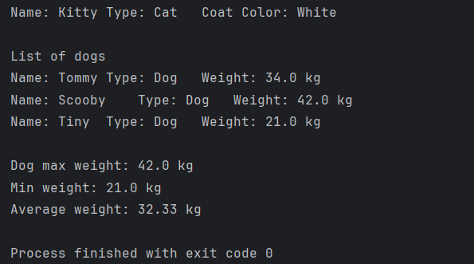

Q6.

Code:

package Q_06;  
  
import java.util.ArrayList;  
import java.util.Scanner;  
  
//import necessary classes  
import Q_01.Pet;  
import Q_04.Dog;  
import Q_04.Cat;  
  
import static java.lang.System.*exit*;  
  
public class Q_06 {  
 public static void main(String[] args) {  
 //create scanner object for input  
 Scanner input = new Scanner(System.*in*);  
 //create an ArrayList to store pets  
 ArrayList<Pet> petList = new ArrayList<>();  
 //create an ArrayList to store Dogs  
 ArrayList<Dog> dogList = new ArrayList<>();  
 //create an ArrayList to store Cats  
 ArrayList<Cat> catList = new ArrayList<>();  
 //create a pet object  
 Pet pet;  
  
 while(true)  
 {  
 System.*out*.println("Enter pet name ('STOP' to stop)");  
 String name = input.nextLine();  
 //check if the user wants to stop  
 if(name.equals("STOP"))  
 {  
 break;  
 }  
 System.*out*.println("Enter pet type ('d' for Dog and 'c' for Cat)");  
 String type = input.nextLine();  
 //create a new Cat object based on the type  
 if(type.equals("c"))  
 {  
 System.*out*.println("Enter pet coat color");  
 String coatColor = input.nextLine();  
 Cat cat = new Cat();  
 pet = new Cat();  
 //set the name of the Cat  
 pet.setName(name);  
 cat.setName(name);  
 //set the coat color of the Cat  
 cat.setCoatColor(coatColor);  
 //typecasting pet object to add coatcolor  
 ((Cat)pet).setCoatColor(coatColor);  
 //add Cat to the cat list  
 catList.add(cat);  
 }  
 //create a new Dog object based on the type  
 else if(type.equals("d"))  
 {  
 System.*out*.println("Enter pet weight (kg)");  
 double weight = input.nextDouble();  
 input.nextLine(); // Consume the newline character  
 pet = new Dog();  
 Dog dog = new Dog();  
 //set the name of the Dog  
 pet.setName(name);  
 dog.setName(name);  
 //set the weight of the Dog  
 dog.setWeight(weight);  
 //typecasting pet object to add weight  
 ((Dog)pet).setWeight(weight);  
 //add Dog to the dog list  
 dogList.add(dog);  
 }  
 else  
 {  
 System.*out*.println("Invalid type.");  
 continue;  
 }  
 //add the pet to the list  
 petList.add(pet);  
 }  
 System.*out*.println("List of cats");  
 //print cats  
 for(Pet p : petList)  
 {  
 if(p instanceof Cat)  
 System.*out*.println("Name: "+p.getName()+"\tType: Cat "+"\tCoat Color: "+((Cat)p).getCoatColor());  
 }  
  
 System.*out*.println("\nList of dogs");  
 //print dogs  
 for(Pet p : petList)  
 {  
 if(p instanceof Dog)  
 System.*out*.println("Name: "+p.getName()+"\tType: Dog "+"\tWeight: "+((Dog)p).getWeight()+" kg");  
 }  
 //Display the menu choices  
 System.*out*.println("\n\nEnter corresponding number to perform task");  
 System.*out*.println("1. Add Cat");  
 System.*out*.println("2. Add Dog");  
 System.*out*.println("3. Remove Cat");  
 System.*out*.println("4. Remove Dog");  
 System.*out*.println("0. Quit");  
 int selection = input.nextInt();  
  
 switch(selection){  
 case 1:  
 //Add a new cat to the Cat array  
 System.*out*.println("Enter the name of the cat: ");  
 input.nextLine();  
 String catName = input.nextLine();  
 System.*out*.println("Enter the coat color of the cat: ");  
 String coatColor = input.nextLine();  
 Cat cat = new Cat();  
 cat.setName(catName);  
 cat.setCoatColor(coatColor);  
 catList.add(cat);  
 break;  
 case 2:  
 //add a new dog to the Dog array  
 System.*out*.println("Enter the name of the dog: ");  
 input.nextLine();  
 String dogName = input.nextLine();  
 System.*out*.println("Enter the weight of the dog: ");  
 double dogWeight = input.nextDouble();  
 Dog dog = new Dog();  
 dog.setName(dogName);  
 dog.setWeight(dogWeight);  
 dogList.add(dog);  
 break;  
 case 3:  
 //Remove a cat from the Cat array by entering the name of the cat  
 System.*out*.println("Enter the name of the cat to remove: ");  
 input.nextLine();  
 String catNameToRemove = input.nextLine();  
 for (int i = 0; i < catList.size(); i++) {  
 if (catList.get(i).getName().equals(catNameToRemove)) {  
 catList.remove(i);  
 break;  
 }  
 }  
 break;  
 case 4:  
 //removing a dog from the Dog array by entering the name of the dog  
 System.*out*.println("Enter the name of the dog to remove: ");  
 input.nextLine();  
 String dogNameToRemove = input.nextLine();  
 for (int i = 0; i < dogList.size(); i++) {  
 if (dogList.get(i).getName().equals(dogNameToRemove)) {  
 dogList.remove(i);  
 break;  
 }  
 }  
 break;  
 case 0:  
 System.*out*.println("Exiting...");  
 break;  
 default:  
 //exit if the selection is invalid  
 System.*out*.println("Invalid selection.");  
 *exit*(0);  
 break;  
 }  
 System.*out*.println("Updated list\n");  
 //Print updated Dogs  
 for (Dog d : dogList)  
 {  
 System.*out*.println("Dog Name: "+d.getName()+"\tWeight: "+d.getWeight());  
 }  
 //Print updated Cats  
 for (Cat c : catList)  
 {  
 System.*out*.println("Cat Name: "+c.getName()+"\tCoat Color: "+c.getCoatColor());  
 }  
  
 }  
}

