***Kingdom of Saudi Arabia***

***College of Computer***

***Science& Information***

***Technology Prince***

***Sattam bin Abdul-Aziz***

***University,***

**Project**

**Crime reporting application**

**Mobaile application.**

***Supervisor***:

***Dr. Imtithal alnour.***

***Team Member:***

***Asayel Al-Dossary***

***Al-Jawhara Al-Dosary***

***(2024)***

***1 ABSTRACT***

*Sometimes a person happens to see a crime, but he is unable to report it to the security authorities because he does not have a number to contact them, and this is what we have worked on, so that we have created an application through which a person can report any crime or traffic accident via a phone call to the competent authority for that.*

*2 Contents*

*1*  *ABSTRACT……………………………………………………………………………2*

*3 introduction………………………………………………………………4*

*5 How the application works………………………………………………6*

*7 Tools used to build the application……………………………………...8*

*9*  *Languages ​​used in application programming…………………………10*

11 *Program interfaces………………………………………………………..12*

*13 Application advantages…………………………………………………………………………………14*

*15 Disadvantages…………………………………………………………………………16*

*17 Its benefits………………………………………………………………..18*

*3 introduction*

*Sometimes a person happens to see a crime, but he is unable to report it to the security authorities because he does not have a number to contact them, and this is what we have worked on, so that we have created an application through which a person can report any crime or traffic accident via a phone call to the competent authority for that.*

*4 How the application works*

*When the application is downloaded to the phone and installed there, the user opens it and a launch screen appears. The program continues to check whether there is Internet or not. If the Internet is present, it launches to the start screen in which the user determines whether he wants to create a new account or whether he already has an account and wants to log in to it. The user creates An account or login. When this is done, a new interface opens that allows him to communicate with one of the security agencies through a phone call to report the crime that he has seen. In this interface, there is an icon to activate the dark and light theme and a bottom bar to move between this page and the developers page and send complaints or a suggestion to the program developer. By email .*

*5 Tools used to build the application*

*1. Visual studio code program*

*2. Android studio program*.

*3. A computer running Windows*

.

*6 Languages ​​used in application programming*

*1.* *dart language.*

*2.* *flutter language*

***7 Program interfaces***

*1. Its starting interface works when the program is running*

*2.Login interface*.

*3. Account creation interface.*

*4. User information display interface*

*5. Crime reporting interface*

*6. . Developer interface and sending complaints and suggestions via*

*email*

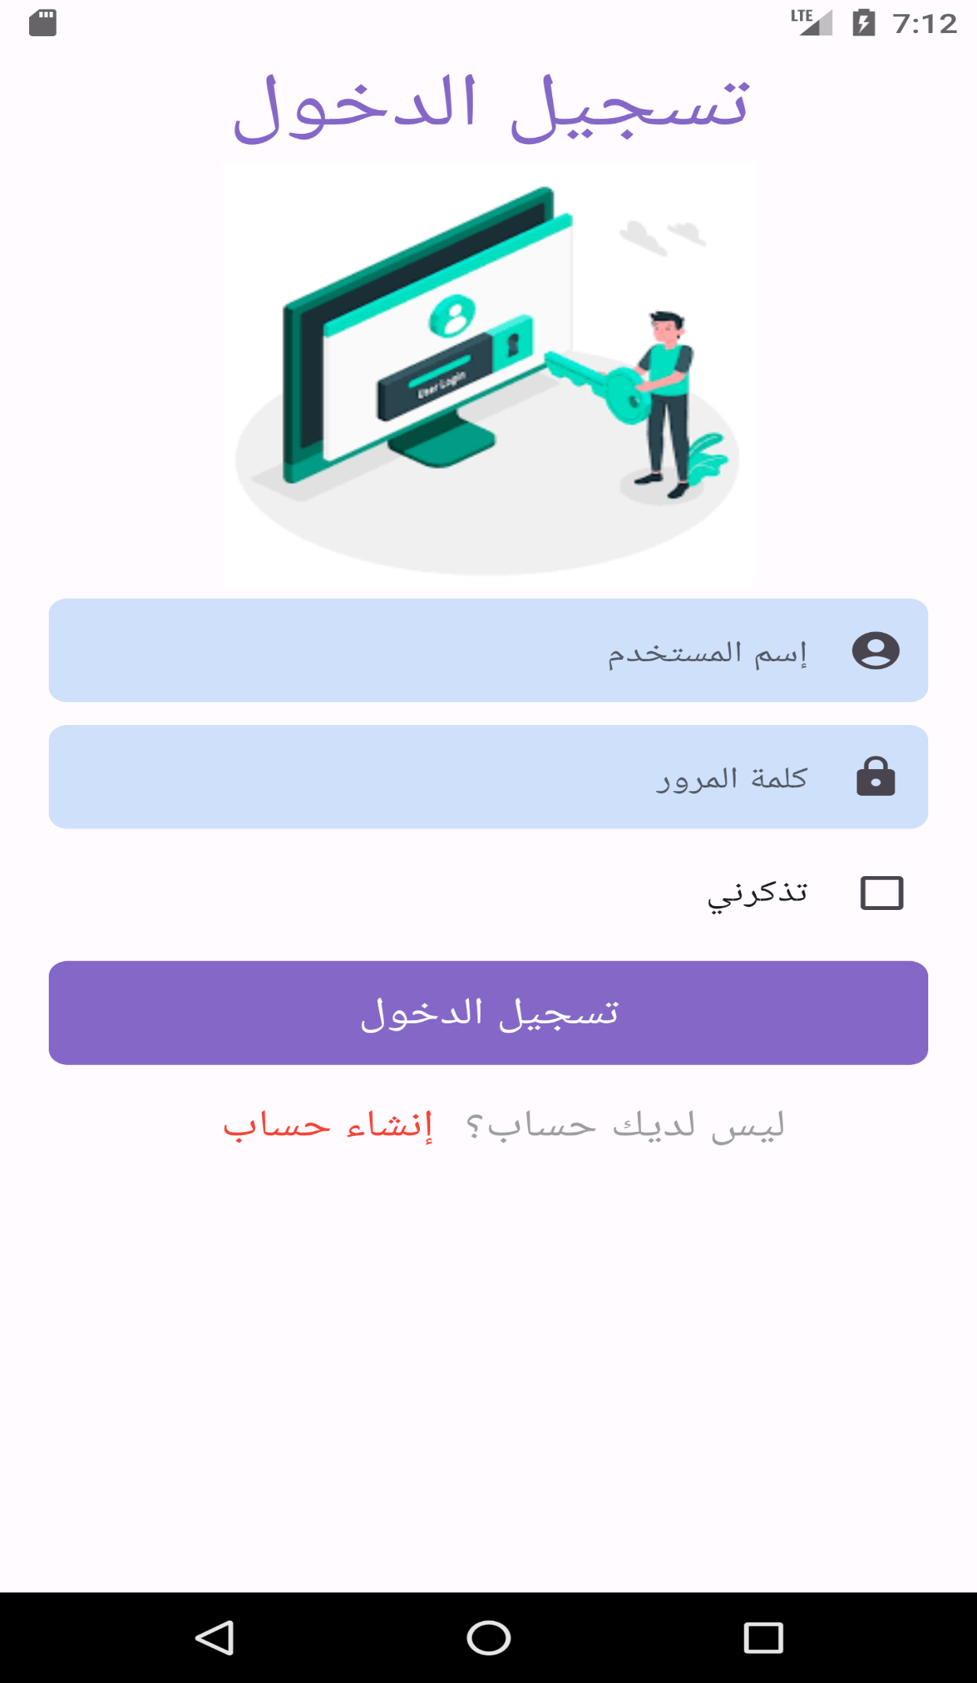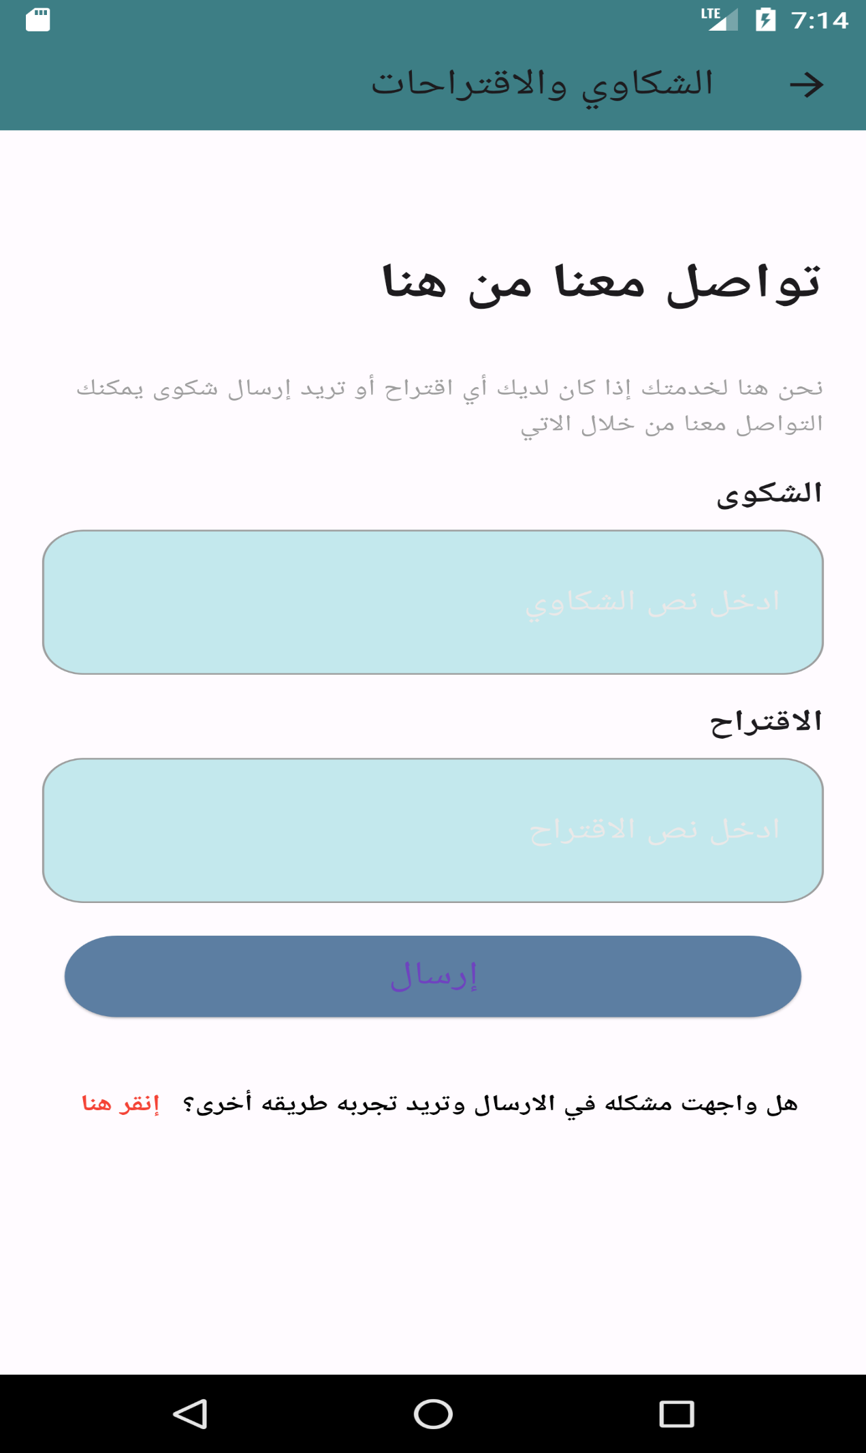

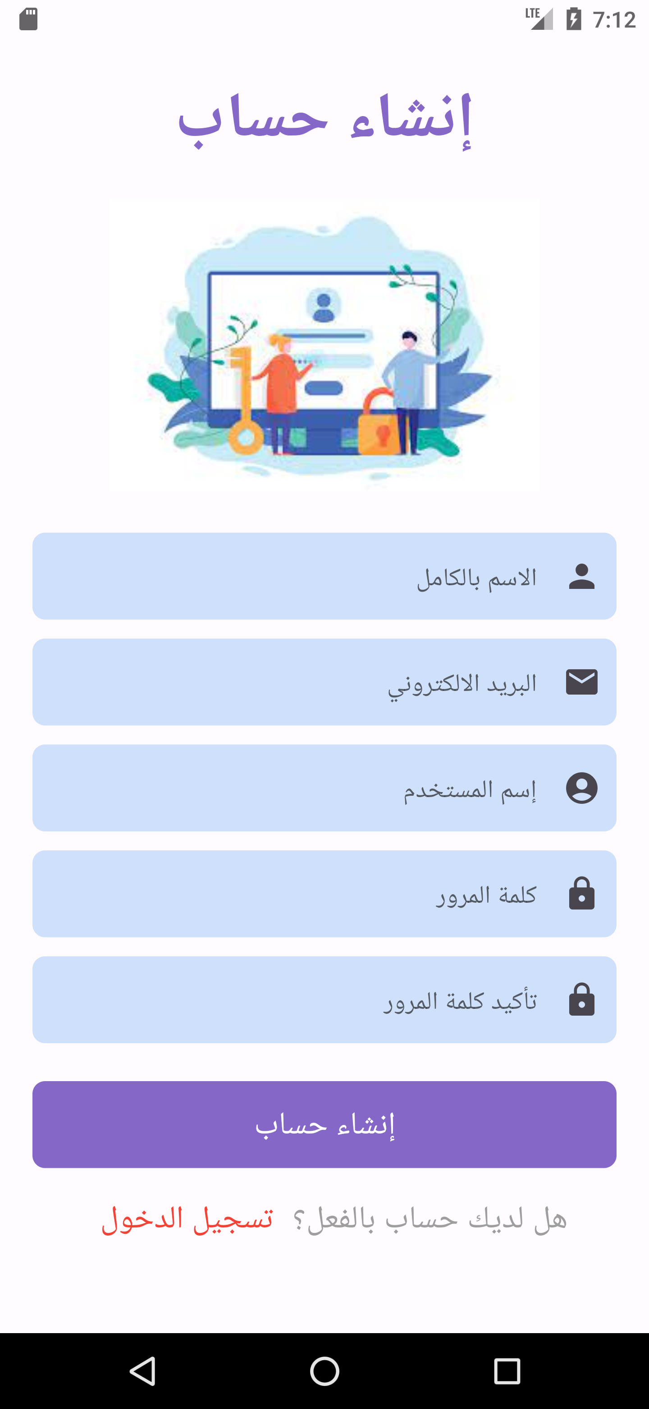

**

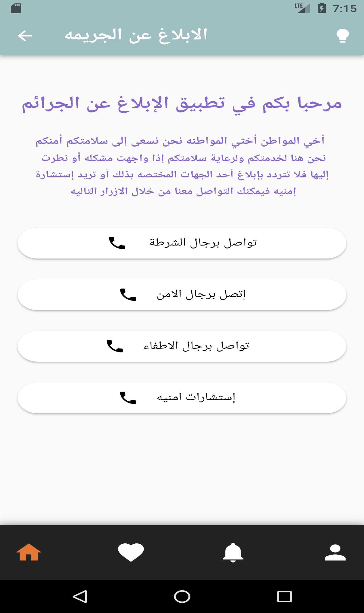

*8 Application advantages*

*1. Interfaces that are simple to use, clear and understandable.*

*2.* *Easy to use and does not have any complexity.*

*3.* . *Small in size and works on any device running the Android system*

*9 Disadvantages*

*It only requires the Internet every time the user opens the application*

*10 Its benefits*

*1.* *Assisting security personnel in identifying crimes and accidents from the place they occur.*

*2. It enhances trust between citizens and security in terms of communication.*

*3. It enhances security and reduces the commission of crimes because every citizen can contact the security authorities*

*4.* *. It helps people who cannot reach a security agency to report crimes and incidents remotely*