2007 CESASC Achievement Award Recipient
Luncheon Keynote Speaker

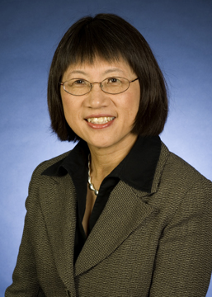 | Ms. Heidi Shyu  徐若冰 女士  Corporate Vice President  of Technology & Research  Raytheon Company

Heidi Shyu is the Corporate Vice President of Technology & Research for Raytheon Company. As Corporate Vice President, she is a member of the Corporate Engineering, Technology & Mission Assurance Leadership Team.
Raytheon Company, with 2005 sales of $21.9 billion, is an industry leader in defense and government electronics, space, information technology, technical services and special-mission aircraft. Headquartered in Waltham, Mass., Raytheon employs 80,000 people worldwide.
Ms. Shyu is responsible for the development and execution of an integrated enterprise-wide technology and research vision and strategy. She is a key participant on the Engineering & Technology Council, as well as, the Chair of the Technology Leadership Team.
Ms. Shyu is currently the Chair of the Air Force Scientific Advisory Board, reporting to the Chief of Staff of the Air Force and the Secretary of the Air Force.
Prior to her current position, Ms. Shyu was the Vice President & Technical Director for Raytheon’s Space & Airborne Systems. She has held senior leadership positions as Vice President of Unmanned and Reconnaissance Systems, Senior Director of the Unmanned Combat Vehicle programs, Director of the Joint Strike Fighter (JSF), Director of JSF Integrated Radar/Electronic Warfare Sensors, Director of JSF antenna technologies. She was responsible for the development of lightweight, low-cost, Tile Active Electronically Scanned Antenna technologies. Prior to that, she served as the Laboratory Manager for Electromagnetic Systems.
Previously, Ms. Shyu was a project manager at Litton Industries and was the principal engineer for Joint STARS Self Defense Study at Grumman. Ms. Shyu began her career at Hughes Aircraft Company.
Ms. Shyu has received Raytheon’s Hero Award, Excellence in Technology Award, Hughes Fellowship, University of Toronto Fellowship, New Brunswick Post-Graduate Scholarship, Atlantic Provinces Inter-University Committee Scholarship, N. Myles Brown Science Award, University Special Undergraduate Scholarship and the 2004 CIE Asian-American Engineer of the Year Award.
Ms. Shyu received a Bachelor’s degree in mathematics from the University of New Brunswick, a Master’s degree in mathematics from the University of Toronto, and a second Master’s degree in Electrical Engineering from UCLA. She has completed the UCLA Executive Management Course and the University of Chicago Business Leadership Program.

