**Unit 1 Homework: Kickstart My Chart**

**Background**

Over $2 billion has been raised using the massively successful crowdfunding service, Kickstarter, but not every project has found success. Of the more than 300,000 projects launched on Kickstarter, only a third have made it through the funding process with a positive outcome.

Getting funded on Kickstarter requires meeting or exceeding the project's initial goal, so many organizations spend months looking through past projects in an attempt to discover some trick for finding success. For this week's homework, you will organize and analyze a database of 4,000 past projects in order to uncover any hidden trends.

**Question1:**

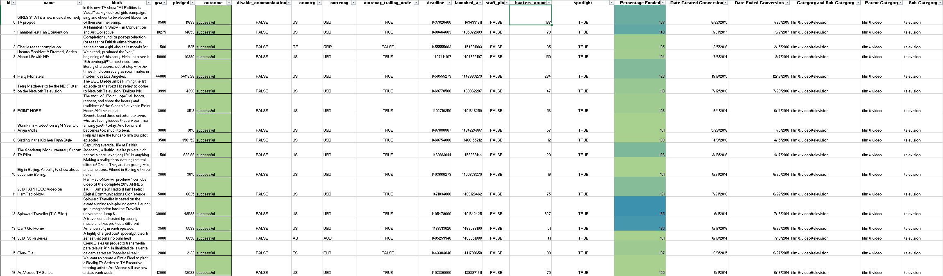

Using the Excel table provided, modify and analyze the data of 4,000 past Kickstarter projects as you attempt to uncover some market trends.

1. Use **conditional formatting** to fill each cell in the state column with a different color, depending on whether the associated campaign was successful, failed, or canceled, or is currently live.

**Responses;**

1.Successful

2. Failed

3. Canceled

4. Currently live

1. Create a new column O called Percent Funded that uses a formula to uncover how much money a campaign made to reach its **initial goal**.

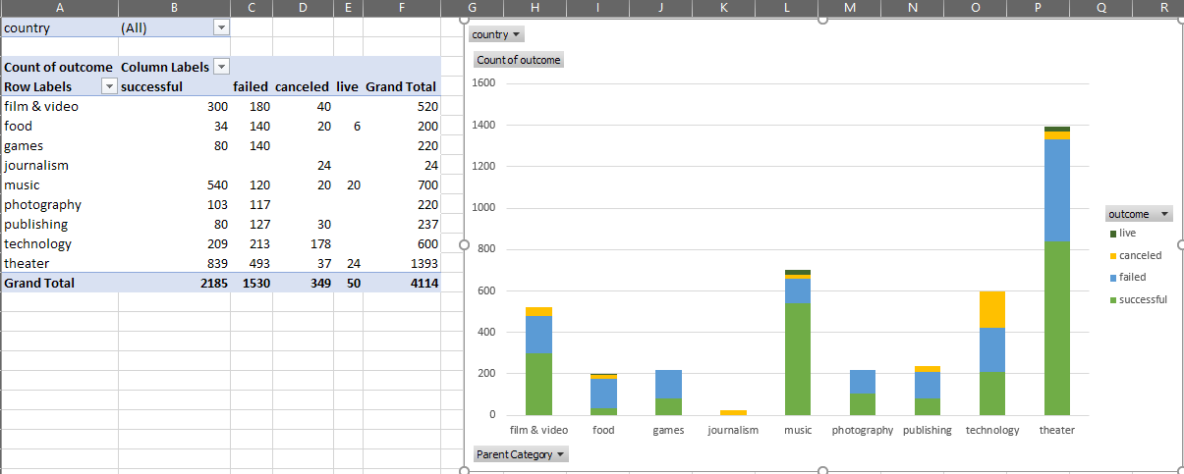

1. Use conditional formatting to fill each cell in the Percent Funded column using a **three-color scale**. The scale should start at 0 and be a dark shade of red, transitioning to green at 100, and blue at 200.
2. Create a new column P called Average Donation that uses a formula to uncover how much each backer for the project paid on average.
3. Create two new columns, one called Category at Q and another called Sub-Category at R, which use formulas **to split** the Category and Sub-Category column into two parts.
4. Create a new sheet with a pivot table that will analyze your initial worksheet to count how many campaigns were successful, failed, canceled, or are currently live per category.
5. Create a stacked column pivot chart that can be filtered by country based on the table you have created.
6. Create a new sheet with a pivot table that will analyze your initial sheet to count how many campaigns were successful, failed, or canceled, or are currently live per sub-category.

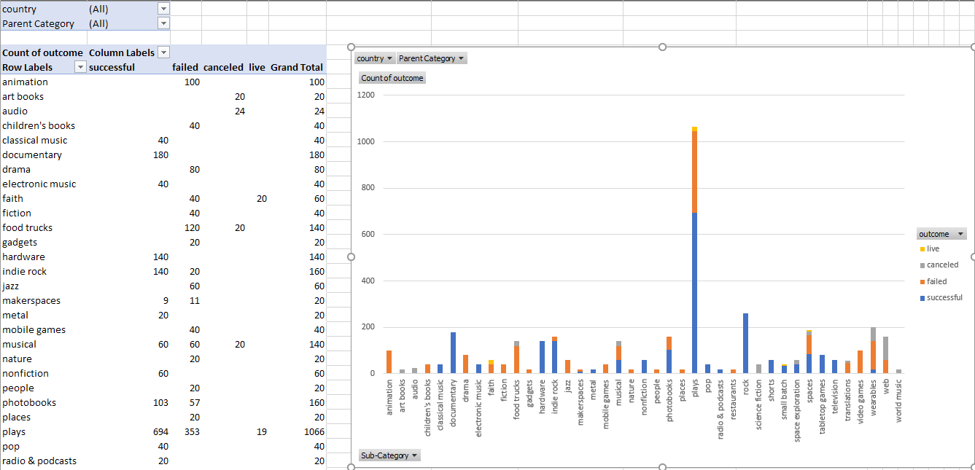

1. Create a stacked column pivot chart that can be filtered by country and parent-category based on the table you have created.

The dates stored within the deadline and launched_at columns use Unix timestamps. Fortunately for us, there is a formula that can be used to convert these timestamps to a normal date.

1. Create a new column named Date Created Conversion that will use this formula to convert the data contained within launched at into Excel's date format.
2. Create a new column named Date Ended Conversion that will use this formula to convert the data contained within deadline into Excel's date format.

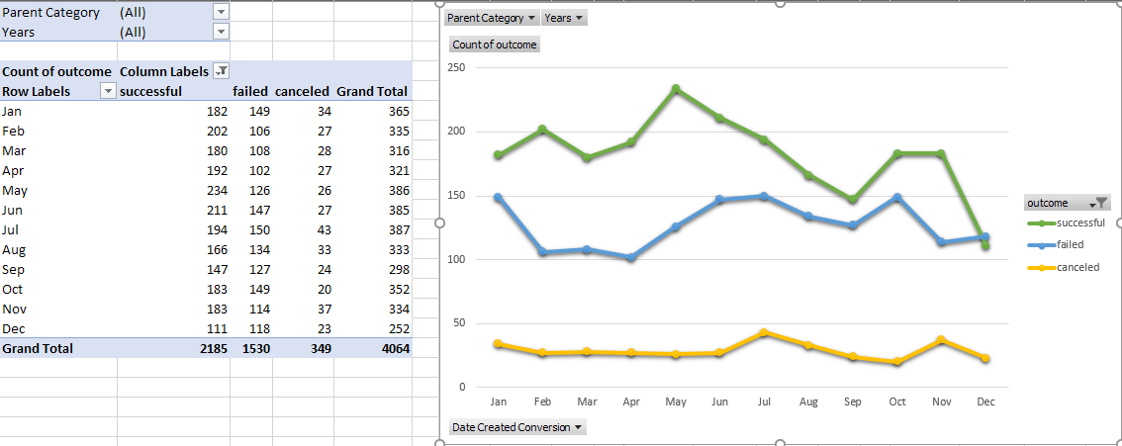

1. Create a new sheet with a pivot table with a column of state, rows of Date Created Conversion, values based on the count of state, and filters based on parent category and Years.
2. Now create a pivot chart line graph that visualizes this new table.
3. Create a report in Microsoft Word and answer the following questions.

Given the provided data, what are three conclusions we can draw about Kickstarter campaigns?

What are some limitations of this dataset?

What are some other possible tables and/or graphs that we could create?

1. Create a new sheet with 8 columns:

Goal

Number Successful

Number Failed

Number Canceled

Total Projects

Percentage Successful

Percentage Failed

Percentage Canceled

1. In the Goal column, create 12 rows with the following headers:

Less than 1000

1000 to 4999

5000 to 9999

10000 to 14999

15000 to 19999

20000 to 24999

25000 to 29999

30000 to 34999

35000 to 39999

40000 to 44999

45000 to 49999

Greater than or equal to 50000

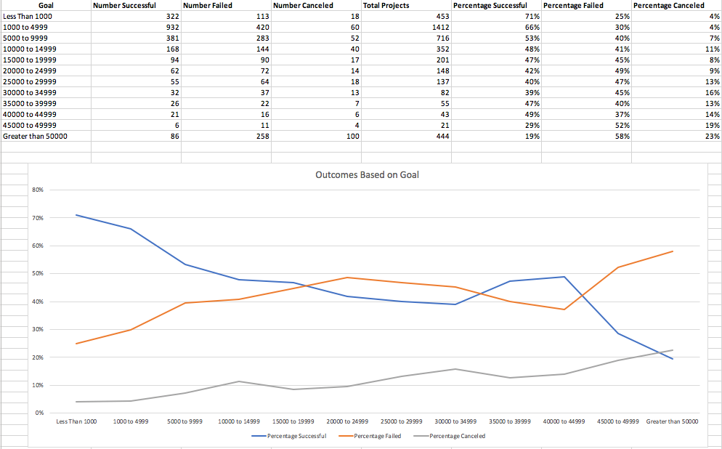

1. Using the COUNTIFS() formula, count how many successful, failed, and canceled projects were created with goals within the ranges listed above. Populate the Number Successful, Number Failed, and Number Canceled columns with this data.
2. Add up each of the values in the Number Successful, Number Failed, and Number Canceled columns to populate the Total Projects column. Then, using a mathematical formula, find the percentage of projects that were successful, failed, or canceled per goal range.
3. Create a line chart that graphs the relationship between a goal's amount and its chances at success, failure, or cancellation.

**Statistical Analysis**

You will evaluate the number of backers of successful and unsuccessful campaigns statistically. Create a new worksheet in your workbook, and create a column each for the number of backers of successful campaigns and unsuccessful campaigns.

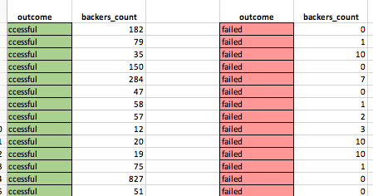

Use Excel to evaluate the following for successful campaigns, and then for unsuccessful campaigns:

The mean number of backers.

The median number of backers.

The minimum number of backers.

The maximum number of backers.

The variance of the number of backers.

The standard deviation of the number of backers.

Use your data to determine whether the mean or the median summarizes the data more meaningfully.