MEDLINKS Healthcare Platform

Client Specification and Implementation Review
Project Code: MEDLINK-Version2
Target Audience: All Medical Field Professionals
Document Version: 1.0
System Reference Date: March 25, 2026

1. Executive Summary
MEDLINKS is a role-based healthcare operations platform designed for clinic and medical-center workflows. The current implementation supports patient management, appointment and walk-in consultation flows, diagnosis and medical test search, prescription lifecycle handling, assistant-driven dispensing, inventory search and stock deduction, user management, analytics, and audit logging.
The strongest implementation area today is the doctor and assistant operational flow:
- doctors can save a complete consultation through a single workflow endpoint
- appointment and walk-in modes are both supported
- prescription items are operationally split into `clinical` and `outside`
- only clinical items enter the dispense queue
- assistant and doctor dispense flows now align with inventory deduction and workflow completion
- patient history is recorded structurally through encounters, timeline events, narrative history notes, and long-term conditions
This document is intended for technical and delivery review. It focuses on what is implemented now, what is stable enough for stakeholder review, and what remains future scope.

2. Document Control
Document title | MEDLINKS Client Specification and Implementation Review
Project code | MEDLINK-Version2
Version | 2.0
Date | March 25, 2026
Status | Tech Manager Review
Primary audience | Technical manager, delivery leads, implementation stakeholders
Basis | Current repository implementation and verified API behavior

Version History
Version | Date | Notes
2.0 | March 25, 2026 | Consolidated handover review aligned to implemented backend behavior

3. System Overview
MEDLINKS currently follows a layered architecture:
- Frontend application
- Doctor, assistant, owner, analytics, and support-facing workflows.
- BFF/API access layer
- Frontend-facing `/api/*` routes and authenticated browser integration.
- Core backend API
- Implemented `/v1/*` business routes for clinical, inventory, auth, user, and audit domains.
- Persistence and platform services
- PostgreSQL, Redis-backed queue support, search integration, structured audit logging, and typed validation.

Role Model
Owner
- staff/admin visibility
- user creation
- broad operational access
Doctor
- doctor workspace
- consultation save
- diagnosis/tests/prescription
- can print prescription
- can dispense when allowed
Assistant
- intake
- appointment creation
- pending dispense queue
- inventory-linked dispense completion

Doctor Workflow Model
Doctor Workspace
- Choose mode
  - APPOINTMENT
  - WALK-IN

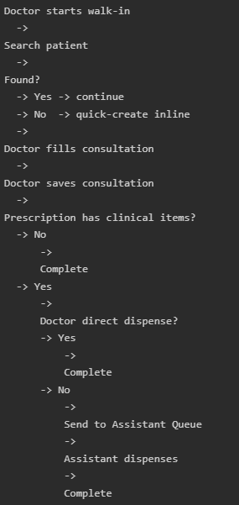
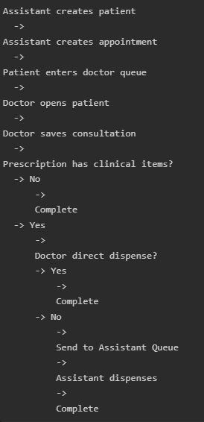
Appointment Mode
Walk-In Mode

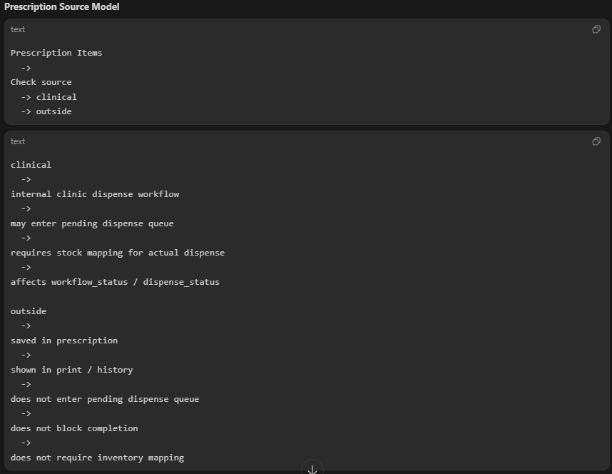
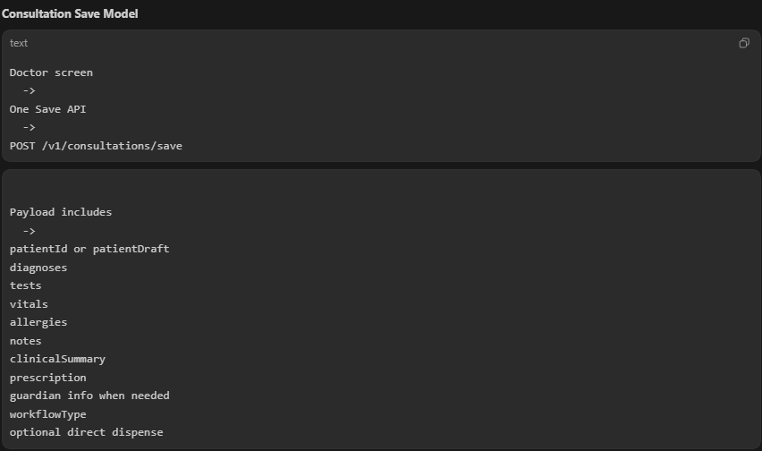
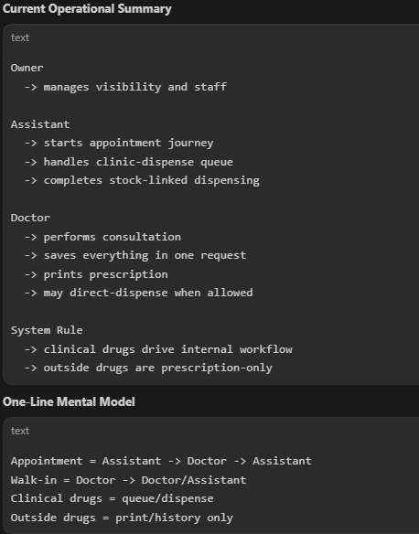
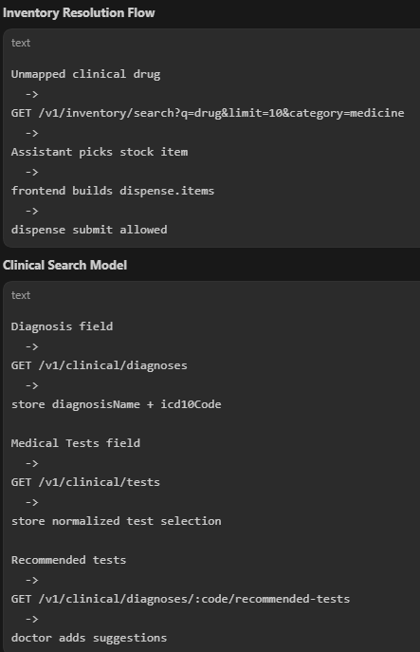
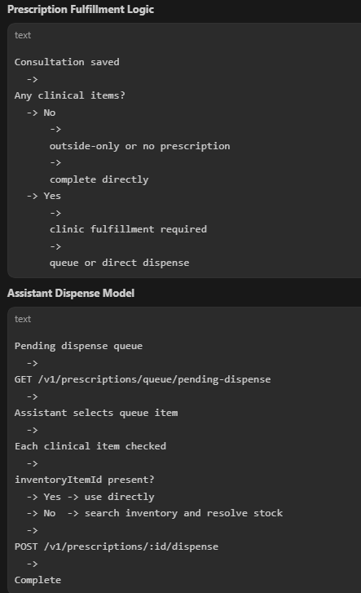

Main Implemented Backend Domains
- Authentication and session management
- Users and permissions
- Patients, families, guardian handling
- Appointments and visit start
- Consultations and encounters
- Prescriptions and dispense workflow
- Inventory and stock movements
- Clinical terminology lookup
- Analytics and observability
- Audit logs

4. Core Functional Scope

4.1 Authentication and Access Control
Implemented:
- login, refresh, logout, current-user session
- effective permission model using role plus extra permissions
- sensitive action throttling
- doctor, assistant, and owner operational permissions
- Important implemented rule:
- frontend should use returned `permissions`, not role name alone, for access decisions

4.2 Patient Management
Implemented:
- patient search and quick selection
- patient summary list and full patient profile
- patient creation and update
- guardian-aware patient creation
- family auto-creation and family linking
- patient allergies, conditions, history, timeline, and vitals
- Important implemented rule:
- `dateOfBirth` is canonical; `age` is only a helper/validation aid

4.3 Consultation Workflows
Implemented:
- one workflow endpoint: `POST /v1/consultations/save`
- `workflowType = appointment`
- `workflowType = walk_in`
- `patientId` for existing patients
- `patientDraft` for inline quick-create
- `guardianDraft` for real guardian creation when needed
- diagnosis, tests, vitals, allergies, notes, clinical summary, and prescription in one save

4.4 Prescription and Dispense
Implemented:
- prescription creation within consultation save
- `source = clinical` and `source = outside`
- pending dispense queue
- doctor direct dispense
- assistant queue-based dispense
- stock deduction and inventory movement creation
- inventory search for unresolved clinical dispense items

4.5 Clinical Lookup
Implemented:
- diagnosis autocomplete
- medical test autocomplete
- recommended tests by diagnosis
- provider-backed terminology integration through backend
- Important implemented rule:
- diagnoses and tests are separate datasets
- lab and observation search is implemented
- imaging and procedure catalogs are future scope

5. Workflow Model

5.1 APPOINTMENT MODE
Entry pattern:
- patient already exists
- appointment already exists
- doctor opens from queue
- Backend behavior:
  - validates appointment and patient match
  - creates consultation encounter
  - stores vitals, diagnoses, tests, allergies, history, and prescription
- if no clinical prescription items exist, workflow can complete immediately
- if clinical items exist and not directly dispensed, workflow stays doctor-finished until dispense is completed
Operational result:
- appointment mode supports assistant handoff after doctor save

5.2 WALK-IN MODE
Entry pattern:
- no appointment required
- doctor searches patient
- if not found, doctor quick-creates inline using `patientDraft`
- Backend behavior:
  - resolves existing patient or creates a new one
  - reuses or creates visit context
  - creates encounter and related clinical data
  - creates timeline event and optional history entry
  - promotes flagged chronic diagnoses into patient conditions
- Important implemented conflict rule:
  - if an active walk-in consultation already exists for the patient, backend returns `409 Conflict` with a clear message instead of failing generically

5.3 Prescription Source Logic
Operational split:
`CLINICAL`
- affects workflow completion
- creates pending dispense queue if not directly dispensed
- requires inventory resolution
`OUTSIDE`
- remains in prescription print/history
- does not create dispense queue
- does not block workflow completion
This is one of the key workflow-hardening changes in the current implementation.

6. API Integration Model

Key Implemented Endpoints
Area | Endpoint
Auth | `/v1/auth/login`, `/v1/auth/refresh`, `/v1/auth/me`, `/v1/auth/logout`
Patient search | `/v1/search/patients`
Patients | `/v1/patients`, `/v1/patients/:id/profile`
Families | `/v1/families`
Appointments | `/v1/appointments`
Visit start | `/v1/visits/start`
Consultation workflow | `/v1/consultations/save`
Encounters | `/v1/encounters`
Prescriptions | `/v1/prescriptions`, `/v1/prescriptions/:id/dispense`
Dispense queue | `/v1/prescriptions/queue/pending-dispense`
Inventory | `/v1/inventory`, `/v1/inventory/search`
Clinical lookup | `/v1/clinical/diagnoses`, `/v1/clinical/tests`, `/v1/clinical/diagnoses/:code/recommended-tests`
Analytics | `/v1/analytics/overview`
Audit | `/v1/audit/logs`

Frontend Contract Direction
Frontend should treat these as the primary patterns:
- Diagnosis field = diagnoses only
- Medical Tests field = test catalog only
- Selected diagnosis = can request suggested tests below
- Consultation save = one workflow payload, not many independent save steps
- Dispense completion = requires real `inventoryItemId` selection for clinical items

7. Error Handling Contract
The backend now exposes clearer frontend-facing behavior around common failure modes.

Important Current Error Cases
Endpoint | Status | Meaning
`/v1/consultations/save` | 400 | Validation/input issue
`/v1/consultations/save` | 404 | Patient, appointment, or guardian not found
`/v1/consultations/save` | 409 | Active walk-in conflict or appointment/patient mismatch
`/v1/prescriptions/:id/dispense` | 400 | Missing or invalid dispense item payload
`/v1/prescriptions/:id/dispense` | 404 | Prescription or inventory item not found
`/v1/prescriptions/:id/dispense` | 409 | Prescription already dispensed or insufficient stock
`/v1/prescriptions/:id/dispense` | 429 | Sensitive action rate limit exceeded
`/v1/clinical/tests` | 503 | Upstream terminology provider unavailable

Important Implemented Conflict Message
{
"message": "Active walk-in consultation already exists for this patient. Complete or dispense the current consultation before starting a new one."
}
This is important for frontend and operational workflows because it prevents duplicate active walk-in consultations.

8. Current Implementation Status

Implemented and Verified
- consultation workflow endpoint
- appointment and walk-in branching
- guardian linking and guardian draft creation
- patient timeline and history integration
- diagnosis persistence into patient conditions
- terminology lookup endpoints
- noisy medical-test result filtering
- pending dispense queue enrichment
- inventory search for assistant stock matching
- doctor-sensitive dispense permission alignment
- source-aware prescription workflow
- walk-in conflict handling with clean `409`
- Swagger request and error response documentation

Verification Status
Current verified state:
- `npm run typecheck` passing
- `npm run test --workspace @MEDLINKS/api` passing
- 76 API tests passing at the time of this document

9. Non-Functional and Operational Notes

Strengths
- typed validation across API boundaries
- transaction-based save flows for critical clinical operations
- permission-driven enforcement
- audit logging support
- cache invalidation support for queue/profile flows
- structured integration patterns for frontend

Current Practical Readiness
Ready for:
- controlled internal clinic deployment
- technical stakeholder review
- frontend/backend coordination
- QA and UAT planning
- workflow-based operational rollout
- Not yet complete for:
- imaging/procedure catalog integration
- advanced external lab integration
- full compliance certification programs
- enterprise-grade patient self-service
- broader interoperability programs

10. Known Limitations and Future Scope

Current Known Gaps
- imaging and procedures are not yet part of the main clinical test catalog
- prescription items do not yet persist inventory linkage at item-create time
- outside items are intentionally excluded from internal dispense workflow
- advanced clinical decision support remains limited
- compliance maturity is operationally helpful but not certification-ready

Recommended Next Steps
- Add imaging/procedure terminology endpoint separate from lab tests.
- Add stronger stock-item linkage at prescription item creation time where possible.
- Continue improving audit/compliance reporting depth.
- Extend manager-facing analytics and export contracts.
- Add clearer frontend retry/recovery UX around conflict and provider-unavailable cases.

11. Handover Recommendation
For technical manager review, the most important achievements so far are:
- backend workflow consolidation around consultation save
- practical doctor UX reduction from many steps to one final save
- proper appointment vs walk-in lifecycle separation
- source-based prescription workflow
- assistant queue and inventory resolution alignment
- clearer frontend error contract and Swagger accuracy
Recommended manager review focus:
- Validate the workflow model against real clinic operations.
- Confirm the current status names and handoff stages fit business language.
- Review remaining terminology/integration scope for imaging and external systems.
- Approve the current API contract as the baseline for frontend completion.

12. Supporting Documents
- `docs/MEDLINKS_Backend_Client_Specification.html`
- `docs/MEDLINKS_Backend_Client_Specification.pdf`
- `docs/MEDLINKS_Backend_Developer_Tracker.html`
- `docs/MEDLINKS_Backend_Developer_Tracker.pdf`
- `docs/CONSULTATION_WORKFLOW.md`

13. Final Note
This document is intentionally aligned to implemented backend behavior rather than idealized future-state language. It is suitable as a technical handover/review draft for management and delivery discussion.

