Chemistry practice paper 1 answers

1.(a) (i) Number of moles of anhydrous borax

= 3.94÷[23×2+10.8×4+16×5+(16+1)×4]. = 0.0166 mol (1 mark)

Number of moles of water

= (7-3.94)÷(16+2×1) = 0.17mol (1 mark)

Relative number of moles of anhydrous borax

= 0.0166÷0.0166 = 1 (1 mark)

Relative number of moles of water

= 0.0783÷0.0166 = 10.23(1 mark)

 ∴ m=10

(ii) m=7 (1 mark)

(b) Covalent bonds and ionic bonds are present (1 mark). Borax has a giant ionic structure. As oppositely charged ions are held by strong ionic bonds (1 mark), a lot of energy is required to break the bonds (1 mark). Hence borax’s boiling point is high.

(c) Number of moles of borax

= 7÷[23×2+10.8×4+16×5+(16+1)×4+(16+1×2)×10] = 0.0168 mol (1 mark)

Number of moles of hydrochloric acid

= 2÷(35.5+1)÷2 = 0.0281 mol (1 mark)

Borax is the limiting agent.

Theoretical yield of boric acid

= 0.0168×(1×3+10.8+16×3)×4 = 4.15g (1 mark)

Percentage yield of boric acid

= 3.925÷4.15×100% = 94.5% (1 mark)

(d) The borax used contains some impurities. (1 mark)

The reaction is incomplete. (1 mark)

(Or other acceptable answers)

2. (a) Supersonic aircrafts. Because vanadium is light but very strong. (1 mark)

(b) Mass of NH4VO3

= 1×(14+1×4+50.9+16×3) = 116.9 g

(c) Theoretical yield = 15.4g (2 marks)

Actual yield = 14.3g (2 marks)

Percentage yield = 92.9% (1 mark)

3. (a) As titanium (iv) chloride is volatile, little energy is required to separate the molecules, and it has a low boiling point (1 mark). Molecules are held by weal van der Waal’s forces (1 mark), and it can be deduced that it has simple molecular structure. (1 mark)

(b) To prevent the entrance of oxygen into the setup. (1 mark)

(c) TiCl4 (l) + 2Mg (s) → Ti (s) + 2MgCl2 (s) (1 mark)

(d) Rinse the mixture with hydrochloric acid to dissolve any excess magnesium. (1 mark)

Add excess water to the mixture to dissolve all the magnesium chloride. (1 mark)

Filter the resulting mixture with a separating funnel and a filter paper. (1 mark)

4. (a) It is the amount of ionisable hydrogen atoms in one molecule of acid (1 mark). The basicity of phosphoric acid is 3 (1 mark).

(b) (i) Lead (1 mark)

(ii) 3Pb (s) + 2H3PO4 (aq) → 3H2 (g) + Pb3(PO4)2 (s) (1 mark)

(c) When adding phosphoric acid to the three metals, only Y has no observable change. Hence, we can deduce that Y is the least reactive (2 marks).

When adding iron (ii) nitrate into the three metals, only Z dissolves to form a metal deposit and colourless gas bubbles. It is known that Z is the most reactive (2 marks).

In conclusion we can arrange the order of reactivities as Y < X < Z (1 mark).

Communication (1 mark)

5. (a) Copper dissolves in gold (iii) chloride to form a blue solution. The yellow colour of the solution fades (1 mark). A golden solid is formed as gold metal is formed (1 mark).

When ammonia solution is added to copper (ii) chloride, a blue precipitate is formed(1 mark). When ammonia solution is in excess, the blue precipitate redissolves (1 mark) to form a dark blue solution (1 mark).

(b) (5 marks)

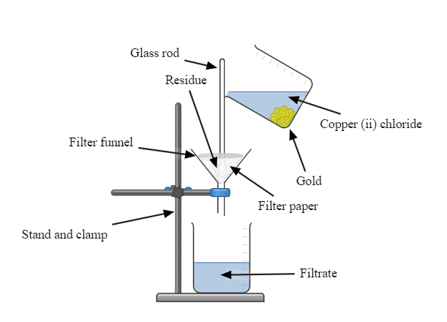

(c) 2AuCl3 (aq) + 3Cu (s) → 3CuCl2 (aq) + 2Au (s) (1 mark)

Cu2+ (aq)+ 2OH- (aq) → Cu(OH)2 (s) (1 mark)

Cu(OH)2 (s) + 4 NH3 (aq) → Cu(NH3)42+ (aq) + 2OH- (aq) (1 mark)

6. (a) (i) Because gas X is less dense than air (1 mark).

(ii) Put a wet red litmus paper into the test tube. It turns from red to blue (1 mark).

(iii) 2NH4Cl (s) + Ca(OH)2 (s) → CaCl2 (s) + 2 NH3 (g) + 2 H2O (l) (1 mark)

(iv) No (1 mark). Because calcium carbonate will be formed, which will further decompose to form calcium oxide and carbon dioxide. The carbon dioxide evolved will contaminate the ammonia gas (1 mark).

(b) Extract the ammonia gas inside the test tube with a gas syringe (1 mark). Attach the syringe to a rubber tubing (1 mark) and an inverted funnel (1 mark). Place a beaker of water with the funnel just above the water (1 mark). Slowly inject gas into the beaker of water to form ammonia solution (1 mark).