Chemistry practice paper 1 Marks: ____ / 65

1. Borax (Na2[B4O5(OH)4]) combines with hydrochloric acid to give out boric acid, sodium chloride and water. The equation is listed as below:

Na2[B4O5(OH)4]·nH2O + 2HCl → 4H3BO3 + 2NaCl + mH2O

(a) Before the start of the experiment, a study on the amount of water of crystallisation was carried out. It was found that after heating a crucible of 7g hydrated borax, 3.94g of anhydrous borax is left.

(i) Calculate n. (4 marks)

(ii) Hence find m. (1 mark)

(b) list out the bonds present in borax. Hence, suggest and explain whether its boiling point is high or low, in terms of structure and bonding. (3 marks)

(c) It is known that 7g borax is allowed to react with 2g hydrochloric acid. If the yield of boric acid is 3.925g, find the percentage yield of boric acid. (4 marks)

(d) Explain the reasons why the actual yield is less than the theoretical yield. (2 marks)

2. Vanadium (V) is a transition metal with atomic number 23. It is the only element that possesses four adjacent oxidation states that are all stable in aqueous solution. In this experiment, ammonium metavanadate is added into sulphuric acid, followed by zinc metal, a strong reducing agent.

The phase for the colour change:

VO2+ (yellow) → VO2+ (blue) → V3+ (green) → V2+ (violet)

Stepwise chemical equations for this reaction:

2NH4VO3 + 2H2SO4 → (VO2)2SO4 + (NH4)2SO4 + 2H2O

(VO2)2SO4 + Zn + 2H2SO4 → 2VOSO4 + ZnSO4 + 2 H2O

2VOSO4 + Zn + 2H2SO4 → V2(SO4)3 + ZnSO4 + 2H2O

V2(SO4)3 + Zn → 2VSO4 + ZnSO4

(a) Suggest and explain one daily life usage of vanadium. (1 mark)

(b) If 1 mol of VSO4 is obtained, find the mass of NH4VO3. (4 marks)

(c) Assume that 12.25g of NH4VO3 and excess H2SO4 are allowed to react, and the loss of the vanadium-containing compound in every reaction is steadily decreasing by 2.5% by mass. calculate the percentage yield of VSO4. (5 marks)

3. Titanium (Ti) is a transition metal with atomic number 22. In the experiment, magnesium is added to titanium (iv) chloride (TiCl4) in an atmosphere of argon. It is given that magnesium is more reactive than titanium.

(a) It is observed that dense fumes evolve continuously before the placement of magnesium. Hence predict and explain the structure of titanium (iv) chloride. (3 marks)

(b) Explain why the reaction is carried out in an atmosphere of argon. (1 mark)

(c) Write a chemical equation for the reaction between titanium (iv) chloride and magnesium. (1 mark)

(d) Given that titanium does not react with acids, explain how titanium is separated from the resulting mixture. (3 marks)

4. The result is shown with different reactions with metals X, Y and Z.

|  |  |  |  |
| --- | --- | --- | --- |
| Reaction/Metal | X | Y | Z |
| Adding phosphoric acid | A solid is formed. | No observable change | A solid is formed. |
| Heating with its oxide alone | A solid with metallic lustre is formed | A solid with metallic lustre is formed | No observable change |
| Adding into an aqueous solution of iron (ii) nitrate | No observable change | No observable change | A metal deposit is formed and colourless gas bubbles evolve |

(a) Explain the definition of basicity and state the basicity of phosphoric acid. (2 marks)

(b) (i) Name metal X. (1 mark)

(ii) Write the chemical equation between metal X and phosphoric acid. (1 mark)

(c) Explain and compare the reactivities of X, Y and Z. (6 marks)

5. Copper is added to gold (iii) chloride. The resulting solution is filtered. Then, excess ammonia solution is added to the filtrate. It is given that gold (iii) chloride is yellow in colour.

(a) Describe the observations involved in the two experiments. (5 marks)

(b) Draw the setup for filtration of the resulting mixture of gold (iii) chloride and copper. (5 marks)

(c) Write the three chemical equations involved in the reaction. (3 marks)

6. Ammonium chloride is heated with calcium hydroxide to form gas X. The process is stated in the diagram as below:

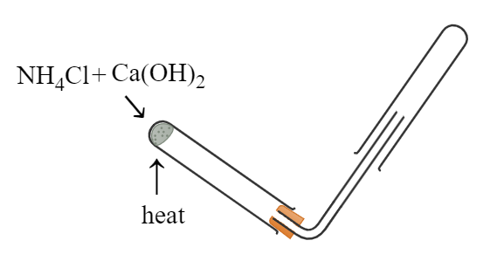

(a) (i) Explain why the test tube for the collection of gas X is placed invertedly. (1 mark)

(ii) Suggest a method to test the presence of gas X. (1 mark)

(iii) Write a balanced chemical equation for this experiment. (1 mark)

(iv) Explain whether ammonium carbonate can act as a substitute of ammonium chloride. (2 marks)

(b) If a solution of gas X is required, state the procedures after collecting gas X in the test tube. (5 marks)

End of paper