Suppl. Fig. 1 | Foram Index values for all samples in descending order. Foram Index values below 2 indicate stressed conditions unsuitable for reef growth. Values between 2 and 4 indicate environments marginal for reef growth and unsuitable for recovery, and values above 4 environments conducive to reef growth and recovery.
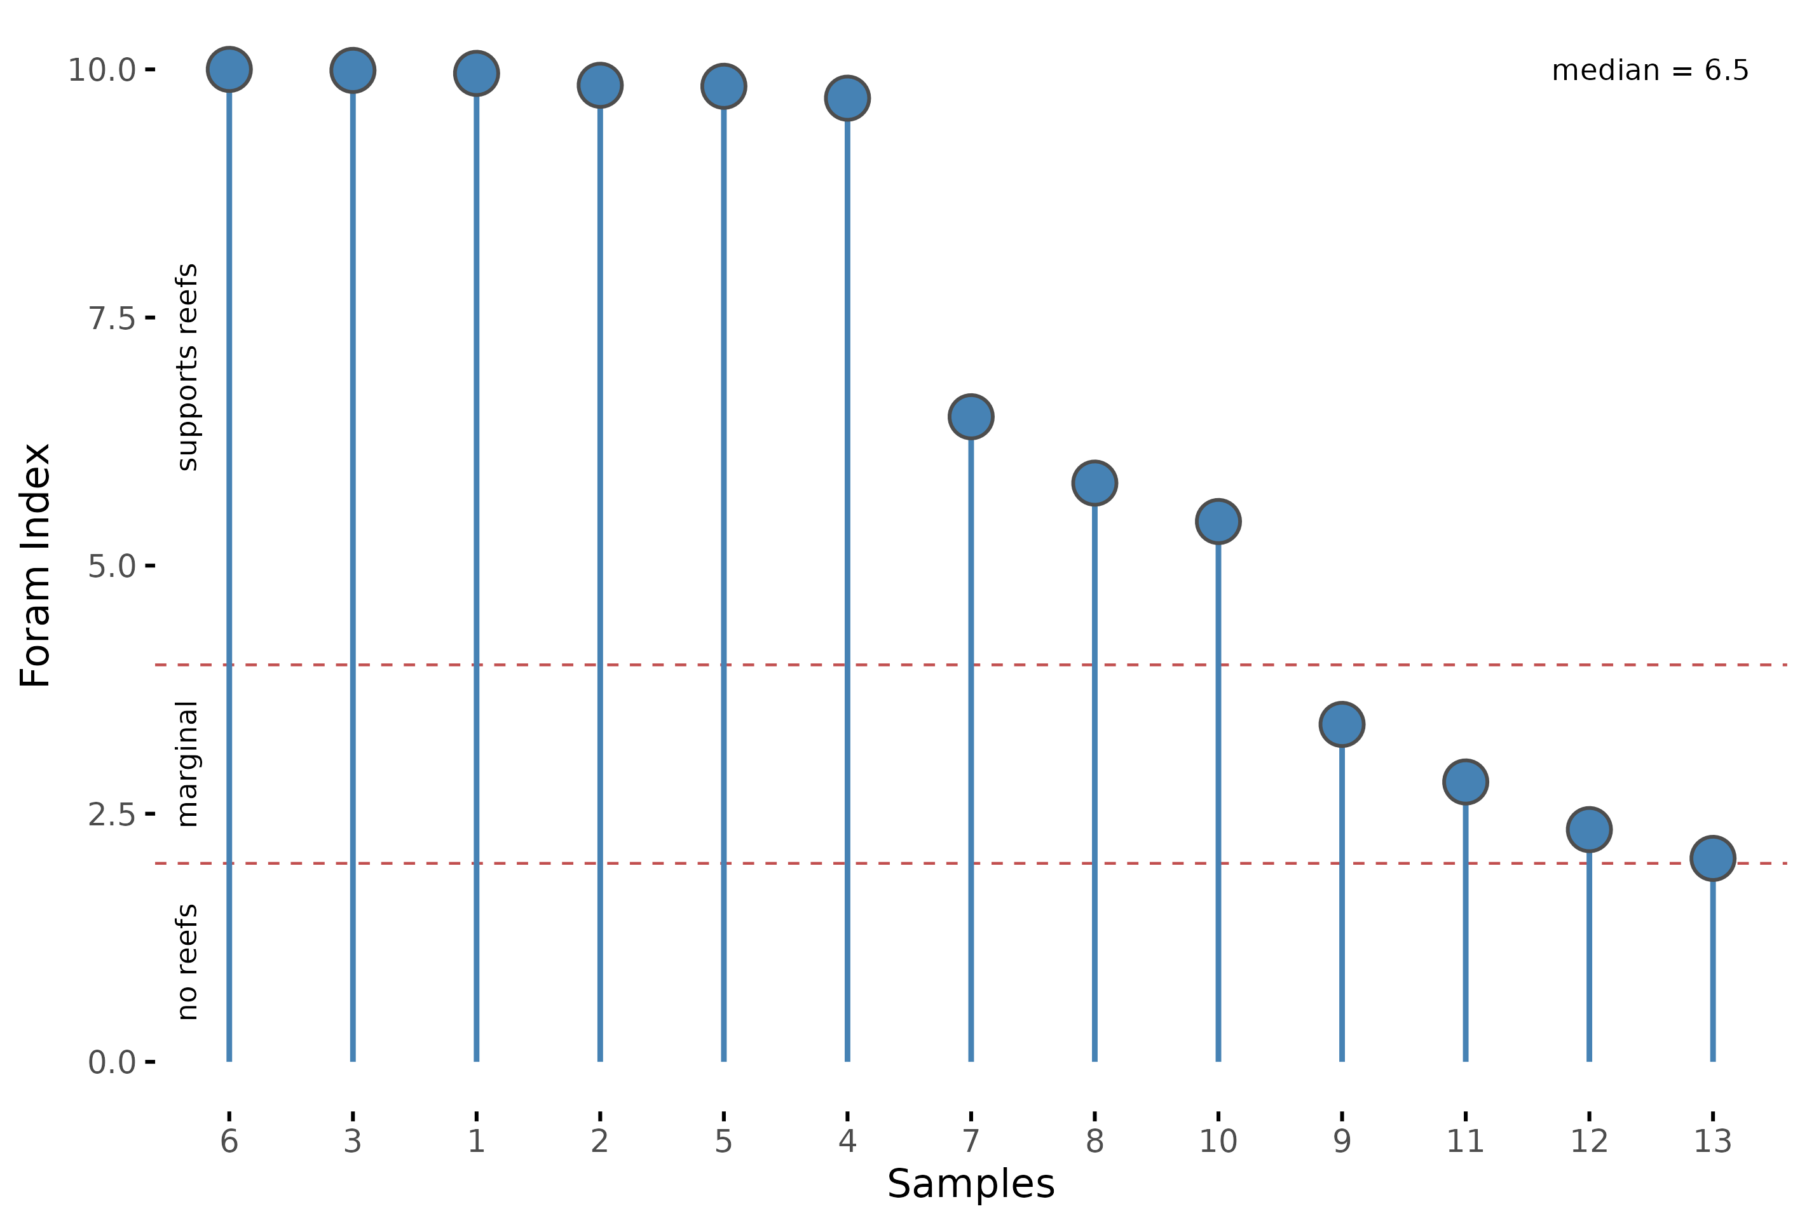

Suppl. Fig. 2 | Results of the robustness check of our analysis compared to the actual coefficient estimates. Grey colour depicts values for the robustness model, where all samples with a Foram Index above 9.5, indicating potentially biased samples, are removed. . The dashed line depicts an effect of zero. The thicker lines show the range of the 89% interval, and the finer lines the 95% interval. Points show the median of the focal joint posterior distribution. The Marine Corps Base is abbreviated as MCBH.
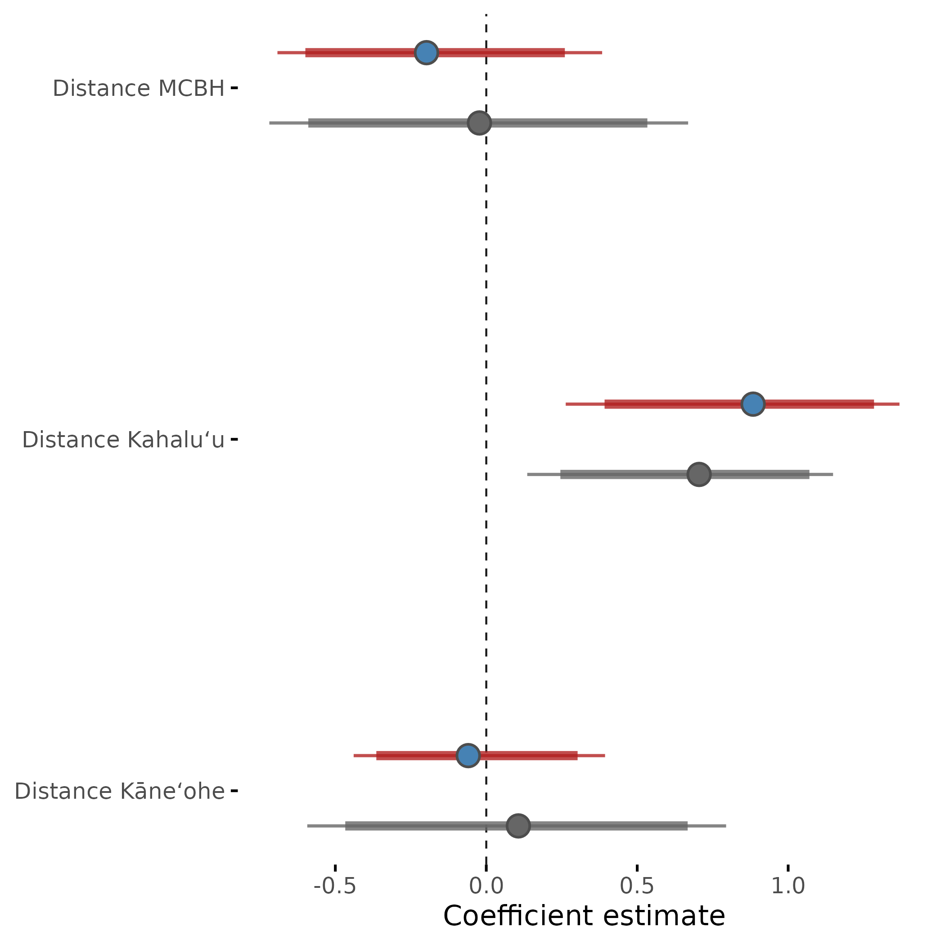
Suppl. Fig. 3 | Non-metric multidimensional (NMDS) ordination of the 13 sediment samples collected in Kāneʻohe Bay, showing a clear clustering of the samples in three groups. Dimension 1 (NMDS 1) represents a community gradient from symbiont-bearing genera (left) to small, heterotrophic and opportunistic genera (right). Dimension 2 (NMDS 2) represents a gradient from high absolute abundance (top) to low absolute abundance (bottom) of foraminifera.

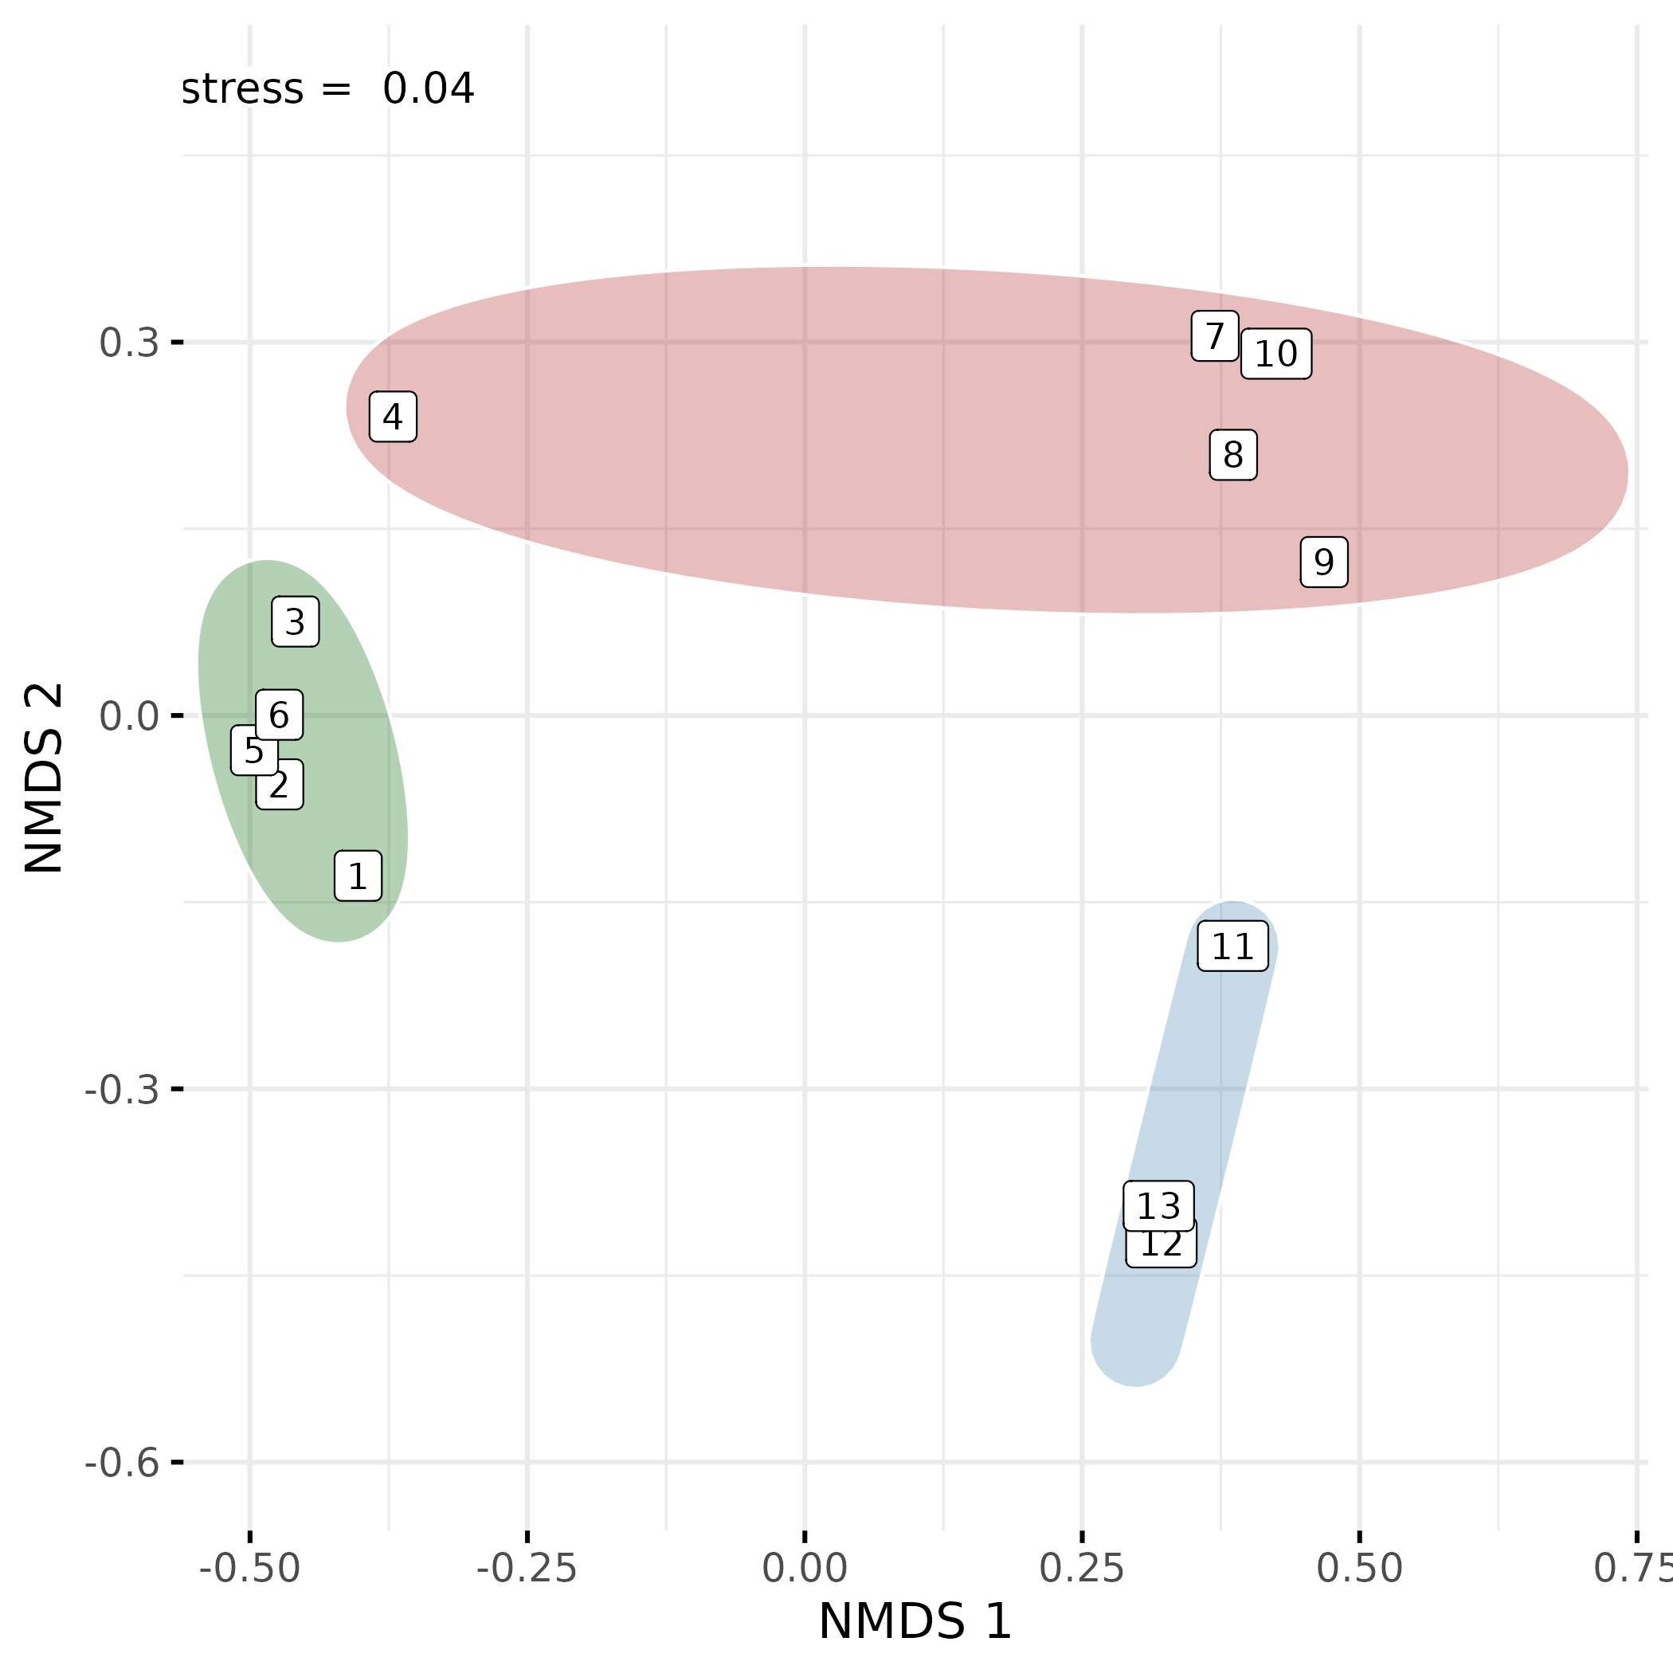

Suppl. Fig. 4 | Model performance check of the final model used to analyse the relationship between FI values and distance to human settlements by means of the effective sample size ratio. Values below 0.1 indicate low convergence of the MCMC sampling.
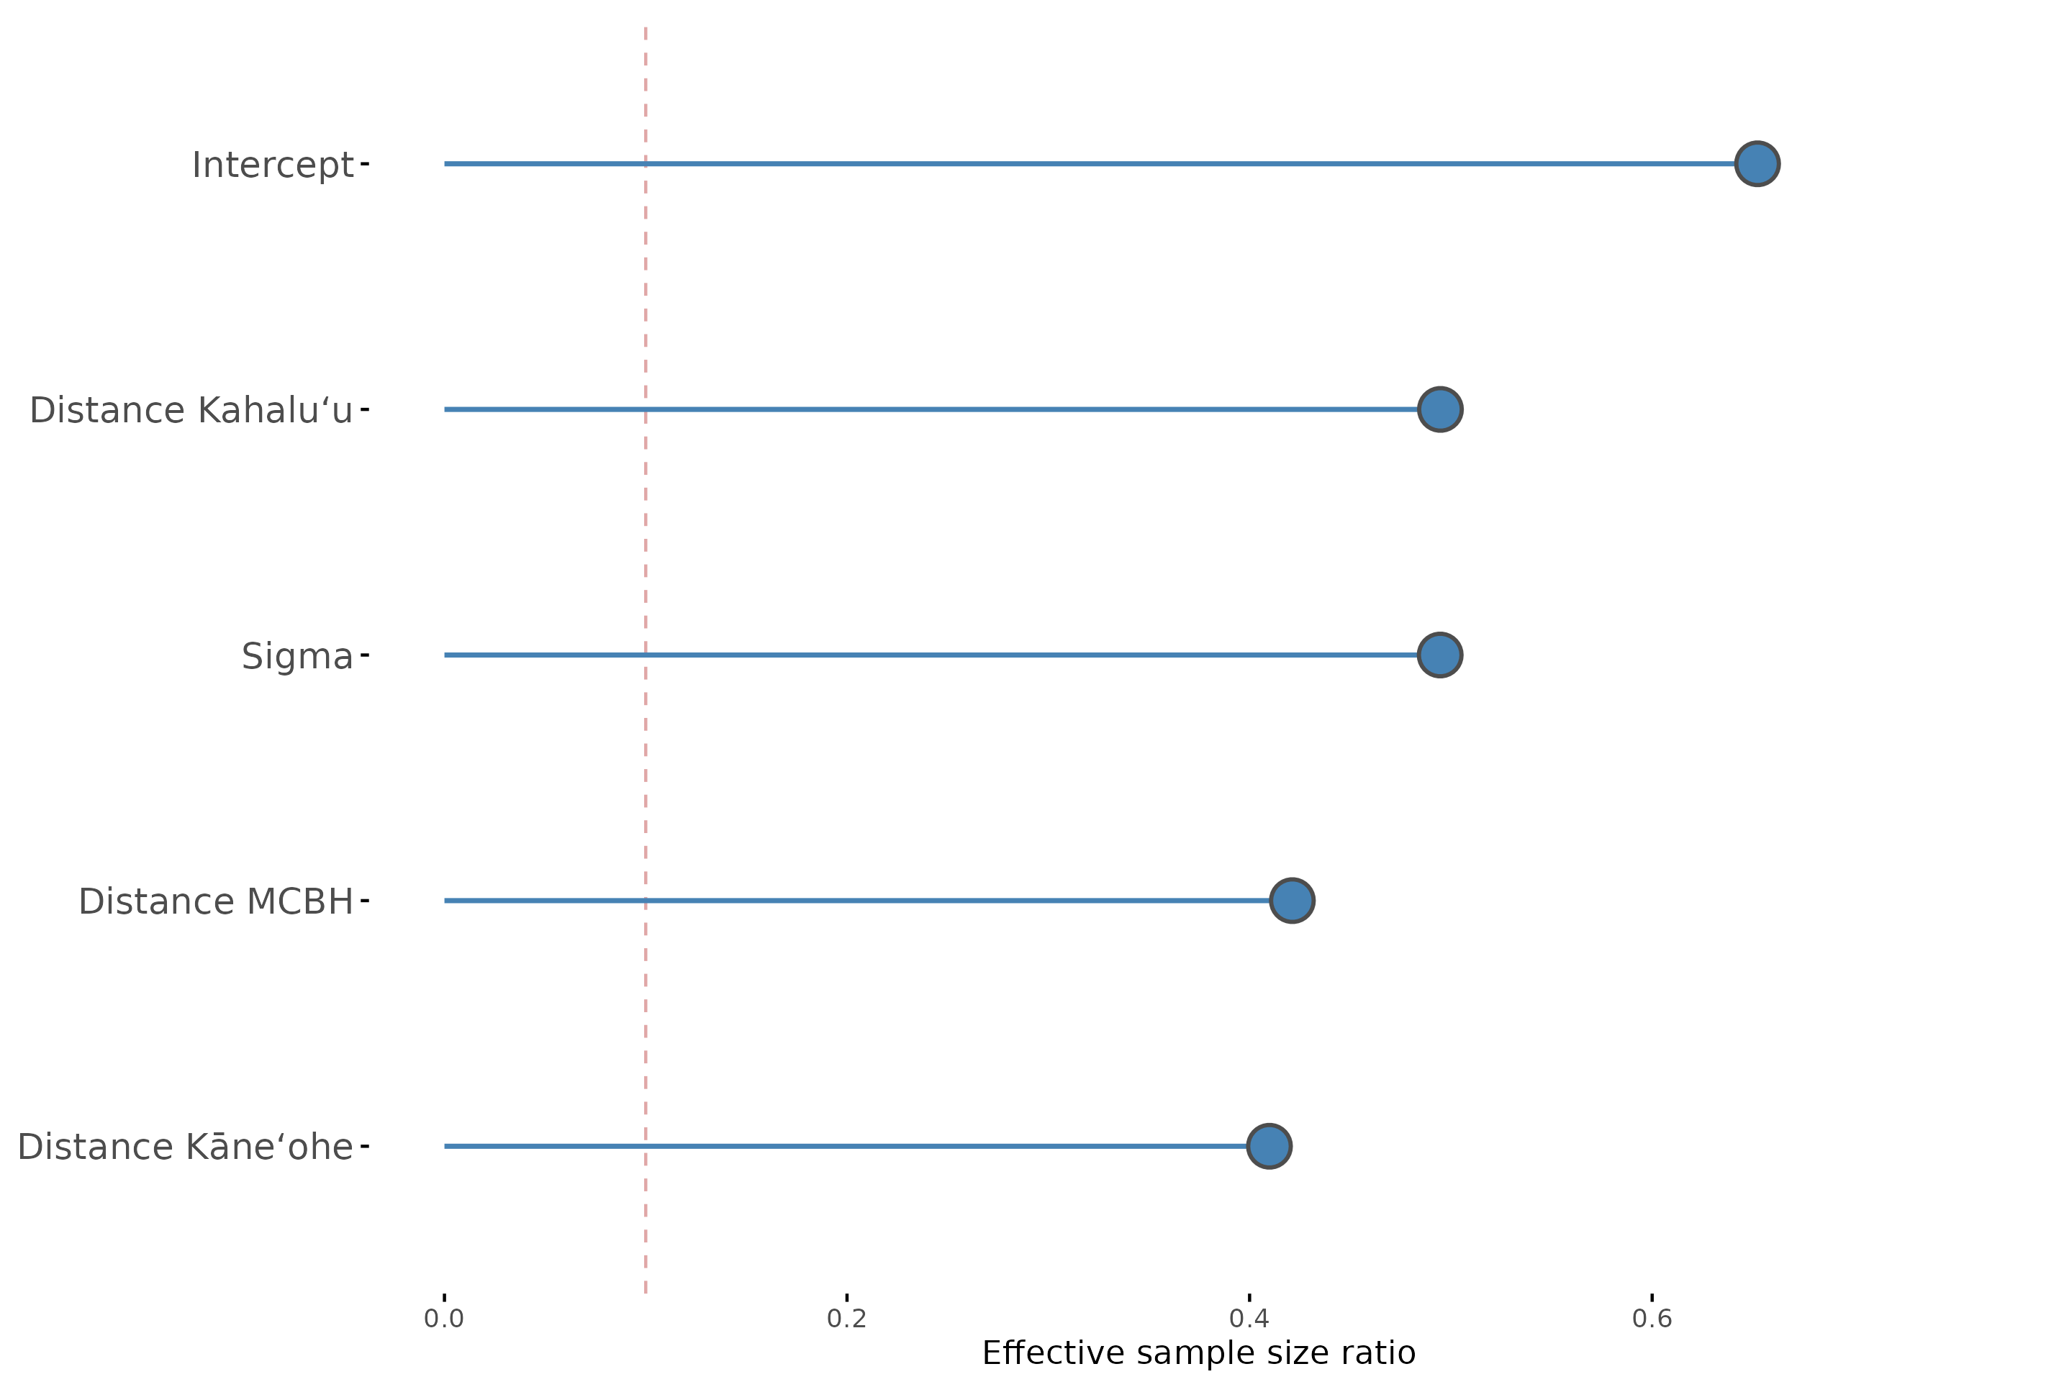

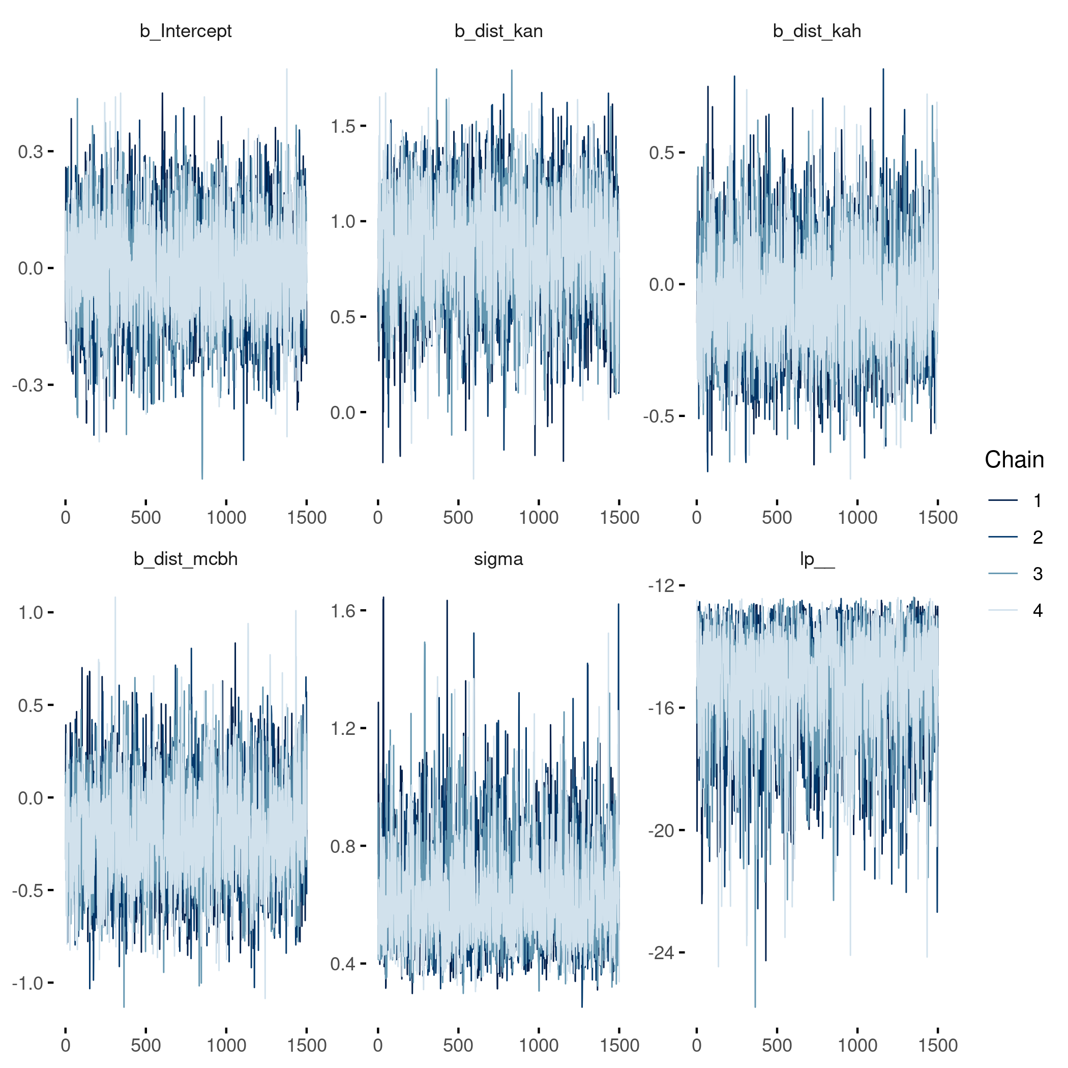
Suppl. Fig. 5 | Trace plot for the Hamiltonian Monte Carlo Markov Chain sampling algorithm, showing good convergence and low divergence indicating a good model fit.

Suppl. Fig. 6 | Trank plot for the Hamiltonian Monte Carlo Markov Chain sampling algorithm, showing good convergence and low divergence of individual chains of each coefficient.

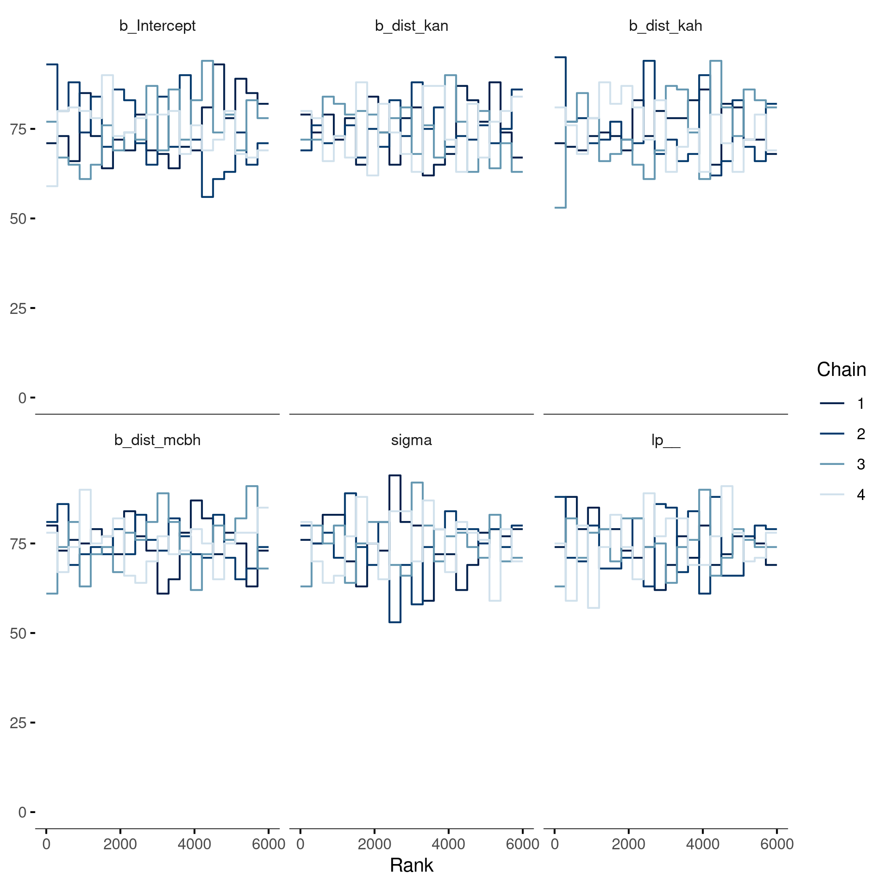
Suppl. Table 1 | Additional information for each sample. The coordinates are given as UTM. Depth is given in meters below water surface. Distances to human settlement are given in kilometres.

Sample | Latitude | Longitude | Depth | Distance Kāneʻohe | Distance Kahaluʻu | Distance MCBH
 | N | E | m | km | km | km
1 | 2150441 | -15780231 | 14.0 | 11.8 | 5.9 | 8.7
2 | 2149284 | -15779793 | 12.0 | 10.0 | 5.3 | 7.5
3 | 21475 | -1577988 | 1.5 | 8.1 | 3.8 | 6.2
4 | 2146843 | -15777818 | 11.0 | 7.6 | 5.5 | 4.2
5 | 2147446 | -15780177 | 2.0 | 8.0 | 3.5 | 6.4
6 | 2146235 | -15777739 | 2.0 | 7.8 | 5.5 | 3.6
7 | 214699 | -1578186 | 5.0 | 7.7 | 1.8 | 7.8
8 | 214588 | -1578019 | 1.0 | 6.2 | 2.9 | 5.8
9 | 214566 | -1578009 | 0.5 | 5.9 | 4.9 | 4.3
10 | 214566 | 1578101 | 0.5 | 5.9 | 3.0 | 5.4
11 | 21449 | -157782 | 3.0 | 5.4 | 5.1 | 3.5
12 | 21453 | -157801 | 6.0 | 5.5 | 3.0 | 5.6
13 | 21431569 | -15778689 | 14.0 | 3.4 | 4.9 | 4.3

Suppl. Table 2 | The Foram Index for each sample.

Sample | Foram Index
1 | 9.96 | 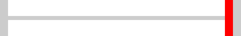
2 | 9.84
3 | 9.99
4 | 9.71 | 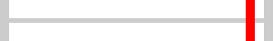
5 | 9.83
6 | 10 | 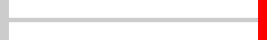
7 | 6.5 | 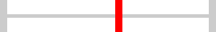
8 | 5.83 | 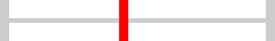
9 | 3.4 | 
10 | 5.44 | 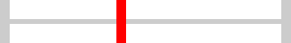
11 | 2.82 | 
12 | 2.34 | 
13 | 2.05 | 

Suppl. Table 3 | The Bayesian estimate of the expected log pointwise predictive density (ELPD) calculated by leave-one-out cross-validation. ELPD difference shows the difference of absolute ELPD values, compared to the best performing model. SE denotes the standard error for each estimate. As the ELPD is an indicator for the predictive performance of a model, the results indicate that the model using distances to human settlements clearly performs better than the null model. Adding water depth to the distance model has no beneficial effect on the model performance, indicating a low dependency of the Foram Index on water depth.

Model | ELPD difference | SE ELPD difference | Absolute ELPD | SE absolute ELPD
Distance | 0.0 | 0.0 | -13.6 | 1.4
Distance + Depth | -1.0 | 0.6 | -14.6 | 1.4
Null Model | -5.3 | 1.4 | -19.0 | 1.2

Suppl. Table 4 | Coefficient estimates for the regression model of the Foram Index regressed against distance to human settlements. The estimate column shows the mean point estimate of the posterior, which is distributed with an standard error as denoted in “Est.Error“. The lower and upper 95% Credible Intervals (CI) are shown in the next two columns. Rhat values denote the model convergence, with a Rhat value of one indicating perfect convergence. The “Bulk_ESS“ column shows the estimated sample size from the posterior.

Coefficient | Estimate | Est.Error | l-95% CI | u-95% CI | Rhat | Bulk_ESS
Intercept | -0.0 | 0.1 | -0.3 | 0.3 | 1.0 | 3,956
Distance Kāneʻohe | 0.9 | 0.3 | 0.3 | 1.4 | 1.0 | 2,521
Distance Kahaluʻu | -0.0 | 0.2 | -0.4 | 0.4 | 1.0 | 3,024
Distance MCBH | -0.2 | 0.3 | -0.7 | 0.4 | 1.0 | 2,582

