Mismatches in functional conservation priorities across scales and locations worldwide
Target journals (to begin with): Nature Ecology and Evolution, Nature Communications. PNAS.
John N Griffin^{1*}, Gregor Mathes^{2,3}, Arianna Chitti^{1,4}, Camille Albouy^{5,6}, Fabien Leprieur⁷, Sara Varela⁸, and Catalina Pimiento^{1,3}

¹Swansea University, Swansea, Wales, UK.
² University of Passau, Passau, Germany
³University of Zurich, Zurich, Switzerland.
⁴
⁵Ecosystem and Landscape Evolution, Institute of Terrestrial Ecosystems, Department of Environmental Systems Science, ETH Zurich, Zurich, Switzerland
⁶Unit of Land Change Science, Swiss Federal Research Institute WSL, Birmensdorf, Switzerland
⁷MARBEC, Univ Montpellier, CNRS, Ifremer, IRD, Montpellier, France
⁸Oportunius Research Professor at Centro de Investigación Mariña, Departamento de Ecoloxía e Bioloxía Animal, Universidade de Vigo, Spain

*To whom correspondence should be addressed. Email: J.N.Griffin@Swansea.ac.uk

Abstract
Global conservation priorities are increasingly evaluated through the lens of functional diversity to safeguard ecological uniqueness. However, the spatial scale at which priorities are assessed may strongly influence which species and regions are considered functionally important—a factor that remains largely unexamined. Here, we reveal a pervasive scale-dependency in species- and spatial- functional priorities using the world’s marine megafauna as a case study. Species’ rankings for functional uniqueness - a key metric indicating which species and ecological roles lack redundancy - show no correspondence across global, provincial, and local scales. Meanwhile, rankings for functional specialisation (which reflects which species have extreme traits), distinctiveness (which indicates which species are most dissimilar from the rest of the community), and a metric further integrating endangerment (FUSE) correlate only moderately across scales. Ranking mismatches are marked and run in both directions: many species that are functionally critical at local scales are undervalued globally, while globally important species are often deprioritized locally. Notably, functional uniqueness varies strongly across species’ ranges, with 42% of species reaching maximum value in at least one locality, where they perform singular functional roles. Finally, global hotspots of functional uniqueness, specialisation, and FUSE all shift substantially depending on the spatial scale considered. These results illustrate that scale is a crucial consideration in conservation prioritization to avoid overlooking species and locations of exceptional value to functional diversity.
Keywords: biodiversity, functional diversity, marine megafauna, uniqueness, distinctness

Introduction
A major challenge in conservation is the identification of priority areas or species (Myers et al. Nature 2000, Roberts et al. Sci, 2002; Xu et al. PNAS 2024). Traditionally, these attempts have focused on taxonomic diversity, highlighting areas with high concentrations of species, especially endemics (Myers, Roberts). Conservation prioritisation methods pivoted from algorithms that optimized taxonomic diversity, to include phylogenetic uniqueness, and recently, increasingly embracing the functional dimension of biodiversity (Gumbs 2018; Gumbs et al. 2020; Streckler 2011; Pipins et al. 2023, Cazorla et al. 2021, Devictor et al. 2010). Species differ in their contributions to functional and phylogenetic diversity, allowing distinct species – and the localities where they are found – to be prioritised. These prioritisation efforts have been gaining momentum across various groups (Pimiento et al. 2020, 2023; Gumbs papers, Webster et al. 2024), but the potential scale-dependence of resulting priorities remains poorly explored (but see Baselga et al. 2025 for phylogenetic diversity). Species deemed relatively unimportant in the global species pool might in fact be functionally crucial at more local scales; equally, globally highly important species may be relatively unremarkable in specific locations at local scales.
Functional diversity describes variation in the traits of organisms and can be considered across scales, from the global pool to local communities. As it captures species’ ecological habits and interactions, it has been linked to ecosystem functioning, including trophic control, energy flow, and fisheries yields (Dee et al. 2016, Duffy et al. 2016, Lefcheck et al. 2015). Species’ contributions to functional diversity are related to their uniqueness, specialisation, and distinctiveness (Mouillot et al. 2013; Violle et al. 2017). Highly unique species lack similar species and thus their loss leaves voids in functional space and roles unfilled (e.g. Micheli and Halpern 2005; Pimiento et al. 2020). Meanwhile, functionally specialised or distinctive species have traits that are extreme relative to others in the assemblage, often linked to important ecological roles (e.g., body size; e.g. Pimiento et al. 2020).
Identifying functionally unique and/or specialised species may help distinguish those species whose conservation or population restoration will yield the largest benefits for functional diversity. In that vein, similarly to the identification of evolutionarily distinct and globally endangered (EDGE) species (e.g. Pipins et al. 2024; Gumbs et al. 2024), functional conservation priorities can be identified by combining species’ functional contributions with their level of endangerment as indicated by their IUCN status (Pimiento et al. 2020; see also EcoEDGE Griffith et al. 2023). Species contributions to functional diversity are often applied at the global scale, aiming to maintain resilience and option value for the planetary species pool (Gumbs papers). Yet, species’ ecological interactions, services, and management, take place at smaller scales (Boero et al. 2019). In addition, it is well known (e.g. Violle et al. 2017) that the metrics commonly used to describe the structure and composition of functional space are intrinsically dependent on the size of the species pool considered, and consequently on the spatial scale (e.g., local vs. regional). Surprisingly, however, the extent to which species’ contributions to functional diversity and priority rank, and spatial hotspots of these species, vary with scale has not been previously considered.
There are several reasons why species’ functional contributions might be highly scale-dependent. First, a number of globally important species are absent at smaller scales, allowing local species to rise up the rankings. Second, less obviously, some species may have close functional analogues/neighbours at global, but not local, scales. Third, shifts in the position of trait space may render some species more functionally specialised or distinctive in the global versus the local species pool, or vice versa (see Violle et al. 2017 ; Gauzere et al. 2022). If scale-dependency determines that priority lists and locations are highly mismatched, it implies the need for consideration of multiple scales to avoid overlooking important species.
Here, we address scale-dependency of species’ contributions to functional diversity using marine megafauna as a study system. These organisms, which are defined as exceeding 45kg in body mass, comprise >320 species dominated by bony fish, sharks and rays, and marine mammals (Estes et al.; Pimiento et al. 2020). They are found around the world’s oceans, and span all twelve marine provinces (refs), where they perform important roles in ecosystems and to the benefit of humanity, including trophic regulation, nutrient transport, and provision of cultural services. Previous work has explored marine megafauna’s functional diversity (Pimiento et al. 2017, 2020), and provided global-scale rankings of conservation priorities. In this study we evaluate species’ functional uniqueness, specialisation, distinctness, and functional conservation priority (FUSE) rankings across scales, from global, to provincial, to local. Our findings highlight the inherent scale-dependency in biodiversity prioritisation, calling for approaches that integrate across scales and avoid overlooking local ecological value and uniqueness in favour of global contributions.

Results and Discussion
Our analyses first reveal strong scale-dependence in species’ functional contributions, and further illustrate that this varies across metrics. Species’ functional uniqueness (FUn) is the most scale-dependent: remarkably, FUn at the scale of individual marine provinces shows no overall correspondence with global ranks (Fig. 1). On the other hand, species’ functional specialisation (FSp) and distinctiveness (FDis) within provinces moderately correlate to global ranks (0.64 and 0.7, respectively). At the local scale (individual grid cell) mismatches with the global rankings remain, but are more variable. For FUn, these vary around 0.02, but reach moderate levels towards the polar regions. Meanwhile, for FSp and FDis, correlations are lower than at the provincial level, centred around 0.48, but are similarly highly variable, spanning between -0.3 and 0.93 (Fig. 1). These patterns are further revealed when examining the identity of the 10 highest ranking species for FUn, FSp and FDi (Fig. 2A). There was reasonable correspondence for FSp and FDis, with local and global priorities showing moderate overlap, with 53% and 46% shared species. However, for FUn there was no correspondence in the top-10 ranked species across scales, with most species identified in the top-10 at the local scale being unremarkable at the global scale, and vice versa; only a small proportion (9%) were shared across these scales (Fig. 2). Accordingly, species’ rankings for functional contributions – especially FUn – are scale-dependent, fully or partially breaking down between global and smaller scales.
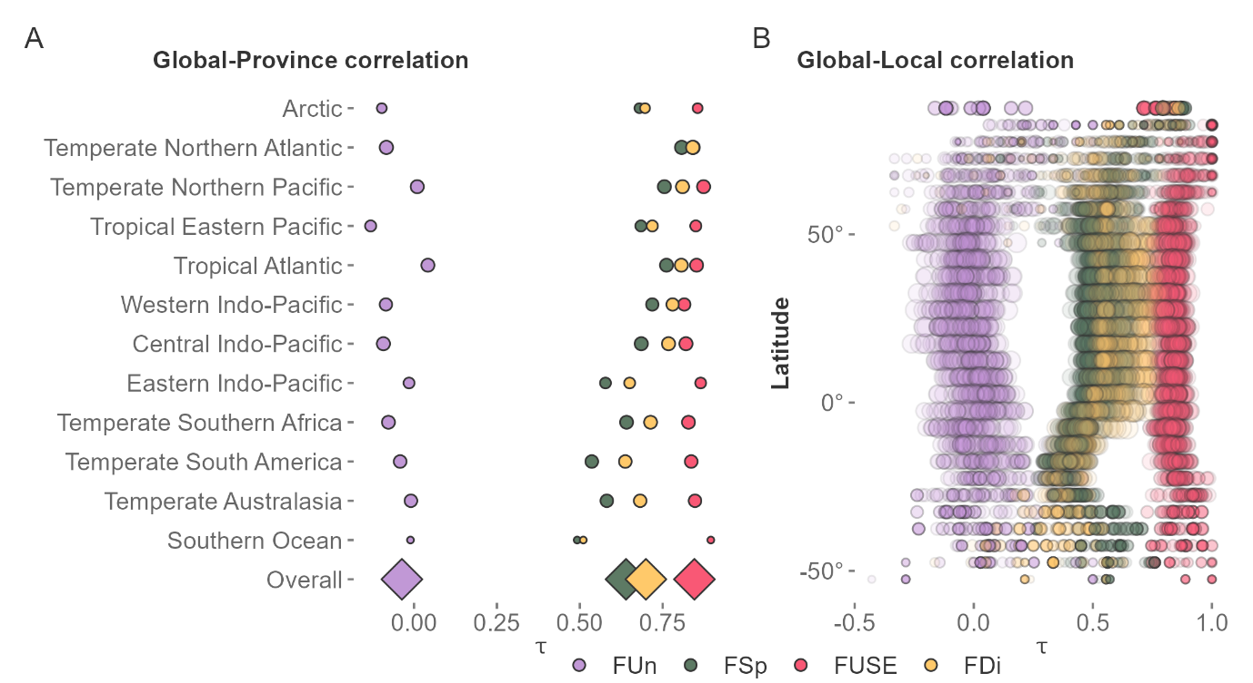
Figure 1. Figure X. Rank–rank correlations (Kendall’s Tau) of species’ functional contributions across spatial scales. (A) Correlation between global species rankings and rankings recalculated within individual marine provinces, shown separately for functional uniqueness (FUn), functional specialisation (FSp), functional distinctiveness (FDi), and FUSE. (B) Correlation between global species rankings and rankings recalculated within local assemblages (5° × 5° grid cells). Each point represents one grid cell.
The high sensitivity of functional uniqueness likely stems from its strong dependence on a handful of species with similar trait values making it highly vulnerable to even small changes in the size of the special pool (i.e. assemblage) considered. On the other hand, FSp and FDis are dependent on changes across the entire community in mean trait differences, being more robust to smaller changes in community composition. It might be argued that the greater robustness of FSp and FDis across scales suggests that they should be preferred over FUn in conservation prioritisation. However, given the strong body of theory and empirical examples that illustrate the importance of functionally unique species in upholding ecosystem functions (refs), rather than abandoning FUn, its strong scale-dependence should be explicitly incorporated into conservation prioritisation and planning.
When considering FUSE rankings, the functional conservation prioritisation metric incorporating IUCN status, the top-10 species identified at the local scale generally correspond poorly with those identified at the global scale, with a mean of 17 and a maximum of 40% agreement (Fig. 2B, map). The lowest levels of agreement are found towards the polar oceans, where ~10% of species show overlap between local and global scales. Meanwhile, a higher – though still poor – degree of agreement is found in the tropics, with the highest levels around the coast of Indonesia and Malaysia, as well as some oceanic islands such as the Galapagos. Indeed, the highest-ranking species – those of the most pressing concern for the maintenance of functional diversity – also vary across scales. For instance, the globally top-ranked species, the green turtle, fell as low as 18th at the provincial scale, and was only the 4th top species at the local scale. Meanwhile, the polar bear, which is 5th highest FUSE species at the global scale, was only 11th, 15th and 28th highest ranking within individual provinces, and yet reached the highest mean local ranking (Fig. 2C). Thus, it is not just that locally or provincially important species may be missed in global-scale rankings, but provincial or local-scale conservation priorities may equally overlook global-scale priorities. Our results show only limited and spatially variable correspondence between local and global FUSE priority lists, especially in lower diversity, high latitude areas.
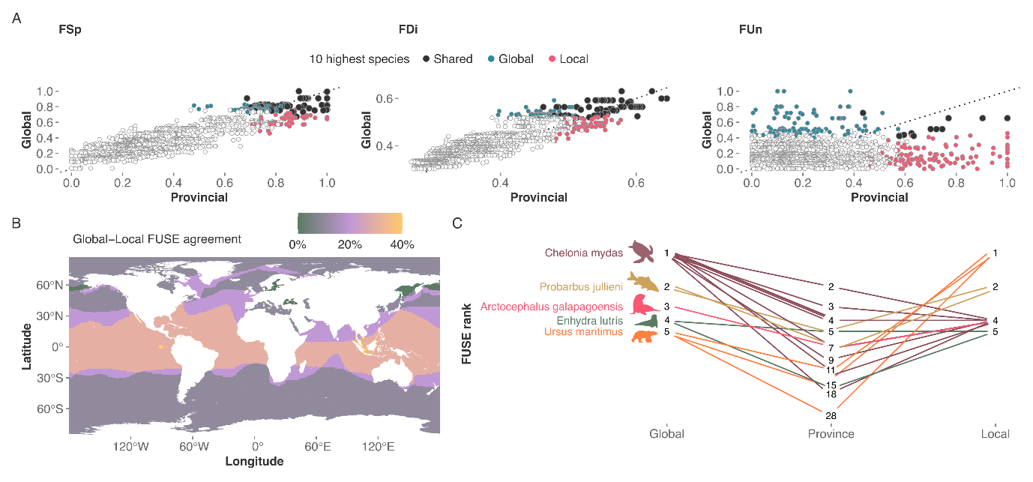 Figure 2. Cross-scale agreement in species’ functional importance. (A) Comparison of top 10 species identified by functional metric (FUn, FSp, FDi) at the global versus provincial scale. Species highlighted in red are among the top 10 regionally but not globally, those in blue are among the top 10 globally but not regionally, and those in black appear in the top 10 at both scales. (B) Map showing the percentage of agreement between the global top 10 species and the local top 10 species within 1°×1° grid cells for the FUSE metric. (C) Functional rankings across scales for the five globally highest‐ranked species based on FUSE, shown at the global, provincial, and local scale. Local values represent the most frequently observed (modal) rank across all 1°×1° grid cells within a species’ range.
Species’ contributions to functional diversity vary widely across their range, further illustrating the location – as well as scale – dependence of functional conservation prioritisation. Around 40% of species reach maximal (1) functional uniqueness levels at some point in their range (see supplementary table). The blue whale illustrates how functional contributions can vary across the range of a species (Fig. 3). While its functional uniqueness is generally low to moderate, it reaches high levels in scattered areas of the world’s oceans, especially towards high latitudes. In contrast, its functional specialisation is much higher, featuring as the top or near-top functionally specialised species, especially in coastal tropical areas of the world. Its functional distinctness varies less widely but is also greater in coastal areas. The highest FUSE is found where it has extreme and unique trait values relative to the rest of the assemblage; meanwhile, it has much lower FUSE values where it is surrounded by functionally similar species and is close to the shifted centroid. Thus, species’ functional contributions are not rigid but - as they are relative to the rest of the community - vary dramatically across their ranges.
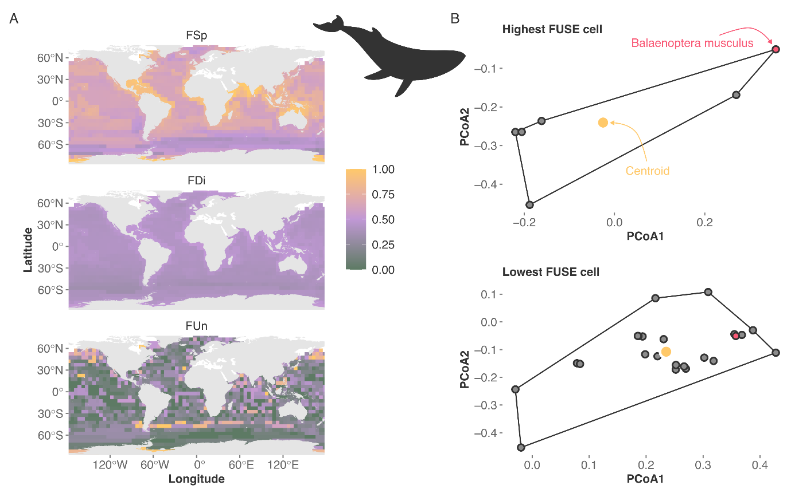
Figure 3. Illustrative example using the blue whale (Balaenoptera musculus). (A) Spatial variation in FUn, FDi, and FSp across the species’ range, calculated within 5°×5° grid cells. (B) Position of the blue whale in functional space in the grid cell where it reaches its highest FUSE value (top) and lowest FUSE value (bottom). The centroid of the assemblage is shown in yellow, the blue whale in red, and all other species present in grey.
These findings also have implications for our understanding of ecological redundancy. Our results clearly show that many species entirely lack redundancy in at least some part of their ranges, and all species have relatively low redundancy in some part of their range. Our results align with the context-dependent effects of species’ losses on the functionality of marine ecosystems. For example, sea otters singularly control grazing urchins in the far northern Pacific, but are supported by several large fish and crustacea in more southern regions (Eisaguirre et al. Ecology 2020). Given the highly migratory nature of many marine megafauna, our results even suggest that individuals have varying functional contributions as they undertake migrations: for instance, a single blue whale may singularly fill the niche of a very large filter-feeder in the Southern Ocean during the summer, but become less unique as it migrates towards the tropics in the autumn. Further, if - as our results suggest - most species uniquely fill a functional niche in at least one part of its range, our findings also help resolve long-standing questions about coexistence of functionally similar species (Hutchinson 1959, 1961, Am Nat). Perhaps most importantly, our results show that low global values of a species’ functional contributions does not mean that a species will not be highly unique or specialised – and thus play important and irreplaceable ecological roles – in some part of its range.
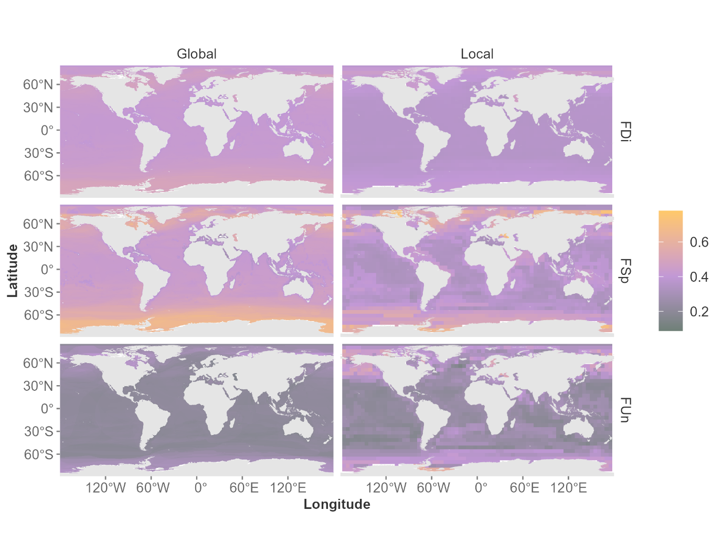
Figure 4. Spatial distribution of functional metrics calculated at global versus local scales. Columns show metrics calculated relative to the global species pool (left; 1°×1° grid) and relative to the local assemblage (right; 5°×5° grid).
Our final analysis aimed to identify regions of the world’s oceans where species have exceptional levels of functional contributions, a form of global biodiversity hotspot, and test whether these are scale-dependent (Fig. 4). Evaluated in terms of their position within a local vs. global functional space, functional uniqueness values naturally increase in absolute terms (Fig. 4A vs. B). More importantly, the locations of hotspots also shift appreciably (Fig. 5). New hotspots emerge in the Baltic Sea, and towards the poles and only show a 12% overlap with global hotspots. In these areas, species on average lack redundancy and show extreme degrees of uniqueness, implying species loss will leave large ecological voids in these areas. The same pattern can be observed for distinctiveness and specialisation, with new hotspots emerging in the Baltic sea and polar regions, with even less overlap between locally and globally defined hotspots (FSp = 6%, FDi = 1%). Identifying regions with exceptional levels of biodiversity remains a key task for conservation (refs). These results show that – in terms of functional priorities – the scale at which species’ contributions are considered can profoundly shift the locations of resulting priority areas of the world’s oceans.
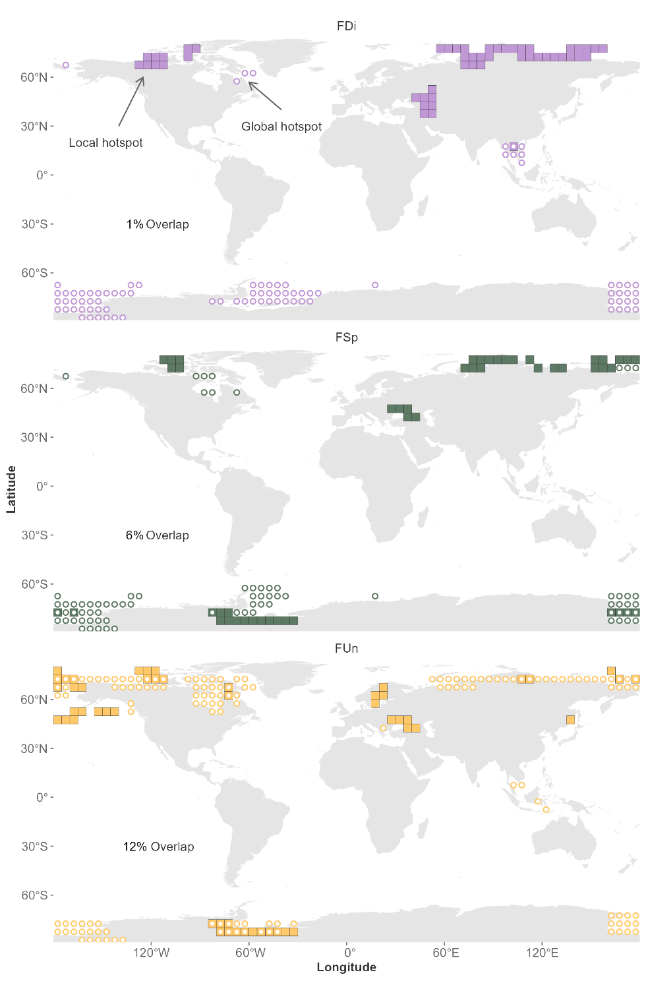
Figure 5. Hotspots of functional diversity identified at global versus local scales. Hotspots are defined as the top 2.5% of grid cells for each metric. Filled rectangles indicate hotspot locations when metrics are calculated locally, while white circles show hotspots when calculated relative to the global species pool. Percentages denote the degree of overlap between global and local hotspots.
Conclusion
Spatial scale is a perennial issue in ecology and conservation but until now has not been considered in light of species’ functional conservation priorities. We show here that, rather than species having a single value for their functional contributions, or indeed their functional conservation rank, this contribution is highly scale – and location – dependent. The same conclusion holds for hotspot locations. These results provide a cautionary tale for conservation prioritisation. Single-scale analyses do not present the full picture; species overlooked at one scale may well emerge as key at different scales or locations. We need an adaptive and pluralistic approach to functional prioritisation with an explicit consideration of multiple scales.
Methods
Species data
We followed the definition of Estes et al. 2016 and Pimiento et al. 2020 for marine megafauna and their provided list of 334 marine megafauna species. According to this definition, marine megafauna includes all large-bodied organisms (body mass, ≥45 kg) inhabiting the coastal and open oceans, including bony fishes, elasmobranchs (sharks and rays), mammals (whales, seals, sea cows, and the polar bear), reptiles (sea turtles), a species of sea bird (i.e., the emperor penguin), and a few species of mollusks (clams, squids, and octopuses). To get the geographic distributions for each of these species, we accessed the IUCN Red List of Threatened Species (IUCN, 2024) on January 19th 2024. The IUCN database provides range maps based on experts’ opinion, outlining polygon areas enclosing all known extant and possibly occurrences for species. We transformed these range maps into a presence-absence matrix with a resolution of 0.5x0.5 degrees latitude. However, the IUCN database did not provide range maps for 39 species from the megafauna list (suppl. Table S1). For these species, we accessed the AquaMaps database (Kaschner et al. 2021) on January 19th 2024, which provides native species range maps based on ecological niche models. We similarly transformed the probability of occurrence of a species from such an ecological niche model into a presence-absence matrix using probabilities >0 as a cutoff, and added the resulting matrix to the IUCN data. Nevertheless, 10 out of the 39 species were also not included in AquaMaps (suppl. Table S1) and were removed from further analysis.
Trait data
We gathered 10 functional traits for marine megafauna from Pimiento et al. (2020) and assigned those to each species where spatial occurrence data was available (suppl. Table S2), describing the main ecological characteristics of marine megafauna species. These comprise maximum body mass, thermoregulation, terrestriality, habitat zone, vertical position, migration, feeding mechanism, diet, breeding site, and group size/sociality. Traits were derived mainly on the species information provided by FishBase (www.fishbase.org/) and IUCN Red List of Threatened Species (www.iucnredlist.org/), as well as on primary literature (see Pimiento et al., 2020).
Functional space
The global marine megafauna functional space was built based on the 324 species from which spatial data was available (see above). We used R version 4.4.1 and the R package ade4 version 1.7-22 for this and subsequent analysis. We first created a trait distance matrix to assess the functional dissimilarity between species based on their trait combinations. Species’ dissimilarities were measured as pairwise functional distances using a generalization of Gower’s distance (Pavoine et al. 2009), which treats different types of functional traits (coded as continuous, ordinal, nominal, and binary variables) and weighs each function equally (Maire et al. 2015). This matrix was generated with the function “dist.ktab” (Dray & Dufour 2007) and laid the basis for building the trait space (Mouillot et al. 2013), where species dissimilarity was decomposed along axes representing traits and extracted from a Principal Coordinate Analysis (PCoA) using the function “pcoa” (Dray & Dufour 2007). To find the dimensionality of the functional space that best describes the functional properties of the species assemblage (i.e. the functional space that faithfully represented species’ initial functional trait values and correctly positioned species between each other), we calculated the mean squared deviation between species’ distances originally measured in the dissimilarity matrix and their distances in the functional space (Maire et al. 2015). We selected the first four dimensions of the PCoA based on the elbow inflection point for the mean squared deviation index, representing the most parsimonious balance between maximising the space’s quality (in terms of representativeness) and minimizing its dimensions (Maire et al. 2015).
Functional metrics
We calculated commonly used functional metrics from the estimated functional space (REF). These comprised functional uniqueness (FUn), functional specialisation (FSp), and functional distinctiveness (FDi). We additionally calculated the FUSE metric (Functionally Unique, Specialized, and Endangered) as defined by Pimiento et al. 2020. All metrics were calculated by R functions provided by Pimiento et al. 2023 and available at https://github.com/Pimiento-Research-Group/sharks-FD_ biodiv_global.
FUn quantifies how isolated a species is within the functional trait space. In practice, for each species, we identified its five closest neighbours in the multidimensional trait space and recorded the average distance to these. Species with high FUn possess unique trait combinations and may therefore perform unique ecological functions within the community (low functional redundancy).
FDi assesses the average dissimilarity of a species relative to all other species within the community. It is calculated as the mean distance in trait space from a given species to every other species. High distinctiveness values indicate that a species differs substantially in its trait composition from the overall species pool, and therefore contributes disproportionately to the breadth of functional strategies present in the assemblage.
FSp measures how far a species lies from the centroid of the trait space formed by all species in the community. The centroid represents the average trait composition. Species with high FSp values possess trait combinations that are far from this average, placing them at the margins of the trait space. These species can be considered functionally extreme and may be particularly sensitive to environmental changes or play specialized ecological roles.
FUSE is a combination of FSp, FUn, and extinction risk based on extinction probabilities in 100 years, as provided by species’ IUCN categories. It allows to identify highly threatened species whose global extinction would result in the most significant functional losses.
We calculated these functional diversity metrics for each species across three spatial scales: global, provincial, and local. At the global scale, species’ positions in the functional space were computed relative to the full species pool across all regions. At the provincial scale, functional metrics were calculated based on species’ positions relative to other species occurring within the same biogeographic province (taken from Spalding et al, 2007). At the local scale, we restricted the species pool to those co-occurring within each 5° × 5° grid cell.
Hotspots
Hotspot cells were defined as the 2.5% of the richest cells for a given functional diversity metric (David et al. 2005; Albouy et al. 2017). We quantified the overlap between local and global hotspots as the proportion of shared cells relative to the union of the two sets.

Acknowledgements
This project was funded by a PRIMA grant (no.185798) from the Swiss National Science Foundation to CP. SV thanks the Xunta the Galicia GAIN Oportunius programme and Consellería de Educación (Galicia, Spain) for additional financial support.
References

