

**Main Manuscript for**

Deep-time climate legacies affect origination rates of marine genera

Gregor H. Mathes1,2, Wolfgang Kiessling1, Manuel J. Steinbauer2,3

1Department of Geography and Geosciences, GeoZentrum Nordbayern, Friedrich-Alexander University Erlangen-Nürnberg (FAU), Erlangen, Germany.

2Bayreuth Center of Ecology and Environmental Research (BayCEER), University of Bayreuth, Bayreuth, Germany.

3Department of Biological Sciences,University of Bergen, Bergen, Norway

*Gregor H. Mathes

**Email:**  gregor.mathes@uni-bayreuth.de

**Author Contributions:** G.H.M. undertook formal analysis, investigation and visualization.M.J.S. was responsible for conceptualization and supervision. W.K. secured resources. W.K. and M.J.S. were responsible for funding acquisition. G.H.M. wrote the original draft and the other authors were involved in reviewing and editing the final manuscript.

**Competing Interest Statement:** The authors declare no competing interests.

**Classification:** Biological Sciences - Evolution

**Keywords:** climate change | fossil record | paleoclimate | evolution | macroevolution.

**This PDF file includes:**

Main Text

Acknowledgments

Figures 1 to 4

**Abstract**

Biodiversity dynamics are shaped by a complex interplay between current conditions and historic legacy. Paleoclimate interactions, the dependency of short-term climate change on paleoclimate, may mask the true relationship of evolutionary responses to climate change if not specifically accounted for. These interactions have been recently demonstrated for extinction risk and biodiversity change but their importance for origination dynamics is untested. Here we show that origination probability in marine fossil genera is strongly affected by paleoclimate interactions. Short-term cooling adding to a long-term cooling trend increases the origination probability by 27.8% (95% Confidence Interval [27.4%, 28.3%]). This large effect is consistent through time and all studied groups. The mechanisms of the detected effect might be manifold but are likely connected to increased allopatric speciation with eustatic sea level drop caused by sustained global cooling. We tested this potential mechanism through which paleoclimate interactions can act on origination rates by including a proxy for habitat fragmentation. This proxy, continental fragmentation, has a similar impact on origination rates as paleoclimate interactions, supporting the importance of allopatric speciation through habitat fragmentation in the deep-time fossil record. The identified complex nature of paleoclimate interactions might explain contradictory conclusions on the relationship between temperature and origination in the previous literature. Our results highlight the need to account for complex interactions in evolutionary studies both between and among biotic and abiotic factors.

**Significance Statement**

The effect of climate change on biodiversity is dependent on previous climatic trends, for example climate warming is more deleterious when added to a long-term warming trend. We tested whether a conditional dependency of climate change on paleoclimate can be detected in origination dynamics. Using data from the marine fossil record, we show that origination rates in the last 485 million years indeed are dependent on the interaction of climate cooling with longer term cooling trends. These findings might solve the ongoing debate on the relationship between climate and origination and underline the complexity of evolutionary dynamics and the presence of intricate interactions in Earth’s system.

**Main Text**

**Introduction**

Biodiversity responses to modern climate change are dependent on past climate (1–3). Paleoclimate was an important driver of both extinction and diversification dynamics in the Quaternary (3–6). However, the effect of paleoclimate on deep-time origination dynamics is largely unknown.

Paleoclimate might affect origination dynamics through a wide variety of ecological mechanism. If short-term change adds to a long-term temperature trend in the same direction (e.g. a short-term cooling following a prolonged cooling trend), species are less likely to have adaptations to the climatic situation due to niche conservatism (7–9). This lack of adaptation to climatic conditions might result in bottleneck and subsequent founder effects, as well as ecological releases (10–12). Such ecological effects influence rates of evolution and speciation (13, 14). Additionally, paleoclimate can hypothetically drive origination rates of marine genera through global sea level changes, affecting the amount of habitat fragmentation in the continental shelf area. Habitat fragmentation and loss is known to be correlated to the rate of ecological interactions (15–17) and speciation rates (18, 19).

Building on these ecological concepts through which paleoclimate might affect origination dynamics, we expect that the interaction between climate change with previous temperature trends is a strong determinant of origination rates in the deep-time fossil record. We hypothesize that origination processes are stronger influenced by temperature change if the change adds to a previous temperature trend in the same direction (synergistic paleoclimate interaction) rather than if the focal change withdraws previous trends (antagonistic paleoclimate interaction). Among synergistic paleoclimate interactions, we expect to detect a weakened origination signal after cooling-cooling due to the “common cause” hypothesis on sampling biases caused by low sea levels (20).

Here we analyze how global trajectories of paleoclimate can affect origination probabilities of twelve marine fossil phyla in the last 485 million years (Annelida, Arthropoda, Brachiopoda, Bryozoa, Chordata, Cnidaria, Echinodermata, Foraminifera, Hemichordata, Hyolitha, Mollusca, Porifera). We use paleoclimate interactions as explanatory variables, which are defined as the interaction of short-term temperature change with long-term temperature trends. We first apply regression models using traditional paleo-temperature variables and sample-standardized genus-level fossil data using a dynamic modeling framework. Dynamic implies that we let the long-term trend vary for each paleoclimate interaction, and subsequently select the best performing model. We then test whether cumulative paleoclimate interactions increase the origination probability of fossil taxa. Our results show, on average, a substantial increase in origination rates whenever a short-term cooling adds on a long-term cooling trend. To estimate whether this increase is caused by a reduction in available habitat space subsequently to cooling-cooling paleoclimate interaction, we then analyzed the effect of a proxy for shelf-area habitat space on origination rates using the same modeling framework.

**Results**

*Origination probability*

Cooling-cooling paleoclimate interactions resulted in an increased origination probability (Fig. 1, Suppl. Table 1). We compared the origination probability for marine groups per paleoclimate interaction, based on the output of our regression models. The overall origination probability was lower after cooling-warming, warming-cooling, and warming-warming paleoclimate interactions compared to the average origination probability of 13.3% per geological stage. On the contrary, cooling-cooling paleoclimate interactions resulted in an increased mean origination probability of 15.1%, whereas the origination probability in all other cases was 11.4%.

*Effect size*

The effect of cooling-cooling paleoclimate interactions on origination probability is large (Fig. 2, Suppl. Table 2). The absolute difference between the mean origination probability of cooling-cooling compared to all other paleoclimate interactions was 3.7 (95% Confidence Interval (CI) [3.7, 3.8]). This difference represents a 27.8% percentage increase compared to all other interactions (95% CI [27.4%, 28.3%]). We used the Cohen’s d statistic to compute the effect size as a standardized measure. Cohen’s d for cooling-cooling was greater than 1, indicating a large effect size. All results for the absolute difference, the percentage change, and the effect size are based on generalized mixed effect models and stay consistent when analyzed in a Bayesian regression framework (Fig.2).

*Group differences*

We additionally tested whether cooling-cooling paleoclimate interactions raised the origination probability of all studied marine groups and if the signal remains robust through time (Fig. 3, Suppl. Table 3). This was the case for all major phyla with sufficient data and throughout all 94 geologic stages, as all log-odds values including 95% CI’s were above 0. Among all groups, Arthropoda, Brachiopoda, and Bryozoa showed a higher than average response to cooling-cooling paleoclimate interactions. Through time, the Paleozoic Era showed the highest origination probabilities which then decrease through time, with the lowest values present in the Cenozoic Era. Note that we excluded the Cambrian from the analysis due to insufficient data (see methods section). Our large effect size of cooling-cooling interactions on origination probability remained consistent throughout all studied groups and throughout the whole Phanerozoic.

*Habitat fragmentation*

Approximating potential causal paths through which paleoclimate can act on origination rates, we further tested the effect of continental fragmentation on origination within our modeling framework. We found that a short-term increase in continental fragmentation following on a long-term increase resulted in a substantial spike in origination rates (Fig. 4). The origination probability after such a continental fragmentation interaction was 22% (95% CI [21.1%, 23%]) greater than the average origination rate.

**Discussion**

The interplay of short-term climate cooling adding to a long-term average global cooling resulted in a profound increase of origination probability. We found this effect to be consistent through time and across all studied groups. Previous studies on the relationship between temperature and origination came to ambiguous conclusions, ranging from a negative relationship (21), no relationship (22, 23), to a positive one (24). Our results show that the relationship between origination rates and temperature is dependent on baseline conditions which were not considered in previous analyses. The large effect size and the conditional dependency of paleoclimate interactions might have obscured or even inverted any apparent relationship between temperature and origination. Explicitly accounting for dynamic interactions in future analysis frameworks will hence provide a more robust foundation to assess the relationship between Phanerozoic marine diversity and climate. This has been recently demonstrated for modern terrestrial and marine assemblages, where biodiversity responses to recent climate change were conditional on the baseline climate (1).

Our results are remarkable as we expected to detect a weakened origination signal after cooling-cooling paleoclimate interactions due to the “common cause” hypothesis (20). Sampling biases caused by low sea levels arise from the removal of originating taxa from the fossil record or a shift of their detection to a later origination datum, leading to an artificially reduced origination probability. These extrinsic biases of fossil data cannot be addressed by sampling standardization (25). The large effect size of cooling-cooling paleoclimate interactions might hence even be an underestimation of the true magnitude. However, we only tested the effect of temperature on origination rates and did not include other environmental parameters (e.g., sea-level, nutrient inputs) which could be more direct drivers of origination rates than temperature. Nevertheless, current research shows that temperature remains a significant predictor of origination rates after accounting for additional environmental parameters (24). Further, temperature can act as a top-down effect, driving the change in other environmental parameters such as sea-level and shelf area weathering. Directly correlating temperature to origination rates, instead of fitting additional mediatory variables, might hence give a more precise estimate of the relationship between climate and origination dynamics.

Other abiotic factors affecting origination probability are not related to temperature. Continental fragmentation can increase the amount of geographic barriers restricting animal movement and thus enhancing allopatric speciation rates (26–28). Our results show that the effect of fragmentation on origination rates is particularly large when an increase in continental fragmentation adds to a previous long-term increase. A drop in eustatic sea level is an additional driver for habitat fragmentation. Cooling-cooling paleoclimate interaction resulting in a drop in eustatic sea level due to glaciation leads to reduced continental shelf area and emerging barriers in this main habitat of the majority of the studied fossil groups. Changes in habitat fragmentation are correlated to the rate of ecological interactions (15–17) and speciation rates (18, 19). Both variables used in our analysis, paleoclimate and continental fragmentation, thus share a common causal mechanism to drive origination probabilities. Our results may therefore support the importance of allopatric speciation through vicariance in the deep-time fossil record (29–31).

Habitat fragmentation may not only drive origination rate but also influence the effect of paleoclimate interactions on extinction. Cooling-cooling paleoclimate interactions have also been shown to drive temperature related extinctions in the fossil record, with warming-warming interactions showing the same signal albeit with lower effect size (2). Vicariance might explain why the effect size for warming-warming interactions on extinction risk is reduced compared to cooling-cooling, even though the supposed underlying mechanism of niche conservatism does not differentiate between the two types of synergistic paleoclimate interactions (7–9). During warming-warming paleoclimate interaction, marine taxa could potentially escape adverse environment through range shifts. During cooling-cooling, however, geographic barriers resulting from sea level drop might impede migration, resulting in the observed increased extinction risk (2) and origination probability (this study) compared to warming-warming and all antagonistic paleoclimate interactions.

Our study supports that evolutionary processes interact with climate by complex effects showing conditional dependencies. Explicitly integrating these effects within a dynamic modeling framework leads to an improved discernment of origination patterns in the fossil record. Previous studies on the relationship of temperature and biodiversity in Earth’s history came to ambiguous conclusions, a non-conformance likely to be fixed in the future by accounting for paleoclimate interactions. However, the mechanisms underlying the grand association between evolution and the observed effect are still unclear. The interpretation offered here, a combination of niche conservatism and ecological effects arising from sea level change resulting in vicariance and allopatric speciation, could be at least partially tested by comparing responses of terrestrial and marine fossil groups to paleoclimate interactions. If sea level change plays a key role, terrestrial groups should show a distinctively different response to cooling-cooling compared to marine groups. Given the large effect of paleoclimate interactions on both extinction and origination, as well as the consistency of this effect through time and studied groups, determining the underlying causes of paleoclimate interactions will improve our mechanistic comprehension of evolutionary dynamics in Earth’s history (32).

**Materials and Methods**

*Fossil data*

All analyses were conducted at the genus level. We accessed data from the Paleobiology Database (PaleoDB, paleobiodb.org) using the chronosphere package interface (33) on 03 March 2021, including all occurrences from the Ediacaran to the Holocene. We filtered the data to only comprise marine animal taxa and heterotrophic protists, i.e. the same taxonomic groups listed in Sepkoski’s (34) compendium, following common processing recommendations (35). Previous studies on the relationship between temperature and biodiversity were mainly based on Sepkoski’s compendium, rendering this data optimal for comparison purposes of our model structures. We binned the data to one of 80 geological stages (36), ranging from the Ordovician to the Pleistocene. Ordovician stages were resolved using biozone and formation entries due to potential stratigraphic errors (35). Further data cleaning included removal of uncertain taxonomical ranks, duplicates in bins, single-collection, and single-reference taxa as well as missing higher-level taxonomy. Taxa confined to a single stage (singletons) were excluded as they tend to produce undesirable distortions of the fossil record (37). Collections from unlithified sediments were omitted to reduce sampling bias (18). We then applied shareholder quorum subsampling (SQS) for sampling standardization (38). SQS is based on frequency distribution coverage of taxa, drawing collections until estimated coverage reaches a fixed target (i.e., until a shareholder quorum is attained). For this, we used a shareholder quorum of 0.8. SQS was applied excluding dominant taxa from all calculations involving frequencies and with a separate treatment of the largest collection in each time slice. We then transformed occurrence data into ranges congruent to a time series with one single origination and extinction event for each genus. The final data set contained twelve major marine fossil phyla with sufficient data to include in the subsequent analysis (Suppl. Figure 1, Suppl. Table 4).

*Climate proxy data*

To reconstruct temperature change over time, we used the tropical whole surface water (mixed layers < 300 m deep) oxygen isotope data set from a compilation of marine carbonate isotopes (39). This temperature proxy is based on δ18O values of well-preserved calcareous shells. To get from raw δ18O values to temperature estimates, we applied the recommended data processing steps of Veizer & Prokoph (39). We first adjusted for the long-term trend in oxygen isotopic composition of seawater and averaged records from tropical and subtropical records. We then assigned the temperature data to geological stages to provide global mean temperature for each of the 81 stages used in our analysis.

*Generalized linear mixed effect models*

All analyses were carried out in R (40). We used the lme4 package (41) to perform the regression analysis, and the tidyverse package compendium (42) for data processing and visualization. We quantified the effect of temperature change interacting with past temperature trends on origination probability using generalized linear mixed effect models with a binomial family error (GLMMs) (43). We used the origination signal from the fossil data as a response variable and a single interaction term including the long-term temperature trend and the short-term temperature change as a predictor variable:

GLM (Origination ~ Trend : Change + (1 | Genus), Family = Binomial).

Using the genus-level as a random effect, we accounted for the multiple occurrence of the same genus within the time-series fossil data.

The short-term temperature change was calculated as the change in temperature for each geologic stage compared to the previous stage. Long-term temperature trends were calculated using ordinary least squares following the processing steps of Mathes et al. (2). For each stage included in the analysis, we calculated ten stages starting one stage prior to the focal stage, each covering a successively growing time of temperature history. We then used a dynamic model framework to select the best performing long-term trend (Suppl. Table 5). This implies calculating 10 GLMMs for each trend while keeping the short-term change fixed. From these 10 GLMMs, we then selected the best performing model using Akaike’s Information Criterion (AIC) . Instead of calculating one model for all short-term changes, we distinguished short-term warming from short-term cooling. This enabled us to quantify the differences in origination probability per paleoclimate interaction (cooling-cooling, warming-cooling, cooling-warming, warming-warming, where the first word denotes the long-term temperature trend, and the second word the short-term temperature change). We used AIC for comparison of model performance. For likelihood approximation, we applied adaptive Gauss-Hermite quadrature (44), which reduces bias and is more robust than other approximation methods (43). We used 25 quadrature points per scalar integral, which is the maximum number of nodes in the quadrature formula of the lme4 package.

*Origination probability*

We separated the predicted origination response for each type of paleoclimate interaction from our GLMMs using the predict() function on the actual fossil data. Any resulting distributions for the origination probability hence reflect climate conditions experienced by the focal fossil group. We calculated the average origination probability as the mean of both model coefficients (i.e. of the model for short-term warming and for short-term cooling).

*Effect size*

We applied non-parametric bootstrapping (45) (Suppl. Figure 2) and Bayesian estimation (46) to the predicted origination response of our GLMMs to calculate the difference in means between origination probability after cooling-cooling compared to all other paleoclimate interactions. While doing so, we accounted for the non-parametric nature of the data (Suppl. Figure 3). Bootstrapping was based on 2000 repetitions. For Bayesian estimation, we used a Markov Chain Monte Carlo method with four chains, 1000 iterations, and 500 warm-up iterations. We used a weakly informed prior for the group mean based on realistic values for origination rates. We further constrained this prior to values between 0 and 100, representing the absolute minimum and maximum values for origination rates expressed in percentage points. The prior for the response variable was sampled from the t-distribution, rendering the model more robust against outliers. We further modeled the sigma coefficient for each paleoclimate interaction individually, allowing group-wise comparisons. The prior for these group variances was sampled from the cauchy-distribution. All model estimates successfully converged using these priors and model parameters. The overall increase of origination probability after cooling-cooling paleoclimate interactions was calculated by dividing the estimated difference of means by the baseline probability of origination. Further, we calculated Cohen’s d effect size based on the raw output of our GLMMs as well as posterior distributions after Bayesian estimation using the formula:

$\frac{\left(μ_{1}−μ_{2}\right)}{\sqrt{{\left(σ_{1}^{2}+σ_{2}^{2}\right)}/2}}$

We then calculated 95% Wald confidence intervals for the applied non-parametric bootstrapping results and 89% highest posterior density intervals for the Bayesian estimation (47).

*Group differences*

Based on the results from our GLMMs, we calculated the log-odds ratio for each major fossil group and for each Phanerozoic Era spanning all studied stages. A second approach was to group geologic stages together to get to a finer temporal resolution (Suppl. Table 3). Grouping of the stages was necessary to obtain a sufficient number of observations to calculate the log-odds ratio and was based on the number of stages included, resulting in evenly spaced intervals. The oldest interval ranged from the Tremadocian to Lochkovian, the second from the Pragian to Artinskian, the third from the Kungurian to Pliensbachian, the fourth from the Toarcian to Turonian, and the youngest period from the Coniacian to Pleistocene. We did not calculate group differences for phyla where data were insufficient to get a log-odds ratio estimate.

*Continental fragmentation*

To estimate whether habitat space and vicariance might be the mechanisms through which paleoclimate interactions act on origination probability, we included continental fragmentation as an explanatory variable in our model framework. We used a continental fragmentation index (28) accessed via the chronosphere package. Data processing was similar to processing of temperature data, including the calculation of short-term changes and long-term trends in continental fragmentation. We then compared the origination probability for marine genera for each possible interaction of short-term and long-term continental fragmentation (increase-increase, increase-decrease, decrease-increase, decrease-decrease) using the same analysis as for paleoclimate.

*Model comparison*

Previous studies used different estimates of temperature to deduce an association between origination and temperature (24, 24, 48, 49). Generally, simple models correlate static temperature estimates at each interval to biodiversity in the same interval. More complex models include temporal lags of temperature, allowing for a suspended response of biota to temperature change (21, 48). Most recent models are based on both estimates but additionally allow for interactions of static estimates and temporal lags (24). To test whether paleoclimate interactions perform better than these traditional model estimates, we calculated a GLMM for each model structure from simple to complex. We then compared the performance of each model to a model allowing for paleoclimate interactions (Suppl. Figure 4 and Suppl. Figure 5). The interaction models were based on the same model structure, but explicitly allowed for interactions of long-term temperature trends and short-term climate changes within a dynamic modeling framework. Comparison of model performance was based on AIC values with results being consistent with Bayesian information criterion (Suppl. Table 6).

**Acknowledgments**

This work was supported by the Deutsche Forschungsgemeinschaft (KI 806/16–1

and STE 2360/2-1) and is embedded in the Research Unit TERSANE (FOR 2332:

Temperature-related stressors as a unifying principle in ancient extinctions).

M.J.S. acknowledges support by European Research Council grant no. 741413 Humans on Planet Earth (HOPE).

**References**

1. L. H. Antão, et al., Temperature-related biodiversity change across temperate marine and terrestrial systems. Nature Ecology & Evolution 4, 927–933 (2020).
2. G. H. Mathes, J. van Dijk, W. Kiessling, M. J. Steinbauer, Extinction risk controlled by interaction of long-term and short-term climate change. Nat Ecol Evol 5, 304–310 (2021).
3. J.-C. Svenning, W. L. Eiserhardt, S. Normand, A. Ordonez, B. Sandel, The Influence of Paleoclimate on Present-Day Patterns in Biodiversity and Ecosystems. Annual Review of Ecology, Evolution, and Systematics 46, 551–572 (2015).
4. A. M. Lister, The impact of Quaternary Ice Ages on mammalian evolution. Philos Trans R Soc Lond B Biol Sci 359, 221–241 (2004).
5. M. Maldonado-Coelho, Climatic oscillations shape the phylogeographical structure of Atlantic Forest fireeye antbirds (Aves: Thamnophilidae). Biological Journal of the Linnean Society, 25 (2012).
6. J. M. Postigo-Mijarra, C. Morla, E. Barrón, C. Morales-Molino, S. García, Patterns of extinction and persistence of Arctotertiary ﬂora in Iberia during the Quaternary. Review of Palaeobotany and Palynology, 12 (2010).
7. M. J. Hopkins, C. Simpson, W. Kiessling, Differential niche dynamics among major marine invertebrate clades. Ecology Letters 17, 314–323 (2014).
8. A. L. Stigall, When and how do species achieve niche stability over long time scales? Ecography 37, 1123–1132 (2014).
9. J. J. Wiens, C. H. Graham, Niche Conservatism: Integrating Evolution, Ecology, and Conservation Biology. Annual Review of Ecology, Evolution, and Systematics 36, 519–539 (2005).
10. D. J. Button, Mass extinctions drove increased global faunal cosmopolitanism on the supercontinent Pangaea. NATURE COMMUNICATIONS, 8 (2017).
11. S. E. Gilman, M. C. Urban, J. Tewksbury, G. W. Gilchrist, R. D. Holt, A framework for community interactions under climate change. Trends in Ecology & Evolution 25, 325–331 (2010).
12. D. M. Raup, Size of the Permo-Triassic Bottleneck and Its Evolutionary Implications. Science 206, 217–218 (1979).
13. A. R. Templeton, The reality and importance of founder speciation in evolution. BioEssays 30, 470–479 (2008).
14. L. M. Wahl, P. J. Gerrish, I. Saika-Voivod, Evaluating the Impact of Population Bottlenecks in Experimental Evolution. Genetics Society of America 162, 12 (2002).
15. M. S. Schuler, J. M. Chase, T. M. Knight, Habitat patch size alters the importance of dispersal for species diversity in an experimental freshwater community. Ecol Evol 7, 5774–5783 (2017).
16. D. Tilman, Competition and Biodiversity in Spatially Structured Habitats. Ecology 75, 2–16 (1994).
17. J. W. Valentine, Climatic Regulation of Species Diversification and Extinction. Geol Soc America Bull 79, 273 (1968).
18. J. Alroy, Dynamics of origination and extinction in the marine fossil record. Proceedings of the National Academy of Sciences 105, 11536–11542 (2008).
19. E. Mayr, R. J. O’Hara, The biogeographic evidence supporting the Pleistocene forest refuge hypothesis. Evolution 40, 55–67 (1986).
20. S. E. Peters, Geologic constraints on the macroevolutionary history of marine animals. Proceedings of the National Academy of Sciences 102, 12326–12331 (2005).
21. P. J. Mayhew, G. B. Jenkins, T. G. Benton, A long-term association between global temperature and biodiversity, origination and extinction in the fossil record. Proc. R. Soc. B. 275, 47–53 (2008).
22. J. Alroy, P. L. Koch, J. C. Zachos, Global Climate Change and North American Mammalian Evolution. Paleobiology 26, 259–288 (2000).
23. D. R. Prothero, Does climatic change drive mammalian evolution? GSA today 9, 1 (1999).
24. P. J. Mayhew, M. A. Bell, T. G. Benton, A. J. McGowan, Biodiversity tracks temperature over time. Proc Natl Acad Sci USA 109, 15141–15145 (2012).
25. S. E. Peters, Genus extinction, origination, and the durations of sedimentary hiatuses. Paleobiology 32, 387–407 (2006).
26. W. Kiessling, Promoting marine origination. Nature Geosci 3, 388–389 (2010).
27. J. W. Valentine, E. M. Moores, Plate-tectonic Regulation of Faunal Diversity and Sea Level: a Model. Nature 228, 657–659 (1970).
28. A. Zaffos, S. Finnegan, S. E. Peters, Plate tectonic regulation of global marine animal diversity. Proc Natl Acad Sci USA 114, 5653–5658 (2017).
29. N. Eldredge, The Allopatric Model and Phylogeny in Paleozoic Invertebrates. Evolution 25, 156 (1971).
30. E. Mayr, Animal species and evolution. Animal species and evolution. (1963).
31. A. L. Stigall, J. E. Bauer, A. R. Lam, D. F. Wright, Biotic immigration events, speciation, and the accumulation of biodiversity in the fossil record. Global and Planetary Change 148, 242–257 (2017).
32. D. Jablonski, Extinction and the spatial dynamics of biodiversity. Proceedings of the National Academy of Sciences 105, 11528–11535 (2008).
33. À. T. Kocsis, N. B. Raja, chronosphere: Earth system history variables (2020).
34. J. J. Sepkoski, A compendium of fossil marine animal genera. Bulletins of American paleontology 363, 1–560 (2002).
35. À. T. Kocsis, C. J. Reddin, J. Alroy, W. Kiessling, The R package divDyn for quantifying diversity dynamics using fossil sampling data. Methods in Ecology and Evolution 10, 735–743 (2019).
36. J. G. Ogg, G. M. Ogg, F. M. Gradstein, A concise geologic time scale: 2016 (Elsevier, 2016).
37. M. Foote, Origination and extinction components of taxonomic diversity: general problems. Paleobiology 26, 74–102 (2000).
38. J. Alroy, Fair sampling of taxonomic richness and unbiased estimation of origination and extinction rates. The Paleontological Society Papers 16, 55–80 (2010).
39. J. Veizer, A. Prokoph, Temperatures and oxygen isotopic composition of Phanerozoic oceans. Earth-Science Reviews 146, 92–104 (2015).
40. R Core Team, R: A Language and Environment for Statistical Computing (R Foundation for Statistical Computing, 2020).
41. D. Bates, M. Mächler, B. Bolker, S. Walker, Fitting linear mixed-effects models using lme4. arXiv preprint arXiv:1406.5823 (2014).
42. H. Wickham, et al., Welcome to the Tidyverse. Journal of Open Source Software 4, 1686 (2019).
43. B. M. Bolker, et al., Generalized linear mixed models: a practical guide for ecology and evolution. Trends in ecology & evolution 24, 127–135 (2009).
44. J. C. Pinheiro, E. C. Chao, Efficient Laplacian and adaptive Gaussian quadrature algorithms for multilevel generalized linear mixed models. Journal of Computational and Graphical Statistics 15, 58–81 (2006).
45. C. Z. Mooney, Bootstrap statistical inference: Examples and evaluations for political science. American Journal of Political Science, 570–602 (1996).
46. J. K. Kruschke, Bayesian estimation supersedes the t test. Journal of Experimental Psychology: General 142, 573 (2013).
47. R. McElreath, Statistical Rethinking, 2nd Edition (2020) (March 5, 2021).
48. A. L. Cárdenas, P. J. Harries, Effect of nutrient availability on marine origination rates throughout the Phanerozoic eon. Nature Geoscience 3, 430–434 (2010).
49. A. Z. Krug, D. Jablonski, J. W. Valentine, K. Roy, Generation of Earth’s First-Order Biodiversity Pattern. Astrobiology 9, 113–124 (2009).

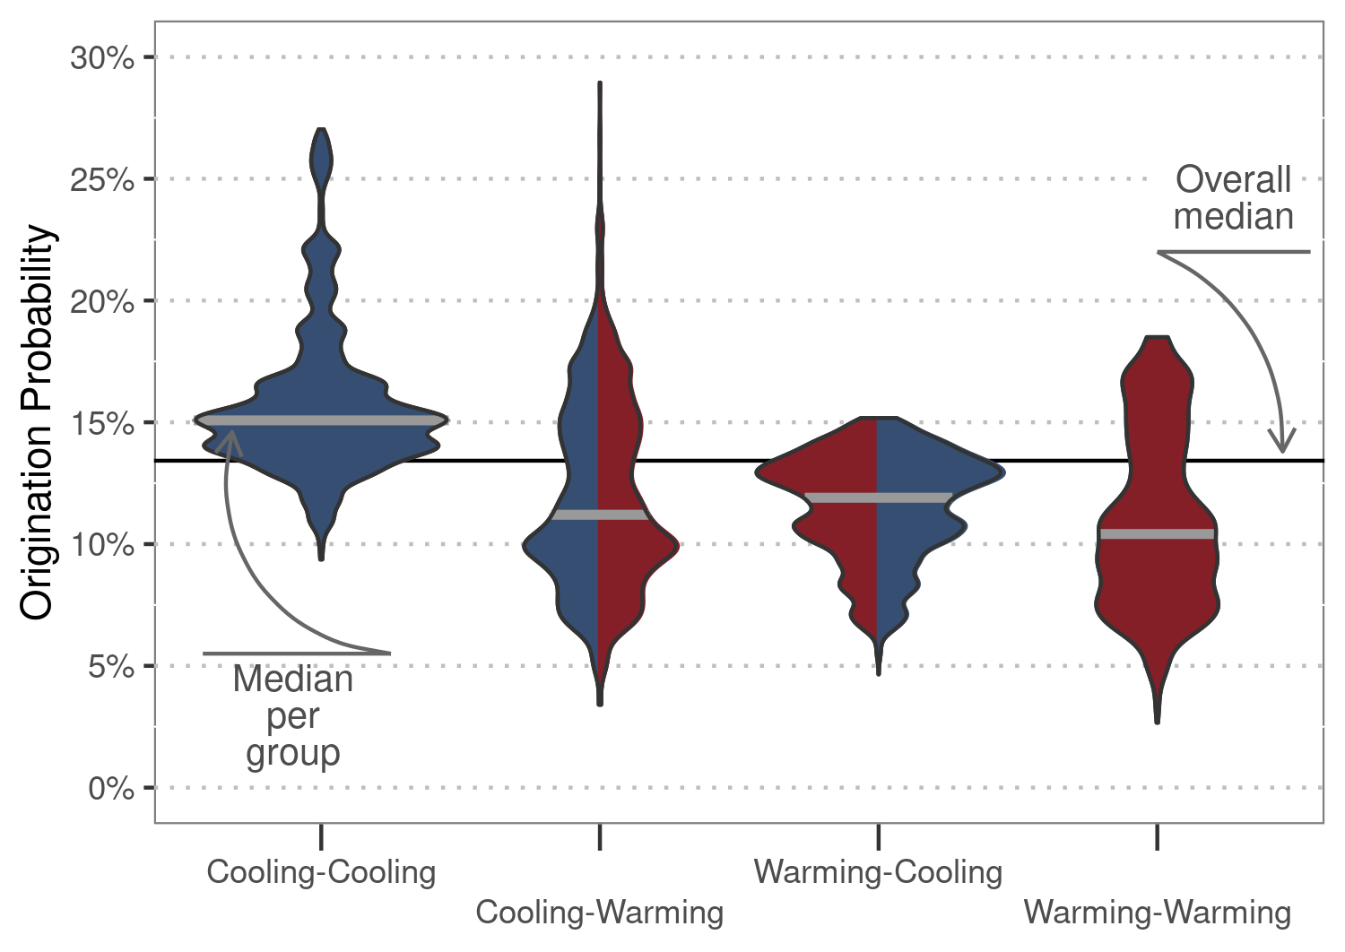**Figures and Tables**

**Figure 1.** Origination probability. Total response distributions to paleoclimate interactions as predicted by generalized linear mixed effect models. Thick gray lines show the median origination probability per paleoclimate interaction, and the black line depicts the median probability for all interactions combined.

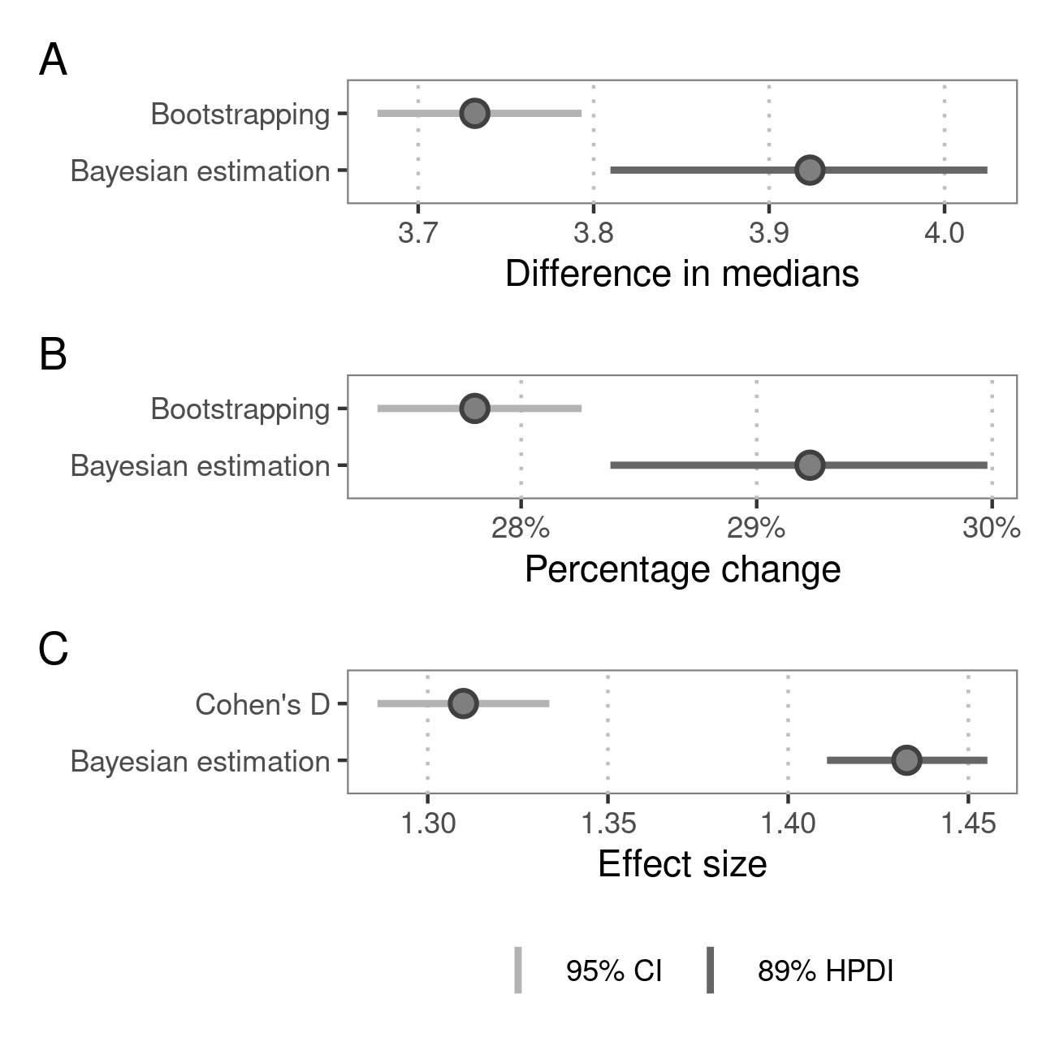

**Figure 2.** Effect size. A) Difference in medians between origination probability after cooling-cooling compared to all other paleoclimate interactions. B) Overall increase of origination probability after cooling-cooling paleoclimate interactions compared to baseline probability. C) Cohen’s d effect size of the observed change in probability after cooling-cooling paleoclimate interactions. Points show median estimates. Light gray lines delineate 95% confidence intervals (CI) based on non-parametric bootstrapping. Dark gray lines depict 89% highest posterior density intervals (HPDI) based on Bayesian regression.

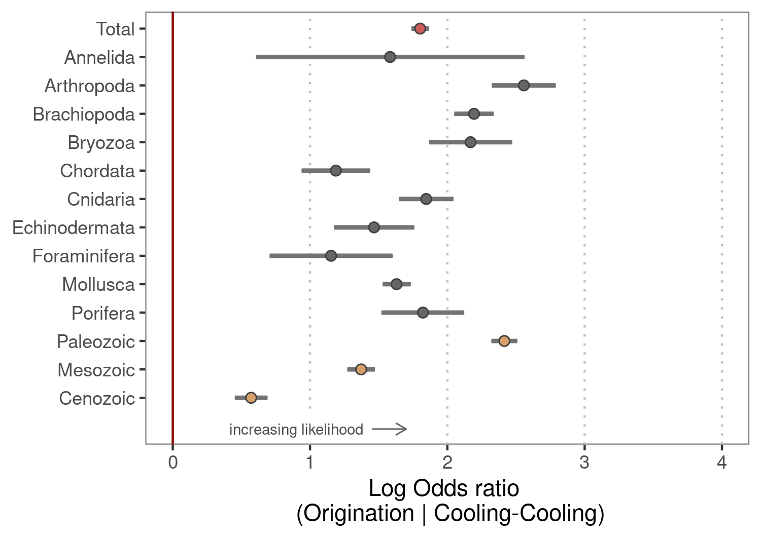

**Figure 3.** Group differences. Origination likelihood for all major phyla and across time after cooling-cooling compared to all other paleoclimate interactions. The red point shows the overall response, gray points per phyla, and brown points response per Era. Gray lines show 95% confidence intervals. The phyla Hemichordata and Nematoda as well as the Cambrian were removed from the analysis due to insufficient data. The red line delineates a log odds ratio of zero. Values above this line indicate a higher probability to originate after cooling-cooling compared to all other paleoclimate interactions.

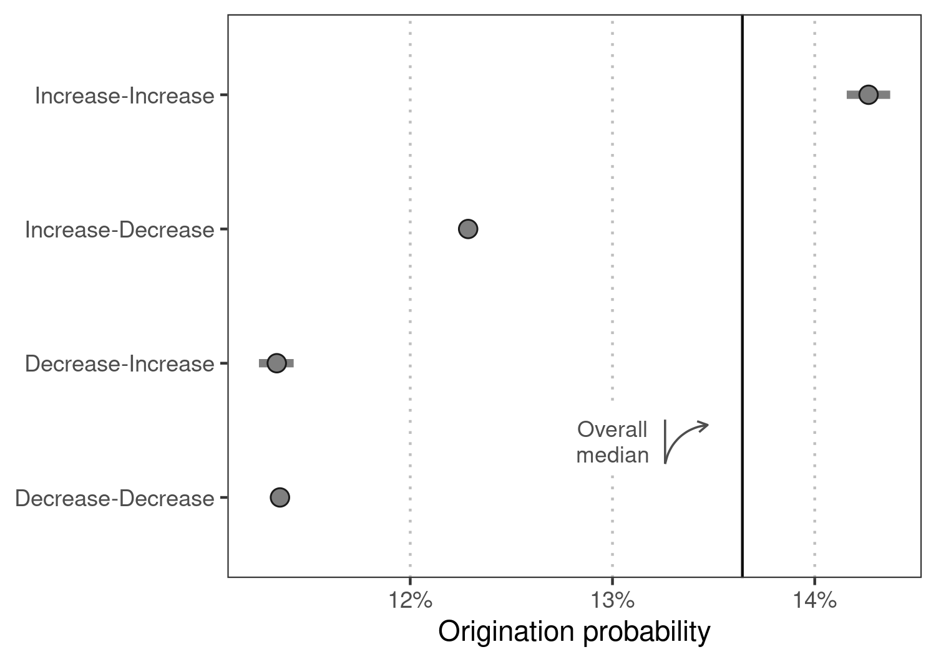

**Figure 4.** Continental fragmentation. Median origination response per continental fragmentation interaction as predicted by generalized linear mixed effect models based on a continental fragmentation index. The black line depicts the median origination probability for all marine genera, and gray lines delineate 95% confidence intervals.